Gettysburg
A Study in Command

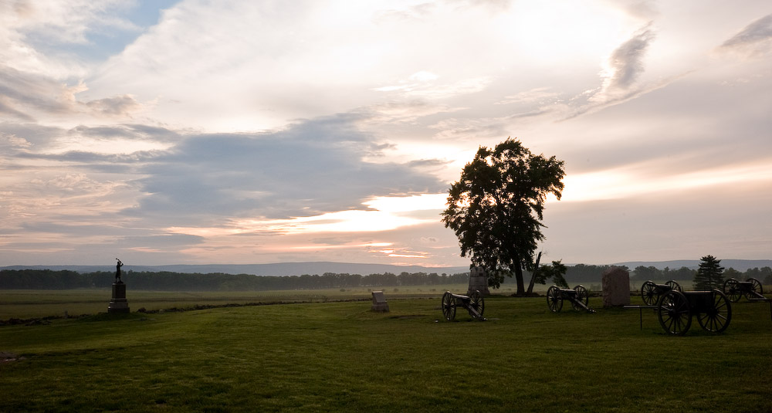

U. S. Army War College
Student Staff Ride Guide
AY16

Middle States Accreditation

The U.S. Army War College is accredited by the Middle States Commission on Higher Education (MSCHE), 3624 Market Street, Philadelphia, Pennsylvania, 19104, (267) 284-5000. MSCHE is an institutional accrediting agency recognized by the U.S. Secretary of Education and the Council for Higher Education Accreditation. Initial accreditation was granted in 2004.

U.S. Army War College
Gettysburg Staff Ride Guide

An Overview of the Gettysburg Campaign

With Selected Correspondence

Originally Compiled and Edited By

Leonard J. Fullenkamp
Professor, Military History and Strategy
Department of National Security and Strategy
U.S. Army War College

Current Editor
Paul C. Jussel, PhD
Professor, Military Studies
Department of Military Strategy, Planning, and Operations
U.S. Army War College

July 2015

Intentionally Blank

Summary of Enclosed Correspondence

Page

Gettysburg Campaign Senior Leader Staff Ride 1

The Gettysburg Campaign 3

Order of Battle, Union and Confederate Forces 5

Chronology of Strategic and Operational Events 7

Map of Southeastern United States 9

Operational Movements Leading to Gettysburg, June 1863 11

Tactical Map of Gettysburg Battle, 1-3 July 1863 13

Gettysburg Battle: Significant Events 15

Fact Sheet, Casualties 19

Meade Appointed to Command the Army of the Potomac 21

Lee's View and Subsequent Reflection on the Battle of Gettysburg 25

Lee's Request for Relief from Command 27

Meade's Request for Relief from Command 30

Lincoln's Letter to Meade 31

War and Policy: Lincoln’s Gettysburg Address 32

Key Personalities 33

Intentionally Blank

Gettysburg Campaign Senior Leader Staff Ride

“In great deeds something abides. On great fields something stays.”
Joshua Chamberlain at the dedication of Maine monuments, October 3, 1889

Chamberlain’s statement rings as true today as it did in 1889. There is something special about the battlefield around Gettysburg. For senior level national security professionals attending the U. S. Army War College in Carlisle, it is a place not only to visit, but also to reflect on the military profession. Secretary of War Elihu Root, during his speech at the dedication of the first Army War College, charged the institution with its enduring mission, “Not to promote war, but to preserve peace.” War College graduates, he said, should be educated in the skills that would enable them “to preserve peace by intelligent and adequate preparation” and, if called upon, be fully capable of applying their education “to repel aggression.” Attaining these ends would be achieved “through studying and conferring on the great problems of national defense, military science and responsible command.”

To study the action of your predecessors at Gettysburg is to get a sense of the challenges and frustrations they encountered during the campaign and the battle. Through this study of past operations, we can get a sense of how others have responded to similar situations each of us face today. Thus, a visit to Gettysburg immerses one in Root’s great problems.

As you move around the battlefield and discuss the campaign and battle, you should reflect on many questions:

- How did each government’s national policy influence their military strategy?
- How did operations in other theater of war influence the eastern theater of war?
- What is the impact of strategic decisions made years, months, or days before the battle commenced?
- How did each army manage its senior leadership?
- What is the value of trusted agents?
- What was the impact of initiative, particularly within the context of commander’s intent?
- Why are some senior leaders in the positons they are in?
- How does one deal with recalcitrant subordinates?
- How did personalities affect the outcome?
- How did technological innovations influence the battle?
- How did operational decisions influence tactical actions?
- How did each of the commanders respond to new situations, lack of information, and challenges to their orders?
- Which side achieved its operational and strategic objectives in this campaign?
- How do you drive innovation/transformation within an organizational culture resistant to change?

Of course, there are also many other factors that can be gleaned from such questioning. The important aspect for senior national security professionals is to avoid being blinded by the myriad of tactical actions and instead, search for the cause and effect relationships that reveal enduring strategic lessons for modern practitioners. While tactics certainly has a role in any discussion of battles, they are not the focus of our attention with this guide. Rather, as we walk the fields of Gettysburg, our task is to think hard about policy-strategy formulation, command, and leadership.

Paul Jussel
July 2015

The Gettysburg Campaign
3 June-1 July 1863

The Confederate States of America (CSA) faced a dilemma in early 1863. President Jefferson Davis and his cabinet still endorsed the national policy of independence, but faced serious military challenges in maintaining that policy. Their main eastern force, the Army of Northern Virginia led by General Robert E. Lee, had achieved significant successes against a variety of Union leaders at the head of the Army of the Potomac. On several occasions, the Confederate army had threatened Washington, DC itself. Now, Major General Joseph Hooker’s Union forces stared across the Rappahannock River and Fredericksburg at Lee’s army, both preparing for action in the coming months.
In the Western theater of operations, Confederate fortunes had not been as successful. After two years of war, Northern forces seemed poised to strike heavy blows along the Mississippi River and in middle Tennessee. Major General Ulysses Grant’s Army of the Tennessee had successfully pushed its way across its namesake state and down the Mississippi River to Memphis. By March, it was making preparations for another advance against the Vicksburg stronghold. A Union Army under Major General Nathaniel Banks, based in New Orleans, also seemed ready to advance against Port Hudson, the lower Confederate bastion on the Mississippi River. In middle Tennessee, Major General William Rosecrans and his Army of the Cumberland was squaring off against General Braxton Bragg’s Confederate Army of Tennessee just south of Murfreesboro, Tennessee. Surely, some action would bring relief to Confederate fortunes in the West.
The first moves came from Grant’s army. Realizing the futility of moving through Mississippi to get at Vicksburg, he crossed to the Louisiana side of the river and began to advance below the Confederate city in late March. While he continued these moves, Hooker decided on a bold plan to outflank Lee’s army. Hooker implemented the plan in late April. Initially successful, Hooker seemed poised to catch Lee in a trap between the numerically superior Union army and the Fredericksburg line. Lee, however, confidently and boldly, turned the tables on Hooker, defeating the Union force at Chancellorsville in early May and driving the Army of the Potomac back to its original encampments opposite Fredericksburg.
Fortunes in the West at Vicksburg were not as sanguine. By early May, Grant had crossed the Mississippi and was driving his Confederate opponent, Lieut. General John Pemberton, back towards Vicksburg. Though Rosecrans had taken no steps to threaten Bragg’s army, the Union Army of the Tennessee was still poised to seize the initiative in middle Tennessee. President Davis had to take action to prevent disaster and called his senior civilian leaders and General Lee to Richmond to discuss options.
While Davis favored reinforcing Confederate armies in the West, Lee argued forcefully that the best strategic effect could be obtained in the East. If Lee’s sharply-honed Army of Northern Virginia took the offensive and moved north, General Lee assured his civilian leaders, he would force the Union army to pursue him, making it vulnerable to defeat in detail. With some trepidation, this plan was adopted and Lee began moving north.
The campaign started in earnest with an opening battle on 9 June at Brandy Station, where Maj Gen J.E. B. Stuart’s cavalry was surprised and fought to a stand-still by the Union cavalry under the command of Maj Gen Alfred Pleasonton. While this helped to confirm Confederate movement towards the Shenandoah Valley, it did not convince Hooker to immediately shift the Army of the Potomac in pursuit. Rather, the Army commander was convinced that the best course of action was to turn south and capture the Confederate capital, Richmond. President Lincoln thought otherwise; his advice to Hooker was “General Lee’s army is your objective.” Eventually, the 94,000 man Army of the Potomac turned to pursue Lee’s 72, 000 Confederates. Hooker continued to offer suggestions to the President and the Secretary of War until, fed up with Hooker’s remonstrances, Lincoln finally relieved Hooker on 28 June and placed Maj Gen George Meade in command.
Reluctantly accepting the command, Meade immediately set about moving his forces to counter Lee’s army. His first general order to the Army of the Potomac established his vison and intent for continuing operations. He placed his former Corps commander and close confidant, Maj Gen John Reynolds, in charge of the Army’s left wing with I Corps, XI Corps, III Corps, and Brig Gen John Buford’s cavalry division under command, ordering them to hug the Blue Ridge/South mountain chains to watch for the Confederates in the Cumberland Valley. The army’s right wing, composed of the II Corps, V Corps, XII Corps, and Brig Gen David Gregg’s cavalry division, continued north shielding Baltimore and Washington. Maj Gen John Sedgwick’s VI Corps and Brig Gen Judson Kilpatrick’s cavalry division moved between both wings, prepared to respond in either direction.
Upon learning that Meade was now in charge and that the Army of the Potomac was north of the Potomac River, Lee issued orders to concentrate first at Chambersburg, then a subsequent order moved the concentration to either Cashtown or Gettysburg, as the situation dictated. By June 29, Ewell’s Corps was moving south from the Carlisle/Wrightsville area towards Gettysburg. Hill’s Corps was leaving the Cumberland Valley, crossing South Mountain and heading toward Cashtown. Longstreet remained concentrated at Chambersburg. Half of Stuart’s troops remained caught on the east side of the Union army while the other half continued its missions of protecting the Confederate lines of communication down the Shenandoah Valley and into the Cumberland Valley and screening Ewell’s Corps. Lee would make further decisions after his army gathered at Gettysburg.
June 30 found Buford’s division approaching Gettysburg from the south almost simultaneously with Brig Gen James Pettigrew’s North Carolina brigade approaching from the west; neither knew the other was there, though each suspected they might encounter opposition. Before the day was over, Meade knew he had found the leading edge of the Confederate army. He subsequently issued an order, eventually known as the Pipe Creek circular, to establish a contingency plan when the main body of the Army of Northern Virginia was finally encountered. That order never reached Maj Gen Reynolds as he arrived in Gettysburg on July 1. The decisions that Reynolds and Buford made early that morning would indeed bring meaning to Buford’s words, “The devils’s to pay.”

The Gettysburg Campaign
Union and Confederate Forces
Order of Battle

Union Army of the Potomac (93,921) Commander: MG George Gordon Meade
- 7 Infantry Corps
I Corps (12,220): MG John Reynolds, 3 Infantry Divisions (Wadsworth, Robinson, and Doubleday)
II Corps (11,226): MG Winfield Scott Hancock, 3 Divisions (Caldwell, Gibbon, and Hays)
III Corps (10,674): MG Daniel Sickles, 2 Divisions (Birney and Humphreys)
V Corps (10,946): MG George Sykes, 3 Divisions (Barnes, Ayres, and Crawford)
VI Corps (14,074): MG John Sedgwick, 3 Divisions (Wright, Howe, Newton)
XI Corps (9,242): MG Oliver Howard, 3 Divisions (Barlow, von Steinwehr, and Schurz)
XII Corps (9,788): MG William Slocum, 2 Divisions (Williams and Geary)

- Cavalry Corps (11,846): MG Alfred Pleasonton, 3 Divisions (Buford, Gregg, and Kilpatrick)

- Artillery with the army: 378 pieces in 68 batteries (mostly 6 gun batteries)

Confederate Army of Northern Virginia (71,699) Commander: General Robert E. Lee
- 3 Infantry Corps
I Corps (20,941): LTG James Longstreet, 3 Divisions (McLaws, Pickett, and Hood)
II Corps (20,597): LTG Richard Ewell, 3 Divisions (Early, Johnson, and Rodes)
III Corps (21,948): LTG Ambrose P. Hill, 3 Divisions (Anderson, Heth, and Pender)

- Cavalry Division (8,105): MG J.E.B. Stuart, 7 Brigades (Hampton, Robertson [not engaged], Fitz. Lee, Jenkins, Jones, Chambliss, and Imboden [not engaged])

- Artillery with the army: 277 pieces in 70 batteries (mostly 4 gun batteries)

Intentionally Blank

Gettysburg Campaign
Chronology of Strategic and Operational Events
February-July 1863
(Items in BOLD indicate operations in other theaters)

23 Feb Lee directs J. Hotchkiss to “Make a map of the Shenandoah Valley from Staunton, VA, to Harrisburg, PA,” and keep his work a closely guarded secret.
15 Mar Lee orders his pontoon trains to Culpeper, VA.
29 Mar Grant begins to move forces below Vicksburg on the Louisiana side of the Mississippi River.
16 Apr RADM Porter’s flotilla runs past Vicksburg batteries.
27 Apr Chancellorsville Campaign begins as MG Hooker begins movement to outflank Lee who occupies Fredericksburg.
30 Apr Grant crosses over to Mississippi from Louisiana.
1-3 May Battle of Chancellorsville; Stonewall Jackson wounded.
1 May Battle of Port Gibson; Grant successfully pushes on towards Jackson and Vicksburg.
10 May Stonewall Jackson dies.
16 May Lee briefs CSA President and Secretary of War in Richmond on tentative invasion plans; Battle of Champion Hill, MS.
19 May 1st assault on Vicksburg.
21 May Siege of Port Hudson, last stronghold on the Mississippi River, begins.
22 May 2nd assault on Vicksburg; siege begins in earnest.
26 May Lee’s second meeting in Richmond; gains final approval.
30 May Lee reorganizes ANV into three Corps; LTG Longstreet, I Corps; newly promoted LTG Ewell, II Corps; newly promoted LTG Hill, III Corps.
3 June ANV movement commences with II, then I Corps; III Corps remains at Fredericksburg.
4 June Hooker detects movement and sends Pleasonton’s cavalry to investigate.
9 June Battle of Brandy Station.
10 June Hooker proposes to march on Richmond; Lincoln disapproves, “Lee’s army is your main objective point.”
15 June Ewell captures Winchester, VA.
16 June Ewell crosses the Potomac; Harrisburg, PA, citizens panic and begin fleeing the city.
22 June Lee’s orders to Ewell, “If Harrisburg comes within your means, capture it.”
23 June Stuart ordered to screen Ewell’s right and report movements of Federal Army (last contact w/Lee until 2 July); departs with 3 brigades; Rosecrans’s Army of the Cumberland departs Murfreesboro against Bragg’s Army of Tennessee as the Tullahoma campaign begins; activity on the Virginia peninsula concerns President Davis who then retains forces near Richmond.
24 June Longstreet and Hill cross the Potomac; Ewell marches on Carlisle, PA.
25 June Stuart begins his ride around the Federal Army.
26 June Early (Ewell) passes through Gettysburg enroute to York, PA;
Hooker reports movement toward Frederick, MD.
27 June AoP crosses Potomac River; Hooker demands control over all forces in the theater; Ewell takes Carlisle, PA.
28 June Meade replaces Hooker as commander, Army of the Potomac; Lee learns of rapid Federal advance; orders Longstreet, Hill and Ewell to concentrate at Cashtown or Gettysburg.
29 June Meade continues northward; Buford’s cavalry advances on Gettysburg.
30 June Hill advances east from Chambersburg; Ewell south from Carlisle; Buford encounters Confederates at Gettysburg; Jenkins’s cavalry brigade (Ewell) skirmishes at Sporting Hill (Mechanicsburg), PA.
1-3 July Battle of Gettysburg.
3 July Rosecrans forces Bragg out of Tennessee.
4 July Vicksburg surrenders; heavy rain at Gettysburg; no fighting.
5 July Lee withdraws through Chambersburg and Fairfield; Federal cavalry burns Lee’s pontoon bridge at Falling Waters.
6 July Federal troops begin pursuit of Lee’s army.
7 July Bragg finishes crossing Tennessee River and occupies Chattanooga.
8 July Port Hudson surrenders; entire Mississippi River under Federal control.
10 July Lee arrives at the Potomac River crossing and finds the river in flood and that his pontoon bridge has been destroyed by Union cavalry.
11 July Federal troops confront Lee’s army at Falling Waters; Union forces unsuccessfully assault Battery Wagner in Charleston harbor.
12 July Meade holds council of war, decides to delay attacking Lee.
13 July Draft riots break out in NYC; Lee makes good his escape across the Potomac.
14 July Meade begins crossing the Potomac; Lee withdraws further south.
19 July Meade completes crossing, presses after Lee; minor skirmishing during the next ten days.
30 July Lincoln cautions Meade against unwise attacks on Lee, Gettysburg Campaign officially ends.

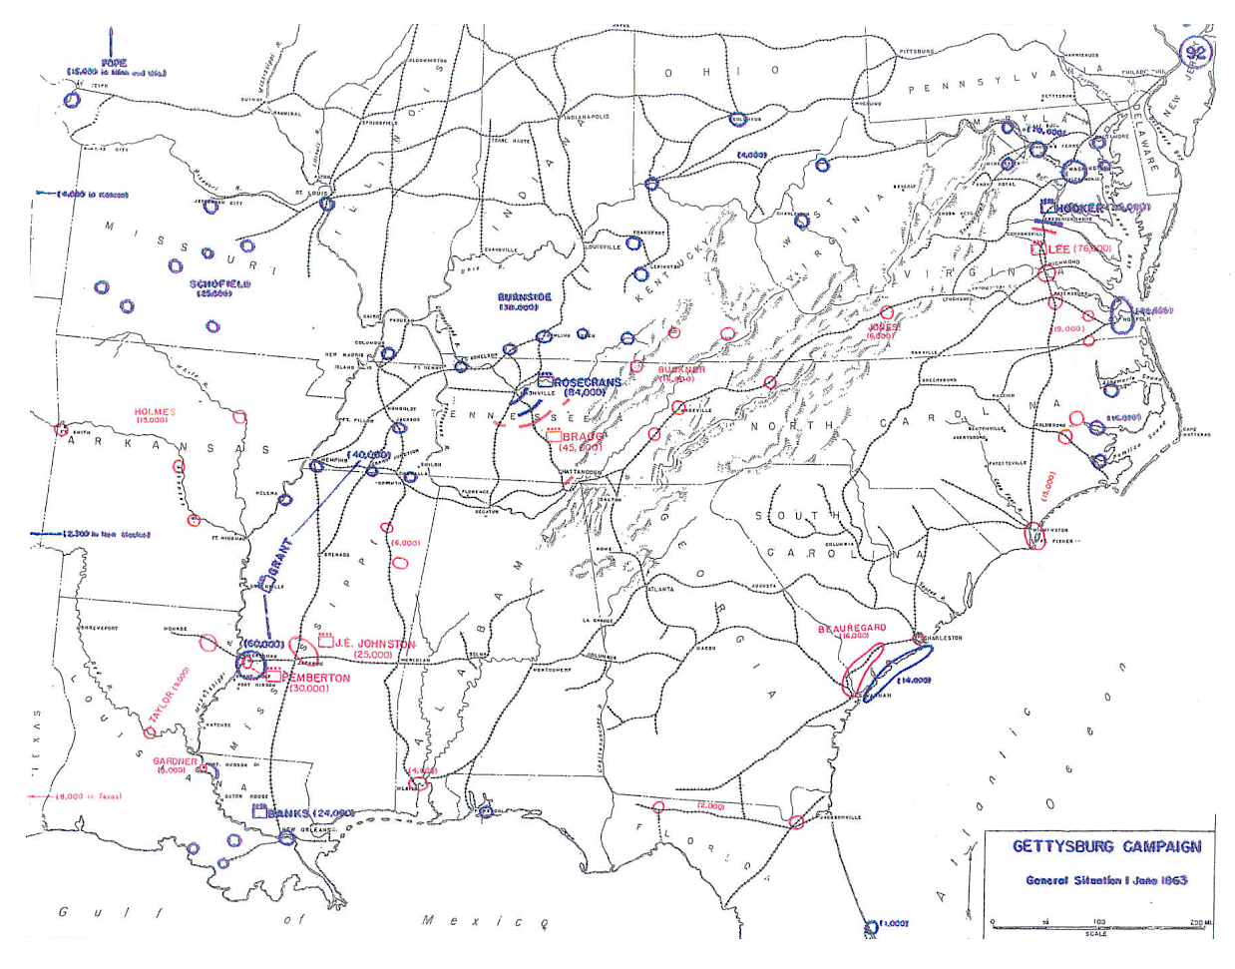

Intentionally Blank

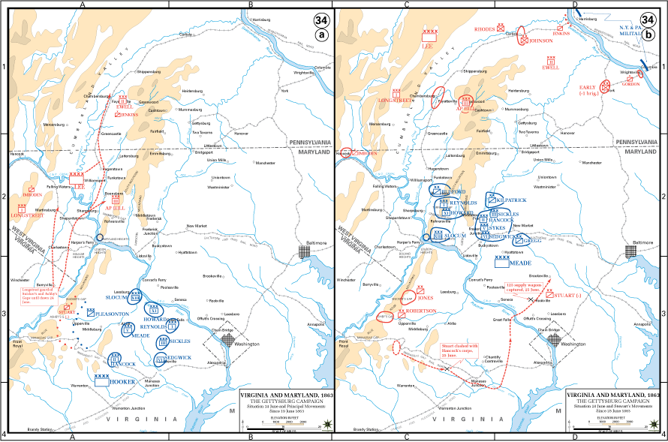

Intentionally Blank

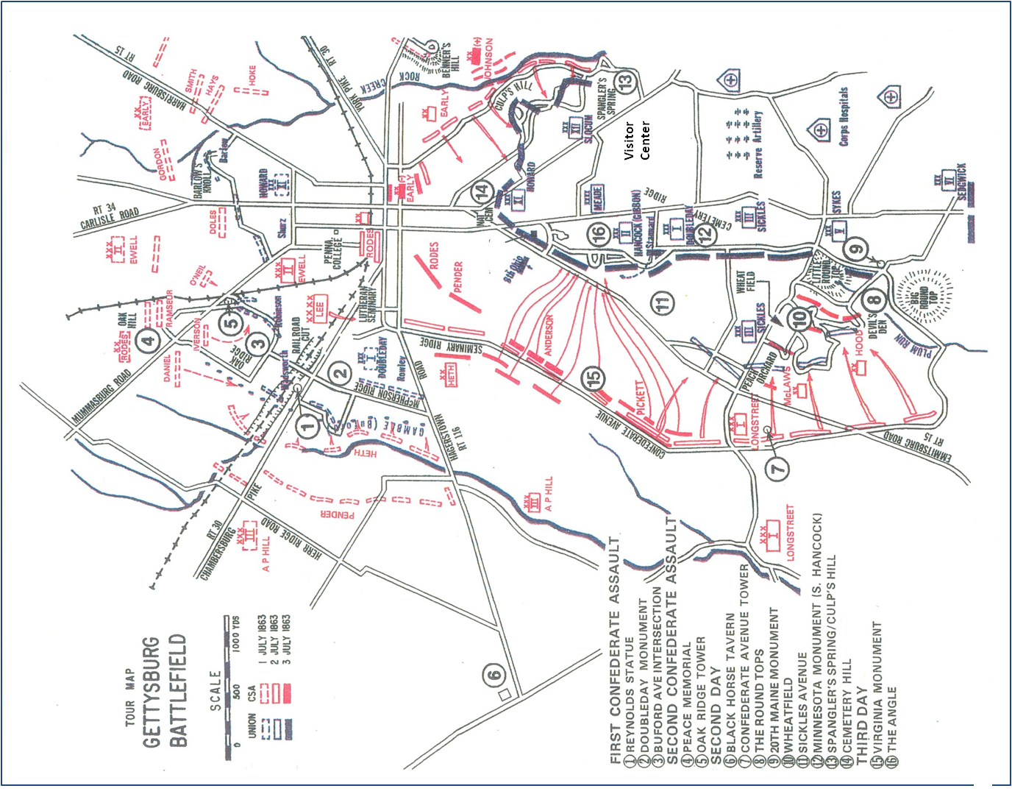

Intentionally Blank
Summary of Significant Events
The Battle of Gettysburg

Day 1 – 1 July 1863, Wednesday, very cloudy, 76 degrees

0830 CSA III Corps (Hill) approaches Gettysburg precipitating a meeting engagement with Buford’s Federal Cavalry Division.

0930-1100 Confederate division under Heth attacks and is repulsed.

1000 MG Reynolds arrives with lead division of USA I Corps

1030 Reynolds is killed but not before he has sent word to Meade to bring along the rest of the Army of the Potomac.

1300 Union Major General Howard’s XI Corps begins to arrive on the field.

1330 CSA II Corps (Ewell) arrives from Carlisle and attacks the northern (right) flank of the Union I Corps line with Rodes’ division; Rodes is repulsed.

1530 Early and Rodes (Ewell) coordinate an attack against both I Corps and XI Corps, collapsing both positions.

1530 CSA III Corps (Hill) nearly simultaneously, attacks with 2 divisions (Heth and Pender) breaking through the I Corps line on Seminary Ridge.

1630 Union I and XI Corps fall back to positions on Cemetery Hill.

1630 Lee orders a discretionary attack on Cemetery Hill. Ewell orders a reconnaissance of the area and subsequently decides not to attack.

1700 USA XII Corps (Slocum) arrives, split between Culp’s Hill and Little Round Top.

2100 Lee concludes that on the merits of success thus far to continue the attack on 2 July.

2300 USA III Corps (Sickles) arrives at southern end of Union line.

Day 2 – 2 July 1863, Thursday, fair skies, 81 degrees

0100 Union army commander Major General Meade arrives on the field after midnight and decides to defend his position on Cemetery Ridge.

0600 Meade orders XII Corps commander William Slocum to plan an attack northward from Cemetery Hill. After a brief reconnaissance Slocum recommends against the attack.

0600 USA II Corps (Hancock) arrives and occupies positons along Cemetery Ridge shortly thereafter.

0930 Lee orders Longstreet (CSA I Corps) to attack the Union left with two divisions (Hood and McLaws), Hill (III Corps) to cooperate with two divisions. Ewell (II Corps) to conduct limited attacks to fix Union forces on the Union right. Longstreet reluctantly accepts the order.

1000 USA V Corps (Sykes) arrives and occupies a reserve positon behind Cemetery Ridge.

1330 Longstreet Corps (Hood’s and McLaws’s divisions), seeking to avoid detection by Union observation posts on Little Round Top, countermarch to their attack position against the Union left.

1330 III US Corps (Sickles), seeking better ground, moves to the Peach Orchard causing a dangerous salient, or bulge, in the Federal line.

1630 Longstreet’s divisions begin attack on the southern end of the Union line. Meade rushes reinforcements to the fight: Caldwell’s division (II Corps), Williams’ division (XII Corps), Barnes’s and Ayres’s divisions (V Corps).

1700 USA VI Corps (Sedgwick) begins to arrive and positons behind Little Round Top.

1830 Anderson’s division (Hill) makes a minor penetration at the Union center; Pender’s division (Hill) fails to advance.

1915 As Hill’s attack stalled, Ewell finally assaults Cemetery Hill and Culp’s Hill. He is repulsed but only after reaching the gates of the cemetery, and in so doing nearly breaching the Federal lines.

2100 Confederate Major General J.E.B. Stuart’s cavalry arrives after the fighting has quieted.

2130 Lee determines to continue the attack on day 3.

2300 Meade calls a council of war; determines to continue his defensive for another day.

Day 3, 3 July 1863, Friday, sunny, 87 degrees.

0800 Lee orders Longstreet to attack the center of the Federal line with George Pickett’s fresh division and two divisions from Hill’s Corps (Pettigrew, commanding for Heth, and Trimble commanding for Pender).

Ewell is to cooperate by attacking Culp’s Hill and Stuart is to gain a position in the rear of the Union line from which he can support Pickett’s breakthrough.

Meade continues to defend with MG Hancock assuming control of the center of his line.

1430 Stuart’s cavalry is stymied by Gregg’s cavalry division (reinforced with Custer’s brigade).

1300-1500 Artillery preparation precedes the attack on the center of the Federal line.

1515 Longstreet’s three-division assault starts and is repulsed.

1600 Meade declines to counterattack.

1630 Kilpatrick’s cavalry division (minus Custer, but reinforced with Merritt’s brigade) makes ill-planned assault on Confederate right and is repulsed.

Day 4, 4 July 1863, Saturday, Showers, 72 degrees

Meade declines to attack.

0200 Lee orders a repositioning of his Corps, with Ewell moving from east of Gettysburg, to west of Gettysburg.

2030 Preceded by the wagon train of wounded, Longstreet, followed by Hill, then Ewell depart the battlefield.

Intentionally Blank
Gettysburg Casualty Figures

About the only thing historians can agree on is to disagree about casualty figures for Civil War battles. Although casualty figures for the Federal army are much more reliable than those for the Confederacy, where in many instances records were lost or destroyed, considerable care must be taken when looking at the numbers. Simply put, there was no standard method for accounting for casualties in battles and campaigns. Were, for example, men who became casualties in minor skirmishes preceding or following the main battles to be counted? What of the men who later died of wounds? How were they to be counted? Many men listed as missing in first reports later straggled back into camp.
In short, all casualty figures are subject to qualification. Perhaps the best source for casualty figures is John W. Busey and David G. Martin, Regimental Strengths and Losses at Gettysburg, Longstreet House, Hightstown, NJ, 2005. Their work is well researched and very carefully edited to give some of the best details of regimental, brigade, division, and corps strengths and losses on both sides. The numbers below are taken from the 4th edition of that work. That said, the following casualty figures for the Gettysburg campaign are generally accepted by historians with the noted qualifications.

Army of the Potomac fighting strength: 93,921

Federal Casualties: (23,049)
Killed Wounded Missing/Captured
3,155 14,531 5,369

Army of Northern Virginia fighting strength: 71,699

Confederate Casualties: (23,231)
Killed Wounded Missing/Captured
4,708 12,693 5,830

Intentionally Blank

Meade Takes Command

The following correspondence includes the letter from Major General Henry Halleck, General-In-Chief of the Union Army, to Major General George G. Meade, alerting him of the President’s decision to place him in command of the Army of the Potomac. In the letter Halleck goes to some length to assure Meade that he will have a free hand to direct the army as he sees fit as well all the men and material the government could provide. One would expect this latitude and support would be given a field commander so why bother to mention it? Meade's predecessor, Major General Joseph Hooker, had tendered his resignation only the day prior because he felt that he was being micromanaged by his superiors in Washington and, worse, denied the resources in men and material he believed necessary for successful prosecution of the war effort. In the first letter Halleck seeks to allay Meade's concerns and provide encouragement and reassurance.
HEADQUARTERS OF THE ARMY,
Washington, D.C., June 27, 1863.
Maj. Gen. GEORGE G. MEADE,
Army of the Potomac :
GENERAL: You will receive with this the order of the President placing you in command of the Army of the Potomac. Considering the circumstances, no one ever received a more important command; and I cannot doubt that you will fully justify the confidence which the Government has reposed in you.
You will not be hampered by any minute instructions from these headquarters. Your army is free to act as you may deem proper under the circumstances as they arise. You will, however, keep in view the important fact that the Army of the Potomac is the covering army of Washington as well as the army of operation against the invading forces of the rebels. You will, therefore, maneuver and fight in such a manner as to cover the capital and also Baltimore, as far as circumstances will admit. Should General Lee move upon either of these places, it is expected that you will either anticipate him or arrive with him so as to give him battle.
All forces within the sphere of your operations will be held subject to your orders.
Harper's Ferry and its garrison are under your direct orders.
You are authorized to remove from command, and to send from your army, any officer or other person you may deem proper, and to appoint to command as you may deem expedient.
In fine, general, you are entrusted with all the power and authority which the President, the Secretary of War, or the General-in-Chief can confer on you, and you may rely upon our full support.
You will keep me fully informed of all your movements, and the positions of your own troops and those of the enemy, so far as known.
I shall always be ready to advise and assist you to the utmost of my ability.
Very respectfully, your obedient servant,
H. W. HALLECK,
General-in-Chief.

Note in this second letter the lack of enthusiasm with which Meade accepts the appointment. Generals in command of the Army of the Potomac had not enjoyed much success for a variety of reasons. Indeed, so little desired was the command that several corps commanders in the army had refused the offer to replace Major General Joseph Hooker. Lincoln and Secretary of War Stanton were faced with the task of no longer asking generals to take command; Meade is simply told he is now in command. Meade reluctance then to assume what he knew to be a heavy burden is understandable. We should appreciate the feeling of little confidence among the senior leaders in this organization.

FREDERICK, MD., June 28, 1863--7 a.m.
(Received 10 a.m.)
General H. W. HALLECK,
General-in-Chief:
The order placing me in command of this army is received. As a soldier, I obey it, and to the utmost of my ability will execute it. Totally unexpected as it has been, and in ignorance of the exact condition of the troops and position of the enemy, I can only now say that it appears to me I must move toward the Susquehanna, keeping Washington and Baltimore well covered, and if the enemy is checked in his attempt to cross the
Susquehanna, or if he turns toward Baltimore, to give him battle. I would say that I trust every available man that can be spared will be sent to me, as from all accounts the enemy is in strong force.. So soon as I can post myself up, I will communicate more in detail.
GEO. G. MEADE,
Major-General.

The third letter, dated 29 June, from Meade to Halleck, is important for it contains a statement of Meade's intent. The commander's intent is powerful leadership tool when used properly. It empowers subordinates to act in the absence of instructions when they find the conditions at hand different from those they had anticipated would obtain at the time they received the original order. Because the commander's intent is clearly expressed as a statement of desired conditions at end state, subordinate commanders are able to adapt to rapidly changing situations and yet take actions consistent with directions their commander would have given. Meade's intent is to find Lee's army and fight it, defensively if he can, but offensively if he must. Thus on 1 July when contact is made with the advance columns of Lee's army, Meade's army without orders moves to engage, thereby setting in motion events that would lead to the battle of Gettysburg.

HEADQUARTERS ARMY OF THE POTOMAC,
June 29, 1863--11 a.m.
Maj. Gen. H. W. HALLECK,
General-in-Chief:
Upon assuming command of the army, and after carefully considering the position of affairs and the movements of the enemy, I have concluded as follows: To move today toward Westminster and Emmitsburg, and the army is now in motion for that line, placing two corps, First and Eleventh, at Emmitsburg; two corps, Third and Twelfth, at Taneytown; one corps, Second, at Frizellburg, and one corps, Fifth, at Union; Sixth Corps at New Windsor; my cavalry guarding my flanks and rear. If Lee is moving for Baltimore, I expect to get between his main army and that place. If he is crossing the Susquehanna, I shall rely upon General Couch, with his force, holding him until I can fall upon his rear and give him battle, which I shall endeavor to do. I have ordered the abandonment of Harper's Ferry, a detachment of not more than 3,000 to proceed with the property, by canal, to Washington, and strengthen your forces there against any cavalry raid; the remainder to move up and join me. The line from Frederick to Baltimore by rail will necessarily be abandoned. While I move forward, I shall incline to the right, toward the Baltimore and Harrisburg road, to cover that, and draw supplies from there, if circumstances permit it, my main objective point being, of course, Lee's army, which I am satisfied has all passed on through Hagerstown toward Chambersburg. My endeavor will be in my movements to hold my force well together, with the hope of falling upon some portion of Lee's army in detail. The cavalry force between me and Washington, as soon as I can learn sufficiently of their movement to pursue and fight without wasting the necessary force by useless movements, will be engaged by my cavalry. Stuart's cavalry, from my best information, have divided into two columns, one on my right, between me and Baltimore, one on my left, through Hagerstown, to join their army. My main point being to find and fight the enemy, I shall have to submit to the cavalry raid around me in some measure. The sections of artillery and small force of cavalry sent from here to Baltimore have been ordered to fall back from Poplar Springs and join General Pleasonton's force, on my right, their route having been intercepted by the enemy's cavalry. I have hastily made up this dispatch to give you the information. Telegraphic communications have been cut off. I have no opportunity to receive a reply to mine asking your advice as to these movements, and upon my best judgment proceed to execute them. I can at present give no orders as to General Schenck's department in Baltimore, or the Potomac in my rear; neither can I, in the absence of telegraphic communication, and on account of the great distance of Couch, exercise any influence, by advice or otherwise, concerning the co-operation of that force. These circumstances are beyond my control. I send this by courier, with the hope and expectation that it will reach you safely. Headquarters to-night are at Middleburg, 3 miles from Uniontown and 13 from Westminster. There is rail communication from Baltimore to Westminster.
GEO. G. MEADE,
Major-General

The fourth piece of correspondence is a circular Meade issues to the army on 30 June. Circulars were so named because the correspondence was sent "around" the army, commander to commander, as a way of rapidly disseminating information. A courier would be dispatched with the circular and would literally ride around the army with the message. In his 30 June circular to the army Meade tells the individual soldiers why they are fighting. It concludes with an interesting motivational appeal.

[CIRCULAR.] HEADQUARTERS ARMY OF THE POTOMAC,
June 30, 1863.
The commanding general requests that previous to the engagement soon expected with the enemy, corps and all other commanding officers address their troops, explaining to them briefly the immense issues involved in the struggle. The enemy are (sic) on our soil. The whole country now looks anxiously to this army to deliver it from the presence of the foe. Our failure to do so will leave us no such welcome as the swelling of millions of hearts with pride and joy at our success would give to every soldier of this army. Homes, firesides, and domestic altars are involved. The army has fought well heretofore; it is believed that it will fight more desperately and bravely than ever if it is addressed in fitting terms.
Corps and other commanders are authorized to order the instant death of any soldier who fails in his duty at this hour.
By command of Major-General Meade:
S. WILLIAMS,
Assistant Adjutant-General.

Lee's View and Subsequent Reflection on the Battle of Gettysburg

It is interesting to read the reports of some who discussed this campaign and battle with the two leaders. In 1898, Maj Gen Isaac Trimble wrote of a conversation he had with Gen Lee on June 27. As Trimble recalled, Lee said,

“Our army is in good spirits, not over fatigued, and can be concentrated on any one point in twenty-four hours or less…. When they hear where we are they will make forced marches to interpose their forces between us and Baltimore and Philadelphia. They will come up, probably through Frederick; broken down with hunger and hard marching, strung out on a long line and much demoralized, when they come into Pennsylvania. I shall throw an overwhelming force on their advance, crush it, follow up the success, drive one corps back on another, and by successive repulses and surprises before they can concentrate; create a panic and virtually destroy the army.”

This comment, though obviously recalled many years later, appears consistent with Lee’s actions at Gettysburg.

Less than a month after the battle of Gettysburg Lee penned the following letter to Jefferson Davis explaining why he fought the battle as he did. The note he refers to included a newspaper clipping that was highly critical of Lee, several named officers, and the army. Well before the true significance of the battle of Gettysburg was understood and thus before men such as Lee looked to protect their reputations, Lee weighs his own performance dispassionately.

To Jefferson Davis

Richmond, Virginia

Camp Culpeper [Virginia]

July 31, 1863

Mr. President:

Your note of the 27 enclosing a slip from the Charleston Mercury relative to the battle of Gettysburg is received. I much regret its general censure upon the operations of the army, as it is calculated to do us no good either at home or abroad. But I am prepared for similar criticism and as far as I am concerned the remarks fall harmless.

I am particularly sorry...that injustice should be done to any officer....No blame can be attached to the army for its failure to accomplish what was projected by me, nor should it be censured for the unreasonable expectations of the public. I am alone to blame, in perhaps expecting too much of its prowess and valor. It however in my opinion achieved under the guidance of the Most High a general success, though it did not win a victory.

I thought at the time that the latter was practicable. I still think if all things could have worked together it would have been accomplished. But with the knowledge I then had, and in the circumstances I was then placed, I do not know what better course I could have pursued. With my present knowledge, and could I have foreseen that the attack on the last day would have failed to drive the enemy from his position, I should certainly have tried some other course. What the ultimate result would have been is not so clear to me. Our loss has been very heavy, that of the enemy’s is proportionally so. His crippled condition enabled us to retire from the country comparatively unmolested. The unexpected state of the Potomac was our only embarrassment....

I remain truly and sincerely yours,

R.E. Lee
Lee’s Request for Relief from Command

Robert E. Lee accepted full responsibility for the outcome at Gettysburg. Stung by the rising criticism for his handling of the battle and campaign he tendered his resignation to President Davis. The president’s reply follows Lee’s letter.

CAMP ORANGE, August 8, 1863.
His Excellency JEFFERSON DAVIS,
President of the Confederate States:
Mr. PRESIDENT: Your letters of July 28 and August 2 have been received, and I have waited for a leisure hour to reply, but I fear that will never come. I am extremely obliged to you for the attention given to the wants of this army, and the efforts made to supply them. Our absentees are returning, and I hope the earnest and beautiful appeal made to the country in your proclamation may stir up the virtue of the whole people, and that they may see their duty and perform it. Nothing is wanted but that their fortitude should equal their bravery to insure the success of our cause. We must expect reverses, even defeats. They are sent to teach us wisdom and prudence, to call forth greater energies, and to prevent our falling into greater disasters. Our people have only to be true and united, to bear manfully the misfortunes incident to war, and all will come right in the end.
I know how prone we are to censure and how ready to blame others for the non-fulfillment of our expectations. This is unbecoming in a generous people, and I grieve to see its expression. The general remedy for the want of success in a military commander is his removal. This is natural, and, in many instances, proper. For, no matter what may be the ability of the officer, if he loses the confidence of his troops disaster must sooner or later ensue.
I have been prompted by these reflections more than once since my return from Pennsylvania to propose to Your Excellency the propriety of selecting another commander for this army. I have seen and heard of expression of discontent in the public journals at the result of the expedition. I do not know how far this feeling extends in the army. My brother officers have been too kind to report it, and so far the troops have been too generous to exhibit it. It is fair, however, to suppose that it does exist, and success is so necessary to us that nothing should be risked to secure it. I therefore, in all sincerity, request Your Excellency to take measures to supply my place. I do this with the more earnestness because no one is more aware than myself of my inability for the duties of my position. I cannot even accomplish what I myself desire. How can I fulfill the expectations of others? In addition I sensibly feel the growing failure of my bodily strength. I have not yet recovered from the attack I experienced the past spring. I am becoming more and more incapable of exertion, and am thus prevented from making the personal examinations and giving the personal supervision to the operations in the field which I feel to be necessary. I am so dull that in making use of the eyes of others I am frequently misled. Everything, therefore, points to the advantages to be derived from a new commander, and I the more anxiously urge the matter upon Your Excellency from my belief that a younger and abler man than myself can readily be attained. I know that he will have as gallant and brave an army as ever existed to second his efforts, and it would be the happiest day of my life to see at its head a worthy leader--one that would accomplish more than I could perform and all that I have wished. I hope Your Excellency will attribute my request to the true reason, the desire to serve my country, and to do all in my power to insure the success of her righteous cause.
I have no complaints to make of any one but myself. I have received nothing but kindness from those above me, and the most considerate attention from my comrades and companions in arms. To Your Excellency I am especially indebted for uniform kindness and consideration. You have done everything in your power to aid me in the work committed to my charge, without omitting anything to promote the general welfare. I pray that your efforts may at length be crowned with success, and that you may long live to enjoy the thanks of a grateful people.
With sentiments of great esteem, I am, very respectfully and truly, yours,
R. E. LEE,
General.

-----

RICHMOND, VA.,
August 11, 1863.
General R. E. LEE,
Commanding Army of Northern Virginia:
Yours of 8th instant has been received. I am glad that you concur so entirely with me as to the want of our country in this trying hour, and am happy to add that after the first depression consequent upon our disaster in the west, indications have appeared that our people will exhibit that fortitude which we agree in believing is alone needful to secure ultimate success.
It well became Sidney Johnston, when overwhelmed by a senseless clamor, to admit the rule that success is the test of merit; and yet there has been nothing which I have found to require a greater effort of patience than to bear the criticisms of the ignorant, who pronounce everything a failure which does not equal their expectations or desires, and can see no good result which is not in the line of their own imaginings. I admit the propriety of your conclusions, that an officer who loses the confidence of his troops should have his position changed, whatever may be his ability, but when I read the sentence I was not at all prepared for the application you were about to make. Expressions of discontent in the public journals furnish but little evidence of the sentiment of an army. I wish it were otherwise, even though all the abuse of myself should be accepted as the results of honest observation. I say I wish I could feel that the public journals were not generally partisan nor venal.
Were you capable of stooping to it, you could easily surround yourself with those who would fill the press with your laudations, and seek to exalt you for what you had not done, rather than detract from the achievements which will make you and your army the subject of history and object of the world's admiration for generations to come.
I am truly sorry to know that you still feel the effects of the illness you suffered last spring, and can readily understand the embarrassments you experience in using the eyes of others, having been so much accustomed to make your own reconnaissances. Practice will, however, do much to relieve that embarrassment, and the minute knowledge of the country which you have acquired will render you less dependent for topographical information.
But suppose, my dear friend, that I were to admit, with all their implications, the points which you present, where am I to find that new commander who is to possess the greater ability which you believe to be required? I do not doubt the readiness with which you would give way to one who could accomplish all that you have wished, and you will do me the justice to believe that if Providence ;should kindly offer such a person for our use, I would not hesitate to avail of his services.
My sight is not sufficiently penetrating to discover such hidden merit, if it exists, and I have but used to you the language of sober earnestness when I have impressed upon you the propriety of avoiding all unnecessary exposure to danger, because I felt our country could not bear to lose you. To ask me to substitute you by some one in my judgment more fit to command, or who would possess more of the confidence of the army, or of the reflecting men of the country, is to demand an impossibility.
It only remains for me to hope that you will take all possible care of yourself, that your health and strength may be entirely restored, and that the Lord will preserve you for the important duties devolved upon you in the struggle of our suffering country for the independence which we have engaged in war to maintain.
As ever, very respectfully and truly, yours,
JEFFERSON DAVIS
Meade’s Request for Relief from Command

As the battle of Gettysburg ended on July 3rd no one knew what tomorrow held. Would the attack be resumed? On the 4th of July both armies awaited an attack. None came. The battering both armies had sustained over the past three days as well as heavy rains discouraged it. With nightfall Lee withdrew his army. Over the next few days Lee’s army made its way back to the Potomac River at Williamsport, only to find that its pontoon bridge had been destroyed by Federal cavalry. With the Potomac River swollen past fording depth by the heavy rains, Lee’s army dug in along a line three miles east of the river and awaited a Union attack.
Meade approached cautiously not wanting to throw away in a moment of carelessness the hard-won victory at Gettysburg. Despite repeated urgings from his superiors in Washington to finish off Lee’s army, Meade hesitated to attack.
Taking advantage of this delay, Lee ordered a makeshift bridge be constructed from whatever materials could be found and on the night of July 13th withdrew the army across the Potomac River to Virginia. By the time Meade got around to ordering an attack for the morning of the 14th, Lee was safely south of the river. The following exchange of letters reflects Washington’s reaction to events and culminates with a letter from Lincoln on the matter.

WASHINGTON, D.C., July 14, 1863--1 p.m.
Major-General MEADE,
Army of the Potomac:
The enemy should be pursued and cut up, wherever he may have gone. This pursuit may or may not be upon the rear or flank, as circumstances may require. The inner flank toward Washington presents the greatest advantages. Supply yourself from the country as far as possible. I cannot advise details, as I do not know where Lee's army is, nor where your pontoon bridges are. I need hardly say to you that the escape of Lee's army without another battle has created great dissatisfaction in the mind of the President, and it will require an active and energetic pursuit on your part to remove the impression that it has not been sufficiently active heretofore.
H. W. HALLECK,
General-in-Chief.

HEADQUARTERS ARMY OF THE POTOMAC,
July 14, 1863---2.30 p.m. (Received 3.10 p.m.)
Maj. Gen. H. W. HALLECK,
General-in-Chief:
Having performed my duty conscientiously and to the best of my ability, the censure of the President conveyed in your dispatch of 1 p.m. this day, is, in my judgment, so undeserved that I feel compelled most respectfully to ask to be immediately relieved from the command of this army.
GEO. G. MEADE,
Major-General, Commanding.

Lincoln to Meade

Executive Mansion, Washington, July 14, 1863

Major General Meade,

I have just seen your dispatch to Gen. Halleck, asking to be relieved of your command, because of a supposed censure of mine. I am very--very--grateful to you for the magnificent success you gave the cause at the country at Gettysburg; and I am sorry now to be the author of the slightest pain to you. But I was in such deep distress myself that I could not restrain some expression of it. I had been oppressed nearly ever since the battles at Gettysburg, by what appeared to be evidences that you... were not seeking a collision with the enemy, but were trying to get him across the river without another battle. What these evidences were, if you please, I hope to tell you at some other time, when we shall both feel better. The case summarily stated is this. You fought and beat the enemy at Gettysburg; and, of course, to say the least his loss was as great as yours. He retreated; and you did not, as it seemed to me, pressingly pursue him; but a flood in the river detained him, till by slow degrees, you were again upon him. You....let the flood run down, bridges be built, and the enemy move away at his leisure, without attacking him....
[M]y dear general, I do not believe you appreciate the magnitude of the misfortune involved in Lee's escape. He was within your grasp, and to have closed upon him would, in connection with our other late successes, have ended the war. As it is, the war will be prolonged indefinitely....Your golden opportunity is gone, and I am distressed immeasurably because of it.
I beg you will not consider this a prosecution, or persecution of yourself. As you had learned that I was dissatisfied, I have thought it best to kindly tell you why.

(The envelope containing this letter bears Lincoln's endorsement "To Gen. Meade, never sent, or signed.")

War and Policy: The Value of the Object

Clausewitz tells us that war should be an instrument of policy. In other words, war is simply not a senseless act of passion, but rather controlled by its political object. The value of this political object must determine the sacrifices to be made for it in magnitude (blood and treasure) and in duration (time). In few other examples from history is the relationship between war and policy so clearly expressed as it is here in Abraham Lincoln’s speech at Gettysburg. With these remarks, Lincoln plainly stated the political purposes for which the war was being fought, and in so doing firmly connected the use of military arms with a set of political objectives. Lincoln’s address transformed a military act into a clear statement of a new national policy, “a new birth of freedom” for the United States.

Gettysburg Address

Abraham Lincoln

Four score and seven years ago our fathers brought forth on this continent, a new nation, conceived in Liberty, and dedicated to the proposition that all men are created equal.
Now we are engaged in a great civil war, testing whether that nation or any nation so conceived and so dedicated, can long endure. We are met on a great battlefield of that war. We have come to dedicate a portion of that field, as a final resting place for those who here gave their lives that that nation might live. It is altogether fitting and proper that we should do this.
But, in a larger sense, we can not dedicate – we can not consecrate - we can not hallow – this ground. The brave men, living and dead, who struggled here, have consecrated it, far above our poor power to add or detract. The world will little note, nor long remember what we say here, but it can never forget what they did here. It is for us the living, rather, to be dedicated here to the unfinished work which they who fought here have thus far so nobly advanced. It is rather for us to be here dedicated to the great task remaining before us – that from these honored dead we take increased devotion to that cause for which they gave the last full measure of devotion – that we here highly resolve that these dead shall not have died in vain – that this nation, under God, shall have a new birth of freedom – and that government of the people, by the people, for the people, shall not perish from the earth.

19 November 1863

Key Leaders

The following is a synopsis of the key leaders, their experience, roles in this battle, and traits that made them effective or ineffective.

Confederate Army of Northern Virginia

Jefferson Davis (55) – Politician, President, Commander-in-Chief (and general-in-chief), USMA 1828. Confederate system has no senior military commander as does the Union. Davis, a war hero from the Mexican War and Secretary of War in the Pierce Administration, holds the military reins tightly in his own hands. In spite of extensive political experience (House and Senate), Mr. Davis is not a skilled politician. Prickly, sensitive to the slightest criticism, his leadership of the South has been stormy. He has as an excellent relationship with R.E. Lee but is lukewarm in his support for the Gettysburg Campaign. The demands of a “States Rights” platform compel him to balance Lee’s request for forces with the needs of Southern governors, especially those of the coastal states of North and South Carolina, and the states along the Mississippi River. Reflect on the president’s view of national policy and the strategy to achieve that policy. How do Davis’s decisions help or hinder the military strategy to achieve the political ends?

Robert E. Lee (56) – General, Commander of the Army of Northern Virginia (ANV), USMA 1829. Loved by his men, revered by Southerners, respected and feared by his foes, Lee is at the peak of his game. His recent victory at Chancellorsville (1-3 May, 1863), where he defeated a Union army that outnumbered him two to one rivals for sheer brilliance Napoleon’s great victory at Austerlitz. Whereas Davis believes in a strategy of exhaustion, Lee understands the correlation of forces and resources to mean that the South must win quickly or lose eventually. A battlefield victory in Pennsylvania could lead to a political settlement and independence for the Confederacy. Does Lee have a good view of the relationship of national policy to military strategy? Can he achieve that policy with his “strategy?”

James Longstreet (42) – Lieutenant General, Commander of I Corps, ANV since June 1862, USMA 1842. Longstreet is among the best corps commander in either army. His role approximates that of a second in command. He prefers defensive battles to frontal attacks. Although he fancies himself a strategist, his real strength is tactics. His loyalty to Lee is beyond question. He can be stubborn when decisions do not go his way. Longstreet supports the invasion of the North but has argued for a defensive battle. How does one handle the loyal subordinate who strenuously disagrees with the corporate decision, especially when that someone is the best at what he does?

Richard Ewell (46) – Lieutenant General, Commander of II Corps ANV since May 1863, USMA 1840. He has only recently returned from a long convalescence after losing a leg at 2nd Manassas in August 1862. Ewell was an aggressive and competent division commander. Indications are he will do well at the next level but as a corps commander Gettysburg will be his first test. He is unsure of himself in his new role and he tends to lean heavily for advice on Jubal Early, one of his division commanders. For Lee he poses a dilemma. Accustomed to giving wide discretion to subordinates, Lee is uncertain how much guidance he needs to give to Ewell. How do senior leaders integrate newly promoted subordinates into the fold? Whose leadership style needs to adapt?

Ambrose P. Hill (38) – Lieutenant General, Commander of III Corps ANV since May 1863, USMA 1847. Along with Ewell, Hill stepped up to corps-level command after the death of Stonewall Jackson. A skilled and brave tactician, Hill was a brilliant division commander with few equals among his contemporaries at that level. How he will fare at corps command is a question. Illness, most likely gonorrhea, plagues him. During this campaign and battle, Hill is virtually absent and provides little guidance or leadership to his Corps. Lee tolerates Hill’s condition in the belief that he has no one who can do better. In this view he is likely blinded by loyalty to a subordinate who has done great service in the past. How does one let go a great man who is no longer capable of handling his duties?

Henry Heth (37) – Major General, Division commander in Hill’s III Corps since May 1863. A Virginian and last in his 1847 class at West Point, "Harry" Heth had been a professional soldier before the war. On 1 July, in obedience to orders from his corps commander, Heth sends his brigades up the Chambersburg Pike to brush aside Union forces, not understanding who he faces. As with so many things in war, the task proves more difficult than envisioned. Before long he, and the Confederate III Corps, is decisively engaged, a condition Lee had specifically warned against. Reflect on how a commander’s vison has been communicated downward to his major subordinates and the impact of initiative when it is outside a commander’s intent.

Robert Emmett Rodes (34) – Major General, Division commander in Ewell’s II Corps since January 1863. A Virginian and an 1848 graduate of the Virginia Military Institute, Rodes early on distinguished himself as a brave and resourceful commander. At Chancellorsville his division led Jackson's flank march and attack, playing a key role in smashing the Federal army. At Gettysburg luck brings him onto the field under similar circumstances. In the vanguard of Ewell's corps, Rodes' division crests Oak Hill to find itself on the right flank of the Union's First Corps. Following Jackson’s admonition to "Always march to the sound of the guns," Rodes attacks. Although his actions on 1 July fit that admonition, his performance on the second and third days of the battle is lackluster at best. How to explain this? Could it be that a good man under a weak leader, such as Ewell, loses his edge?

James Ewell Brown Stuart (30) – Major General, Commander of the ANV cavalry division since June 1861, USMA 1854. J.E.B. Stuart is the “Gallant Knight of the Confederacy,” a daring cavalier who has led Lee’s cavalry since the opening days of the war. Brave but rash, Stuart loses contact with Lee’s army in the opening days of the campaign, a cardinal sin for one who is the Chief of Reconnaissance for the army. For eight critical days during the campaign Stuart will be off on a ride around the Federal army with 3 of his brigades, all the while being out of touch with Lee. Has Stuart let Lee understand who has taken on his ride around the Union army? How has Stuart set up his commander to continue to receive information from the remaining four cavalry brigades? Does Lee trust the other cavalrymen to give him the same kind of information that he depends on Stuart to provide?

George E. Pickett (38) - Major General, division commander in Longstreet’s I Corps since October 1862, USMA 1846. Pickett’s ranking at the bottom of his class belied his talents as a soldier. He proved himself to be a brave and inspirational leader while serving in the Mexican War. Service in this war to date has earned him distinction for his bravery and leadership as commander of a brigade, earning him a reputation for competency and dash. Circumstances have kept him out of the thick of fighting over the last six months and he is eager to get his division back into the middle of things. At Gettysburg fate, and Robert E. Lee, will afford him that opportunity.

Union Army of the Potomac

Abraham Lincoln (54) – Politician, President and Commander-in-Chief. No significant military experience, captain of a volunteer infantry company in the Black Hawk War from 7 April 1832 to 16 June 1832. He served one term as a congressman from Illinois during which he opposed President Polk’s war with Mexico. Lincoln has no background in strategy but is blessed with a keen intellect. Learning by doing, he has been making steady progress as a strategist. Now confident in his judgment, he is quick to remove generals who do not measure up even while retaining incompetent ones with political connections he can use to his advantage. While all around him are fretting, Lincoln alone sees the Confederate invasion of the north as less a disaster than an opportunity to destroy Lee’s army, and urges his army commander to seize the moment. How does Lincoln’s understanding of national policy and politics influence military strategy?

George Gordon Meade (48) – Major General, Commander of the Army of the Potomac, USMA 1835. He is competent as a general but was Lincoln’s fifth choice to replace MG Hooker, whom he relieved on 28 June. Meade is technically able and in Lee’s view, “unlikely to make a mistake.” He is also cautious, and laboring under orders that pull him in two directions. He is to find and defeat Lee’s army, but to protect Baltimore and Washington at all times, a balance between offense and defense that proves difficult. Personally cold and distant, his gruff temperament has earned him the nickname, “The Old Goggle-eyed Snapping Turtle.” Meade’s conduct in this battle lets us observe a senior leader new to his role groping for the levers of command while contending with nearly overwhelming challenges.

John Reynolds (42) – Major General, I Corps Commander since November 1862, USMA 1841. Many thought of him as the best corps commander in the Army. He declined Lincoln’s offer to command the AOP saying the job came with “too much political influence from the politicians in Washington.” Reynolds is loyal to Meade and trusted by him. He firmly understands Meade’s intent to fight Lee and thus is disposed to think creatively. He chooses the good ground at Gettysburg and sets favorable conditions for battle. In so doing, he shows us the value of understanding commander’s intent and the right man in the right place at the right time.

Winfield Scott Hancock (39) – Major General, II Corps Commander since May 1863, USMA 1844. Hancock is an inspirational leader and probably the best corps commander in Meade’s army after Reynolds. Although of differing political views from Meade, he is loyal to his commander and enjoys his complete trust. The hardest tasks and the greatest responsibilities are generally given to him. He serves as Meade’s sounding board and fireman. He does not abuse the trust invested in him. Though junior to other Corps commanders, Meade places him in key positons during the battle. How do senior leaders manage talent and age differences?

Daniel Sickles (43) – Major General, III Corps Commander since February 1863, New York University 1844. A Tammany Hall politician of the worst sort but, as a “War Democrat,” is invaluable to Lincoln who keeps his kind around to show broad support for the war. Sickles is ambitious, egotistical and possesses a far greater estimate of his martial abilities than performance to date would suggest. He routinely places his judgment above that of the army commander and is frequently heard to slander the cabal of “West Point men” who he thinks are ruining the army. Loosely supervised, a man like Sickles can get into mischief. As commander of a corps, he manages to make trouble for the entire army. How do senior leaders manage recalcitrant subordinates?

Oliver Otis Howard (33) – Major General, XI Corps Commander since April 1863, USMA 1854. Quiet, young, reverent, prickly and prudish, Howard is a mystery to most who serve with him. He commands a corps composed of many immigrant regiments, who prefer to speak their native dialects, a predilection that on occasion contributes to confusion in battle. At Chancellorsville his corps was struck in the flank and disintegrated, nearly leading to a rout of the Union army and earning for the corps a despised moniker, “Howard’s Cowards.” He seeks to regain honor for himself and his corps at Gettysburg. His seniority among major generals places him near the top, but Meade is disinclined to invest trust in him for a variety of reasons. Managing subordinates who are outside of the “Inner Circle” is a key component of senior leadership.

John Buford (38) - Brigadier General, Division Commander, Cavalry Corps since May 1863, USMA 1848. Buford, a professional soldier with long years of service on the frontier fighting Indians, is talented, respected, and known throughout the army for his skills as a trainer. He has been in forefront of those developing new tactics for the cavalry in this war. Reports of Confederate infantry have drawn him to Gettysburg. Early on 1 July his division comes under fire on the ridge west of town. Understanding of Meade’s mission and intent, Buford commits to holding the key ground until the Union infantry can be brought up. Key subordinates, acting as they understand the vision and intent, are essential to success. How willing are senior leaders to underwrite this kind of initiative, with no foreknowledge of the outcome?

Gouverneur K. Warren (33) - Brigadier General, Chief Engineer, Army of the Potomac, USMA 1850. An engineer by training, Warren, like many of his peers rose to prominence in the Civil War by serving with the infantry. Success as a brigade commander has earned him his stars. While awaiting appointment to command a division, his keen eye for ground has earned him appointment as Meade’s chief of engineers. As such he has no line authority, but his competence and availability have caused Meade to employ him as a nominal deputy commander. His actions during several critical hours on 2 July prove pivotal to the outcome of the battle. Initiative, not only within the commander’s intent, but also as a senior leader with no actual authority, is key with this person. How willing are others to take this level of responsibility?

Henry Hunt (37) – Brigadier General, Chief of Artillery, Army of the Potomac, USMA 1839. Noted as one of the best artillerymen in the Regular Army before the war, Hunt drove innovation and efficiency with the Army of the Potomac artillery batteries. His ideas resulted in the creation of the Reserve Artillery brigades in the Army of the Potomac. Gettysburg would be one of his greatest battles. His actions throughout July 2-3 are key to Union success. How do we develop subordinates who are willing to take action consistent with their commander’s intent, issuing orders to organizations they do not command?

Intentionally Blank

In 1901, at the time of the dedication of the first Army War College located at Washington Barracks (now Fort McNair), then Secretary of War Elihu Root created the Army’s first senior service school in response to the Army’s lackluster handling of the deployment and employment of forces during the Spanish American War, 1898-1901. Quotation is adapted from the U.S. Army War College Curriculum Pamphlet, 2003-2004, p. 2.
Order of battle is a term of art. It refers to the strength, command structure, and organization of military units.
The Union Army had only two grades of general officer in 1863. Brigadier Generals normally commanded brigades, but could be found in command of divisions as well. Major Generals commanded divisions, corps, armies and departments, the latter being geographic areas of responsibility. By 1863 the Confederacy had four grades of general officer: Brigadiers commanded brigades, Major Generals commanded divisions, Lieutenant Generals commanded corps, and Generals commanded armies and departments.
All times are, at best, estimates. Wristwatches were yet to be invented and no effort was made to synchronize pocket watches. Most witnesses estimated time by the position of the sun, leading to a general approximation at best. One student of the battle who sought to establish exact times for events gave up in disgust, observing “Now I know why Joshua commanded the sun to stand still. That was the only way one could be sure of the time.” The quote is attributed to John Batchelder, first historian for the Gettysburg Battlefield Monument Association.
Official Records, Vol. XXVII/1, p. 61.
Ibid., pp. 61-62.
Emphasis added.
Ibid., pp. 66-67.
Emphasis added. Circular is found in Official Records, Vol. XXVII/3, p. 415.
Isaac Trimble, “The Battle and Campaign of Gettysburg,” Southern Historical Society Papers, V26, 116-128. (Southern Historical Society: Richmond, VA 1898)
The Wartime Papers of R.E. Lee, Clifford Dowdey and Louis H. Manarin, editors, pp. 564-65.
The Wartime Papers of R.E. Lee, pp. 589-90.
Official Records, Vol. XXIX/2., pp. 639-40.
Official Records, Vol. XXVII/1, p. 92.
Ibid., p. 93.
Roy P. Basler, editor, The Collected Works of Abraham Lincoln, p. 327-328.
Confederate armies were named after the regions where the armies operated while Union armies were named after the major rivers in the regions where they served.
Stuart’s Cavalry Division numbered approximately 7,500 men and was divided into 7 brigades of near equal size.
Ezra J. Warner, Generals in Gray, p. 239.

