CAMPAIGN PLANNING
HANDBOOK
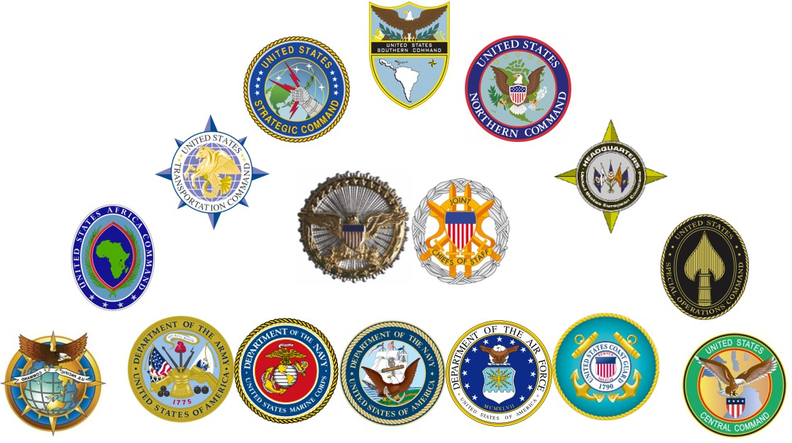

Academic Year 2016

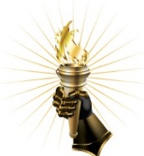

United States Army War College
Department of Military Strategy, Planning, and Operations
Carlisle Barracks, Pennsylvania 17013-5242
Middle States Accreditation
The U.S. Army War College is accredited by the Middle States Commission on Higher Education (MSCHE), 3624 Market Street, Philadelphia, Pennsylvania, 19104, (267) 284-5000. MSCHE is an institutional accrediting agency recognized by the U.S. Secretary of Education and the Council for Higher Education Accreditation. Initial accreditation was granted in 2004.

Table of Contents
Page
INTRODUCTION 1
CHAPTER 1: National Strategic Direction and Guidance
- Strategic Direction 3
- National Military Guidance 4
CHAPTER 2: Joint Operation Planning
- Introduction 9
- Campaigning 9
- Joint Planning and Execution Community 10
- Adaptive Planning and Execution System (APEX) 11
- Types of Joint Operation Planning 12
- Joint Planning in a Comprehensive Context 14
- Joint Operations Activities 16
- Options 17
- Risk ………………………………………………………………………………………20
CHAPTER 3: Operational Design
- Introduction 21
- An Operational Design Approach to Campaigning 22
- Link between Operational Design and Planning. 26
- Link between Operational Design and Execution 27
- Conducting Operational Design 29
CHAPTER 4: Development of Theater Strategy
- Introduction 43
- Sources of Guidance and Direction for Theater Strategy 44
- Components of Theater Strategy 45
- Using Operational Design for Building a Theater Strategy 47
- Theater Campaign Plan 53
- Components of a Theater Campaign Plan 54
- Supporting Plans 57
CHAPTER 5: Joint Operation Planning Process
- Introduction 59
- Initiate Planning 60
- Conduct Mission Analysis 61
- Develop Courses of Action 73
- Analyze Courses of Action 81
- Compare Courses of Action 86
- Approve a Course of Action 89
- Develop the Plan 92
Appendix A – APEX IPR Process A-1
Appendix B – Global Force Management B-1
Appendix C – PMESII Systems Construct C-1
Appendix D – Crisis Action Planning and Reference Times D-1
Appendix E – Glossary E-1

List of Figures
1 National Strategic Direction and Guidance 4
2 Contents of the GEF 5
3 Contents of the JSCP 7
4 The Joint Planning and Execution Community 10
5 Joint Operation Planning 12
6 Options and Courses of Action 18
7 An Operational Design Approach to Campaigning 23
8 The Operational Design Activities 24
9 Operational Design and Planning 26
10 PMESII Systems Analysis 31
11 Tensions that Describe our Problem 35
12 Sample Line of Operations 39
13 Sample Lines of Effort 40
14 Brainstorming……………………………………………………………………….
15 Mind Mapping……………………………………………………………………….
14 The Joint Operation Planning Process 59
15 JOPP Step 1: Initiate Planning 60
16 JOPP Step 2: Conduct Mission Analysis 62
17 Sample Mission Analysis Brief Agenda 69
18 JOPP Step 3: Develop Courses of Action 73
19 Relationship between End State, Objectives, Effects, and Tasks 76
20 JOPP Step 4: Analyze Courses of Action 81
21 Sample Wargaming Steps 84
22 JOPP Step 5: Compare Courses of Action 86
23 Sample COA Comparison Matrix (Weighted Numerical) 88
24 Sample COA Comparison Matrix (Descriptive) 89
25 JOPP Step 6: Course of Action Approval 90
26 Sample COA Decision Brief Agenda 91
27 Commander’s Estimate 92
28 JOPP Step 7: Develop the Plan 93
29 A Phasing Model 94

A-1 The APEX Process………………………………………………………………..A-4

B-1 Force Apportionment Bins B-2
B-2 Global Force Management Process B-4

D-1 Relationship between JOPP and CAP………………………………………….D-3
D-2 The CAP Process………………………………………………………………....D-4

THIS PAGE INTENTIONALLY BLANK

Introduction
The purpose of this document is to assist United States Army War College students during the Theater Strategy and Campaigning (TSC) course. It also serves to assist commanders, planners, and other staff officers in combatant commands (CCMD), joint task forces (JTF), and service component commands. It supplements joint doctrine and contains elements of emerging doctrine as practiced globally by joint force commanders (JFCs). It portrays a way to apply doctrine and emerging doctrine at the higher levels of joint command, with a primary emphasis at the combatant command level.

Commanders have used campaign planning to synchronize efforts and sequence several related operations throughout history. Gen. George Washington planned the Campaign of 1781 to coordinate the actions of a French fleet, a French expeditionary army, and his "main army" to destroy the British forces at Yorktown. Lt. Gen.
Ulysses S. Grant planned simultaneous offensives by his subordinate commands against the Confederacy for the 1864 Campaign. During World War II, campaign planning became essential to coordinate the actions of joint and combined forces in all Allied theaters. As a mature example of campaign planning in the Pacific Theater of War, General of the Army Douglas MacArthur issued his Strategic Plan for Operations in the Japanese Archipelago, DOWNFALL, in May 1945. In this 25-page document, MacArthur explained how the plan "…visualizes attainment of the assigned objectives by two (2) successive operations (OLYMPIC and CORONET)." The cover letter described this plan as a "general guide covering the larger phases of allocation of means and of coordination, both operational and logistic. It is not designed to restrict executing agencies in detailed development of their final plans of operation."

Campaign planning received new emphasis during Operation DESERT STORM in 1991, when Gen. Norman Schwarzkopf used a campaign plan to guide the synchronized employment of his forces in Iraq. In the wake of Operations ENDURING FREEDOM and IRAQI FREEDOM, theater strategy and campaign planning have become high priorities within the Department of Defense, and several other executive departments have given both a higher priority. Theater and subordinate joint commanders now develop a comprehensive set of nested strategies and plans, beginning with a theater or global strategy, followed by a theater or functional campaign plan, and supported by theater security cooperation, contingency, and posture plans. All of these are nested within the context of ongoing operations.

This handbook focuses at the combatant command and subordinate joint force command levels. In some cases, where there is an apparent dichotomy between joint and Service doctrine, the handbook reconciles the differences where possible and focuses on "best practices" for theater commanders.
THIS PAGE INTENTIONALLY BLANK

CHAPTER 1: National Strategic Direction and Guidance
1. Strategic Direction. Strategic direction is the common thread that integrates and synchronizes the activities of the Joint Staff, combatant commands, Services, and combat support agencies. As an overarching term, strategic direction encompasses the processes and products by which the President, the Secretary of Defense (SecDef), and the Chairman of the Joint Chiefs of Staff (CJCS) provide strategic guidance. The function of national strategic guidance is to provide long-term and intermediate objectives by defining the ends and means, with the interagency, including joint force commanders, responsible to provide the ways. From a military perspective this guidance should include a description of what constitutes success (ends) and the allocation of resources and forces (means).
a. Strategic guidance from civilian and military policymakers is a prerequisite to develop a military campaign plan. The President provides strategic guidance through the National Security Strategy (NSS), Presidential Directives [the current administration uses the term Presidential Policy Directives (PPDs)], and other strategic documents, in conjunction with additional guidance from other members of the National Security Council (NSC). The National Security Council System is the principal forum for coordinating executive departments and agencies to develop and implement national security policy. The NSC System advises the President in integrating all aspects of national security policy as it affects the United States – domestic, foreign, military, intelligence, and economic (in conjunction with the National Economic Council). The NSC develops policy options, considers implications, coordinates operational problems that require interdepartmental consideration, develops recommendations for the President, and monitors policy implementation. The NSC considers all practical options to present the President with clear alternatives for debate among his advisors and for his final decision. The system of Presidential Directives that the President initiates ensures that concrete policy alternatives are considered at every stage of the policymaking process. These policy decisions provide the basis for both military planning and programming. The most recent NSS was published in 2015.
b. The SecDef is required by law to conduct a Quadrennial Defense Review (QDR) every four years. The review must include "a comprehensive examination of the national defense strategy, force structure, force modernization plans, infrastructure, budget plan, and other elements of the defense program and policies of the United States with a view toward determining and expressing the defense strategy of the United States and establishing a defense program for the next 20 years" (Title 10 United States Code [USC] section 118). The QDR is mandated to provide an updated National Defense Strategy (NDS) consistent with the most recent NSS. However, the NDS may also be a stand-alone document, as was the case in 2005 and 2008. The NDS establishes broad defense policy goals and priorities for the development, employment, and sustainment of U.S. military forces. Chapter II of the 2014 QDR report is considered the current national defense strategy until superseded by the SecDef with another optional, stand-alone NDS (not published since 2008) or other guidance such as the 2012 Defense Strategic Guidance.
The National Defense Authorization Act for 2015 reforms the previous Quadrennial Defense Review (QDR) by replacing it with a Defense Strategy Review (DSR) which must include “a comprehensive examination of the national defense strategy, force structure, modernization plans, posture, infrastructure, budget plan, and other elements of the defense program and policies of the United States with a view toward determining and expressing the defense strategy of the United States and establishing a defense program" (Title 10 USC Section 118, effective October 1, 2015). This review will be conducted in consultation with the Chairman of the Joint Chiefs of Staff (CJCS) and will consider three timeframes: 1) the near-term (associated with the future-years defense program), 2) the mid-term (10 to 15 years), and 3) the far-term (20 years). Among other requirements, the DSR will include the National Defense Strategy (NDS) of the United States, delineate the prioritized missions of the armed forces, to include each service's roles and missions, and articulate gaps, shortfalls, and risks when evaluating the force size, structure, and capabilities against the aforementioned missions. The DSR also explains the projected budget and other elements of the defense program necessary to conduct the missions in the NDS. The CJCS is required to provide a review of the DSR that includes a risk assessment with a description of the capabilities needed to address that risk. The DSR also "includes an analysis of enduring mission requirements for equipping, training, sustainment, and other operation and maintenance activities of the Department of Defense, including the Defense Agencies and military departments, that are financed by amounts authorized to be appropriated for overseas contingency operations." In contrast to the QDRs it replaces, the DSR evaluates gaps, shortfalls, and risks in more detail and provides prioritized missions for the armed forces in support of the NSS.
c. The CJCS develops the National Military Strategy (NMS), which provides strategic direction for the Armed Forces of the United States to support the NSS, NDS, and QDR. This document describes the ways and means to protect the United States, prevent conflict and surprise attack, and prevail against adversaries who threaten the U.S. homeland, deployed forces, allies, and friends. The 2015 NMS “continues the call for greater agility, innovation, and integration. It reinforces the need for the U.S. military to remain globally engaged to shape the security environment and to preserve our network of alliances.” The new NMS is more resource-informed and focused than previous editions. For example, and for the first time, the 2015 NMS lists 12 prioritized military missions—which can be seen as the “ways” of the NMS. These missions support the “globally integrated operations” concept found in both the 2012 Capstone Concept for Joint Operations (CCJO) and in this NMS. These missions support the following three national military objectives, or the “ends” of the NMS: 1) deter, deny, and defeat state adversaries; 2) disrupt, degrade, and defeat violent extremist organizations; and 3) strengthen the U.S. global network of allies and partners. Ultimately, all of these missions and objectives support the goals of the NDS and NSS.

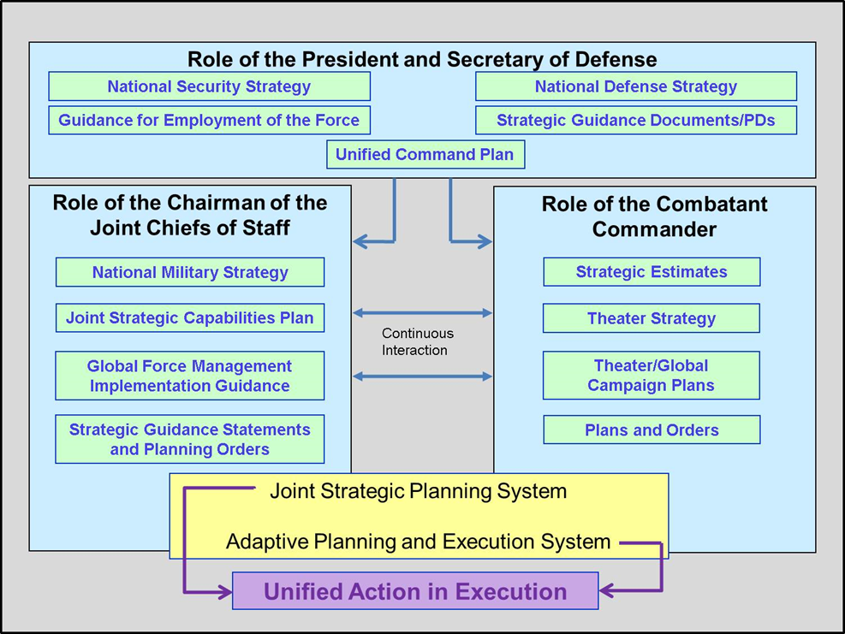

Figure 1: National Strategic Direction and Guidance
2. National Military Guidance.
a. The Unified Command Plan (UCP), prepared by the CJCS for the President to issue, sets forth basic guidance to all combatant commanders (CCDRs). The UCP establishes combatant command missions and responsibilities, delineates geographic areas of responsibility for geographic CCDRs, and specifies responsibilities for functional CCDRs. The UCP generates a flexible unified command structure that changes as required to accommodate evolving U.S. national security needs. Title 10 USC 161 tasks the CJCS to conduct a review of the UCP "not less often than every two years and submit recommended changes to the President through the Secretary of Defense."
(1) There are six Geographic Combatant Commands (GCCs): U.S. Africa Command (USAFRICOM), U.S. Central Command (USCENTCOM), U.S. European Command (USEUCOM), U.S. Northern Command (USNORTHCOM), U.S. Pacific Command (USPACOM), and U.S. Southern Command (USSOUTHCOM). These commands are responsible for all military operations within their areas of responsibility (AOR) designated in the UCP.
(2) There are three Functional Combatant Commands (FCCs) with functional responsibilities not bounded by geography: U.S. Special Operations Command (USSOCOM), U.S. Strategic Command (USSTRATCOM), and U.S. Transportation Command (USTRANSCOM).
b. The Guidance for Employment of the Force (GEF), prepared by SecDef and approved by the President, is the principal document through which the SecDef provides strategic guidance to the CCDRs. It directs the CCDRs to create theater or functional strategies and campaign plans to achieve the strategic end states found in national-level strategic guidance documents. It also directs the CCDRs to create various contingency plans, which serve as branches to the theater’s single campaign plan. The GEF is normally developed in parallel with the Joint Strategic Capabilities Plan (JSCP) to ensure complementary and synchronized guidance from the SecDef and CJCS.
c. Significantly, the 2015 GEF includes several changes (general and CCMD-specific) as compared to previous versions of the GEF. While the GEF is still a “top down” strategy-driven document, these changes are commensurate with the guidance in the latest NSS, QDR, and NMS, and reflect the evolving character and complexity of the global security environment, the increasing adaptability required of the CCMDs, and persistent resource limitations. See figure 2 for the outline contents of the GEF. The following are significant points of the 2015 GEF:
- The GEF provides strategic assumptions of the global security environment as well as CCMD AOR-focused threat assessments and assumptions. These help CCDRs to more effectively use limited joint force capability.
- Prioritized theater-strategic end states (up to 10-year time horizon) have been replaced by prioritized campaign objectives for each GCC and FCC. The SecDef’s intent is to focus the CCDRs’ finite resources more closely on prioritized objectives that can be accomplished in 2-5 years.
- The GEF gives strategic steady-state deterrence missions to the CCDRs.
- The CCDRs are still required to produce campaign plans: Theater Campaign Plans (TCPs) for the GCCs and Functional Campaign Plans (FCPs) for the FCCs. The aim of these campaign plans is to accomplish the GEF-assigned campaign objectives.
- Resource-informed planning guidance puts more emphasis on the near-term readiness and capability of Global Force Management Implementation Guidance (GFMIG)-apportioned forces.
- Country-specific Security Cooperation Sections (CSCS) have replaced Theater Security Cooperation Plans as one of the sub-components of the TCPs/FCPs. The CCMDs will develop CSCSs for each country in their AORs and these CSCSs should directly support both the intermediate military objectives (IMOs) in the TCP as well as the U.S. Ambassadors’ Integrated Country Strategies (ICS).
- The CCMDs will develop theater posture plans.
- The 2015 GEF more explicitly links steady-state TCP/FCP activities with the phase 0 (shaping) requirements of the various contingency plans.
- CCMD contingency plans dealing with a single threat will normally be “bundled” so that the SecDef can review them simultaneously or nearly so.
- The contingency planning guidance is now consolidated and published as Annex A to the GEF.
- During contingency plan development, level 3T and 4 plans will normally require two to three in-progress reviews (IPRs) prior to approval. Level 1, 2, and 3 plans will likely require fewer IPRs, some only one. TCPs and contingency plans will normally undergo annual reviews (or as directed). Upon completion of the initial TCP reviews, CCDRs may request biennial TCP reviews through the Joint Staff J5 to the Under Secretary of Defense for Policy (USD-P).
Overall, the 2015 GEF is a more focused and resource-informed document compared to the previous editions. The SecDef may issue a Strategic Guidance Statement (SGS) to update the GEF; an SGS addresses an unforeseen situation or modifies guidance in the GEF. An SGS, issued only as needed, may be used to direct CCMDs or other DoD organizations to develop options or plans for an emerging crisis or to prevent a situation from becoming a crisis.
- Global posture and global force management guidance.
- Security cooperation priorities.
- Overarching DOD andU.S.nuclear policy.
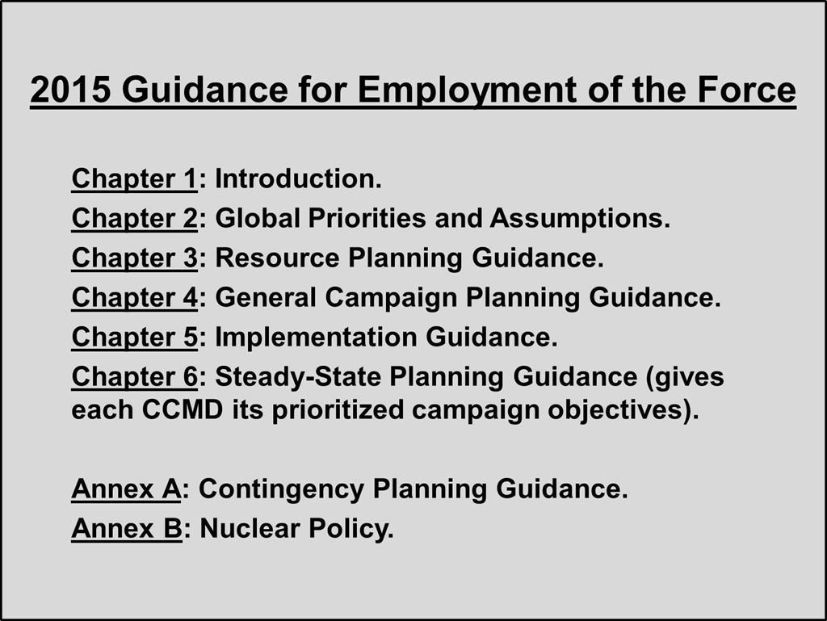
Figure 2: Contents of the 2015 GEF
Chapters Seven (Functional Planning Guidance, for the Functional CCDRs) and Eight (Regional Planning Guidance, for the Geographic CCDRs) are further divided into combatant command specific sections that provide focused guidance to the respective commands. The guidance is grouped under the categories of:
- Planning Requirements – to include specific planning scenarios.
- Strategic Context – not simply boiler-plate, this stove-pipe breaking guidance places the AOR or functional area in a broader framework.
- Prioritized end states – the GEF distinguishes prioritized theater-strategic end states for GCCs and prioritized global strategic end states for FCCs. Beginning with the 2014 GEF (to be published), campaign objectives should be emphasized instead of end states allowing the CCDRs to focus increasingly limited resources more effectively. See more details of the anticipated changes below.
- Theater Strategic Assumptions – these assumptions narrow the focus of Chapter Two’s Global Strategic Assumptions.
- Campaign Planning Priorities – this guidance groups nations and organizations, as appropriate, into the categories of critical regional partnerships, key supporting partnerships, and actors of concern.
- Additional Planning Guidance.
- Contingency Plans Requirements – specific guidance, to include level of planning requirement, for contingency plans.
- The new GEF will eliminate prioritized theater strategic end states and replace
them with prioritized campaign objectives to be accomplished within two to five years.

- CCDRs will no longer be required to produce theater strategies or even theater campaign plans but will plan campaigns to accomplish their assigned campaign objectives.

- For the FCCs, global campaign plans will be replaced by functional campaign plans.

- Contingency plans will be bundled based on threats with one lead CCMD and several supporting CCMDs---all contributing to the same plan. The Joint Staff will serve as the global integrator to ensure there are no seams or gaps through which new threats can emerge.

- The new GEF will be more resource-driven and will contain more explicit resource guidance to include the creation of a force availability and readiness model which should accurately reflect the near-term availability and readiness of the joint force.
In an effort to reduce the number of plans required for DoD IPR review from the CCMDs, formal campaign support plans (e.g. from service components and DoD agencies in support) will no longer be required by the DoD for approval in the IPR process. Planning and plans, of course, will still continue in support of the affected CCMD.
d. The Joint Strategic Capabilities Plan (JSCP) is prepared by the CJCS and is nested with the GEF and provides more specific planning guidance in several areas to the CCDRs. by translating strategic end states from the GEF into military campaign and contingency plan guidance. Additionally, it apportions forces provides force apportionment guidance for planning based upon the requirements of current and projected force deployments in support of ongoing operations.
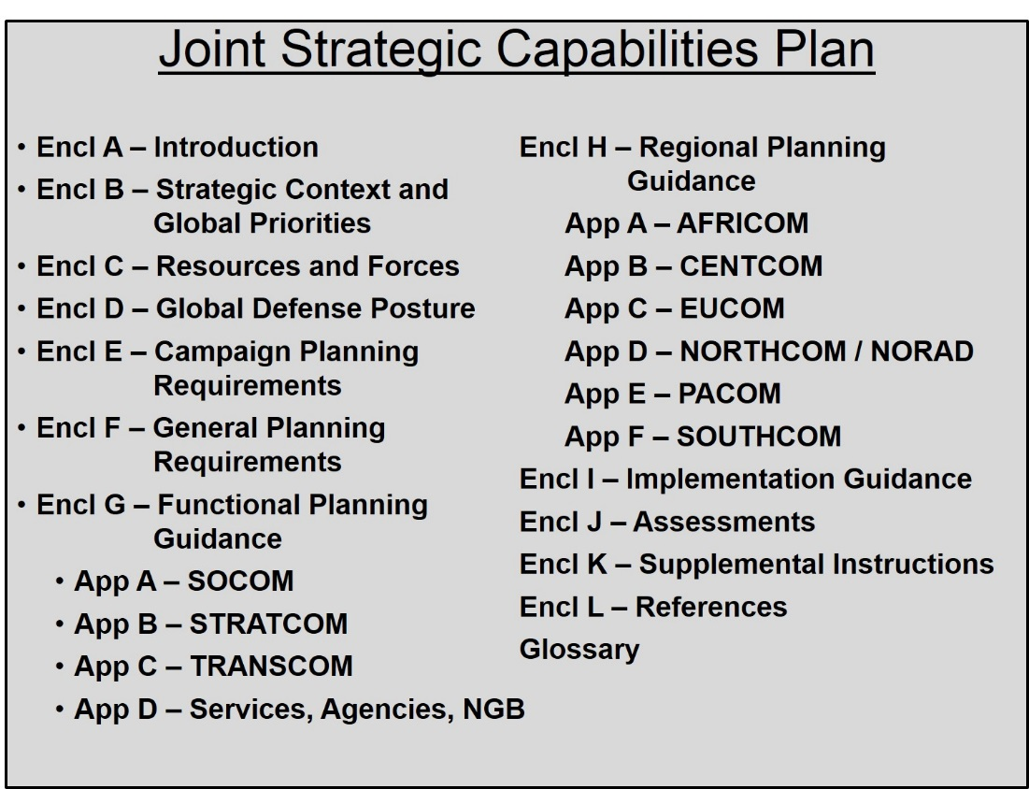
Figure 3: Contents of the JSCP
The JSCP gives more detailed TCP/FCP planning guidance to the CCDRs and directs them to produce various supporting plans to support each other’s GEF-directed contingency plans and campaign plans. directs geographic CCDRs to develop a Theater Campaign Plan (TCP) in support of their theater or functional strategies. This "strategy-centric" planning drives a proactive approach to prevent problems from emerging in the world, with contingency plans to react to deviations from the plan. The intent of the TCP/FCP is to "operationalize" the CCDR’s strategy. The TCP/FCP identifies steady-state force and resource requirements, and identifies those likely deviations from the desired steady state that may have to be addressed through contingency plans. The TCPs/FCPs are intended to:
- Integrate Phase 0 (shaping) activities directly in support of particular contingency plans with broad shaping and security cooperation activities that occur during steady state operations.
- Ensure CCDR actions and words are comprehensively integrated to convey clear messages to U.S. world partners (both friends and adversaries).
- Connect posture changes to DOD’s functional and regional strategies and provide a vehicle for continuously reassessing and refining posture needs and updating DOD and regional posture plans accordingly.
- Enable DOD to synchronize the theater strategies with current priorities to appropriately allocate resources.
The JSCP also directs that the FCCs (and, in some cases, the GCCs) build functional campaign plans for selected global requirements. GCCs and the other FCCs then become supporting commands to the specified supported CCDR for these functional campaign plans. In the case of an FCP or functional contingency plan, the supported FCC is responsible to coordinate and synchronize the activities of all of the other CCDRs, as well as the Defense Agencies, to perform actions required of the functional mission. Examples of functional mission sets are:
- War on Terror.
- Global Pandemic Influenza.
- Countering Weapons of Mass Destruction (WMD).
- Strategic
  - Deterrence.
  - Cyberspace.
  - Space.
e. Important note: The new JSCP is still under development at the time of publication of this campaign planning handbook. This handbook will be updated accordingly when the new JSCP is published.

** The Naval War College released an excellent Primer on the GEF, JSCP, APEX, and the GFM (6 December 2013). It can be accessed at: https://www.usnwc.edu/Academics/Faculty/Patrick-Sweeney/Publications/NWC-2061D-GEF-JSCP-APEX-Dec-2013-CHG-1.aspx

CHAPTER 2: Joint Operation Planning
1. Introduction. Joint operation planning is the overarching process that guides CCDRs and/or JFCs to develop plans for the employment of military power within the context of national military objectives and strategy to shape events, meet contingencies, and respond to unforeseen crises. The continuous monitoring of global events may trigger the planning process to prepare military options. The planning process is a collaborative effort that can be iterative and/or parallel to provide actionable direction to commanders and their staffs across multiple echelons of command.
Joint operation planning combines both art and science to develop plans and orders to enable the military to meet national strategic guidance. There are two major components of Joint operation planning: the Adaptive Planning and Execution (APEX) process and the Joint Operation Planning Process (JOPP). APEX is a system of policies, processes, procedures, and reporting structures, supported by communications and information technology, that is used to monitor, plan, and execute joint operations. APEX replaced the Joint Operations Planning and Execution System (JOPES) to facilitate a way to provide more flexible options for application of military force to national decision makers in a dynamic environment. JOPP provides a common procedure for developing a plan or order. The planning staff uses JOPP to conduct detailed planning to fully develop options, identify resources, and identify and mitigate risk. The planning "products" of JOPP are coordinated, vetted, and recorded by the Joint Planning and Execution Community (JPEC) through APEX. In this chapter, we will discuss joint operation planning and APEX. We will cover JOPP in more depth in Chapter 5.
2. Campaigning. A campaign is a series of related military operations aimed at accomplishing a strategic or operational objective within a given time and space (JP 1-02). Campaigns may link multiple operations over time to achieve a strategic objective, but may also link multiple operations over space to achieve the objective.
a. Campaigning reflects the operational level of war; that is, the linkage of tactical operations to achieve strategic objectives. In many cases, the joint force will be in a situation which is complex enough that it cannot achieve the desired ends through the execution of a single operation. There are various reasons that this may be the case. Insufficient forces may be available to defeat the enemy in a single operation (consider the U.S. Civil War in 1861-65). Physical, mobility, or political limitations may force sequential operations (consider DESERT SHIELD/DESERT STORM, the defeat of Japan in WWII, or Cuba, 1898). The enemy’s center of gravity may be so well protected that it must be attacked indirectly (consider the defeat of Nazi Germany).
b. Among other responsibilities, joint force commanders plan and execute campaigns. Theater commanders orchestrate military campaigns as part of a national level campaign, which synchronizes all instruments of national power to achieve the national objectives. The joint force commander, while focused mainly on the application of military power, must work with other actors to integrate all instruments of national power available to achieve the military objectives. He must also coordinate with other actors to integrate military power to achieve their objectives, with the purpose to apply all of the instruments of power in concert to achieve national objectives. Subordinate joint commanders may also plan and conduct campaigns. Generally, Service forces not assigned as a joint force conduct operations rather than campaigns, but they may have a supporting plan to the joint campaign plan that links multiple operations to accomplish their specific mission.
c. Not all military objectives require campaigning. A non-combatant evacuation operation (NEO), for example, may be executable in a single operation. A punitive strike may also achieve the strategic objective in a single operation. However, the theater commander must usually achieve strategic objectives in a more complex environment, requiring multiple operations and the synchronization of those multiple operations to achieve the military end state and support achievement of the national end state.
3. Joint Planning and Execution Community. The JPEC consists of the CJCS and the Joint Staff, the Military Services and their major commands, the geographic and functional combatant commands and their subordinate commands, the National Guard Bureau, JTFs, and the combat support agencies. Though close coordination with interagency and coalition partners is encouraged, the formal procedures for joint operation planning are limited to the JPEC. Note also that the Office of the Secretary of Defense, though closely coordinated with the JPEC, is not part of the JPEC but rather the key player in providing strategic guidance to the JPEC. The CJCS, in his Title 10 role as an adviser to the President and Secretary of Defense, provides the linkage between the JPEC and the national civilian decision makers.
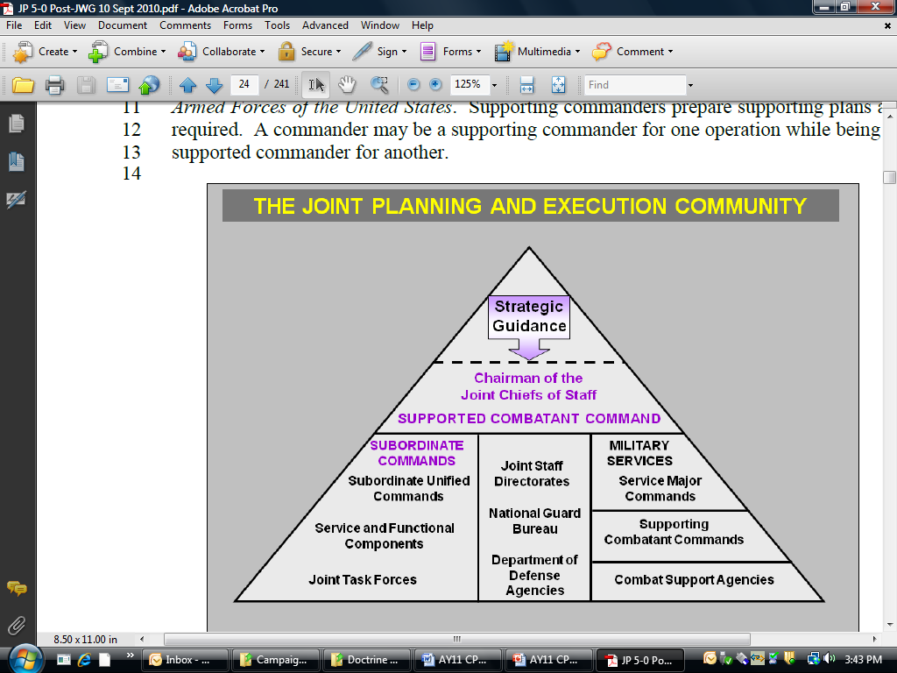
Figure 4: The Joint Planning and Execution Community
4. Adaptive Planning and Execution (APEX). APEX is a system of joint policies, processes, procedures, and reporting structures supported by communications and information technology used by the JPEC to monitor, plan, and execute mobilization, deployment, employment, sustainment, redeployment, and demobilization activities associated with joint operations. It occurs in a networked, collaborative environment, requires the regular involvement of senior leaders, and results in plans containing a range of viable options readily adaptable to defeat or deter an adversary and achieve national objectives.
a. APEX is intended to coordinate integrated, flexible plans with fully integrated databases to enable rapid build of executable joint plans. This flexible planning system is intended to facilitate the adaptive planning principles:
- Clear strategic guidance and iterative dialogue.
- Early interagency and coalition coordination and planning.
- Integrated intelligence planning.
- Embedded options.
- “Living” plans.
- Parallel planning in a network-centric, collaborative environment.
b. Until republished as the APEX manuals, the multi-volume set of Chairman of the Joint Chiefs of Staff Manuals (CJCSM) 3122 series prescribes the policies and procedures of JOPES and are still in use by the joint force. These CJCSMs will be retitled and rewritten as APEX volumes to complete the transition from the legacy JOPES. APEX will evolve as the tools are developed to fully enable it to meet the intent described above. Portions of APEX are already in practice, such as the inclusion of In-Progress Reviews (IPR) by CCDRs with the SecDef during the plan development process.
c. A key part of APEX is the plans review process to bring greater congruence between the CCMDs and the DOD civilian leadership. A series of up to four in-progress reviews (IPR) of the JSCP-directed plans accomplish this end. Depending on the priority of the plan, it may go through all of the IPRs or only one or two. See Appendix A for more on SecDef IPRs. Furthermore, and depending on the audience at the IPR, commanders should be prepared to deviate from the detailed sequences otherwise prescribed by the JOPP. Commanders might also need to conduct the IPR with language and terms familiar to the civilian leaders and decision-makers. While the focus of each IPR is flexible, they follow this general sequence:
(1) Initial IPR: Review strategic guidance. The result is a common view and understanding of the problem, the assumptions, mission analysis, and initial estimate of insights or options available.
(2) IPR: Review plan concept. The result is an understanding of the operational approach, refined options or recommended courses of action, and the impact of resource constraints. Under time constraints, this IPR may be combined with the first one.
(3) IPR: Review the plan. The result is an approved plan, with a full accounting of risk.
(4) IPR: Assess the plan. The result is guidance for plan modification. The Office of the Secretary of Defense (OSD) will typically review each plan up to every 18 months, except for theater campaign plans and functional campaign plans, which will be reviewed annually (unless the situation has changed significantly).
5. Types of Joint Operations Planning. Joint operation planning focuses on two types of planning: deliberate planning and crisis action planning (CAP). Both use JOPP and relate equally to Operational Design. See chapters 3 and 4 for more detail.
a. Deliberate planning occurs in non-crisis situations. Deliberate planning produces Theater and Functional Campaign Plans (TCP/FCP) that are the basis for execution of theater strategies, contingency plans, which are branches to the TCP/FCP, and supporting plans of various types. All geographic CCDRs are currently required by the GEF and JSCP to develop and execute TCPs. Functional CCDRs and occasionally geographic CCDRs may be directed to lead the deliberate planning of specified FCPs. CCDRs must also develop contingency plans specified in the GEF and JSCP, but may also direct planning not specified in the GEF/JSCP to meet emerging requirements as they see fit for their theater.
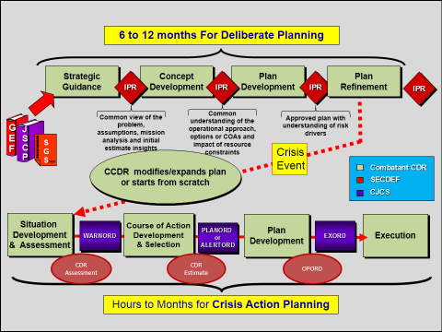
Figure 5: Joint Operation Planning
Deliberate planning is an iterative process and is adaptive to situational changes within the operational and planning environments. The process allows for changes in plan priorities, changes to the review and approval process, and contains the flexibility to adjust the specified development timeline to produce and refine plans. TCPs and FCPs are aimed at desired steady-state strategic conditions, and therefore must be inherently flexible to react to changing assumptions. Contingency plans, however, are based on specific assumptions; a review of critical assumptions is essential to ensure the continuing relevance of the contingency plan.
The JSCP directs that CCDRs develop assigned contingency plans to a specified level. Similarly, the CCDR may direct preparation of internally-directed plans to a particular level of detail.
    - Level 1 (Commander’s Estimate): The Commander’s Estimate provides a set of Courses of Action (COA), with a recommended COA, to address a contingency. The product may be a COA briefing or a command directive or memorandum. This level of detail provides the SecDef with military COAs to meet a potential contingency.
    - Level 2 (Base Plan): A Base Plan (BPLAN) describes a COA that is developed into an executable concept of operations (CONOPS) including key functional concepts and actions, required forces, and anticipated timelines for execution to complete the mission. A Level 2 plan normally does not include annexes or Time Phased Force Deployment Data (TPFDD).
    - Level 3 (Concept Plan): A Concept Plan (CONPLAN) is an operations plan (OPLAN) in abbreviated format that may require considerable expansion or alternation to convert it to an OPLAN or an operations order (OPORD). It includes a base plan with selected annexes: Task Org (A), Intel (B), Operations (C), Logistics (D), Command Relationships (J), Communications (K), Special Technical Operations (S), Interagency Coordination (V), Strategic Communication (Y), and Distribution (Z). It may or may not include a troop list and a TFPDD. Level “3T” plans include the above annexes plus a TFPDD. These plans are usually higher priority CONPLANs and are more easily developed into a level 4 OPLAN when needed.
  - Level 4 (Operations Plan): An Operations Plan (OPLAN) is a complete and detailed joint plan containing a full description of the campaign or major operation, all annexes, and a TPFDD. It identifies specific type forces, functional support, and resources required to execute the plan, and provides closure estimates for the force flow into theater.
b. Crisis Action Planning (CAP) occurs in crisis situations. A crisis is an incident or situation that typically develops rapidly and creates a condition of such diplomatic, economic, or military importance that the President or SecDef considers commitment of U.S. military forces and resources to achieve national objectives (JP 5-0). There may be little or no warning, requiring accelerated decision making. Sometimes a single crisis may spawn another crisis elsewhere. The planning process (using JOPP) for both deliberate and crisis action planning is the same, though different products result. In a crisis, the CCDR has three options:
- Use an existing contingency plan that anticipated the crisis situation, with minor adaptations required.
- Use an existing contingency plan as a base but modify it significantly to meet the crisis situation.
- Build a new plan from scratch.
See Appendix D for more on CAP.
6. Joint Planning in a Comprehensive Context. Military planning is integrated within a more comprehensive environment in order to produce plans and orders that achieve the national objectives established by the President, and to consider the objectives and capabilities of other relevant actors. Joint operation planning integrates military actions with those of other instruments of national power and our multinational partners in time, space, and purpose to achieve a specified end state.
a. The comprehensive context includes all of the relevant actors in the national security environment, including, but not limited to, the following:
- The joint community.
- Whole of Government (the other agencies of the U.S. government).
- Multinational partner nations.
- International Organizations (e.g. the United Nations, the North Atlantic Treaty Organization, the Organization of American States).
- Non-Governmental Organizations (e.g. the International Committee of the Red Cross/Red Crescent, Doctors without Borders, the Afghan Women’s Network).
- Relevant non-state actors (e.g. financial institutions, shadow governments, multinational corporations, terrorist organizations, empowered academics and consultants).
b. National Security Presidential Directive-44 (7 December, 2005), Management of Interagency Efforts Concerning Reconstruction and Stabilization (R&S), established the Whole of Government Planning Initiative and:
- Designated the State Department’s Office of the Coordinator for Reconstruction and Stabilization (S/CRS) as U.S.-government lead to coordinate the development of civilian capability and capacity to plan, prepare for, and conduct reconstruction and stabilization (R&S) operations. The S/CRS has since been disestablished and its role and purpose subsumed by the Bureau of Conflict and Stability Operations in the Department of State (DOS).
- Directed the DOS and DOD to work together to integrate reconstruction and stability (R&S) capabilities.
c. The GEF applies the principles of NSPD-44 and specifically directs the DOD components to:
- Strengthen DOD planning by harmonizing it with the efforts of other agencies in order to create more unified and integrated U.S. Government (USG) planning efforts. This includes ensuring DOD plans are, to the appropriate extent, informed by, coordinated with, and synchronized with the activities of relevant non-DOD organizations.
- Develop all theater campaign plans (TCP) in collaboration with other agencies to the maximum extent practicable.
The JSCP further directs that:
- When developing campaign plans, planners should seek to identify opportunities to support and promote unified action in achieving DOD strategic end states.
- Contingency plans will establish a framework to determine where interagency support would speed transitions between phases. When authorized, planners will liaise with relevant agencies and country teams to validate projected support with regard to agency capacity and intentions. It is important to remember that DOD planners do not normally “task” non-DOD governmental entities to perform tasks or missions, but rather work in a collaborative manner to seek “buy in” and ultimately achieve unified action.
d. Diplomacy, Development, and Defense (3D) Planning – as represented by the Department of State, the United States Agency for International Development (USAID), and the Department of Defense – involves the three main pillars that provide the foundation for promoting and protecting U.S. national security interests abroad. 3D Planning is an ongoing initiative to build understanding and synchronize plans to improve collaboration, coordination, and unity of effort among these organizations.
e. As it is unlikely that the United States will operate alone in future conflicts, joint operations planning must be conducted with a multinational perspective, rather than as an add-on to U.S. planning. U.S. forces may operate as part of a coalition or an alliance, work through unity of effort between nations of similar aim, or work toward an end state that supports U.S. partner nations’ objectives as well as U.S. national objectives. Commanders and staffs must consider interests, equities, contributions, and limitations posed by the multinational environment. Some considerations for planners and operators during multinational operations:
- National objectives of the various partners.
- Building and maintaining a multinational force.
- Mission analysis and assignment of tasks.
- Differences in language, culture, and national sovereignty.
- Legal considerations by the participants (international law and law of war).
- Doctrine, training, and resources.
- Differences in force protection and rules of engagement (ROE).
- Limits to sharing intelligence and information.
- Communications and spectrum management.
- Logistics and host nation support.
- Differing standards for health service support.
- Nuanced perspectives on media relations.
7. Joint Operations Activities. Joint operations planning encompasses the full range of activities required to conduct joint operations. These activities include the mobilization, deployment, employment, sustainment, redeployment, and demobilization of forces.
a. Mobilization is the process by which all or selected parts of the Armed Forces of the United States are brought to the necessary state of readiness for potential military operations. Mobilization may include activating all or part of the Reserve Components (RC), and may include some industrial mobilization. Mobilization is primarily the responsibility of the Military Services in close cooperation with the supported CCDRs and their Service component commanders. (See JP 4-05, Joint Mobilization Planning).
b. Deployment encompasses the movement of forces and their sustainment resources from their original locations to a specific destination to conduct joint operations. It includes movement of forces and their requisite, sustaining resources within the United States, within theaters, and between theaters. Deployment is primarily the responsibility of the supported CCDRs and their Service component commanders, in close cooperation with the supporting CCDRs and USTRANSCOM. (See JP 3-35, Joint Deployment and Redeployment Operations).
c. Sustainment is the provision of logistics and personnel services required to maintain and prolong operations until successful mission accomplishment. The focus of sustainment in joint operations is to provide the CCDR with the means to enable freedom of action and endurance and extend operational reach. Sustainment is primarily the responsibility of the supported CCDRs and their Service component commanders in close cooperation with the Services, combat support agencies, and supporting commands. (See JP 4-0, Joint Logistics).
d. Employment encompasses the use of military forces and capabilities within an operational area. Employment planning provides the foundation for, determines the scope of, and is limited by mobilization, deployment, and sustainment planning. Employment is primarily the responsibility of the supported CCDRs and their subordinate and supporting commanders. (See JP 3-0, Joint Operations).
e. Redeployment encompasses the movement of units, individuals, or supplies deployed in one area to another area, or to another location within the area for the purpose of further employment. Redeployment also includes the return of forces and resources to their original location and status. Redeployment is primarily the responsibility of supported CCDRs and their Service component commanders, in close cooperation with the supporting CCDRs and USTRANSCOM. (See JP 3-35, Joint Deployment and Redeployment Operations).
f. Demobilization is the transition of a mobilized military establishment and civilian economy to a normal configuration while maintaining national security and economic vitality. It includes the return of Reserve Component units, individuals, and materiel stocks to their former status. Demobilization is primarily the responsibility of the Military Services, in close cooperation with the supported CCDRs and their Service component commanders. (See JP 4-05, Joint Mobilization Planning).
8. Options. A major function of the CCDR is to assist the CJCS in his advisory role in informing the President and SecDef about military options to help them form national strategy and guidance. This is a different requirement from developing plans that are directed in the GEF or directed during crises; those plans are dependent on the guidance provided, and generally focus on a single mission. Options may not technically be courses of action, but may be developed into them. Options assist the senior civilian leaders think about the use of military force in the context of the entire instruments of national power: diplomatic, information, military and economic (DIME). Likewise, options are not accomplished as an afterthought during planning, but rather are addressed as a precursor to planning efforts. Options can be theater centric or more specific and require CCDR involvement (or functionally centric in the case of functional CCDRs).
An illustrative example may help. In 2002, SecDef Donald Rumsfeld asked the USCENTCOM CCDR, General Tommy Franks, for military options to remove Saddam Hussein from power in Iraq. The CCDR provided a summary of an OPLAN that did just that. The SecDef, however, viewed that plan as just one method of removing Hussein but wanted additional options, which were not forthcoming. One result of this paucity was that civilian staff in OSD tried to develop options without the deep understanding of feasibility that military planners would have. If, however, the CCDR had presented some options, along with their accompanying assumptions and risks, the SecDef would have been in a better position to help the President form the national strategy for this problem. Some other options may have been the seizure of the southern Iraqi oil fields to increase economic pressure on the regime, to arm the Kurds and/or Shia tribes, to escalate Operations NORTHERN and SOUTHERN WATCH, or to work with Iran to increase pressure on the regime. These are widely varying options, with different timelines for achievement of the national objective, different kinds of risks, and certainly different resultant missions for the military.
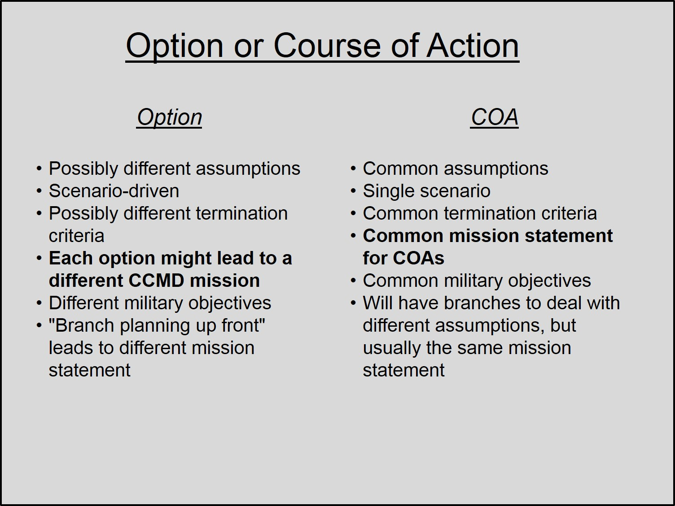
Figure 6: Options and Courses of Action
Development of options is a key part of both deliberate planning and crisis action planning. In deliberate planning, the best time to provide the options is during development of the Guidance for Employment of the Force, since the GEF provides the objectives desired for the directed plans. CCDRs have a key role in the development of this document. In fact, to a great extent, they influence the content. However, the CCDR should also continue the dialogue on options after the GEF is published to react to changes in the environment. This dialogue may happen as part of the APEX IPR process or through more informal communications between the CCDR and his staff, the CJCS and the Joint Staff, and the SecDef and the OSD staff.
Communication of an option must be in a format and language that is easily understood by civilian leaders and policy makers. Though there is no standard for an option, each one should contain the following elements:
- Scenario and assumptions upon which the option is based.
- Desired end state conditions.
- A description of the concept with emphasis on the use of military actions in the context of the use of other instruments of power.
- A general description of the resources required.
- A general timeline for how the option would play out.
- The strategic and operational risks entailed in this option.
Some CCMDs have formalized options in capstone plans, which are an overarching set of plans that deal with the various scenarios that may evolve in a given contingency situation. Other CCMDs embed the options within the plan. Multiple options might lead to multiple mission statements, whereas multiple COAs are concepts designed to fulfill a single approved mission statement.
In CAP, CCDRs engage early with the CJCS and SecDef in providing analyzed military options to help shape the national strategy and guidance. Again, the various options presented by the CCDR might result in different missions for his command. There are many ways that the CCDR can communicate options to the CJCS and the SecDef during a crisis. One way is through the formal CAP messages (see Appendix D). A CCDR is expected to provide a commander’s assessment as early as possible during the situation development phases of CAP. The CCDR should describe the options for military activity in this assessment. The commander and staff should follow through with continued development of the options as time allows and demands. Later steps of CAP narrow the strategic guidance and direction to enable the CCMD to focus on the mission they must execute. However, they must continue to keep in mind the other possible options for the use of military force as the situation changes.
There is also a need to consider and communicate options during execution. Commanders and staffs must acknowledge that the dynamic environment will likely require strategic reassessment and adaptation during execution. They therefore must be prepared to present options to adapt the strategy (and potentially the policy) to react to the changing environment. This requirement for change might be due to unforeseen successes, failures, or other circumstances. It is especially important for the commander and staffs to look at the holistic national strategy to determine the need for and the impact of changes to the military approach to adapt to the circumstances.
9. Risk. Central to planning and execution at any level is the concept of risk. Using the general strategy model of ends, ways, and means, risk results from the imbalance of these three components. Merriam-Webster’s dictionary defines risk as “the possibility that something bad or unpleasant (such as injury or loss) will happen.” The DOD dictionary (JP 1-02) defines risk as “probability and severity of loss linked to hazards.” These definitions may not be entirely adequate for those advising senior leaders or conducting planning. The concept of risk resides firmly in the realm of decision-making. Risk has meaning when leaders weigh options to achieve desired objectives and assess the likelihood and magnitude of adverse outcomes. Those who write about risk often reside in academia or the business world where risks must be quantified to be useful. The discipline holds that risks can be accepted, avoided, mitigated, or offset. A whole industry – insurance – deals with offsetting or transferring risk.
In most cases, military professionals first experience the concept of risk with the operational risk management process when risks are identified and controlled by educating subordinates and establishing measures to avoid or reduce the probability of negative outcomes. At the lowest level, the holiday safety briefing to subordinates is perhaps the most well-known. Range safety briefings are other examples. When planning military operations, commanders and staffs usually think about risk to mission accomplishment and risk to the force. Good planning processes, combined with knowledgeable and experienced staff members, will describe risks and find ways to reduce the probabilities or mitigate the consequences of adverse events or threats.
At the theater strategic level, senior national security professionals must have the ability to articulate risk to senior decision-makers at the national level who may not have a military or national security background. Therefore, campaign planners must expand the conventional categories of risk to encompass others that are relevant to people making strategic decisions. The risk categories below are not intended to be prescriptive, since each planning situation is unique; there may be others not listed that should be considered and assessed.
- Mission – achieving campaign objectives.
- Troops – joint and coalition forces assigned, allocated, or apportioned.
- Time – expected duration of the campaign.
- Coalition – maintaining external political and material support.
- Commitment – maintaining domestic political and popular support.
- Escalation – adversary reactions that may require more resources.
- Resources – money, time, and interagency and intergovernmental participation.
- Inaction – likely or foreseeable trends that may lead to undesirable developments.
Once the staff develops categories of risk that are relevant to the campaign, risks can be assessed and managed using a logical framework, such as that depicted in Figure 8 which has been used by the Chairman of the Joint Chiefs of Staff. Joint doctrine mandates a risk assessment (specifically, risk to mission) as part of the mission analysis phase of the Joint Operation Planning Process. It also directs that risk be addressed during in-progress reviews (IPR). In addition to the probability and consequences of any particular source of risk, another dimension that should be considered is the immediacy of the risk, or how rapidly the risk may arise and impact operations. Immediacy affects the leader’s ability to take timely mitigating activities to address the risk.

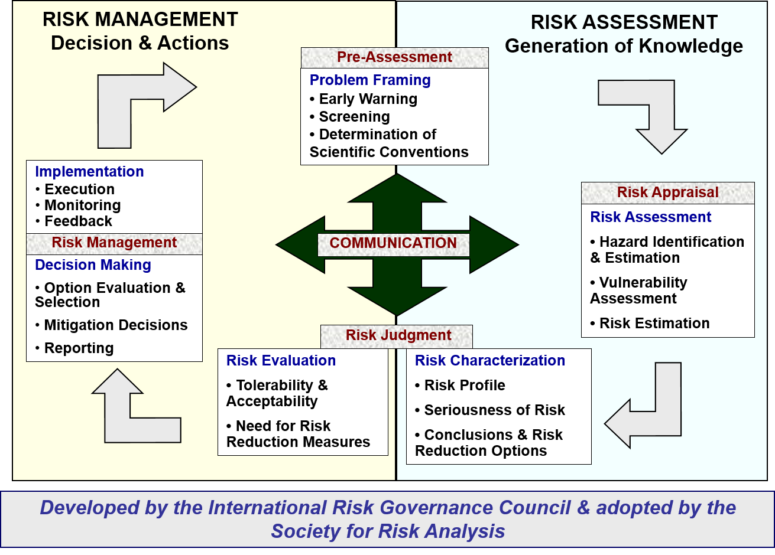
Figure 8: Basic Risk Framework
Another important document where risk is addressed is in the commander’s intent for the campaign or operation. Purpose, end state, and operational risk are the essential elements of intent. An explicit statement of where, when, and what kinds of risk will be accepted or rejected provides a way to prioritize effort in the absence of resources and allows subordinate commanders to better execute mission command. Chapter 5 will address describing operational risk as it applies to campaign planning.

THIS PAGE INTENTIONALLY BLANK

CHAPTER 3: Operational Design
1. Introduction.
a. Military force has always been used in an environment of complexity, largely because warfare is a human endeavor dealing with relationships between humans, which guarantees uncertainty. Since the end of the Cold War, the military has dealt with problems with less structure than it had become comfortable with as an institution. While the U.S. military has remained agile, flexible, and adaptable at the tactical level, there is a perceived need for the institutional culture to become more adaptive. Recent history is filled with examples of tactical excellence within an environment of strategic confusion, largely due to failure to define the military problem correctly and to adapt planners’ understanding of that problem as the environment changed. Commanders are often provided vague guidance, requiring them to develop an understanding of the environment quickly to be able to discern the problem that must be solved using military force.
Recent Joint and Service doctrinal publications introduce the concept of operational design as a way of dealing with the complexity and lack of structure in problems faced by commanders. Operational design acknowledges the uncertainty and dynamics of warfare and enables planners to seize opportunities to shape the environment and adapt operations as they progress. It acknowledges the need to look for those weak signals that suggest a change to the environment that may require significant changes to the way the military operates. The critical and creative thinking that underpin operational design are not new. The great captains of history, from Sun Tzu to General U.S. Grant to Field Marshall Rommel, have all used this thinking. Hence, operational design is not a discovery, but instead is a reminder within a methodology for use by contemporary military and national security professionals to deal with an incredibly nuanced and complex global environment. The goal of operational design is deeper and broader understanding, not closure. The JOPP works seamlessly with operational design to provide the needed closure that will drive orders and action.
Note that there are some differences in terminology between the Army’s description of the "Army Design Methodology” in Army Doctrinal Reference Publication (ADRP) 5-0 The Operations Process, and the joint description of "Operational Design" in Joint Publication (JP) 5-0 Joint Operation Planning. Though most of the differences are superficial, they are explainable largely by the purposes of the publications. ADRP 5-0 is intended to provide an approach to deal with complex situations that Army leaders may encounter at all levels; it is broader in approach. In slight contrast, JP 5-0 is intended for situations in which joint warfighters may find themselves; it is more narrowly focused on the requirements of joint operations. Thus, "operational design" can be thought of as a subset of the "Army design methodology.” Both methods use the same logic and seek similar outcomes. While this campaign planning handbook remains consistent with joint doctrine in that it uses operational design terminology and logic, it incorporates some of the underlying thinking behind the Army design methodology so that operational design can be applied to problems normally found outside the realm of joint warfare (e.g. above the theater level).

b. The two definitions highlight these distinctions: Army design methodology is a methodology for applying critical and creative thinking to understand, visualize, and describe unfamiliar problems and approaches to solving them (ADP 5-0). In Joint doctrine, operational design is defined as the conception and construction of the framework that underpins a campaign or major operation plan and its subsequent execution. (JP 5-0).

c. Operational design provides an organized way to think through the complexity of the environment and the problems that may require the use of force. This logical approach to thinking seeks wider and deeper understanding, not necessarily closure. While operational design provides a good methodology to do the conceptual work for developing approaches to complex situations, it is especially useful at the higher levels of Joint command, which deal predominantly with strategic guidance, strategy development, campaigns, and major operations. Operational design can help develop the conceptual framework of a strategy or plan and enable a logical way to continually assess execution to determine if adaptation is needed.
d. Some questions you may ask to determine if you should spend time developing the conceptual framework through the use of operational design might be:
  - Do we know enough about the situation to move forward in a meaningful way? Is a course of action clear and evident?
  - Are the actions we are taking having unexpected and/or surprising effects?
  - Is the problem so familiar and solution so obvious that we already know what to do (a heuristic, or standard operating procedure)?
  - Do we know what end state conditions we are trying to achieve, or are the desired end state conditions unclear?
  - Are actions and techniques that were originally effective now falling short of achieving the desired impact?
e. Key to success in using an operational design approach is a climate that encourages open dialogue and exchange of ideas. This exchange is not only internal to the organization, but also vertically with higher and lower echelons and horizontally with other relevant partners. It is through such interchange that a shared understanding and common vision can be achieved. While leaders and staffs at higher echelons may have a clear strategic understanding of the problem, those at lower levels are likely to have a better understanding of the realities of the local circumstances. Merging these perspectives is crucial to achieving a common vision or synthesis, which can enable unity of effort. For this reason, operational design is especially appealing in interagency and coalition efforts.
2. An Operational Design Approach to Campaigning. Operational design helps the commander interpret strategic guidance and employ operational art effectively to envision the requirements and framework for the employment of military force. It enables the United States and its partners to develop and revise the framework for dealing with a particular situation. A commander does this initially when presented with a complex situation with little structured guidance. He continues to adapt as the operational environment changes through the campaign to achieve the desired end state in the strategic/operational environment. Operational design enables the organization to continuously scan the environment for signals that the current campaign approach is or is not working, or is oriented on the wrong problem, and adapt the approach if appropriate. This approach enables both the adaptability and the continuity required to be successful in the complex environment. Figure 8 shows a way to graphically represent an operational design approach to campaigning. Note that this figure shows that taking action (via convergent thinking, coming to closure, and issuing orders that drive this action) will likely change the operational environment, recursively requiring divergent thinking and possibly reframing of the environment.

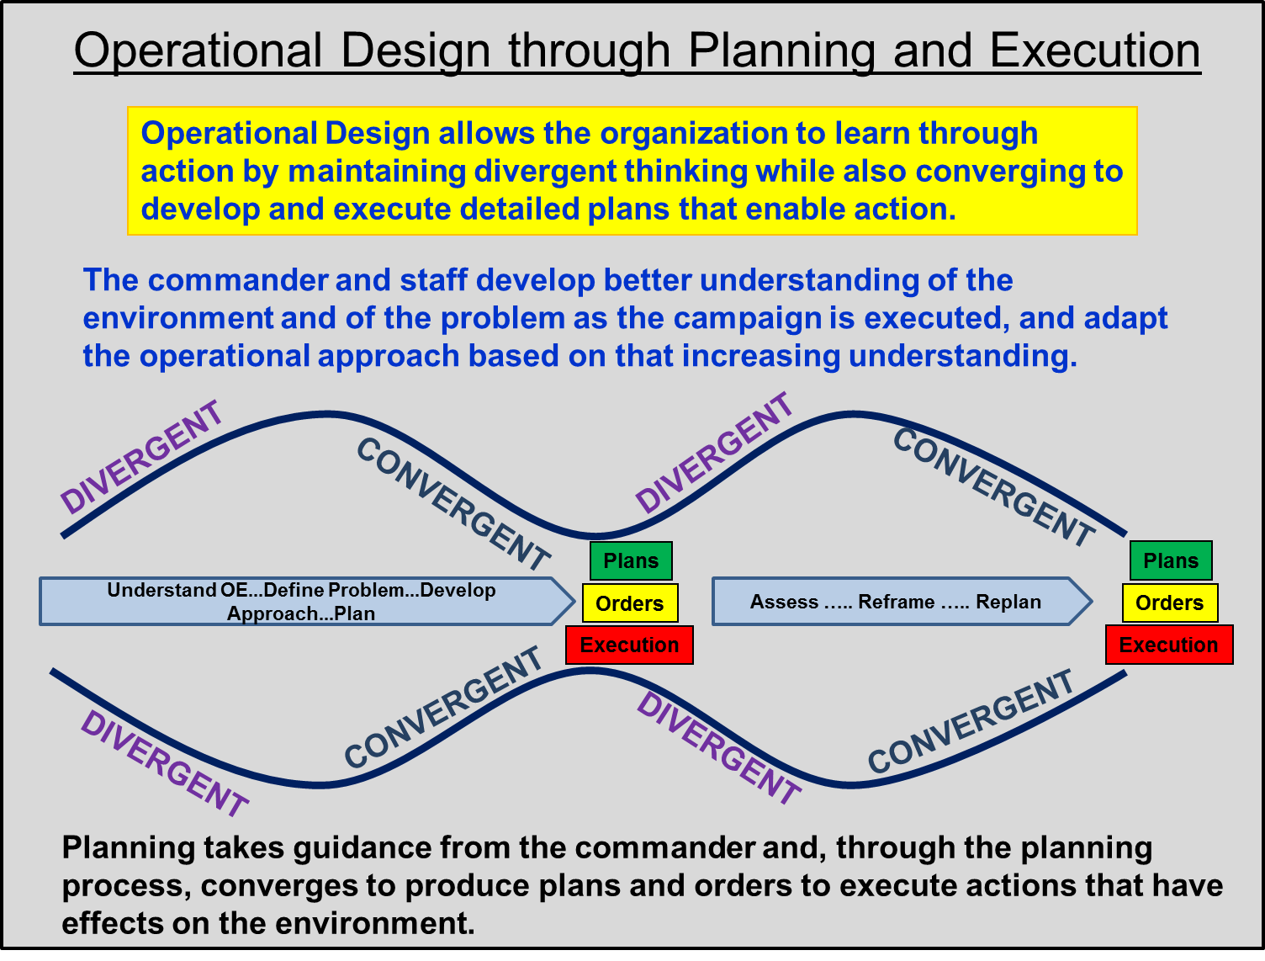
Figure 7: An Operational Design Approach to Campaigning
a. Three interrelated activities collectively provide understanding and visualization of the purpose of the use of military force. These activities include understanding the operational environment, defining the problem, and developing an appropriate operational approach to solve the problem. Though not all problems lend themselves to "solutions" in operational design, we must frame the problem in such a way that it can be solved or at least managed by the organization. This often requiresU.S.to see the problem in its temporal aspects; what can be solved now and what we must do to set conditions for later resolution of the higher order problem. Framing is a way to focus relevancy by including relevant aspects and excluding other factors. It helps organize thinking to provide guideposts to understanding, visualization, and action.

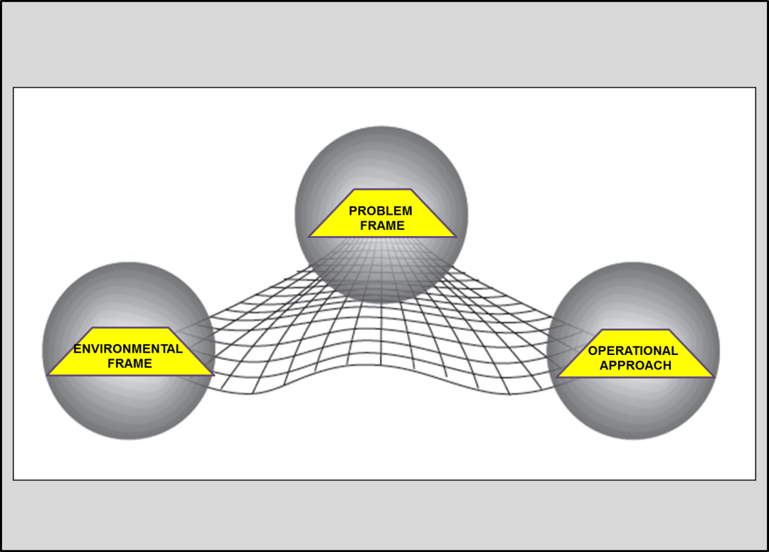
Figure 8: The Operational Design Activities
- Understanding the operational environment. What is the context in which operational design will be applied? Commanders and planning teams review existing guidance and articulate existing conditions. By identifying tendencies and evaluating potentials of relevant actor relationships, those conducting operational design can develop a desired end state that accounts for the context of the operational environment and higher guidance. The environmental frame maps and describes the actors and their relationships to understand existing conditions and the desired end state in the light of guidance. In framing the operational environment, we describe the set of conditions we wish to see at end state, as well as the competing conditions that other actors would like to see. We also need to consider in which direction the environment will move if we take no action at all.
- Defining the problem. What underlying problem is the campaign intended to solve? This effort seeks to understand the problem to visualize possible solutions. In framing the problem, we describe the differences, or the tensions, between our desired end state and other possible end states, and discern those differences that must be reconciled and those similarities that should be embraced to achieve the acceptable end state. Framing the problem supports the commander’s discourse with his superiors to define the problem clearly and create common expectations regarding its resolution. Further, it establishes a mutual understanding of the situation within which the military force will operate. It is in this context that options, addressed in Chapter 2, are most beneficial. Examination of options during is invaluable to the joint force commander and will feed future discussions with the SecDef and President.
- Developing operational approaches to the solution. What broad, general approach could solve (or manage) the problem? Considering operational approaches to the problem provides focus and sets boundaries for the selection of possible actions that together lead to achieving the desired end state. The commander and staff converge on the types and patterns of actions they hope will achieve the desired conditions by creating a conceptual framework linking desired conditions to potential actions. This operational approach helps shape subsequent JOPP activity, especially COA development.
- The real power of operational design comes from the synthesis of all three frames. They really are not separate activities, but three areas of thinking in the same methodology. They are totally iterative and a better understanding of one frame will lead to a deeper understanding of the other frames. To frame the environment, you cannot help but see the competing trends emerge which will help to better define the problem. As you see a potential operational approach emerging, you may discover new problems or need to modify existing ones and ask more questions about the environment. As you analyze the operational approach and look for ways to avoid or mitigate undesired effects, you will likely redefine the problem and see aspects of the environment that you had not previously understood. As you work with operational design, you will get more comfortable working the frames iteratively, so it will feel less and less like three separate frames and more like a single, synthetic, cognitive approach.
- Understanding the situation and visualizing solutions to the problem are only part of the challenge. This understanding and visualization must be described to other commanders, leaders and planners so that they can help implement the solution. The synthesis of the three activities can be described through the commander’s operational approach. The operational approach describes the commander’s understanding and resultant visualization of the campaign’s parameters. He must clearly transmit his synthesized approach to his staff and other interested parties who will be involved in planning and executing the campaign; this transmission can take the form of commander’s initial or updated planning guidance.
b. There are several ways in which operational design may be applied by the commander and staff. Operational design may precede planning, with the commander providing initial guidance to the staff as they begin the planning process. Alternatively, the commander may conduct operational design in conjunction with planning, as his approach to building his commander’s estimate and guiding the staff through planning. Additionally, he may conduct operational design throughout preparation for and execution of the operation or campaign to increase his understanding of the environment and the problem, and his visualization of the campaign so that he can adjust the organization’s efforts as needed. Most likely, the commander will use the operational design approach in each of the instances above. In any case, the commander’s operational design is progressive, and iterative, with the staff’s analysis informing the commander’s operational design as much as the commander informs the staff of his maturing operational approach. This is not to imply that operational design is only the purview of the commander while the staff works the science of planning. Staffs can conduct or at least contribute to operational design as well.
c. Commanders may see the need to establish an operational design team separate from the planning staff. There is no doctrinal template for an operational design team; membership and participation is at the discretion of the commander and is dependent on the situation. Operational design may benefit from an expansion of the traditional planning team or cell to ensure that the widest possible range of views and expertise is present. Design creates understanding through inquiry and likely cannot be fully explained or transferred between people in its entirety without having been a participant in all of the deliberations. Conducting operational design with some of the core of the detailed planning team can be an advantage. The key is to ensure that continuous dialogue continues between a design team and a planning team if they are separate.
d. Not enough can be said about the need to have, and to develop, the right people and command climate for an operational design approach to flourish. Operational design is not a mechanical, scientific, or entrenched activity. Successful operational design assumes that complex and unfamiliar problems cannot be reduced to simple constructs and it is beyond the ability of any one individual to fully understand, let alone solve. To be successful, the organization must have open, honest dialogue that questions the assumptions, operational approach, vision, guidance, and end state. Successful organizations also seek a deeper understanding of what they cannot explain or know about the environment and the problem. Perhaps the greatest value to such an approach can be seen in execution of the campaign, as the organization actively looks for and stays attuned to indicators that suggest that the current campaign plan may no longer be appropriate.
Simply put, operational design encourages an open dialogue based on the competition of ideas to develop the best possible understanding of the situation and develop ways to deal with it. It produces a series of improving hypotheses about what the problem is and how to solve it, and encourages an organizational atmosphere open to challenges to the hypothesis so that the organization’s approach remains relevant and correctly aimed and focused.
3. Link between Operational Design and Planning.
a. Operational design is done before planning, throughout planning, during preparation, and throughout execution. In fact, the operational design effort never ceases in a dynamic environment. The commander and staff may begin operational design before planning is initiated to provide the staff, subordinates, and other associated partners some initial planning guidance based on understanding of the situation. In peacetime deliberate planning, this is likely the result of an ongoing analysis by the combatant command of its AOR, with greater emphasis given to those situations or locations designated as areas of potential crisis and instability within the theater campaign plan.
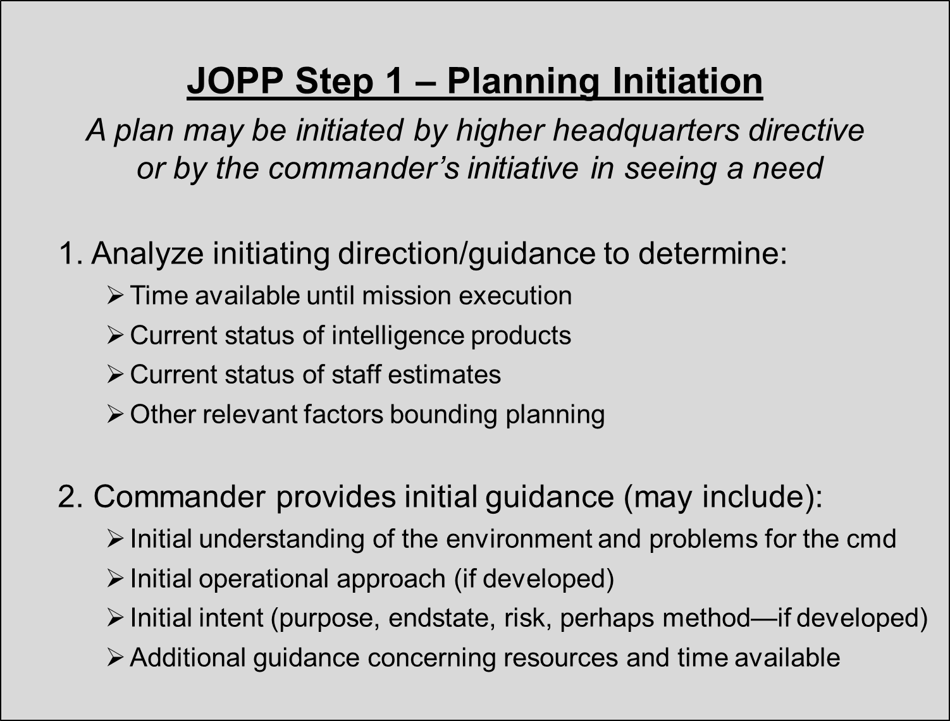
Figure 9: Operational Design and Planning
b. It is important to note the complementary nature of operational design and the planning process. By necessity, the planning process must be convergent, in order to yield executable plans and orders. Operational design enables a balance between this required convergence and the divergence needed to remain open to numerous stimuli to better understand the operational environment and better define unfamiliar or ill-structured problems. While the continuous dialogue of operational design enables the command to keep its “thinking aperture” as wide as possible to always question the mission’s continuing relevance and suitability, the structured process of the JOPP allows us to quickly build a plan that will enable the organization to execute the commander’s current vision. By integrating both of these approaches, the friendly force can maintain the greatest possible flexibility and do so in a proactive (instead of reactive) manner.
c. Operational design provides the vision and logic of the campaign, which can then be turned into flexible, adaptable courses of action. Through detailed analysis and planning, those courses of action are developed into plans for future synchronized, joint, interagency, intergovernmental, and multinational (JIIM) execution.
4. Link between Operational Design and Execution.
a. The commander’s operational design work transcends the planning process. That is, during operations, while the staff is primarily concerned with coordination and synchronization to accomplish the objectives that support the command’s mission, the commander is primarily concerned with trying to better understand the campaign as both it and the environment evolve so that he can determine if the current mission and operational approach are right. Remember that the commander’s operational approach is a hypothesis for action. In a complex situation we cannot know how the environment will react to any given action, but we can know more about the environment as we assess its reaction to an action; thus, learning becomes the driver for operational initiative. While those working to execute the plan may see one reaction, those looking outside the plan may see an altogether-different reaction, possibly one that causes the commander to reframe the problem. The commander must know when his understanding of the problem and potentially his visualization of the campaign have changed to such an extent that he must redirect the command’s campaign approach. Thus, through execution, operational design must be challenged and validated to ensure it yields the desired objectives and end state, and most critically, that the objectives and end state that drive the campaign are the right ones. This does not suggest that during execution the staff should not be keen to changes in the environment, the problem, or the operational approach. It does suggest, however, that the commander may be in a better position to "see" and "synthesize" the components of operational design as the environment changes during execution.
b. Assessments are a critical part of the design approach to campaigning and operations. Assessment at the operational and strategic levels typically has a wider scope than at the tactical level and focuses on broader tasks, effects, objectives, and progress toward the end state. Continuous assessment using Measures of Effectiveness (MOE) help the JFC and his component commanders determine if the joint force is "doing the right things" to achieve its objectives. Tactical-level assessment typically uses Measures of Performance (MOP) to evaluate task accomplishment. These measures let commanders determine if their force is "doing things right."
As the commander and staff continue to assess changes in the environment, they must continually challenge their original framing of the situation to ensure the campaign is meeting the stated objectives and end state. They must assess whether the envisioned objectives continue to be appropriate to meet the end state. Finally, they must know if the intended end state still makes sense. While we use MOEs and MOPs to assess effectiveness and performance of the plan, it is critical to assess the strategic level objectives and end state. Are we focused on the correct objectives? Is the desired end state correct and has it remained relevant as the operational environment has evolved? Are the inherent risks to the campaign or operation still acceptable? How do we measure these aspects of the campaign? The divergent nature of the operational design approach offers a solution to this challenge. The commander and his operational design team must reevaluate the stated objectives and end state against other possibilities and outcomes.
c. Reframing is the iterative or recurring conduct of operational design in the event that the commander’s understanding of the OE or of the problem have changed to such a degree that a different operational approach is warranted. Essentially, reframing is required when the hypothesis of the current problem and/or operational approach may no longer be valid. As he updates his understanding and visualization of the environment and its tensions, the commander may determine that changes to the operational approach could range from minor modifications to a completely new campaign plan. Reframing may cause the commander to direct the command to shift the campaign’s approach.

Reframing may be as important in the wake of success as in the case of apparent failure. By its very nature, success transforms the environment and affects its tendencies, potentials, and tensions. In fact, any action in or on the environment could cause changes that generate new problems. Organizations are strongly motivated to reflect and reframe following failure, but they tend to neglect reflection and reframing following successful actions.
5. Conducting Operational Design. The details of the methodology described below combines elements of the Army design methodology (as described in ADRP 5-0), operational design (as described in JP 5-0), and some of the techniques for conducting the Army design methodology from the Army Techniques Publication 5-0.1 into one that works for the JFC, with a special focus at the theater level of campaigning.
The commander and his operational design team should use a set of interconnected cognitive activities to help build their understanding of the situation and visualization of the campaign. These iterative activities constitute a methodology for the commander and his team to learn about the answers to three broad questions:
- What is the context in which the campaign will be conducted?
- What problem is the campaign intended to solve?
- What broad, general approach for the campaign could solve the problem?
The deliberation on these three questions is iterative and recursive--that is, as one question is answered, new questions will be generated, and questions already asked may be asked again to gain deeper understanding. The purpose of the dialogue is to develop an operational approach that can be turned into an executable campaign plan, or into modifications to an existing plan, and can be continued throughout the campaign to help determine when adaptation to the plan is appropriate.
Those conducting operational design collaborate extensively with all parties who are interested in the problem or have knowledge about the problem that may help enlighten the operational approach. Inclusion of interagency and coalition partners, as well as the whole range of those with unique expertise or broadening perspectives, is absolutely critical. Not only will the analysis be richer, but such collaboration might also enable broader "buy-in" by other agencies early on, and then continuously. Dialogue between echelons of command is also critical to gain the best understanding possible.
a. Understand the Operational Environment. The environmental frame describes the context of the situation. It describes how the environment has been formed in its current state and how it may trend to the future. The commander and his operational design team analyze the current environmental conditions and determine what the desired future environment should look like, keeping in mind that existing higher level guidance is part of the considered environment. The environmental frame should also describe the alternative future environments that other relevant actors may desire (or that which might exist if we take no action at all), so we can consider this in developing an operational approach that will not only meet our end state, but also preclude the undesirable aspects of opposing end states. The team will compare the current environment to the friendly desired end state and identify those conditions that need to be different to enable end state achievement, while also considering the natural tendency of those conditions to move to a particular state in the absence of our activity. This natural tendency is critical, as it is the basis on which we must act to achieve our desired conditions.
In framing the OE, commanders can ask questions such as:
- What’s going on?
- Why has this situation developed?
- What is causing conflict among the actors?
- What are the strengths and weaknesses of the relevant actors?
- What does it mean?
- Why is the situation (or the projected future situation) undesirable?
- What’s the real story?
- What conditions need to exist for success?
- What are indicators that we are on the path to success?
- What are indicators that we are going in the wrong direction?
(1) Describe the current environment. To envision developing and employing options for joint, interagency, intergovernmental, and multinational (JIIM) action, the commander must understand the series of complex, interconnected relationships at work within the OE.
One way of viewing these interrelated challenges for most military operational situations is from a systems perspective. In doing so, it is critical to consider the systemic look — that is, the relationship between all aspects of the system. The initial task is to develop a baseline of information on the adversaries, on ourselves, and on relevant neutral or other interested parties by collecting and analyzing a wide array of data. We begin with outlining the way that the system operates. Analysis includes identifying roles and functions in each of the systems and mapping their inter-relationships. This process includes identifying the "nodes" (i.e. the people, facilities, forces, information, and other elements) and the "linkages" (i.e. the behavioral, physical, or functional relationships) between these nodes.
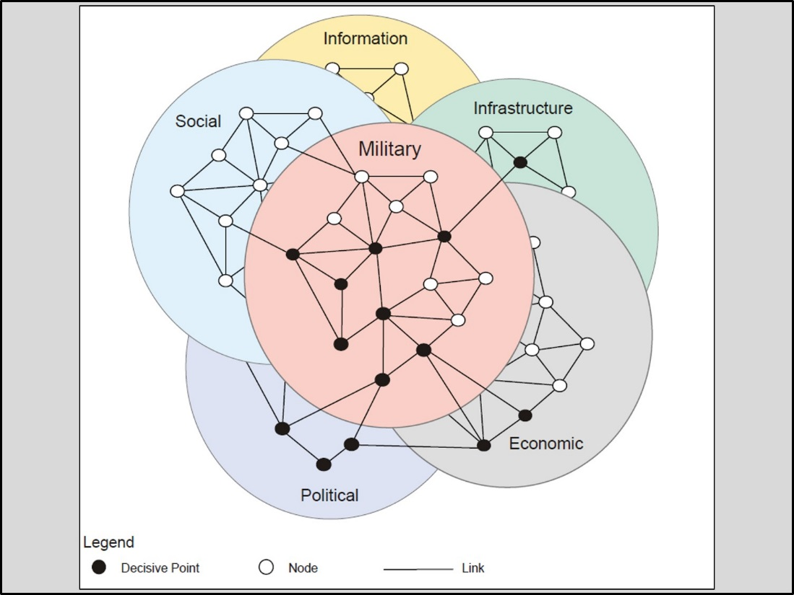
Figure 10: PMESII Systems Analysis
The team can use a framework such as PMESII (Political, Military, Economic, Social, Informational, and Infrastructure) to analyze the environmental “system of systems” and determine relevant and critical relationships between the various actors and aspects of the environment. However, be careful not to stovepipe the analysis – the most important analysis leads to an understanding of the dynamics of the relationships between the various parts of the environment. Appendix C provides some points to consider and questions to ask during analysis. The most important questions are those that will cause deeper analysis to continue to deconstruct the OE.
Analysis then shifts to define how these systems interrelate with one another. This analysis produces a holistic view of the relevant enemy, adversary, neutral, and friendly systems as a complex whole, within a larger system that includes many external influences. While identifying the nodes and links within a system may be useful in describing important aspects of the OE, more important is describing the relevant relationships within and between the various systems that directly or indirectly affect the problem at hand. Commanders and staffs must understand that relationships, especially those dealing with human interaction, are extremely dynamic. These dynamic relationships often make it difficult to determine clear causality, which makes it difficult to know if actions taken in the context of the operational approach will ultimately be effective. This reinforces the importance of the iterative nature of operational design and “learning as you act.”
The "product" of the analysis of the current OE is a set of narratives that describe the important interests of the key actors in the OE and the relationships between them. Though the narratives may be PMESII-based, they go far beyond the baseline PMESII analysis to describe the dynamics of the relationships between critical aspects of the environment. One example narrative might be to explain the interaction of the Taliban with the drug lords, its relationships with the local Afghan population, and the effects on those relationships of actions by outside actors.
(2) Determine the tendency of the future OE. Keep in mind that the OE continues to move forward, so we need to project the current OE into the future to be able to affect it. If no outside actors influence the OE, it will still change due to inherent tendencies in the system. It is important to understand the natural tendencies of the system, and project what the conditions will be through this system inertia. Given the natural tendencies of the OE, we may be able to better define our desired end state. We may also be able to use this insight to help form our operational approach. The point of time for the projection in the future depends on the timeframe of the campaign.
(3) Analyze guidance. (Note that JP 5-0 describes the activity of analyzing guidance as a distinct activity of operational design. In this handbook, we consider guidance to be integral to the environment). The commander and the operational design team must analyze and synthesize all available sources of guidance. These may be written directives, oral instructions from superior commanders, speeches, domestic and international laws, policies of other organizations that are interested in the situation, strategic communication guidance, or higher headquarters orders or estimates. Some of the guidance may be contradictory or ambiguous and should be questioned for the sake of clarity. Part of the design approach is to enable collaborative dialogue up and down levels of command to discern a common view of ongoing events and of what the intended guidance means.
The end state conditions described in higher-level guidance must be translated into desired conditions at our level. We recognize and define two levels of strategic end states in a single campaign: a national strategic end state and a theater strategic/military end state. The national strategic end state describes the conditions that the President envisions for the region or theater. National strategic end state conditions derive from Presidential/SecDef guidance that is often vague. Often, senior military leaders will assist the President and SecDef in developing and articulating the end state conditions. Below is an example of a national strategic end state:
An economically-viable and stable Country X, without the capability to coerce its neighbors.
In analyzing the guidance, the commander and staff must discern the standards that military activity must achieve to support the national end states. These standards are called termination criteria, those specified standards that must be met before conclusion of a joint operation. When addressing conflict termination, commanders and their staffs must consider a wide variety of operational issues, to include disengagement, force protection, transition to post-conflict operations, reconstitution, and redeployment (JP 5-0).
Termination criteria may change as the campaign progresses, and it is important for commanders and staffs to keep an eye out for potential changes, as they may result in a relook at the relevance of the mission. Therefore, it is crucial for the military to maintain a close dialogue with the national civilian leadership and the leadership of other agencies and other partners.
Some examples of termination criteria are:
Country X’s borders are secure.
Country Y no longer poses an offensive threat to the countries of the region.
Country X’s national army is sufficient to repel internal rebellion.
The campaign will most likely define national strategic objectives to accomplish. These objectives would describe national level goals on which the various national instruments of power will orient, and may or may not involve the military instrument. Strategic objectives clarify and expand upon end state by defining the decisive goals to achieve in order to assure U.S. policy.
The military end state is a subset of the national strategic end state discussed above and generally describes the military conditions necessary to achieve that national strategic end state. It is a succinct description of the conditions that meet the termination criteria. Note that achieving the military end state may or may not end military involvement in the national security issue, though military activity would no longer be the primary instrument of power. An example of a military end state is:
Country X is unable to project military power against its neighbors.
(4) Analyze available DIME power and limitations. Part of analyzing the environment is to get an understanding of what instruments of power may be applied to help achieve the desired conditions described by the end state. Commanders and their teams should look not only at national instruments of power (Diplomatic, Informational, Military, Economic), but also at the instruments of power that other actors can bring to bear. Some powerful instruments may be controlled by other governments, by international organizations, by private corporations and organizations, or even by independent individual actors.
(5) Determine the desired future OE. Define the key conditions that must exist in the future OE to achieve our desired end state. Put a temporal aspect to this set of conditions to be able to perform some feasibility and acceptability analysis.
(6) Determine alternative future OEs, to include the natural tendency of the OE. Most critically, consider the conditions of the natural tendency of the environment, as those conditions will almost certainly have the greatest inertia. Other actors will also be affecting the OE and may have significantly different desired end states. The enemy/adversary will have a desired set of conditions for some point in the future. These conditions describe their desired end state. Friendly or neutral actors may not have an opposing mindset, but some of their desired conditions, or unintended consequences of their actions, may oppose our desired end state conditions. Conversely, some of the desired conditions of other actors may converge with our own desired conditions, presenting an opportunity for exploitation, synergy or cooperation (depending on point of view).
b. Define the problem. As the JFC’s understanding of the environment matures, tensions and problems come into sharper focus. The commander tries to find the explanation for the conflict through framing the problem. Though the root causes of the problem may be identifiable, they may not be solvable. In framing, we are trying to find the problem(s) that we can solve, mitigate, or manage which will ultimately help achieve the conditions of the desired end state. This includes seeking a clear understanding of which of the resulting tensions must be solved to achieve our desired end state, as well as where there are opportunities presented by the convergence of other actors’ desired conditions with ours.
Commanders may ask questions like:
- What needs to change?
- What doesn’t need to change?
- What are the opportunities and threats?
- How do we go from the existing conditions to the desired conditions?
- What tensions exist between the current and desired conditions?
- What tensions exist between our desired conditions and adversaries’ desired conditions?
- What are the risks in going to the desired conditions?
(1) Define the critical differences between and similarities in alternative future OEs. Find those conditions in our desired OE and those of the natural tendency and other desired future OEs that are different and if not reconciled will preclude achievement of our national end state. Be sure to consider those future naturally occurring conditions that may oppose our desired conditions. Find the conditions that are shared between us and other actors. These represent opportunities. These sets of competing and converging conditions are the basis for determining the problem that we have to address.

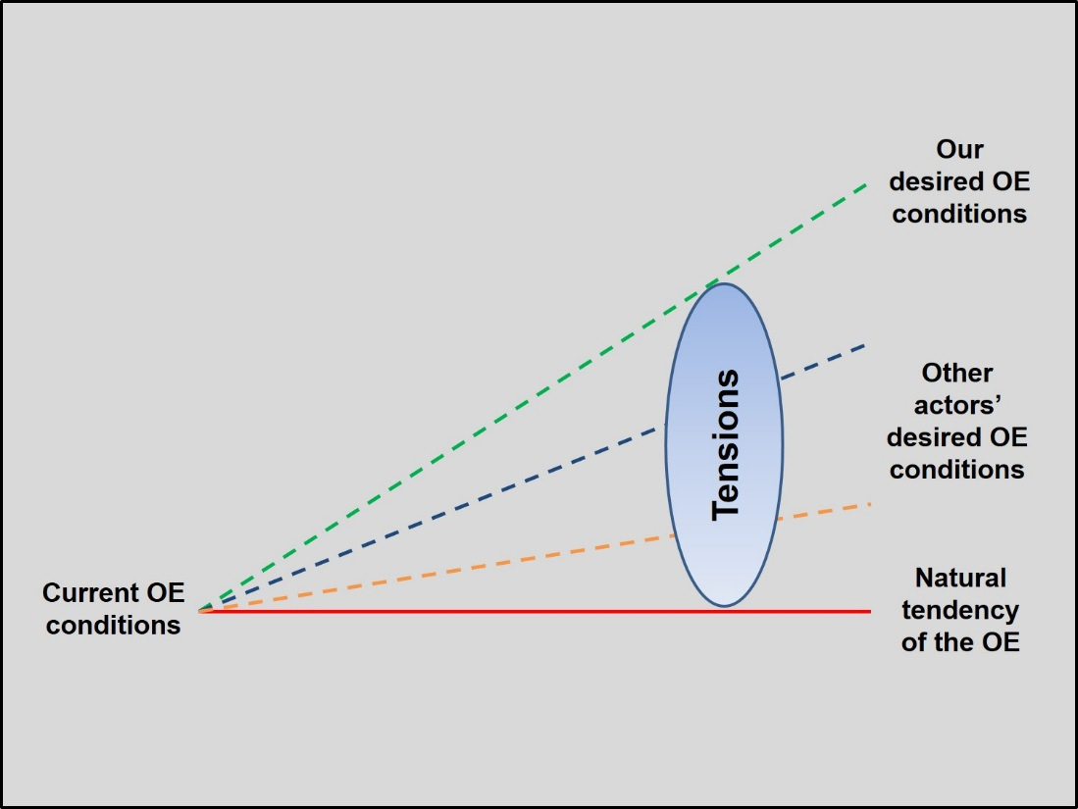
Figure 11: Tensions that Describe our Problem
(2) Identify the problem. An important part of problem framing is to determine what relevant factors and relationships in the OE need to be acted on to reconcile the possible OE condition sets. Some of the conditions are critical to success while others are less so. In identifying the problem, the operational design team restates the tensions and opportunities between our desired future conditions and the alternative future conditions, and identifies those areas of tension and opportunity that merit further consideration as candidates for possible intervention.
Though it is important to understand the root causes of the divergence of the OE from our desired end state conditions, we may not be able to, or even need to, address the root causes to achieve our desired conditions. Instead, we are interested in identifying OUR problem(s) – and what must we do to achieve OUR desired conditions. If we are a combatant command, our problem is how we apply military power in coordination with other instruments of national power to achieve desired military conditions. Operational design might reveal several problems well beyond the remit of the JFC. In these cases, other governmental or non-governmental agencies should take the lead to resolve or manage them.
(3) Prepare a concise statement of our problem. The problem statement should define clearly and concisely the problem that we must solve. It should include the major condition sets with a time aspect. For example, there may be some tensions that must be resolved within six months, others that must be solved within five years, and others that we must set conditions for resolution in the long term. This is the problem statement that the operational approach must solve, and it is likely the basis for the campaign’s mission statement. It is the basis for the hypothesis that the operational approach will describe. An example problem statement follows; it contains more than one problem:
Insurgent and jihadist forces still hold the security of Afghanistan at risk. The ANSF is not yet ready to assume full security responsibilities from ISAF and it is not clear that they will be able to sustain security after transition, even with enough financial and resource support from outside entities. Within the next two years, the ANSF must complete the transition of security responsibilities from ISAF and be capable of providing security within Afghanistan. The ANSF will need continuing and residual assistance to reach these conditions.
c. Consider operational approaches. The operational approach is the commander’s description of the broad actions the force must take to achieve the desired military end state (JP 5-0). The conceptualization of this operational approach results from a synthesis of the understanding provided through the environment and problem frames. The purpose of developing the operational approach is threefold. First, it provides focus and boundaries to the development of courses of action. Second, it defines the solution hypothesis that becomes the basis for execution and assessments through the campaign. Third, it enables continued synthesis by looking at the environment and problem frames through the lens of the operational approach.
(1) Develop potential ways to address the problem set. One way to describe the operational approach and solve or manage the defined problems is through the identification of campaign objectives that will enable realization of the desired conditions. Follow these objectives with descriptions of associated lines of effort or operation, each with key decisive points (DP) that provide a path to accomplishment of the objectives.
Campaign objectives are the clearly-defined, decisive, and attainable goals towards which joint actions focus to achieve the conditions of the military end state. They should begin with a verb and specifically address the problem statement. The objective must be prescriptive and unambiguous. Examples of theater strategic military objectives might be:
Restore pre-hostility borders between Country X and Country Y.
Reduce Country X’s offensive military capabilities to prevent it from attacking neighboring countries.
Ensure Country X no longer supports regional insurgent and/or terrorist groups that threaten stability in neighboring countries.
Ensure Country X possesses only defensive capabilities and is integrated into regional cooperative defense arrangements.
A Line of Effort (LOE) or Line of Operation (LOO) is a linkage of key effects and objectives to achieve operational and strategic conditions. They are graphical representations of the logic and basic synchronization and chronology of these linked objectives. The most effective way to determine operational objectives and DPs is to conduct center of gravity analysis. The purpose of such analysis is to provide a base of understanding of friendly, adversary (and possibly neutral) systems which, in combination with the PMESII systems analysis, enable development of DPs which will contribute to achievement of campaign objectives.
The center of gravity (COG) is the source of power that provides moral or physical strength, freedom of action, or will to act (JP 1-02). The COG always links to the mission and its supporting objectives; therefore, as the mission changes, the "center of all strength and power" to accomplish or oppose these objectives may change as well. We should strive to identify only one COG at any level of war, at any given time in the campaign, or the term will lose its meaning and usefulness. This does not mean that COGs cannot change. The strategic COG may well change if the strategic environment changes. Likewise, if the campaign objectives change (which is likely as we progress through the campaign), or as we readdress the nature of the problem we face, the operational COG will likely change.

COG analysis must include the friendly and enemy strategic and cultural perspectives. Keep in mind that COGs are in the context of an adversarial environment. Objectives and missions focus actions from adversary perspectives as well; therefore, we must analyze, understand, and present to the commander how and where the adversary perceives his own centers of strength and power, and the critical factors that feed this strength. Since the COG is a source of power and ability to accomplish objectives, the adversary will protect his COGs. Thus, the COG itself is rarely susceptible to direct attack, but should be attacked through its vulnerabilities (or by attacks to create a vulnerability), while vulnerabilities of our COG must be protected. Analysis focuses on identifying the critical factors that enable the COG to be the COG:
- Critical capabilities (CC) are those capabilities deemed to be crucial enablers for a COG to function as such and are essential to achieve the desired objective(s). Example CCs might be as command and control, the integrated air defense system, and loyalty of subordinate commanders.
- Critical requirements (CR) are essential conditions, resources, and means for a critical capability to be fully operational. CRs that align with the example CCs could be such things as communications nodes, bandwidth, or financial resources to buy weapons or influence.
- Critical vulnerabilities (CV) are those aspects or components of critical requirements that are deficient, or vulnerable to direct or indirect attack in a manner that achieves decisive or significant results. For our example CRs, corresponding vulnerabilities might be power supplies, communications satellite capacity, and revenue from crude oil sales.
After COG analysis helps you determine a set of critical requirements and vulnerabilities, you must determine which of these are candidate DPs. A decisive point is a geographic place, specific key event, system, or function that, when acted upon, allows commanders to gain a marked advantage over an adversary or contribute materially to achieving a desired effect, thus greatly influencing the outcome of an action (JP 5-0). DPs may be physical in nature, such as a constricted sea lane, a town, WMD capabilities, or destruction or neutralization of a key insurgent group. Key events such as an election, repair of damaged key infrastructure, control of a population center, or establishment of a competent local police force, may be DPs. In still other cases, DPs may be systemic, such as political linkages among key leaders of the regime; trust among a particular influential social group; or discrediting an adversary leader.
At times, we may not be able to find a vulnerability associated with a critical capability, and instead we may have to attack its strength to uncover or create a vulnerability that can be exploited. Exploitation of one vulnerability in one area may well expose vulnerabilities in other areas. For example, disruption of a cellular phone network may cause the enemy to increase use of couriers. This traffic could uncover a key transit route for forces or supplies, which can then be monitored and attacked at the appropriate times.
We must determine and prioritize which vulnerabilities, capabilities, or key events offer the best opportunity to achieve the effects on the OE that will lead to accomplishing our objectives. Some potential DPs may be:
In-theater ports, airfields, rail lines, or roads needed for deployment/operational movement.
Maritime or land choke points at canals, straits, or mountain passes.
Training infrastructure for host-nation security forces.
Country Z begins conducting effective counterinsurgency operations.
Credible national and local elections.
Decisive points can and should often be converted into intermediate objectives on a LOO or LOE. Using the first example DP above, an intermediate objective might be secure in-theater ports, airfields, rail lines, and roads needed for deployment/operational movement. DPs or the resultant intermediate objectives can be organized into LOOs or LOEs to provide a framework for the commander to describe his visualization of a campaign. They enable the command to organize the coordination and synchronization of joint, combined, and interagency action.
A Line of Operation is a physical line that defines the interior or exterior orientation of the force in relation to the enemy or that connects actions on nodes and/or decisive points related to time and space to an objective(s). Figure 12 shows an example of a LOO.
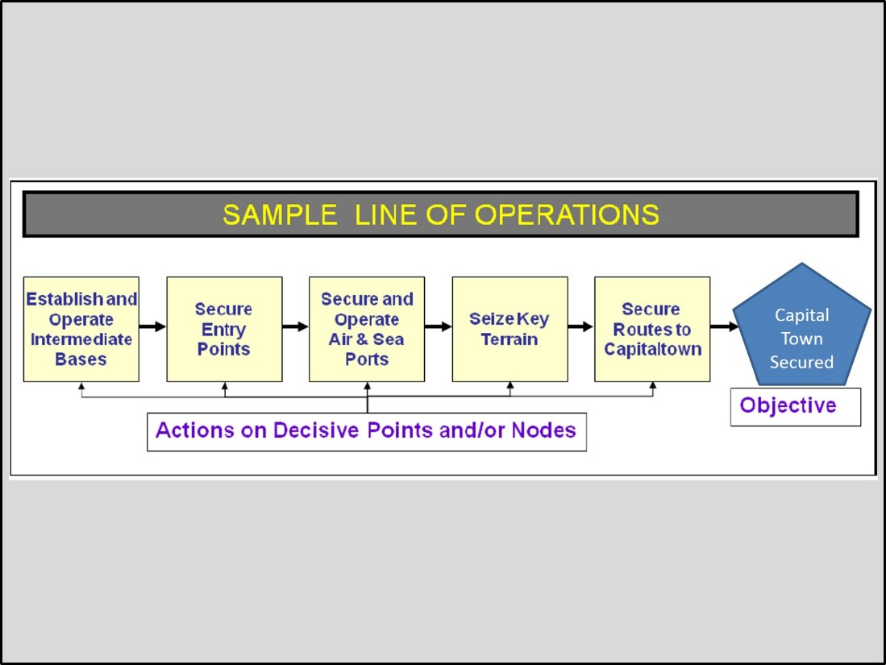
Figure 12: Sample Line of Operations
A Line of Effort links multiple tasks and missions using the logic of purpose – cause and effect – to focus efforts toward establishing operational and strategic conditions. It describes and connects the major efforts/actions of the campaign when positional reference to an enemy or adversary has less relevance or is insufficient to guide the conduct of the campaign. In contrast to a LOO, an LOE focuses more on depicting a logical arrangement of tasks, effects, and/or objectives, and helps the commander visualize and articulate the "logic of the campaign," i.e. how he might organize his major efforts over the course of the campaign to achieve synchronized, unified action. For this reason, LOEs are probably used as much as LOOs in contemporary campaigns. Figure 13 shows an example of LOEs as part of an overall operational approach to a campaign.

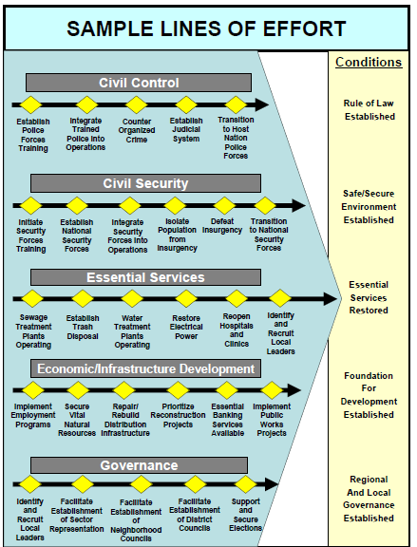
Figure 13: Sample Lines of Effort
(2) Determine likely effects on the OE of the potential approach. Recalling that operational design is iterative, the operational design team should go back to the environment frame to analyze the potential impacts of the approach on the environment. While the first order effects should be as expected (since the operational approach was developed to achieve those effects), the team must look carefully for potential undesired effects. Note any undesired second and third order effects and either modify the operational approach to mitigate those effects, or transmit those risks to the operational approach to planners and other interested parties in the effort.
d. Build the Operational Approach. The operational approach can help transmit to the planners and operations team not only the commander’s planning guidance, but also the logic for the guidance. The operational approach is a synthesis of all three frames and should include graphical representations and narrative descriptions of the logic behind each frame. Products of the synthesized operational approach include:
- Text and graphics describing the operational environment.
- Commander’s understanding of higher guidance.
- Systems relationships diagrams that describe the environment.
- Key actor relationship diagrams.
- Description of what might cause key conditions to change.
- Description of the desired end state.
- Description of key aspects of alternative end states.
- The problem statement.
- Initial (or refined) commander’s intent that provides the general purpose and end state for the campaign. See page 68 for a description of commander’s intent.
- Initial commander’s planning guidance for a broad operational approach to solve the problem. The commander issues this guidance to his staff and subordinates to initiate the planning process. The planning guidance focuses the staff’s efforts, links desired end state conditions to potential combinations of actions, identifies elements of risk, and provides any other information that the commander thinks will enhance staff focus. Page 70 contains a more detailed description of commander’s planning guidance.
6. Organizing for Operational Design Work. There are many ways to organize to do operational design work. The way that works for your organization depends on several aspects: the organizational climate; the degree to which the commander will be involved in the operational design work; the size, experience, and training of the staff; the amount of time available; and the degree of complexity of the problem. The team should be large enough to enable a range of diversity of perspective, but not so large as to preclude achieving some consensus on issues to keep the process moving forward. Diversity of perspective and subject matter expertise should be solicited as needed to inform and broaden the discourse. Generally, higher level headquarters will have more staff and more time available, and will deal with greater levels of complexity than lower level headquarters. This suggests a larger team with more diverse representation.
a. Roles. To enable the proper balance between broad discourse and progress (after all, the goal is to produce a usable concept), the design team leader may assign roles to team members:
- Someone to record the discussion and key results.
- Someone to capture ideas in graphical form (pens and whiteboards work well for this, especially when framing the environment).
- Someone to think about and develop metrics to test insights.
- Someone to facilitate the team discussion.
- Someone to play devil’s advocate to question assumptions (though all members must keep this in mind).
- Someone who ensures the feasibility of concepts discussed (again, this is the responsibility of all design team members).
b. Challenges. An operational design team will face several innate challenges, some of which will lessen as the team works together:
- Getting the dialog going and moving in a meaningful direction.
- Developing effective open-ended questions to stimulate thinking.
- Ensuring all planners contribute their thinking despite the differences in rank among the team members.
- Helping people "break free" of their conceptual anchors and preconceived ideas.
- Guiding the dialog without limiting it; avoiding rambling but still staying open to new perspectives.
- Recognizing when the team is unnecessarily “in the weeds” (worried about details) and getting out of those weeds.
- Managing team members who are disruptive, dismissive, or domineering.
- Balancing input across the team.
- Helping the team to converge eventually to a decision.
c. Some tips for leaders of operational design groups:
- The commander must be directly involved.
- Dedicate time and limit interruptions.
- Avoid jumping directly to the solutions without exploring the environment and problem frames.
- Just dialogue for a while before you write anything down.
- Carefully manage your own information and ideas initially to encourage others to participate.
- Refrain from advocating a position if you are the group leader.
- If necessary, the leader can initially play the role of devil’s advocate to encourage a climate of productive and respectful openness (but then pass this role to another member of the team).
- Ask probing questions that elicit assessment and reasoning.
- Ask open-ended questions rather than yes/no questions.
d. Tools and Techniques. The following are tools and techniques from ATP 5-0.1 Army Design Methodology, 1 July 2015, and represent ways in which commanders, planners, and other leaders can actually use operational design. These tools and techniques have equal utility within Service and joint doctrines.
(1) Brainstorming and mind mapping. Brainstorming is a group creative thinking technique that uses the different perspectives of individuals in a group to develop and build on ideas. Used effectively, it will generate a large quantity of ideas while avoiding the immediate judgment of the relative value of each. A technique for brainstorming involves a divergent thinking phase where members of the planning team attempt to answer key “focal questions” about the environment or problem followed by a convergent phase where the group then culls the different answers or thoughts into categories which can then generate further dialog and/or mind mapping. Outliers are carefully considered by the group for much greater investigation or are possibly irrelevant and discarded. The use of sticky notes and a white board are ideal for this technique. Figure 14 below shows an example.

Figure 14: Brainstorming

Mind mapping is a technique for discerning and depicting the relationships of relevant phenomena, variables, and actors in an operational environment or complex problem. A technique for mind mapping begins with a single idea, actor, or topic represented in the center of a white board or paper (for example insurgent recruitment). The planning team then writes out secondary and connected ideas, phenomena, actors, or words associated with insurgent recruitment using lines, symbols, pictures, and colors to show relationships. As the planning team builds and expands the mind map on the white board, it continues dialog to broaden and deepen the members’ understanding of the growing mind map. At some point, the team should refine the “map” and develop an accompanying narrative that captures the members’ synthesized understanding of the environment and/or problems. This synthesized understanding will help shape the operational approach portion of operational design. Figure 15 below shows an example.

Figure 15: Mind Mapping
(2) Meta-questioning and four ways of seeing. These techniques are individual and group thinking techniques that can be used by the planning team while conducting mind-mapping or other operational design activities. Meta-questioning is a critical thinking skill that enables a more complete understanding of a topic by asking higher order questions. A way to understand the concept of meta-questioning is by thinking of the different views one gets from different levels of a ladder. An individual’s view is somewhat restricted when standing next to a ladder. However, as the individual takes a few steps up the rungs of the ladder, the view becomes broader. This is true of meta-questions. As individuals or groups ask and answer successively higher order questions, their understanding should become broader and more comprehensive. Examples of meta-questions include:
- Why did it happen?
- Why was it true?
- How does X relate to Y?
- All reasoning depends on the idea that X is the source of conflict. Why is reasoning based on X instead of Y?
- Are there other possibilities?

In the four ways of seeing technique, the planning team seeks to broaden and deepen its understanding of the environment or problem specifically by looking at them through the eyes of the adversary(ies) or other actors. For example, the planning team can answer the following about actors X and Y:
- How does X view itself?
- How does Y view itself?
- How does X view Y?
- How does Y view X?

Of course, there are many more possible questions about how X and Y above relate to the environment and/or problem that the planning team should ask when conducting operational design. These four are just a start. Finally, the techniques above are not necessarily stand-alone events that must be chosen at the exclusion of others. Indeed, the planning team should conduct many of them simultaneously or nearly so. It is ultimately up to the planning team and its leadership to determine which are used, for how long, and for what part of the design methodology. Ultimately, and when used in an iterative manner, they will contribute to a deeper and broader understanding of the environment and help shape a sound operational approach.

CHAPTER 4: Development of Theater Strategy
- Introduction.

a. Theater strategy is an overarching construct outlining a combatant commander’s vision for integrating and synchronizing military activities and operations with the other instruments of national power in order to achieve national strategic objectives (JP 3-0). Theater strategy is determined by CCDRs based on analysis of changing events in the operational environment and the development of options to set conditions for success. Developing theater strategy is about understanding the complexity of the environment, translating national level aims into desired conditions in the theater, and building flexible, adaptable approaches that will enable military means to work with other instruments of power to achieve the desired conditions.
b. The purpose of theater strategy is to clarify and exert influence over the environment of today to create strategic effects favorable to achievement of the desired environment of tomorrow. Theater strategy must be framed in terms that allow adaptability and flexibility to react to the changing environment, to seize opportunities, and to hedge against setbacks. CCDRs develop a theater strategy focused mainly on the desired end state (described by a set of desired conditions at the end of the considered timeframe) for their theater that will further national interests. A CCDR publishes a theater strategy, intended to serve as the framework for his theater campaign plan, which ties the ends, ways, means, and risk together and provides an action plan for the strategy.
c. In time of war, the President of SecDef may designate a theater of war, in which case a CCDR, or an assigned subordinate commander, may develop a theater strategy for the accomplishment of national or coalition aims within that theater of war. However, for the purposes of this chapter, our point of reference for developing a theater strategy by the CCDR is for his assigned AOR in the Unified Command Plan. Note that the thought process for developing a strategy for a theater of war would be very similar.
d. The policy-strategy dynamic. Strategy is always subordinate to policy. However, there is a two-way dependent relationship between policy and strategy. Though many in the military would like to be given clear policy aims and then be left alone to apply military power to achieve them, in reality, it does not work that way―nor should we want it to work that way. In fact, there is a dynamic between policy aims and strategy (use of the instruments of power to achieve the aims). Our military strategy must be clear and flexible to react to changing policy aims. The aims may evolve even as the strategy is being implemented and we see the effects – real and potential – of that strategy. Our policy may change in reaction to unanticipated opportunities or challenges. The role of the CCDR is to keep the national policy makers informed about changes to the environment that affect such policy decisions and to provide advice on the potential outcomes of changing the aims. Military commanders must be completely frank about the limits of what military power can achieve, with what risk, in what time frame, and at what cost. So, the CCDR must bridge the inevitable friction that policy and politics create when developing strategy.
- Sources of Guidance and Direction for Theater Strategy.
a. The combatant command translates national policy and strategy into military activity. The guidance to the CCDR formulating the theater strategy comes from a variety of sources -- none of them adequately definitive and comprehensive. Very often, the national policy and corresponding guidance is not clear-cut and often is not even formally published. This places a premium on the CCDR’s ability to interpret, analyze, and synthesize the many sources of such national intent, and then communicate this synthesis back to the national policy makers to ensure that he is in sync with their vision (in fact, he may actually shape their vision). One relatively clear source is the GEF, which, though certainly not complete, provides national guidance for prioritized theater end states. The JSCP further defines some of the objectives, lists some assumptions, and describes some of the resources available to the CCDR. The CCDR must understand the U.S. national security interests described in the National Security Strategy and the intended role of the military in supporting those interests as described in the National Defense Strategy, the National Military Strategy, and the Quadrennial Defense Review. The CCDR must stay attuned to evolving descriptions of and applications of our national interests as described by the President and other senior government officials since policy is ever-evolving. Perhaps most importantly, the CCDR must continually analyze his theater and the dynamic relationships within it to determine other conditions that describe the desired end state and present some limitations on ways to achieve that end state.
b. Identifying and collaborating with stakeholders. CCDRs must coordinate and synchronize their strategies and implementation activities with other stakeholders, to include non-DOD government agencies and other nations. One critical partner is the Department of State (DOS), which provides some guidance and many of the resources for the CCDR’s theater security cooperation program, which is vital to the implementation of the theater strategy. Clearly, the CCDR must ensure compatibility of objectives for the region between DOS and DOD. Similarly, other agencies, such as the U.S. Agency for International Development (USAID), routinely conduct developmental activities in countries of the region, requiring the CCDR to ensure synchronicity between military activities and USAID’s activities. The CCDR and staff will have to find ways to work through some OSD policies that inhibit formal coordination with non-DOD executive branch agencies. The CCDR should coordinate closely with our international partners, to include nations, international organizations, and non-governmental and private organizations. Though it is not always realistic to align goals and activities among all stakeholders, it is important to understand the purpose of the other activities, and to work towards mutual benefit when possible. On the other hand, the CCDR should be aware of activities by other non-U.S. organizations (and, in rare cases, U.S. organizations) that present obstacles to achievement of the theater strategy objectives. Formally, the CCDR works through OSD to reconcile and synchronize activities with other organizations, but an informal coordination network is also crucial to success. It is important to consider that non-military and international actors have legitimate agendas and will be active (sometimes the lead) players to a greater or lesser extent across the full spectrum of conflict.
- Components of Theater Strategy. A theater strategy consists of:
- Key factors of the environment that provide context for the strategy and affect the achievement of the desired ends in the theater.
- Description of the desired strategic end state (ends).
- Strategic approach to apply military power in concert with the other instruments of power to achieve the desired end state (ways).
- Resources needed to source the operational approach (means).
- Risks in implementing the strategy.

a. Environment. The CCDR must describe the current environment of the theater, as well as the desired environment that meets national policy aims. This provides the context for the strategy. While strategy is always subordinate to policy, it is also subordinate to the environment; that is, as the environment changes, so must the strategy. The CCDR and staff conduct a theater strategic estimate, which describes the broad strategic factors that influence the theater strategic environment. This continually updated estimate helps to determine the missions, objectives, and potential activities required in the theater. The estimate should address the following:
- Command’s mission.
- Capabilities available to and limitations facing the command.
- States or non-state actors in the theater (or outside of the theater) that may challenge the command’s ability to secure U.S. interests in the theater.
- Significant geo-political considerations.
- Major strategic or operational challenges facing the command.
- Known or anticipated opportunities that the command may be able to leverage.
- Risks inherent in the security environment of the theater.
b. Ends. The ends for the theater describe what the theater needs to look like to achieve the national aims as derived from various sources of strategic guidance. As noted above, the comprehensive aims will likely not be clearly and completely laid out in directive guidance to the CCDR, so he must combine guidance with his understanding of the environment to clearly describe the set of conditions in the theater environment that will further national interests. This set of desired conditions describes the desired end state. That desired end state, then, provides the context for understanding what aspects of the current environment must change or must remain the same. The CCDR must describe how achievement of the theater end state will support securing the national interests and specified or implied national aims.
Note that there is a difference between the desired end state and the theater objectives as we describe the theater strategy. While the end state is a description of those conditions necessary to support the national aims, theater objectives would describe the ways the CCDR will achieve the end state conditions. Some examples of end state conditions follow. Note that a condition is expressed as a state of being, not as an action.
- Free access to markets and resources.
- Protection of U.S. nationals.
- Support of bilateral and international treaties to which the United States is a party.
c. Ways. The strategy’s ways describe the strategic approach to achieving the end state. This strategic approach should describe in general how resources (means) will be applied to achieve the desired conditions. The most critical aspect of developing the strategic approach is proper identification of the objectives, accomplishment of which will create the strategic effects required to achieve the desired end state conditions. The CCDR is primarily concerned with military objectives. Some of these military objectives may achieve a condition or conditions on their own, while others may support other actors’ objectives as they apply non-military instruments of power to achieve conditions. An objective should be expressed as an action, with a verb.
- Support regional stability through development of a regional mutual defense relationship.
- Develop bilateral support relationships with Country X.
- Contain the aggressive tendencies of Country Y.
- Promote transparency of military activity with Country Y.
- Increase capacity of Country X’s military forces.
- Promote a healthy civil-military relationship in Country Z.
The strategic approach also describes the general activities needed to accomplish the objectives (which, in turn, achieve the desired theater conditions). The strategic approach should be explicit enough to provide sufficient guidance to planners, but not so detailed as to inhibit their creativity. One way to lay out the strategic approach is to develop lines of effort that lead to accomplishment of the objectives. LOEs should also consider potential second and third order effects that will cascade towards achievement of other strategic effects. The strategist must also anticipate potential undesired effects and work to avoid or mitigate them. The Capstone Concept for Joint Operations (CCJO) is a useful source in describing some typical ways in which military power can be applied to accomplish objectives. Since some military objectives support other actors’ objectives, it is critical that the objective and its supporting line of effort be closely coordinated with the other pertinent actors.
In describing the ways, keep in mind that not all resources are readily available. Part of the purpose of building the strategy is to identify shortfalls in required resources. On the other hand, if there is no reasonable expectation that a gapped resource may become available, then you have an infeasible strategic approach, resulting in an unbalanced and hence risk-prone strategy. In any case, the potential effects of any gap in required resources must be described in the risk assessment, discussed below.
d. Means. Means are the resources necessary to support the strategic approach. Resources may be tangible (such as military forces, foreign military financing, or seats in U.S. schools), or intangible (such as cultural appeal, goodwill from previous activities, or fear of invasion by another country). The theater strategy addresses the use of all available instruments of power, with a particular focus on how military power can be employed in concert with the other instruments. The CCDR should consider all instruments that are available or may be made available in developing the strategy. He should attempt to reconcile the gap between those that are available and those that are needed but are not yet available. Note that some of the resources available may be from non-U.S. actors. The strategic approach will likely include ways to use these non-U.S. instruments of power or develop them. If there is not a reasonable expectation that the required means will become available, then the CCDR must develop another way to accomplish the objectives within the means that are available or can reasonably become available. If there is no possible way to work within the means, then the CCDR must adjust the objectives of the strategic approach. After adjusting the theater objectives, if there is still no alternative approach that can achieve the desired conditions, then the CCDR must go back to the national policy makers and show how the national aims cannot be met, to reassess the national policy.
e. Risk. The strategist must weigh the potential advantages and disadvantages of the strategy in terms of risk. He must ensure a proper balance between ends, ways, and means, as discussed above. At that point where constraints on the strategic approach or on the means available to execute that concept risk achievement of the end state, the strategy is in jeopardy.
Additionally, the CCDR must conduct a risk analysis of the strategy, with the purpose of managing the risk. There are two components to this risk management: risk avoidance and risk mitigation. Risk avoidance comprises those measures the CCDR can take to reduce the probability of an undesired condition or event happening. Risk mitigation comprises those measures the CCDR can take to reduce the impact of an undesired condition or event. The CCDR should include both risk avoidance and risk mitigation measures into the strategic approach. Nonetheless, the CCDR must ensure that policy makers and other actors understand that there will still be some unavoidable elements of risk to the strategy.
- Using Operational Design for Building a Theater Strategy. Developing a theater-level strategy requires an approach that allows the JFC and staff to gain an understanding of the complexity of the environment, translate national level aims into desired conditions in the theater, and build flexible, adaptable approaches that will enable military means to work in concert with other instruments of power to achieve the desired conditions. As discussed above, the dynamic between policy and strategy demands that strategy be built to provide flexibility both to react to changes in policy and to advise policy makers as to the feasibility and potential effects of the policy.
Current joint doctrine does not provide a definitive method for developing theater strategy. The Joint Operation Planning Process (JOPP), described in JP 5-0 and in a later chapter of this handbook, provides a systematic process to develop a plan, but focuses on development of courses of action to accomplish a specified mission. Planners can use a process such as JOPP to guide development of the theater campaign plan, but the strategy that underpins that campaign plan must be clearly understood and communicated first. Operational design as described in Chapter 3 provides a way to think through the complexity to build the strategy. While operational design can help planners work the conceptual aspects of any plan, to include a campaign plan, it is especially suited to the development of theater strategy, which must inherently deal with complexity and a multitude of unfamiliar and ill-structured problems.
The methodology described below adapts operational design as described in Chapter 3 to work for the development of the theater strategy. Though some of the words are different, the principles are the same. It is especially true for theater strategy that the operational design approach must continue well beyond the initial development of the strategy to constantly assess the impact of the strategy on the environment, in order to reframe the strategy as needed during execution.
a. Frame the Theater Environment. In considering the environmental aspects of the theater, the CCDR analyzes the current environmental conditions, to include existing guidance, and determines what the desired future environment should look like. The CCDR also considers what those opposing us (or are neutral) may desire as end state conditions. Other interested parties should be invited to participate in the dialogue to frame the environment in order to gain as wide an understanding as possible. A secondary benefit of this inclusion is to gain potential buy-in for the eventual strategy by other relevant actors. Some big questions that this framing is intended to pursue are:
- What are the key actors, relationships, other factors, and trends in the theater?
- What is causing conflict among the actors in the theater and from outside the theater?
- What are the key historical and cultural aspects of the environment?
- How can our national interests be affected in the theater?
- What specific guidance have we been given? Implied guidance? Is there any conflicting guidance?
- What aspects of the current and projected situation in theater are desirable and undesirable?
- What do we want the theater to look like (conditions) in five/ten years?
- What other actors have interests in the region that may present opportunities or challenges? What do other actors want the theater to look like?
- What conditions are likely to emerge in the region if parties outside the region take no action?
- What conditions are not acceptable to us that others may want to see?
- Whom can we count on for support?
- What limitations/opportunities might there be in garnering applicable instruments of power (DIME)?
- Who should we be concerned about as potential opposition to our desired end state and why?
(1) Describe the current environment. This effort is described in the previous chapter. At the theater level, it is critically important to consider the impact of history and culture on aspects of the environment. To understand the essence of the environment that will affect the strategy, the analysis should enable a dialogue on how the various systems interrelate. Identification of the relevance and impact of key relationships between the many state and non-state actors are extremely important in this analysis and synthesis. Finally, there must be a clear understanding of how U.S. national interests are affected by the theater environment.
(2) Determine the tendency of the OE. Based on an understanding of the current environment, project the environment into the future to determine its tendencies that we need to affect. This will help describe the desired end state, as we want to capitalize on opportunities presented by the natural tendencies wherever possible. Since the theater campaign plans generally look out 5-7 years, the logical projection of the environment should be 5-7 years. If there are anticipated major milestones in the interim, or aspects of the environment that are of longer term consideration, consider multiple projections of the tendency of the OE.
(3) Analyze guidance. These may be written directives; oral instructions from the President, SecDef, or CJCS; Presidential or Cabinet-member speeches; domestic and international laws; policies of other organizations that have interest in the theater; or existing strategic estimates (ours or other parties). Some of the guidance may be contradictory and should be clarified and confirmed. One key source of guidance is the GEF, which provides an initial summary of desired conditions for the theater. It is likely that the CCMD will have recent perspectives on the theater that will enable a reconciliation of guidance, to include the biennial GEF. One challenge in reconciling the various sources of guidance is in the varying timeliness of the guidance. It is important to include members of the policy-making apparatus in this dialogue to help gain insights, as well as to reconcile the differences in interpretation of the various forms of guidance among both policy makers and the CCDR.
(4) Analyze available DIME power and limitations. Gain an understanding of what instruments of power that can be brought to bear by the United States or by other parties that we may be able to influence.
(5) Determine the desired end state for the theater. Describe the key conditions that must exist in the future OE to achieve the national aims. Focus on military conditions, but do not exclude other conditions that may impact the military conditions or achievement of which military activity may support (or potentially interfere with). Get a sense for the realistic timing for achievement of these conditions: 1 year, 5 years, sometime far into the future? Review the relationship between national and theater end states from the previous chapter.
(6) Determine alternative end states. Other actors have interests in the theater and may well have significantly different desired end states. There may be adversaries with opposing desired conditions to ours. There are likely to be other actors, not really adversarial, that have different aims or objectives that will have second or third order effects which can complicate our strategy. We need to understand these, so that we can either work with or try to influence those other actors.
b. Frame the problem set that the theater strategy must solve. The commander tries to understand further the environment and the context for the theater strategy by trying to describe the set of problems that must be solved. This problem set starts with identifying the differences between the conditions that we want to see at end state and those that others want to see, and also between our desired conditions and those of the natural tendency of the environment. Think of the natural tendency as another actor, in fact, likely the most powerful actor. These comparisons between our desired conditions and the alternatives describe the relevant tensions in the environment. We restate this set of differences, then determine which of the differences must be reconciled, which of the differences are important but not imperative and can be mitigated, and which of the differences may be too difficult to reconcile and may therefore cause us to change our desired end state. We also identify the points of congruence between our desired conditions and others’ desires. Those points of congruence offer opportunities that, if exploited, can help us achieve our desired conditions. Some of these opportunities are significant enough that they should also be part of the problem description.
Though identifying the root causes of problems in the theater is certainly important and is part of the calculus, it is not the end of the problem framing. We may find that we cannot solve the root causes, and can only mitigate the effects of the root causes on our strategy. So, we are trying to define that set of problems that our strategy must solve to meet our desired conditions.
The commander may see that the tensions are too great and the opportunities too few to be able to achieve a particular desired condition or set of conditions. In that case, the commander may see a need to adjust the desired end state. In this case, he is obligated to dialogue with the national policy makers to reconcile the differences from their vision.
Commanders may ask questions like:
- What are natural tendencies of the environment that will pose challenges to achievement of our desired conditions?
- What are the differences between our desired conditions and those of other actors?
- Which of all the identified tensions will preclude us from achieving our end state conditions?
- What are the similarities between our desired conditions and those of others?
- Which similarities between other actors’ desired conditions and ours offer opportunities for synergy in achieving our desired conditions?
- What are natural tendencies of the environment that we can use to help achieve our desired conditions?
- What are strengths and weaknesses of the various key actors that will affect how we can reconcile the differences?
- What needs to change?
- What doesn’t need to change?
- What are the opportunities and challenges?
- What are the risks to achieving the desired conditions? What are the unintended long-range consequences of achieving our desired conditions?
- What is the reasonable timing for achieving the desired conditions? Do we need to have different short- and long-term timelines?
Our goal in framing the problem is to describe the problem set concisely and completely. It should include the major condition sets with a time aspect. This problem statement is the one that the operational approach must answer. An example of a problem statement for a theater strategy might be:
Stability in the ORANGECOM AOR must improve within the next five years to create conditions for market economies to thrive without fear of military action, and to dissuade aggressive behavior by Country Y, while precluding influence in the region by Country Z that puts at risk U.S. economic and security interests.
c. Develop the strategic approach. The strategic approach describes how the problem will be solved. It is detailed enough to provide direction and bounds for those implementing and supporting the strategy, but not so much that it precludes creativity by those implementers. The purpose is to outline the way to achieve the desired theater end state. It is important to understand that in the volatile and complex theater environment, the operational approach is only a hypothesis to answer the problem. Thus, the approach must include flexibility to adapt to a different approach if the hypothesis is shown to be incorrect as the strategy influences the environment.
In developing the strategic approach for a theater strategy, commanders might ask questions like:
- What distinguishable, measurable objectives will let us achieve our desired conditions and prevent the other actors from achieving competing conditions?
- What is preventing us from accomplishing the objectives?
- How can we exploit natural tendencies to achieve our conditions?
- What opportunities might allow us to achieve objectives? Are there points of convergence of our problem with others’ problems?
- How might we shape the environment to make our desired conditions appealing?
- What are key events, activities, or states of the environment along the way that will either enable us to or preclude us from achieving our desired conditions?
- Is the problem we described achievable? If not, how can we reframe it?
- What are the lines of effort that we might use to organize our activities?
- What else might happen as a result of our activities?
- What are the risks of this approach? Can I avoid or mitigate those risks by adjusting the approach?
(1) Develop objectives that will address the problem set. Determine the set of objectives that will enable the required conditions of the theater end state by reconciling those aspects of the environment that may preclude achievement of those conditions, especially those opposing desired conditions of other actors. This set of objectives must consider the tendencies of the environment and the challenges presented by other actors as they work to achieve their desired conditions. The objectives should be focused on the stated problem, and should consider four areas: key actors, key relationships, managing tensions between actors, and managing opportunities presented by the convergence of desired conditions among actors. Some examples of theater objectives are:
- Assist regional countries in organizing a military cooperation forum.
- Assist in professionalizing the security forces of Country R.
- Establish a bilateral military relationship with Country S.
- Maintain freedom of navigation in the Gulf of Blue.
(2) Build a strategic concept that will link the objectives together in such a way as to achieve the desired conditions. One way to build the concept is to determine decisive points that must be dominated to accomplish the objectives. Decisive points describe the specific aspects of the environment that must be acted on to accomplish the objectives. Control of decisive points can be thought of as intermediate objectives. Note that control of decisive points may support accomplishment of more than one objective, either directly or indirectly. See the section on developing decisive points and LOE/LOOs from the previous chapter.
(3) Link the decisive points together to accomplish campaign objectives through lines of effort. These lines of effort will be the framework to which planners and implementers will attach specific activities and resources. Keep in mind the resources that are available or likely to become available. Note the needed resources as you build the lines of effort.
(4) Capture the strategic approach in a narrative that forms a hypothesis for the operational approach ("if we do this, then we will solve the problem we defined"). Supplement the narrative as needed with graphics of the lines of effort.
(5) Analyze the strategic approach. First, determine if the available and potentially available resources are sufficient to source the strategic approach. Second, determine if the strategic concept will accomplish the objectives. Third, determine if the objectives, when accomplished and if sequenced properly, will achieve the conditions that describe the desired theater end state. Look for second and third order effects of applying resources and of accomplishing objectives to find any places where the strategic approach may produce effects that complicate achievement of our desired conditions. Where you find these friction points, look for ways to avoid or mitigate the undesired effects. Last, identify those remaining elements of strategic risk and discuss them with the national leadership. Some questions the CCDR may ask to conduct a risk assessment of the strategy are:
    - What are the probable consequences of success and failure of the strategy?
    - What assumptions were made in this strategy and what is the effect if one of them is wrong?
    - What effect would a change in certain aspects of the environment have on the strategy?
    - How will other actors react to certain activities of the strategy, and what happens to the strategy if they take unfavorable actions in reaction?
    - What is the balance between intended and unintended consequences (effects) of our activities on the strategy?
    - What mitigating activities will reduce the impact of unintended consequences of our activities?
5. Theater Campaign Plan. The theater campaign plan (TCP) flows from the commander’s theater strategy and provides the action plan to implement the strategy. While each combatant command’s campaign plan may approach the task of operationalizing the strategy differently, a GEF-directed TCP will address the commander’s AOR in an interconnected and holistic manner and seek to avoid a myopic focus on one or two stove-piped contingency plans. The current construct for nesting plans for a theater is first to build a campaign plan that implements the activities required to achieve the desired conditions for the theater from a comprehensive, proactive, and integrated strategy, then deal with deviations from the strategy as branches requiring contingency plans. The TCP should:
    - Describe the theater environment.
    - Describe the desired military and associated conditions for the theater in the timeframe covered by the strategy.
    - Address the use of all instruments of power, but be specific about the role of the military instrument in the strategy.
    - Describe the military objectives that will support achieving the desired conditions for the theater.
    - Describe the current and required force posture for the theater, and identify elements of risk in the gap between current and required forces.
    - Prioritize activity among subordinate components.
    - Link security cooperation activities to specific objectives.
    - Describe branches to the TCP that require contingency plans and describe the connectivity between the day-to-day activities of the TCP and the various contingency plans’ Phase 0 (shaping) activities, such as setting the theater for successful contingency plan execution should it be required.
6. Components of a Theater Campaign Plan. The GEF and JSCP mandate some of the elements that must be included in a TCP, but there is no prescribed format for a TCP. In fact, several of the GCCs use a slightly different format, and even the substance of the various TCPs differs, though all generally address the key requirements directed by the GEF/JSCP.
a. Current strategic guidance directs that TCPs include the following:
- Initial Theater Assessment. Where we are today. Describe threats, challenges, opportunities, and theater trends. Identify assumptions that will inform further planning and the risks they bring. Identify critical partners and actors of concern.(these terms are no longer used in the GEF/JSCP).
- Mission Statement. Outlines the essential tasks and the who, what, where, when, and why to achieve the campaign plan’s main objectives. the how these objectives will achieve the desired end state conditions.
- Posture Plan. Outlines the forces, footprints, and agreements within each AOR and how the CCDR intends to synchronize these to achieve his campaign objectives. Concept of Engagement. Describes the strategic approach. Includes priorities for theater shaping, force posture and access, capacity building, and steady-state operations supporting partner nations and regional stability. Describes the lines of effort to achieve objectives.
- Intermediate Military Objectives. Describes the milestones to achieve the TCP’s campaign objectives. end state conditions. Serves as the basis for tasks to subordinate organizations and requests to other partners to accomplish tasks.
- Country-specific Security Cooperation Sections (CSCS). CCDRs should produce one of these sections for each country in his AOR depending on the size and significance of the security cooperation program for that country. They will directly support the accomplishment of the CCDRs’ IMOs and the U.S. Ambassadors’ ICSs. Coordinating Instructions. Discuss authorities, agreements, operational limitations, assumptions, and strategic communication themes. Describes the context for how to achieve the Intermediate Military Objectives.
- Resources. Describes forces required and funding programs. Describes the impact of resource shortfalls in terms of strategic and operational risk, and possible mitigation measures.
b. Relationship of the Theater Campaign Plan to Contingency Plans. The GEF and JSCP may direct development of specific contingency plans to deal with potential crises in the region. The CCDR may also direct preparation of contingency plans to deal with potential failures of the steady-state TCP. One example might be a plan to remove the regime of Country Y and restore stability in the region. Such a plan is likely to be a subordinate campaign plan that would link several major operations together to achieve the campaign end state. Another example of a contingency plan might be a plan to conduct a noncombatant evacuation operation (NEO) in the event of instability in a country. Such a plan would probably be a single operation plan, rather than a subordinate campaign plan.
The TCP should identify the likely conditions that might initiate a contingency plan. Execution of a contingency plan should either bring the situation back to the TCP’s desired conditions, or cause a revision of the theater strategy due to the changed environment. Phase 0 (shaping) of a contingency plan provides the direct linkage between the steady-state TCP and the contingency plan. Phase 0 activities are those shaping activities that are designed to dissuade or deter potential adversaries and assure friends, as well as to set conditions for the contingency plan (such as infrastructure building) and are generally conducted through security cooperation activities. There is a very delicate, sometimes only incremental, balance between the steady state TCP and Phase 0.
c. Theater Security Cooperation and the CSCS. The CSCS is an integral component of the TCP that describes the security cooperation and assistance activities in detail: who, what, where, when, why, and the source of the fiscal resources for each activity. This plan is dynamic, as activities and their purposes must adapt as both conditions and resource availability change. The very nature of the many security cooperation activities, which often span multiple objectives and outcomes, contributes to the theater campaign plan’s goal of a cohesive framework. Some of the FCCs may also integrate security cooperation plans into their functional campaign plans. FCCs must be very conscious of coordinating their plans with those of the regional GCCs. Security cooperation activities include the following 10 focus areas:
(1) Operational Access and Global Freedom of Action. Gain unfettered access to and freedom of action in all operational domains. Support global defense posture realignment and larger U.S. political and commercial freedom of action and access needs.
(2) Operational Capacity and Capability Building. Build usable, relevant, and enduring partner capabilities while achieving U.S. and partner objectives.
(3) Multinational Operations Capacity, Interoperability, and Standardization. Develop operational and technical capabilities, doctrine, and tactics, techniques, and procedures with partner nations to enable effective combined operations or improve a collective defense capability.
(4) Intelligence and Information Sharing. Gain and share specific kinds of intelligence or information and developing shared assessments of common threats.
(5) Assurance and Regional Confidence Building. Assure allies and partners, enhance regional stability and security, reduce the potential for inter- or intrastate conflict and international consensus building, and expand the community of like-minded states dedicated to more peaceful and secure international order.
(6) Institutional Capacity and Security Sector Reform. Assist allies with transforming their defense/security establishments to become publicly accountable, well-managed, and subject to the rule of law.
(7) International Armaments Cooperation. Promote technological collaboration, foster mutually beneficial exchanges of technology and defense equipment, gain access to foreign technology, and reduce the overall cost of defense to the U.S. taxpayer.
(8) International Suasion and Cooperation. Build cooperative political-military relationships with key security influencers and offset counterproductive influence in key regions and international organizations.
(9) Human Capacity and Human Capital Development. Conduct SC activities that enable the ability of partner country civilians and military personnel to understand the proper role of the military in society, promote human rights, and respect the rule of law.
(10) Support to Institutional Capacity and Civil Sector Capacity Building. Help develop the ability of partner country civil sector organizations to provide services to their populations, respond to humanitarian disasters, and improve the living conditions of their populations.
d. Theater Posture Plan. The Theater Posture Plan is usually an annex to the TCP that describes how the theater is currently prepared to meet the objectives of the TCP. GCCs update the Theater Posture Plan annually and submit it to the Joint Staff and OSD. The latter office then prepares an annual global defense posture synchronization report that enables coordination of department-wide activity across the global lines of effort. The Theater Posture Plan includes topics such as:
- A footprint diagram showing the force lay-down and describing any host-nation relationships and agreements.
- Identification of ongoing or new initiatives to further theater objectives.
- Proposed costs to implement any required posture changes.
- Identification of risks to assured access in the region and associated mitigation plans.
- Any required deconfliction with other DOD or other agency activities.
- Supportability of global reach in support of contingency plans (own theater, other theaters, functional plans).
e. Assessment. In the end, the theater strategy is successful if it achieves the desired conditions for the theater. The TCP must lay out the plan to assess whether the strategy is doing so. While lower level plans may focus primarily on quantifiable measurements of inputs (application of resources) and outputs (progress toward goals), the most useful assessments at the theater level are outcome-based. These assessments focus on strategic effects, which directly impact achievement of end state conditions. An example of an outcome might be that a regional nation has rejected overtures by another competing global power to enter a bilateral security agreement.

(1) Objectives determine effectiveness, while the ways to apply resources determine efficiency. As objectives are accomplished, are they moving the conditions forward toward the desired end state? This progress is critical, as implementation of the strategy changes the environment, and so the intended effects of accomplishing objectives may no longer really help achieve the desired conditions, or the desired conditions may need to change. Thus, the CCDR must reassess and reframe the strategy constantly to reflect the changing environment.

(2) A lack of efficiency increases the costs of implementing the strategy, while a lack of effectiveness precludes the success of the strategy at any cost. At first glance, this may cause us to place more emphasis on measuring effectiveness, but both aspects are important, since a strategy may become unacceptable if it is inefficient in its execution.

7. Supporting Plans. The CCDR will likely develop other plans nested under the TCP to support other combatant command plans, either GCC theater campaign plans or FCC functional campaign plans. These plans may be supporting campaign plans, or may be specific operations plans supporting other theater or functional campaigns or operations. Alternatively, the CCDR may elect to include these supporting plans within his TCP. A good example of the use of this alternative might be the integration of the CCDR’s operations in support of the functional campaign plan for war on terrorism.

THIS PAGE INTENTIONALLY BLANK

CHAPTER 5: Joint Operation Planning Process
1. Introduction. We develop plans for campaigns through a combination of art and science. The art of operational design enables us to continuously understand the environment of the campaign, visualize the problem that the campaign must address, and develop a "running hypothesis" for an operational approach to solve the problem. Commanders must transmit their vision, to include their view of the operational approach, to their staff, subordinates, partner commands, agencies, and multinational/non-governmental entities so that their vision can be translated into executable plans. The science of planning facilitates this translation by applying the rigor of coordination and synchronization of all aspects of a concept to produce a workable plan. While we have well-documented and practiced ways to work the science of planning, until recently, there were few equivalents to conduct the art of planning. Operational design offers a way to think through the conceptual work of planning. Commanders must use such an approach, but planners can also use operational design to complement the structured process of the Joint Operation Planning Process (JOPP).
JOPP provides a structured process to formulate a mission, develop appropriate courses of action to accomplish the mission, and coordinate and integrate the details of a plan to execute the selected course of action.
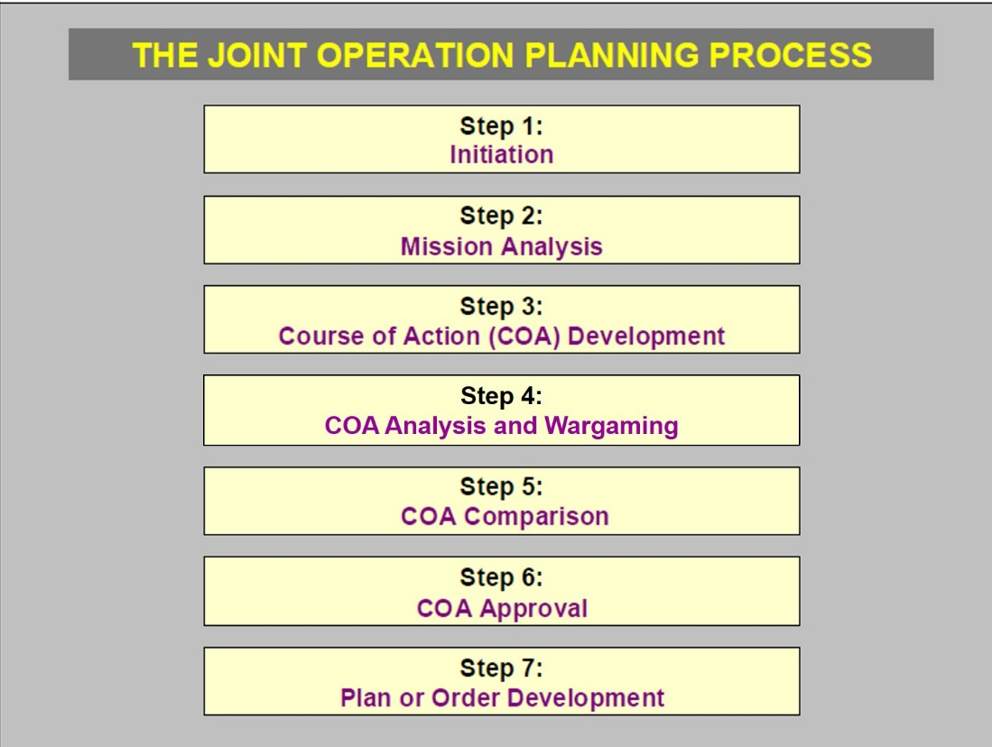
Figure 14: The Joint Operation Planning Process
Campaign planning is conducted as part of a comprehensive national effort. This means that in some cases military activity will be a supporting effort to other instruments of national power, while in other cases military activity will be the supported effort. In both cases, the commander is responsible to build a military campaign plan that he integrates with the other instruments of power. If the military is the supported effort, the joint force commander will normally lead the coordinated efforts. If the military is the supporting effort, the JFC must closely coordinate with the designated lead organization to ensure that the military plan is nested with the supported plan. This will require collaboration with many other actors to assist them in developing their plans (while enriching our own), to include when the military is the supporting organization.
2. Initiate Planning. Upon receiving strategic guidance from higher headquarters, or as directed by the commander, the staff begins the JOPP by initiating planning. The commander will likely form a Joint Planning Group (called an Operational Planning Group or Operational Planning Team in some commands) to focus on the mission.
Figure 15: JOPP Step 1 – Initiate Planning
If the commander anticipated the mission, he would likely have already begun work to understand the situation using operational design. He may have developed an understanding of the environment and problem and formulated an operational approach that he will provide to the staff as initial planning guidance. If he has not anticipated the mission, he will quickly develop initial planning guidance to get the staff working, then continue his own operational design to provide more detailed guidance as he better understands the mission.
The staff must conduct some preliminary actions before they can begin planning. They should look for existing staff estimates that relate to the current situation, as well as existing intelligence products from the various agencies. They must understand the impact of time…How much time is available to develop a plan? When must intermediate products be ready for review? What is the readiness status of forces that may be affected, and do any of them need to begin movement now to support execution of the eventual plan? They determine who should be involved in the various aspects of planning, to include appropriate multinational partners and representatives of other USG agencies. They should also consider who the other interested parties are that may help formulate the plan, or should be brought in to achieve their buy-in or knowledge of the plan.
The start point for the contingency plan is the Theater Campaign Plan. Likewise, the end state for the contingency plan should be a return to the desired conditions of the TCP. Some contingency plans, however, cause such a shift in the environment that a revised theater strategy is required.
3. Conduct Mission Analysis. The staff analyzes the mission to: 1) provide a recommended mission statement to the commander, and 2) to inform the commander’s initial analysis of the environment and the problem. This helps him refine his operational approach. As the staff presents analysis on both the requirements and potential points of focus for the campaign, they enable the commander to develop his vision further to use synchronized, integrated military operations as a part of unified action. He can then provide detailed planning guidance to his staff and share his vision with his counterparts to enable unity of effort in application of all of the instruments of power across the U.S. government and our international partners. Concurrently, the J-2 leads the initial steps of the Joint Intelligence Preparation of the Operational Environment (JIPOE) to describe the potential effects of the OE on operations, analyze the strengths of the enemy/adversary, and describe his potential courses of action.
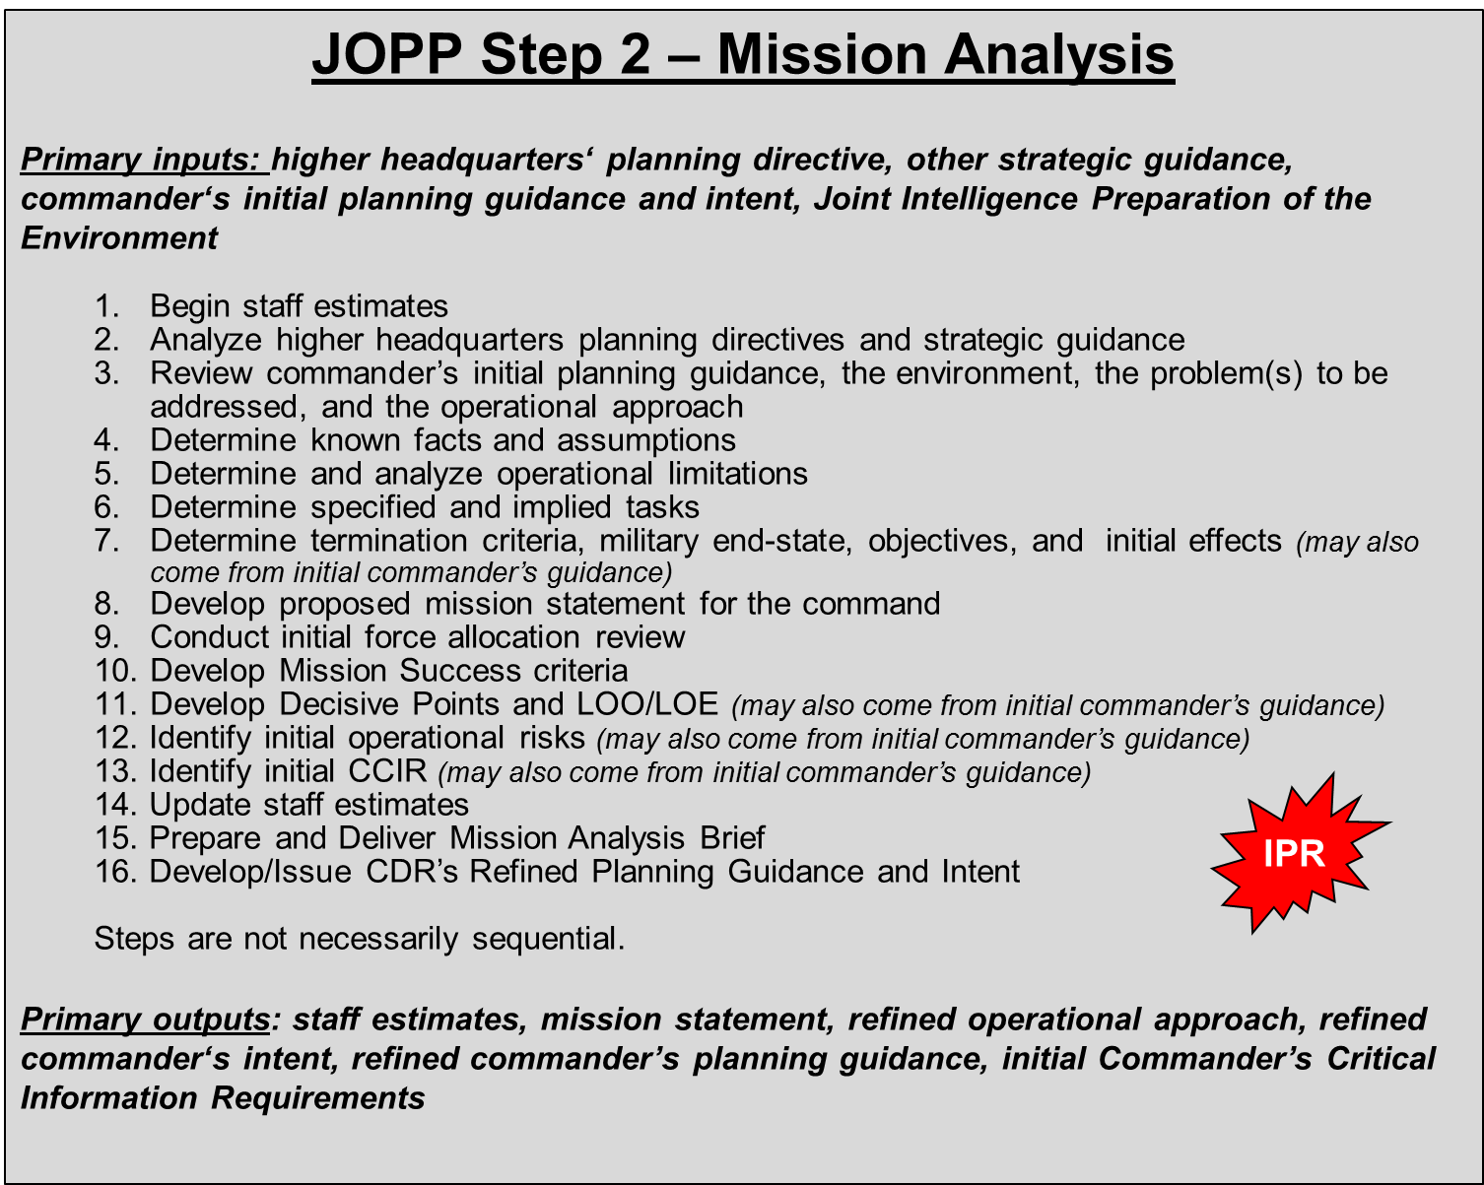
Figure 16: JOPP Step 2 – Conduct Mission Analysis
a. Begin staff estimates. Each staff section develops a staff estimate that is a running assessment of current and future operations to determine if the current operation is proceeding according to the commander’s intent and if future operations are supportable from the perspective of that staff section’s function. The estimate focuses on supportability of the potential mission from that staff section’s functional view. This estimate helps the staff provide recommendations to the commander on the best COA to accomplish the mission. The staff estimate also provides continuity among the various members of the staff section. If the staff has not already begun a staff estimate by this point, it should do so now.
The estimates are also valuable to planners in subordinate and supporting commands as they prepare supporting plans. Although the staff can delay documenting the estimates until after the preparation of the commander’s estimate, they should send them to subordinate and supporting commanders in time to help them prepare annexes for their supporting plans.
b. Analyze higher headquarters planning directives and strategic guidance. Much of the work of this step is done in the commander’s framing work as he looks at the operational design of the campaign. The staff must start with the commander’s understanding of the environment and the framing of the problem, while reviewing guidance received from higher headquarters and other relevant actors. The staff will first focus on the end state and objectives. The end state gets to the "why" of a campaign plan and seeks to answer the question, "How does the U.S. strategic leadership want the OE to function at the conclusion of the campaign?" Objectives normally answer the question “What needs to be done to achieve the end state?” We must also understand the desired conditions of the next higher headquarters end state – and their objectives – so that we can understand what our campaign must achieve. See a description of the relationship between end state, termination criteria, and objectives in Chapter 3.
Answering the "why" and "how" questions of the higher headquarters is different at the theater strategic level when compared to the operational and tactical levels. Often, there is no clear, definitive guidance collected in one location. There is no "higher order" from which a planner can simply "cut and paste" the pieces into the emerging plan’s OPORD. Instead, the NSS, NDS, NMS, PDs, SecDef and Presidential speeches, and verbal guidance all provide direction (often disparate and contradictory) that helps define an end state and the corresponding objectives. Though not directive in nature, guidance contained in various U.S. interagency and even international directives, such as UN Security Council Resolutions, will also impact campaign end states and objectives.
Strategic communication guidance often provides clarity to other guidance, but should also be considered a source of limitations. National communication guidance shapes not only the commander’s strategic communication guidance, but also shapes the whole mission, and it certainly may provide some explicit and implicit limitations that must be considered. It specifies how the U.S. government will engage key audiences to create, strengthen, and/or preserve conditions favorable to accomplish national policy objectives. The guidance may also describe the coordination of programs to inform and influence key audiences and provide limitations on what and what not to say and do in planning and executing the campaign. This guidance may not be available in the early stages of deliberate planning or crisis action planning. Strategic leaders normally provide such guidance over time, as the interagency community develops a specific policy to deal with an emerging problem.
c. Review the commander’s initial planning guidance. The commander should develop his initial understanding of the environment and of the problem, and an initial vision of the campaign or operation by using operational design as early as possible in campaign development. Depending on how much time the commander has had to understand the situation, he may have a well-developed understanding and visualization of the campaign’s parameters. The staff must understand how the commander sees the OE, how he defines the problem to be solved, and share his visualization of the appropriate operational approach. Recognize that this is initial guidance, which will mature as the staff provides detailed analysis to the commander to inform his operational design.
d. Determine known facts and assumptions. Facts are the major pieces of information known to be true and that are pertinent to the planning effort. First, understand and synopsize the geostrategic factors derived from analysis of the OE that will influence the strategic end state. This synopsis is no mere laundry list of factors, but a synthesis of the key factors in the OE that will enhance mission analysis, e.g. "How will the domestic and international environments impact the conduct of the campaign?" To answer this question, consider the long- and short-term political causes of conflict, domestic influences (including public will), competing demands for resources, economic realities, legal and moral implications, international interests, positions of international organizations, and the impact of information.
The JPG should leverage the strategic estimate as a useful means to organize and consider geostrategic factors in an attempt to gain a better understanding of their impact and interrelationships. This analysis includes not only the PMESII analysis, but also the physical characteristics (topography, hydrography, climate, weather, and demographics) and temporal characteristics (the effect of timing aspects on the OE and on the campaign). The key is to determine potential effects of these physical and temporal aspects on possible operations of friendly, neutral, adversary, and enemy military forces and other instruments of power. Additionally, they assess factors such as adversary organization, communications, technology, industrial base, manpower and mobilization capacity, and transportation.
The staff develops assumptions to continue the planning process in the absence of facts. Assumptions are placeholders to fill knowledge gaps, but they play a crucial role in planning and must be held to a minimum throughout planning. These assumptions require constant revalidation and reassessment. Facts should replace them as more information becomes available.
A planning assumption must be logical, realistic, and essential to continuing the analysis and planning. It is logical and realistic if there is sufficient evidence to suggest that it will become a fact. It is essential if required for planning to continue. Assumptions should also be clear and precise. Normally, the higher the command echelon, the more initial assumptions exist. Incorrect or risky assumptions may partially or completely invalidate the entire plan. The JPG should develop branches for assumptions to the basic plan that, if untrue, would derail the plan. Examples of theater-level assumptions are:
- Political:
- Countries A & B will allow over-flight, basing and host nation support.
- Countries C & D will remain neutral.
- Country E will support Country X with air and naval forces only.
- Forces:
- APS 3 and MPS 1 & 2 will be available for employment at C+10.
- A CSG and a MEU/ARG are forward deployed in theater.
- Timeline:
- Major deployments begin upon unambiguous warning of enemy attack.
- There will be X days unambiguous warning prior to enemy attack.
- Enemy:
- Country X’s forces can sustain an offensive for seven days before culmination.
- Country X will use chemical weapons once coalition forces cross the border.
e. Determine and analyze operational limitations. Limitations are the restrictions placed on the commander’s freedom of action. They may be part of strategic direction or stem from regional or international considerations or relationships. Limiting factors are generally categorized as constraints or restraints.
- Constraints: Constraints are tasks that the higher authority requires subordinates to perform, e.g., defend a specific site, include Country Y in the coalition with its caveats, meet a time suspense, or eliminate a specific enemy force. Constraints are "must do" actions.
- Restraints: Restraints are things the higher authority prohibits a subordinate commander(s) or force(s) from doing, e.g., do not conduct preemptive or cross-border operations before declared hostilities, do not approach the enemy coast closer than 30 nautical miles, or do not decisively commit forces. Restraints are "must not do" actions.
f. Determine specified and implied tasks and develop essential tasks. Analyze strategic direction to determine the strategic tasks specified or implied as a part of the given strategic end state and objectives. Examples of specified tasks to a combatant command might be:
Deter Country X from coercing its neighbors.
Stop Country X’s aggression against its neighbors.
Reduce Country X’s WMD inventory, production, and delivery means.
Remove Country X’s regime.
Note that these tasks focus on achieving the end state and are extracted from guidance from higher echelons. They are broad tasks that may require using many instruments of national power and the action of several elements of the joint force. Finally, they do not specify actions by components or forces.
After identifying specified tasks, the staff identifies additional, major tasks necessary to accomplish the assigned mission. These additional, major tasks are implied tasks – those the joint force must do to accomplish the higher echelon’s specified tasks. Tasks that are inherent responsibilities, such as deploy, conduct reconnaissance, sustain, are not implied tasks unless successful execution requires coordination with or support of other commanders. Examples of implied tasks are:
Build and maintain a coalition.
Conduct Non-combatant Evacuation Operations (NEO).
Destroy Country X’s armored corps.
Provide military government in the wake of regime removal.
Essential tasks derive from the list of specified and implied tasks and are those tasks that the joint force must conduct in order to accomplish the mission successfully. These tasks usually appear in the mission statement.
g. Write the initial mission statement. After identifying the essential tasks, and with the context of the relationship of those tasks to the achievement of the national end state and military end state, the staff normally develops a derived mission statement using the format of who, what, when, where, and why. This statement should be a direct, brief, and effective articulation of the essential tasks and purpose for military operations. This mission statement is also critical in that the commander of the next higher echelon will approve it, or its key elements; in the case of a CCDR, the SecDef and the President will most likely adopt the key elements of the mission statement because they orchestrate unified action and articulate the rationale for military operations to potential coalition partners.
Since mission statements are primarily intended to focus the staff, military subordinates, and supporting commands, translation of the wording of tasks into doctrinal terms for completion is important. Mission statement refinement during the entire plan development process, and, in fact, throughout execution of the campaign, is important to ensure that it meets the needs of the commander and the national leadership. A mission statement might look like this:
When directed, USORANGECOM employs joint forces in concert with coalition partners to deter Country X from coercing its neighbors and proliferating WMD. If deterrence fails, the coalition will defeat X’s armed forces; destroy known WMD production, storage, and delivery capabilities; and destroy its ability to project offensive force across its borders. On order, USORANGECOM will then stabilize the theater, transition control to a UN peacekeeping force, and redeploy.
h. Conduct initial force allocation review. The SecDef issues the Global Force Management Implementation Guidance (GFMIG). Planners must review the GFMIG to determine the apportioned forces for the mission (if in deliberate planning) or allocated forces (if in CAP). Another consideration in CAP is to note shortfalls in forces that were apportioned for planning but may not actually be available for execution due to readiness issues or previous commitments. Determine if the forces available are sufficient to accomplish the mission and the specified and implied tasks. This is a preliminary look, recognizing that detailed force requirements cannot be determined until a concept of operations is developed. However, it is necessary to enable the command to identify significant force and capability shortfalls early in the planning process to 1) alert higher headquarters that additional forces and capabilities will be required; and 2) develop feasible COAs.
i. Develop mission success criteria. Mission success criteria describe the standards for determining mission accomplishment. These criteria help the commander determine if and when to move to the next campaign phase or major operation. This set of criteria becomes the basis for the plan assessment. For example, if the mission is to conduct a NEO, the mission success criteria might be: 1) all U.S. personnel evacuated safely; and 2) no violations of the rules of engagement (ROE) (JP 5-0).
Mission success criteria should be set not only for the overall campaign, but also for each subordinate phase or operation. Since these success criteria should be echeloned and nested, they will necessarily be different for each level of command, focused on accomplishment of that command’s mission.
j. Identify initial operational risks. Risk management is the process of identifying, assessing, and controlling risks arising from operational factors and making decisions that balance risk costs with mission benefits. Strategic guidance may not clarify what U.S. leadership will/will not risk, especially in the political and economic arenas, thus requiring further discussion. In developing the campaign focus, the commander and staff focus on those elements of risk that affect accomplishment of the strategic mission. The commander must be clear as to what aspects of the campaign are critical to mission success, and where risk must be accepted or avoided. Identification of these elements of risk early will allow the staff to analyze them throughout the development of concepts of operation to look for mitigation strategies, and also help shape assessment methodologies. Some examples of operational risk elements:
The viability of our coalition of the willing will be threatened by a prolonged campaign.
Pressure from Country M may cause Country Z to limit the use of its seaports by the U.S. military in the campaign.
If friendly military operations in Country X cause collateral damage to infrastructure and personnel from Country M who are working in Country X, then Country M may deploy protective military forces to Country X, risking escalation of the conflict.
k. Identify initial Commander’s Critical Information Requirements (CCIR). Commander’s Critical Information Requirements are key items of analyzed information required by the commander to make key operational decisions. They are tied to the identified commander’s decision points (not the same as decisive points discussed previously), or to support the commander’s understanding of the environment that may lead to reframing. CCIR are dynamic; commanders add, delete, or alter CCIR throughout the operation to help them gain clarity of the situation and in anticipation of opportunities. CCIR should meet two criteria:
- Answering a CCIR must inform a decision by the commander that a staff officer cannot make, or alert the commander to a possible reframing opportunity or requirement.
- The information or intelligence necessary to answer the CCIR must be critical to mission success.
The commander designates the CCIR. Doctrine lists two types of CCIR:
- Priority Intelligence Requirements (PIR). PIR are those intelligence requirements for which a commander has an anticipated and stated priority in the task of planning and decision making.
- Friendly Force Information Requirement (FFIR). FFIR is information that the commander and staff need about the forces available for the operation.

Not all PIR and FFIR are CCIR -- only those meeting the criteria above. You may hear discussion of a third (now outdated) type: Essential Elements of Friendly Information (EEFI). An EEFI is a key question likely to be asked by adversary intelligence officials and systems about specified friendly intentions, capabilities, and activities, so they can obtain answers critical to their operational effectiveness; that is, what information about ourselves do we need to protect from the enemy. EEFI is definitely important to enable operational security, but is no longer considered a doctrinal type of CCIR.
While CCIR are developed throughout the planning process, commanders may develop some during operational design and in development of initial LOE/LOOs. These may be CCIR that are critical to the planning effort, such as emerging policy constraints on forces available, or the progress of the building of the coalition.
l. Update staff estimates. Staff officers should update their estimates with their analysis of the mission now that they have a better idea of what the functional requirements may be.
m. Prepare and deliver the mission analysis brief. The purpose of the mission analysis brief is to provide to the commander and the staff, as well as other key partners, the results of the staff’s analysis. The commander has likely been continuing his own analysis in parallel so this brief should be an opportunity to dialogue about the mission. At the conclusion of the brief, the commander should not only approve or modify the command’s mission, but also provide his understanding and vision of the campaign or operation through commander’s intent and planning guidance. Depending on how much time the commander has had to think about the situation, he may update his initial intent and guidance that he discerned through his operational design.
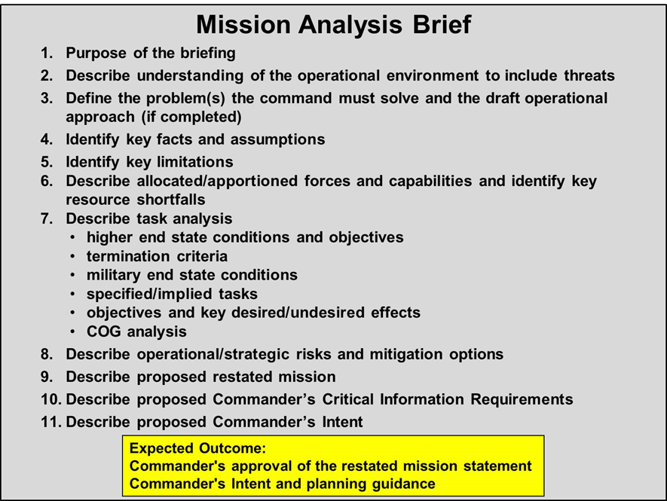
Figure 17: Sample Mission Analysis Brief Agenda
n. Develop and issue the refined commander’s intent and planning guidance. The commander now uses the understanding he has gained through his operational design, informed additionally through the mission analysis process, along with his experience, education, and wisdom, to update his vision for the campaign. This vision is the commander’s personal insight on how he will employ military operations, in conjunction with interagency and multinational efforts to apply all instruments of power, to achieve success. This vision, provided through commander’s intent and planning guidance, will facilitate military course of action development, as well as proposed actions among the interagency that he believes will accomplish the desired national strategic end state and objectives.
(1) The commander’s intent is a concise narrative describing the key aspects of his understanding of the environment and the problem and his visualization of how the campaign must progress to achieve the desired end state. He uses operational design to build his intent, enriching both his understanding and visualization through interaction with the staff as it progresses through the planning process. The purpose of commander’s intent is to focus the staff and assist subordinates and supporting commanders in taking actions to achieve the desired end state, even when operations do not unfold as planned. Given the complexities of the OE at any joint level, the commander must empower subordinates to make decisions within an overall vision for success in the campaign. Using mission command, the commander leaves much of the detailed planning and execution of joint warfighting to his subordinate commanders and requires them to use initiative and judgment to accomplish the mission.
At the theater strategic level, commander’s intent will be much broader than at the tactical level. It must provide an overall vision for the campaign that helps the staff and subordinate commanders, as well as other non-US and non-military partners, to understand the intent to integrate all instruments of national power and achieve unified action. The commander must envision and articulate how joint operations will dominate the adversary and support or reinforce other actions by the interagency and our allies to achieve strategic success. Through his intent, the commander identifies the major unifying efforts during the campaign, the points and events where operations must dominate the enemy and control conditions in the OE, and where other instruments of national power will play a central role. He links national strategic objectives to theater strategic objectives, and lays the foundation for the desired conditions of the military/theater end state. Essential elements of commander’s intent follow:
- Purpose clearly answers the question, "Why are we conducting this campaign?" This explanation may look a lot like the national strategic end state. However, it must state to subordinate and supporting commanders why the use of the military instrument of national power is essential to achieve U.S. policy and the strategic end state. This articulation is essential not only to achieve a unity of purpose among subordinate commands, but is also crucial to provide a purpose around which military commanders may build consensus with interagency and multinational partners. Thus, this statement is vital to build the unity of purpose amongst key shareholders that precedes unity of effort in planning and execution.
- End state specifies the desired theater strategic/military end state. Along with higher guidance, the commander uses the military end state developed during his operational design and mission analysis as a basis to articulate this statement of military success. Additionally, since military forces may have to support other instruments of national power, the commander also explains how and when these supporting efforts will conclude at the termination of the crisis.
- Operational Risk focuses on mission accomplishment. The commander defines the portions of the campaign in which he will accept risk in slower or partial mission accomplishment, including a range of acceptable risk and how assuming risk in these areas may or may not impact overall outcome of the mission.
Commander’s intent may also include other items, which assist the staff, subordinate commands, and coalition partners to share more fully the commander’s vision for unified action. Other possible elements of commander’s intent are:
- Objectives provide clear statements of goals of the campaign that, in combination, will lead to achievement of the military end state. The commander may also relate the campaign objectives to the national strategic objectives to enable the staff to better develop COAs that will ensure proper nesting, and better enable planning interaction of all instruments of power.
- Effects Guidance provides a vision of the conditions and behaviors in the OE that must be in place at the successful conclusion of the campaign. This guidance enables the staff to better link the objectives as visualized by the commander with concepts of operation that may result in tasks to achieve those objectives.
- Method provides a visualization for subordinates on arrangement and synchronization of the major operations to develop future options for action. While method will focus on how the commander envisions operations to achieve the military end state, it should also explain how to support policy aims as the command becomes a supporting effort to the final achievement of the U.S. strategic ends at conflict termination. Method does not describe the specific conduct of these operations; it enhances concept of operation development and understanding by others, but does not describe those details. The commander generally should not give detailed guidance on the method so as to allow maximum flexibility to the JPG in developing COAs.
(2) Once the commander has given his intent for the upcoming campaign, he will normally provide the JPG/staff and subordinate commanders with updated planning guidance that provides additional clarity and detail essential to facilitate timely and effective COA development. The commander will have built this planning guidance through his own operational design approach, as enriched by the staff’s analysis. Planning guidance should enable the staff and components to understand the major themes and guiding principles for the campaign and develop detailed COAs for action. However, guidance should not be so specific as to limit the staff from investigating a full range of options for the commander. Planning guidance will provide a framework, the "left and right limits," to develop options to integrate the use of military and non-military power. The content of planning guidance is at the discretion of the commander and depends on the situation and time available. No format for the planning guidance is prescribed. Planning guidance may include:
- An approved mission statement, and his logic for the mission.
- Key elements of the operational environment.
- A discussion of national strategic end state (or higher headquarters’ end state). This may include updated strategic guidance that has become available since mission analysis, perhaps from discussions with the SecDef, CJCS, other agency leaders, regional leaders, or coalition partners.
- Termination criteria for the campaign (or operation) and a discussion of the military end state and its relationship to the national strategic end state (or higher headquarters’ end state).
- A clear statement of the problem to be solved.
- Key assumptions.
- Key operational limitations.
- Commander’s visualization of the operational approach for the campaign (or operation) to achieve the end state.
- Military objectives and course of action (COA) development guidance.
- Commander’s initial thoughts on key decisive points that need to be controlled to accomplish objectives.
- Commander’s thoughts on organizing the campaign’s activities through lines of effort and/or lines of operation.
- Acceptable and unacceptable areas of risk.
- Any coordinating instructions, to include requirements to coordinate/plan with interagency, inter- and non-governmental agencies, and coalition partners.
- Strategic communication and information operations guidance.
- Initial thoughts on CCIR.
The commander may provide guidance in a variety of ways and formats, based on his preference. He may provide it to the entire staff and/or subordinate commanders, or meet each staff officer or subordinate unit commander individually as dictated by geography, security, and type and volume of information. Additionally, the commander can give guidance in written or verbal form. The key challenge is to ensure universal understanding of this guidance across all elements of the command, a wide range of supporting commands, and enabling agencies. The commander may issue updated planning guidance throughout the decision making process. Because the COA development process will continue to analyze the OE and examine effects on enemy, neutral, and friendly elements, the commander may participate in the COA development process as the JPG examines issues, challenges, and limitations. This engagement may also cause the commander to revisit his operational design for the campaign. Consequently, there is no limitation as to the number of times the commander may refine and reissue his planning guidance.
o. In Progress Review. At the theater level and as part of the APEX process, CCDRs conduct a series of in-progress reviews with the SecDef (or his designated representative) to keep the orientation of the campaign planning in line with the thinking of the national leadership. If the combatant command does not identify the correct end state and corresponding objectives to orient the campaign, further planning is meaningless. Based on strategic direction, the supported CCDR will participate in this first of up to three IPRs to ensure the CCDR’s views are in-synch with those of the SecDef before further planning proceeds. The CCDR will normally present his initial analysis in the form of a briefing (at most, a few slides) that synopsizes his understanding of strategic guidance, the linkage of the theater/military end state to the national end state, the analysis of facts and assumptions, and proposed mission and intent for the upcoming campaign. These IPRs have evolved to be more about dialogue between civilian and military leaders than about concrete approval. The national decision-makers always want to keep options open and do not like to be conceptually “boxed in,” even when the CCDR needs some form of approval to allow continued planning.
The commander considers his operational design, as complemented and supplemented by the staff’s analysis. While the staff has been focused on the planning aspects, the commander has continued to apply an operational design approach to the overall situation. Through his dialogue with the national policy makers (President, SecDef, CJCS), Joint Staff, military service chiefs, other supporting commands and agencies, allies, subordinate commanders, academia, think tanks, and others, he continues to enrich his understanding of the environment and the problem, and continues to extend and refine his visualization of the campaign. Through his experience and application of operational design, he is able to sense changes in the environment and refocus his understanding as appropriate. He transmits this increased understanding and visualization to his staff and subordinates as often as he believes there is need for updated focus. The CCDR brings his most recent understanding and visualization to the SecDef IPR.
A result of the first IPR is a common view of the problem and mission analysis and initial estimate insights. The SecDef will approve the CCDR’s mission statement and provide further guidance as required to guide continued operational design and planning. The CCDR uses these results to refine his vision for the campaign and provide further guidance to both staff and subordinate commands on how they should begin developing options for future, unified action. See Annex A for more on SecDef IPRs within APEX.
4. Develop Courses of Action. The commander and staff will work together to refine and develop the commander’s initial vision and intent for the campaign into a specific, well-developed concept to accomplish unified action. The staff supports the commander through in-depth analysis and presentation of a range of options for future military and non-military actions that will accomplish the desired strategic and military ends. One way staffs help commanders refine their visualization is to develop alternative Courses of Action (COA) to execute the commander’s envisioned operational approach and achieve the objectives.
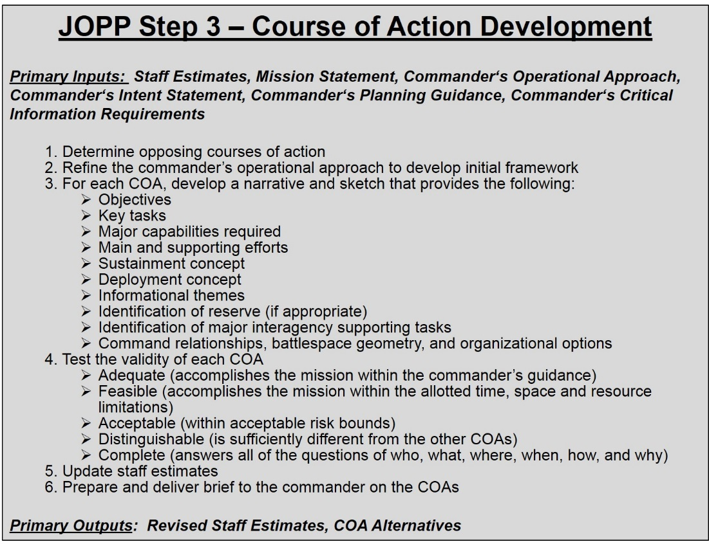
Figure 18: JOPP Step 3 – Develop Courses of Action
A COA is any force employment option in combination with other instruments of power that, if adopted, could result in the accomplishment of the mission. For each COA, the staff must enable the commander to envision the holistic employment of friendly forces and assets, taking into account externally-imposed limitations, the factual situation in the area of operations, and the conclusions from mission analysis. Equally important, the commander must envision how military force will work in conjunction with the other instruments of national power to achieve military and strategic ends. Furthermore, COA development is seamlessly and firmly connected to the previously-developed operational approach as part of operational design. In fact, the LOOs/LOEs, objectives, and decisive points developed during operational design will directly drive and shape COA development.
a. Determine opposing courses of action. Before developing possible COAs, the staff must gain an appreciation of what other actors may do to shape the future environment to their desired end state. We can use the JIPOE process to help us gain such an appreciation, though we must consider not only enemy and adversary actions, but also neutral and friendly actions that may (unintentionally) impede achievement of our desired end state.
The staff determines how other relevant actors will attempt to accomplish their strategic goals by identifying their likely objectives and desired end states, potential strategic and military capabilities, and estimate how the opposition leader may apply his instruments of power in the future – the opposing courses of action (OCOAs). We must also consider aspects of other adversarial and even neutral actors courses of action as they may either support or limit achievement of our desired end state.
The staff’s analysis will identify all known factors affecting the opposition’s actions, including time, space, weather, terrain, and the strength and disposition of military forces, as well as other key factors that may oppose achievement of our desired conditions. The analysis of military capabilities will look across the air, space, maritime, land (including special operations forces), and cyberspace domains.
Developing OCOAs requires the commander and his staff to think as the opponent thinks. From that perspective, postulate possible adversary objectives first and then visualize specific actions within the capabilities of adversary forces to achieve these objectives. Potential adversary actions relating to specific, physical objectives normally must be combined to form course of action statements. Below are the key elements of an OCOA, which may be in the form of a sketch, or a narrative, or a combination:
- Adversary objectives.
- Adversary force posture at the outset of the conflict.
- How the adversary will employ his instruments of power to accomplish objectives.
- Adversary posture when the conflict is over.
- Aspects of the desired OE opposed by neutral or friendly actors.
- Posture of relevant neutral actors at the outset of conflict.
- Likely actions taken by neutral or friendly actors that may impede, or assist, achievement of our desired conditions.
The staff will identify for the commander both the most-dangerous OCOA, as well as the most-likely OCOA, based upon the situation anticipated and/or at hand. Often, the most-likely and most-dangerous OCOAs are not the same, so there must be a conscious decision for the baseline assumption OCOA for friendly planning. Usually, commanders consider the most-likely OCOA as their baseline for friendly action unless the consequences of not focusing on the most-dangerous OCOA preclude doing otherwise.
A thinking and adaptive adversary will change perspectives and OCOAs to maximize his chances for success based on how his opponent (the American JFC) succeeds in changing the OE. Regardless of which OCOA supports the baseline planning effort, staffs must develop branches for the others, as time permits. After OCOA selection to support baseline planning, the staff develops a listing of associated adversary vulnerabilities for friendly-force exploitation and neutral/friendly potential actions that need to be mitigated. This list will aid in analysis of friendly COAs against the selected, baseline OCOA, and assist with determination of the advantages and disadvantages of friendly COAs during JOPP Step 5 COA comparison.
Finally, this analysis will not only influence the JPG’s development of COAs, but will also form the basis to focus and develop PIR and those FFIR related to potentially unhelpful friendly and neutral actions. Based upon the commander’s guidance, PIR serve as the focus to develop collection-and-analysis efforts and forwarding requests for information (RFI) to supporting agencies. The staff can focus efforts to collect, process, produce, and disseminate the required intelligence and other information.
b. Refine the commander’s operational approach to develop an initial framework. The commander provided his vision for a campaign design through his intent and planning guidance, based upon his experience, wisdom, and best understanding of the OE informed by his own operational design, including his increased visualization of the campaign as he and the staff developed the campaign focus through mission analysis. However, he likely has not yet had the opportunity to visualize and understand the details of a campaign concept, and requires the staff integration to build the detailed concept.
The JPG will analyze the commander’s guidance to develop a more detailed framework of nested objectives and effects for accomplishment during the campaign to achieve the military end state. In refining the commander’s operational design, the staff analyzes how the broad, overarching guidance for the campaign will break down into more detailed and achievable blocks as the campaign unfolds. This analysis of nested objectives and effects provides a framework for the logical development of tasks by components and functions that will achieve the desired conditions in the OE. With this framework, the staff then identifies the key tasks that must be performed to achieve the commander’s visualization.
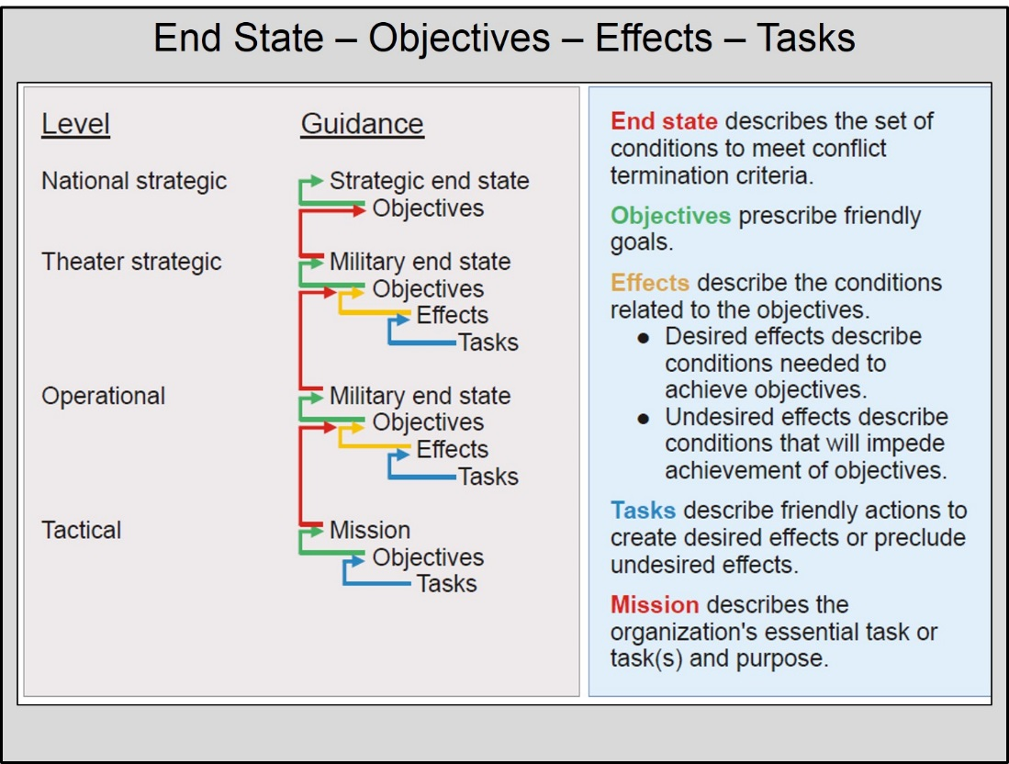
Figure 19: Relationship between End State,
Objectives, Effects, and Tasks
The strategic end state describes the conditions that must be met from a unified action point of view in order to achieve or preserve U.S. national interests. These conditions will often be similar to the termination criteria for the campaign or major operation.
The Military end state describes the conditions that the military must achieve, through the accomplishment of its assigned objectives, in support of the strategic end state. It is also the point beyond which the President does not need the military to serve as primary instrument of national power to achieve the remaining national objectives or interests. However, this does not indicate the cessation of all military activity. The military might still conduct transition activities, force protection, reconstitution, and redeployment after the military end state has been achieved.
Objectives describe what we want to do accomplish.
Effects describe what conditions must exist for accomplishment of objectives.
Tasks describe what actions must be taken to achieve those effects.
Objectives are the clearly-defined, decisive, and attainable goals toward which joint capability is focused to accomplish the military end state. Military objectives are one of the most important considerations in operational design and campaign or major operation planning. They define the role of military forces in the larger context of – and nested within – national strategic objectives. They specify what to accomplish and provide the basis to describe campaign effects. Although the commander describes his visualization of the campaign’s objectives in his intent and guidance, his staff should verify and refine them.
An effect is a physical and/or behavioral state of a system that results from an action, a set of actions, or another effect (JP 3-0). Effects bridge the gap between objectives and tasks by describing the conditions that need to be established through performance of tasks to accomplish objectives. This helps commanders and staffs visualize achievement of objectives, so they can develop the required tasks. From subordinate headquarters receiving tasks, effects can be seen as providing the "purpose" to tasks. Effects may be expressed in two ways:
- Desired Effects: "How do we want the environment to behave when we reach end state, or at particular points of the campaign en route to the end state?"
- Undesired Effects: "What are the behaviors and conditions in the OE that we must avoid during the campaign?"
Other agencies and partners can use the desired effects to help them visualize their activities to support the military activity if it is the primary means of achieving objectives, or how they will be supported by military activity if they provide the key means to achieve national strategic objectives. Thus, effects may be a prime means to bridge military and interagency understanding by describing how the OE should behave to show policy achievement.
Joint doctrine has no specific convention for writing effects, but there are four primary considerations according to JP 5-0:
- They should link directly to one or more objectives.
- They should be stated as conditions of the environment, not as another objective or task.
- They should be measurable.
- They should not specify ways and means for accomplishment.
Once the commander and staff understand the objectives and effects that define the campaign, they then develop appropriate tasks to create the desired effects, and preclude undesired effects. Not all tasks are connected to effects, e.g., support tasks related to logistics and communications. However, the commander emphasizes the development of effects-related tasks early in the planning process because of the obvious importance of these tasks to objective accomplishment. The following is an example of the nesting of these components:
Endstate: Regional stability, territorial integrity, and trade are restored to pre-conflict levels. Newland no longer threatens Oldland or the region through the use of insurgency or state-sponsored terrorism.
Objective 1: Restore and protect Oldland’s (our key partner and neighbor of Newland) western border with Newland IAW the 1956 agreement.

Effect 1: Oldland’s armed forces and police are capable of providing for internal defense against insurgency and terrorism.
Effect 2: Oldland’s military is an active participant in regional security structures.

Task 1: Build and implement a robust security cooperation program with Oldland.
Task 2: Ensure Oldland military participation in annual exercises Assured Resolve, Python Quest, and Iron Fist.

c. Develop courses of action. The JPG develops and analyzes a range of potential military and non-military actions, and assesses how well each of these actions accomplish the desired effects on the OE, given the time and resources available.
An initial COA should be simple, brief, and complete, and will answer the following questions:
- What are the objectives and effects to achieve over time to obtain military and strategic success?
- What major tasks must happen, and in what sequence, to achieve the desired effects and avoid undesired effects?
- Where, when, and how should coalition air, space, naval, ground, cyber, and special operations forces be applied?
- How much force is necessary to accomplish the mission?
- Generally, in what order should coalition forces deploy?
- How will the coalition be sustained for the duration of the campaign?
- What are the initial command relationships?
- How does the COA achieve the desired end state?
Because COAs are meant to be initial concepts, designating phases at this point probably is not useful. One possible method of visualizing the sequence during COA development is to organize tasks and lines of operation/effort into Pre-hostilities, Hostilities, and Post-hostilities periods vice more detailed phases.
There are many ways to develop COAs, and each headquarters likely has an accepted norm for doing so. The following describes one way of COA development that works.
(1) Develop an initial concept graphic and narrative. Based upon the initial framework, the JPG visualizes how to accomplish these objectives/effects over time. The staff develops an initial concept narrative and, if appropriate, a graphic that describes the major actions of the campaign as a useful reference. The following sequential steps can help in building the sketch and narrative:
- Determine Forces Available/Apportioned. Determine how much force is in theater and additional forces apportioned for planning. COA development should visualize force requirements at the end of each period (pre-hostilities, hostilities, and post-hostilities). Remember at this point the staff is only developing a concept, not refining a plan. The staff can get to this level of detail later during COA analysis when it checks to see if these forces are sufficient for the tasks required.
- Post Decisive Points. Review the operational centers of gravity (COG) as the point of focus for our operations and post the major physical and logical decisive points that will be relevant to the COA. These might include ports, population centers, critical infrastructure, major events such as elections, support of key actors, etc. During COA development, these serve as points where friendly actions can, and probably will, come in contact with the enemy, and serve to orient planners on where major tasks/actions must focus.
- Array Forces at Military End state. Position forces geographically where they are needed in the theater at the end of the campaign and determine what those forces will do. Use the sketch to help visualize the forces and their locations.
- Identify Initial Entry Points. Based on initial guidance and knowledge of theater access and facilities, display where the forces can enter the theater from land, air and sea deployments, and show the initial bases/staging areas available to support this deployment. Also portray the initial lines of communication that will connect forces back to in-theater (intermediate staging bases) and strategic (CONUS or forward-deployed) bases of operations.
- Maneuver the Forces Forward to End State. Looking at the sketch with the end state and objectives/effects by period (or phase) in mind, determine the best way to get the forces into theater from bases in friendly territory to their ultimate locations at the end of the campaign. This activity will help formulate the desired basing plan for the beginning, middle, and end of the campaign.
- Array Forces at Pre-Hostilities. Visualize force positioning in Pre-hostilities after they enter the theater at these potential entry points, and formulate the initial concept for a basing plan and Joint Reception, Staging, Onward Movement, and Integration (JRSOI).
(2) Identify main and supporting efforts. As you develop tasks for components/supporting organizations, identify main and supporting efforts during each period. At this point in initial concept development, there is no need to specify who the main effort is, but identifying what is the main effort is important.
(3) Determine the tasks required in each period. During each of the periods, analyze how military and non-military actions will accomplish the required changes in the operational environment. It is not important yet to identify which subordinate organization will accomplish each of the actions, which are the tasks. It is, however, important to identify suitable tasks for or requests to our interagency partners (DOS, Dept. of Treasury, etc.), coalition and international organizations (UN, NATO, regional organizations like the European Union, etc.), and other non-governmental partners (International Committee of the Red Cross, etc.).
Focus on the effects to achieve or to avoid, and consider how to employ joint forces (via the joint functions) in conjunction with other instruments of power. Considerations for tasks include:
- Tasks required by the main effort.
- Tasks required by the supporting efforts.
- Initial entry into theater: basing, access, and overflight.
- Deployment and reception of the force (JRSOI).
- Protection of forces and host-nation points of entry.
- Building and maintaining a coalition force.
- C2 with joint, host-nation, and coalition forces.
- Achieving the desired effects.
- Preventing undesired effects/events, such as a humanitarian crisis, loss of local support, etc.
- Tasks required to support the use of other instruments of power.
- Tasks to protect the force from cyber-attack or exploit the use of cyber-attack.
- Sustaining the joint force, and additional support required to enable and maintain host-nation and coalition participation.
- Post-hostilities conditions, and how the joint force will maintain military gains and transform them into long-term strategic success.
(4) Determine if the forces and capabilities allocated (in CAP) or apportioned (in deliberate planning) are sufficient to meet the task requirements. Note any deficiencies. Sketch a troop-to-task analysis to help with determining the appropriate command structure.
(5) Determine an appropriate deployment scheme to introduce the right forces and capabilities in a logical sequence.
(6) Based upon the initial concept/sketch, develop an initial structure for C2. At this point, identify the basics of how you will organize by components, any JTFs requirements, and how the joint force will control or coordinate its efforts with the host nation, multinational forces, and interagency elements as necessary. Again, this structure is an initial organization around which to continue COA development, and may change when tested in wargaming. Some considerations:
- Geometry – how to allocate the battle space (e.g. joint operations area, joint special operations area, or joint security area).
- Organization (functional components, service components).
- Interagency considerations (coordination mechanisms).
- Multinational considerations (initial coalition command/coordinating structure).
d. Test the COAs for validity. Before going further in developing the COAs, determine if the COA meets the validity criteria:
- Feasible: Can execute within time, space, and resources available.
- Adequate: Accomplishes the mission within guidance; meets end state, objectives, and effects for campaign.
- Acceptable: Achieves ends balanced with costs/risk.
- Distinguishable: The COA is different from others, e.g. key elements such as force structure, defeat mechanism, main effort, or use of reserves, etc.
- Complete: Incorporates all key elements (5Ws and how).
If the COA does not meet the criteria above, it should be discarded or adapted so that it is valid. A caution – after you’ve adapted a COA, ensure that the adapted version still passes the distinguishable test.
e. Update staff estimates. Staff directorates analyze and refine each COA to determine its supportability. A purpose of the staff estimate is to determine whether the mission can be accomplished and to determine which COA can best be supported. This, together with the supporting discussion, gives the commander the best possible information from which to select a COA. Each staff section analyzes each COA, its supportability, and which COA is most supportable from their particular, functional perspective.
Because of the unique talents of each joint staff directorate, involvement by all is vital to the process. Each staff estimate takes on a different focus that identifies certain assumptions, detailed aspects of the COAs, and potential deficiencies that are simply not known at any other level but, nevertheless require detailed consideration. Such a detailed study of the COAs involves the corresponding staffs of subordinate and supporting commands.
f. Prepare and deliver the initial COA brief to the commander. At this point in the process, the staff has transformed its understanding of the commander’s vision into a number of COAs for his consideration, guidance, and approval for further analysis. This initial exchange expands the commander’s perspectives on what is/is not possible and helps the commander to better visualize the opportunities and challenges within the OE. It also helps to confirm/adapt the staff and subordinate commands’ understanding of the commander’s vision. Finally, it helps to identify emerging resource shortfalls and challenges/impediments to accomplishing the full extent of the objectives. This leads to better-informed discussions with the CJCS and SecDef to ensure alignment of resources with objectives.
The goal is to provide the commander an "azimuth check" before proceeding into the next step of COA analysis, and to gain insights on whether the work thus far meets guidance. At the end of this briefing, the staff must know which COAs should move forward for further analysis and development, with additional guidance on modifications, improvements, and/or risk.
5. Analyze Courses of Action. The JPG analyzes in detail each COA that survived Step 4. The objective of this step is to analyze each COA critically, independently, and according to the commander’s guidance in an effort to determine the advantages and disadvantages associated with each COA.
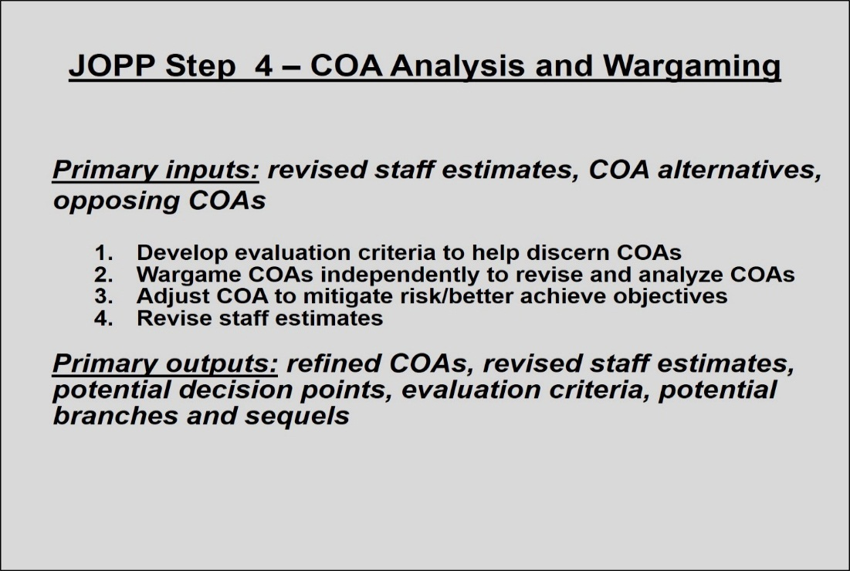
Figure 20: JOPP Step 4 ― Analyze Courses of Action
It is critical that the analysis first looks at each COA independently from the other COAs; a comparison will come later. At this point, the staff is looking for best answers to the following questions (not inclusive):
- Will the tasks identified achieve the desired effects in a way that will achieve the desired conditions, and avoid generating unintended effects?
- How will military operations change the adversary and the operational environment over the course of the campaign?
- What are the points at which COAs do not offer enough flexibility to oppose adversary actions, and where might branches and sequels be required?
- What are the strengths and weaknesses of each COA, and how well does each COA meet the commander’s vision for success? How well do they hold up under the rigor of a realistic opposing force or situation (for an HA mission, the enemy might not be an armed force).
- What are potential decision points where the commander must make a key decision, and the critical information requirements (CCIR) for the commander to make such a decision?
- Which aspects of the COA may introduce strategic challenges that must be resolved?
Wargaming is "a simulation of a military operation involving two or more opposing forces, using rules, data and procedures designed to depict an actual or assumed real-life situation" (JP 1-02). It is a conscious effort to visualize the flow of a plan, within an OE, using joint forces, while integrating the other instruments of power as appropriate, and confronting a realistic, thinking, and adaptive adversary. Wargaming assists joint-force planners to identify the strengths and weaknesses, associated risks, and asset shortfalls for each friendly COA. While joint doctrine refers to visualizing the flow of a military operation as the key element in wargaming, the commander and staff must also consider the application of all instruments of national power (DIME).
a. Develop evaluation criteria. Determining the initial evaluation criteria is a critical requirement that begins before COA analysis. The commander may specify some of these criteria, but the JPG normally develops most of them. The chief of staff may also help in building the criteria and some may be gleaned easily from strategic guidance. The commander is the final approval authority for the criteria, regardless of who develops them. The insights available from Mission Analysis, and from the commander’s intent and planning guidance, may suggest appropriate evaluation criteria. Through the wargaming process, some additional evaluation criteria may emerge for use later in COA comparison. Some examples of potential evaluation criteria are:
- Risk (during and after operations; strategic and operational).
- Flexibility.
- Speed.
- Sustainment/support.
- Surprise.
- Defeats/protects the center of gravity.
- Force protection.
- Casualties or collateral damage.
- Use of Flexible Deterrent Options.
- Financial costs.
- Impact on policy
- Impact on coalition interests.
b. War game each COA independently. Wargaming provides a useful means for the commander and staff to analyze and test each friendly COA against a selected opposing COA (usually the enemy’s most likely or most dangerous COA) in an action-reaction-counteraction methodology. The COAs must be evaluated through the other actors’ eyes, given their political and cultural perspectives and biases, to determine if the proposed actions will change the intended behaviors in the manner that friendly planners believe -- a key aspect to achieve desired, rather than undesired, effects. Keep in mind that, in addition to actions by adversaries, actions by neutral or even friendly actors may need to be considered as "opposing" actions, as the goal is to achieve our desired operational environment. While the main effort is on applying the use of military power, consider all available instruments of power. While the commander may not be able to control the D, I, and E actions, he can coordinate these instruments with other actors who may be able to influence their application.
(1) Decide which type of war game to use. This decision rests upon the commander’s guidance, time, and resources available, staff expertise, and availability of simulation models. Wargaming has manual and computer-assisted components. Manual wargaming makes up the bulk of activity when staffs war game. Automation normally resolves questions regarding outcomes during specific moments in the fight, to determine the gross requirements for each class of supply, and to conduct initial strategic transportation feasibility. Automation can never supplant the combined experience of the people conducting the war game. When time and automated resources are lacking, manual-only wargaming will suffice. There are several approaches to visualize the flow of the war game. The preference of the commander, the scope and nature of the plan, and the level of sophistication of the JPG determine which approach to use. Methods include:
- Major periods construct with Pre-Hostilities, Hostilities and Post-Hostilities.
- Phasing model articulated in joint doctrine or another phasing model developed for the campaign.
- Critical events sequencing, decisive points or major tasks.
- Computer assisted.
(2) Prioritize the opposing COAs for analysis against the friendly COAs. In time- constrained situations, wargaming against all COAs may not be possible, so consider carefully the priority in which to war game OCOAs.
(3) Conduct the war game. The JPG will conduct the war game by assembling information, marshalling and assembling the proper tools and teams for analysis, and following a well-ordered process for systemic analysis of the proposed COAs.
A simple manual war game method employs an action-reaction-counteraction format between "Blue" and "Red" teams. A possible framework to guide the flow is to use the Lines of Operation or Lines of Effort sequentially to work through the campaign. The supervisor of the war game directs the questioning and ensures that war game time is not wasted. Blue, Red, and, if appropriate, Green (neutral actors) teams who THINK and speak for their forces when directed by the supervisor are critical to the process. The supervisor should identify a separate recorder to document the results in a useful format and to record any issues that cannot be resolved quickly.
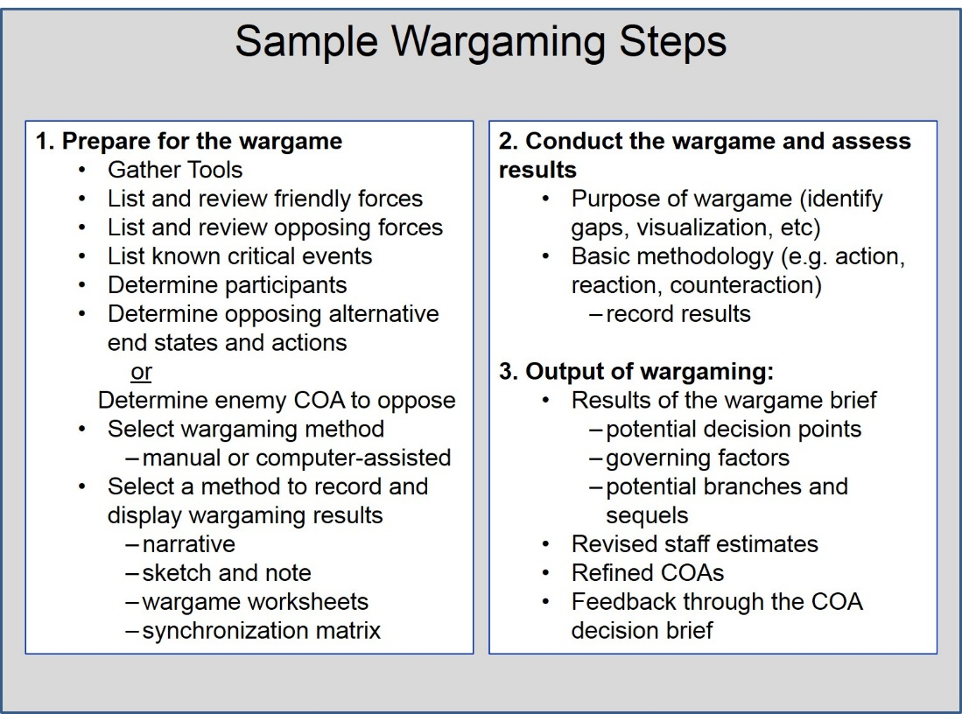
Figure 21: Sample Wargaming Steps
As the JPG conducts the war game, they interpret the results of analysis to ensure each COA remains valid. If a COA is inadequate, infeasible, or unacceptable, they must discard or modify that COA. The JPG may also find that it needs to combine aspects of COAs to develop new ones. Throughout the analysis and wargaming process, the JPG must remain focused on the following areas:
- Objectives: strategic, theater strategic, and operational.
- Balance between creativity and the realities of the OE.
- The elements of operational design.
- Joint functions (JP 3-0).
(4) Record the war game. Proceedings of the war game can be recorded by a variety of means:
- Narrative describing the action, probable reaction, counteraction, assets, and time used.
- Sketch-note which uses a narrative but adds operational sketches to paint a clear picture.
- Synchronization matrix organized by time or major events as columns, with functional and other major activity areas as rows. If used as a recording tool, this would form the beginning of the synchronization matrix that will provide the commander and staff a visualization tool for the campaign. It can be refined throughout planning, and should be updated throughout the campaign. The synchronization matrix helps staff officers build the detailed functional plans that support the campaign plan.
Whichever method of recording the war game is used, it is important to capture the decision points, CCIRs, COA adjustments, potential branches and sequels, and potential undesired effects.
(5) Analyze the COA. The analysis of the COA as a result of the war game should include the following areas.
- Propensity to achieve the desired operational environment. Will the COA achieve the objectives? How long will it take?
- Advantages and disadvantages. What are the major elements of this COA that may present distinct advantages or disadvantages to the command?
- Critical events, decision points, and CCIR. What are the critical events that will determine whether objectives are achieved? What may happen that will require a commander decision to change the plan? What information does the commander need to make that decision? What elements of assessment must be added to the plan?
- Potential branches and sequels. What branches to the plan may be required to deal with possible deviations from the expected campaign? What branches or sequels may be required in the event of more rapid than expected success?
- Risks of undesirable effects. What are the potential second order effects of our actions (or of other actors’ actions) that may have to be mitigated?
- Strategic challenges that must be resolved. What strategic issues emerged that must be brought to the attention of higher commands or civil authorities or partners? What are some possible mitigation strategies to these challenges?
After the war game is complete, there should be sufficient visualization of the campaign to solidify the tasks required. Some of these tasks will be related directly to achieving effects that will enable objectives to be met, while others will be supporting tasks (such as building bases, establishing logistics stocks and resupply routes, conducting JRSOI).
c. Adjust the COA to mitigate risk and enable it to better achieve objectives. After analysis of the COA through wargaming, the staff can refine the COA to improve its likelihood of achieving the objectives in the time desired (given other limitations noted) and reduce the elements of risk. If the COA becomes significantly different, then it should be re-briefed to the commander. Care must be taken not to "morph" the COA so that it is no longer distinguishable from the other COAs.
d. Update staff estimate. Record observations about the COAs in the staff estimate, to include functional requirements, relevant challenges to the functional area, and mitigation measures relevant to the staff section’s function.
6. Compare Courses of Action. After rigorous independent analysis of each COA, the JPG compares the COAs using a common set of criteria. During the comparison process, the JPG focuses on evaluating the value of each COA through the commander’s eyes -- using his visualization of the campaign as the standard. The purpose of the comparison is to determine which COA is the best fit for his intent, with least cost and risk, and greatest chance of success. Using evaluation criteria derived mostly from his intent and guidance, the staff evaluates the COAs against the evaluation criteria ― not against one another ― to identify the one that best meets the commander’s needs.
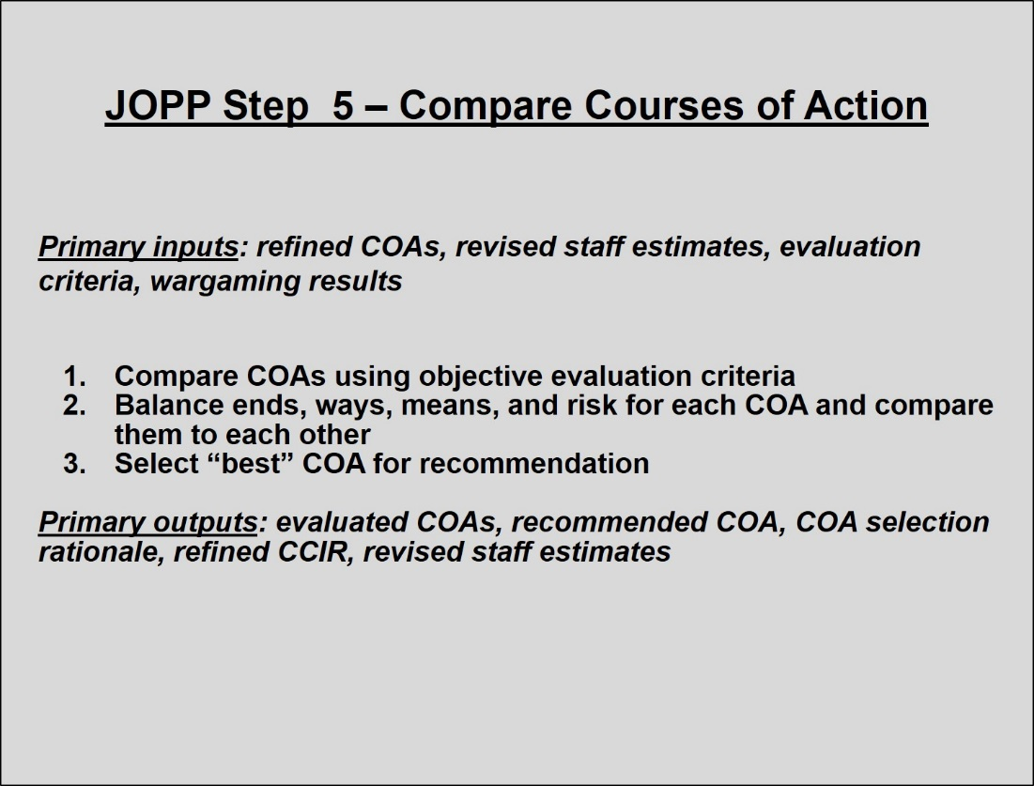
Figure 22: JOPP Step 5 ― Compare Courses of Action
a. Compare COAs using evaluation criteria. The COAs are compared using the evaluation criteria that was established prior to the wargaming (and probably augmented as a result of wargaming). The inputs to COA comparison are the independent staff estimates and war game results. The chief of staff or JPG leader directs the comparison discussion. Staff planners normally conduct the comparison in isolation from the commander, and may include the subordinate component staffs.

The staff should remain as objective as possible when comparing the COAs and avoid manipulating criteria to promote a "favorite COA." Weighting evaluation criteria is a frequent and often helpful technique to identify the most-critical criteria. Weighting, like evaluation criteria selection, should come prior to formal COA comparison to avoid assigned weight manipulation.

b. Select the "best" staff-recommended COA. After the comparison analysis, the staff must select the COA that they will recommend to the commander. This selection must consider not only the JPG analysis, but also each staff section’s functional analysis of the COAs. COA comparison is ultimately a subjective process that uses collective staff judgment and should not become a purely mathematical exercise, though using “+, -, 0” or 1, 2, 3 as expressions of relative value may be appropriate. The key element in this process is the ability to articulate to the commander why one COA is preferred over another in terms of how well the COA meets the evaluation criteria. Using some type of decision matrix may help, but be careful to keep it as objective as possible. In essence, we are trying to use a measure of objectivity to evaluate and differentiate subjectivity.

One type of COA comparison matrix uses weighted numerical comparisons. In this method, each criterion is given a comparative weight based on its importance. This weight likely would be implied by commander’s intent and guidance. Note that because the COAs are compared to the evaluation criteria, rather than to each other, there is no need to identify the 1st, 2nd, 3rd "place" COAs for each criterion. If "+, -, 0" is used, "+" means it does well in meeting the criteria, "-" means it does not do as well, and "0" means it is balanced. If 1-3 is used as a scale, lower is better, so 1 means that the COA meets the evaluation criteria well, 3 means not well, and 2 is in the middle.

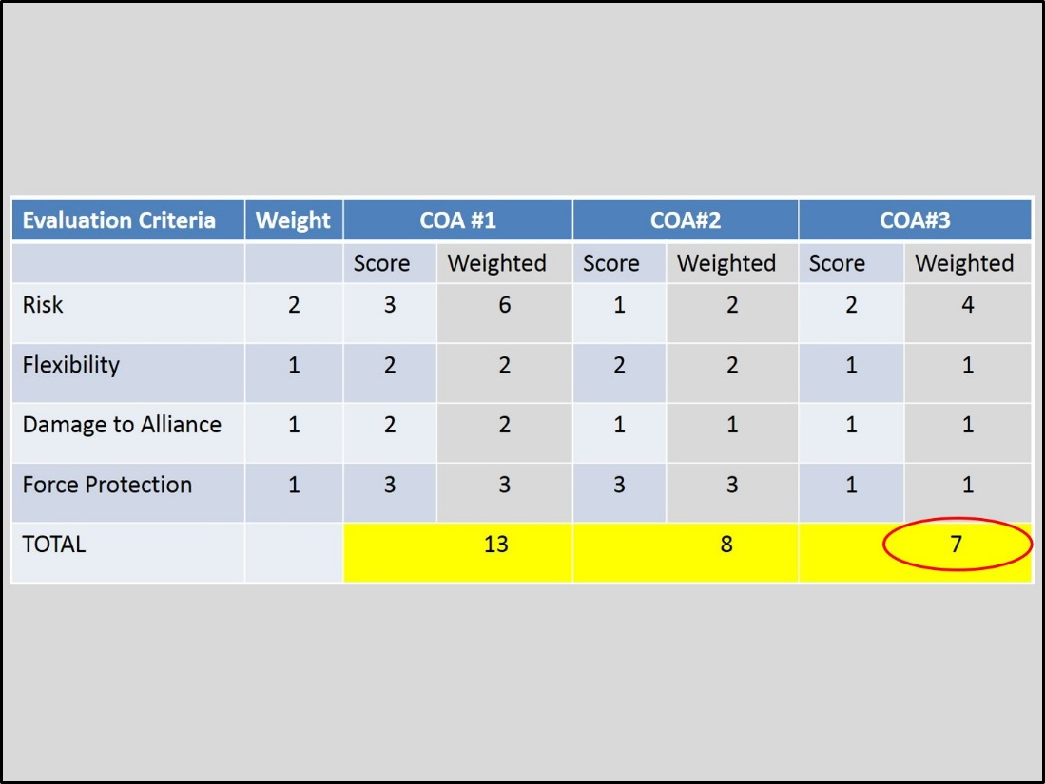
Figure 23: Sample COA Comparison Matrix
(Weighted Numerical)
Some commanders are less comfortable with numerical ways to present the comparison. Another type of comparison matrix is below. Each COA is described in terms of advantage or disadvantage against the evaluation criteria.
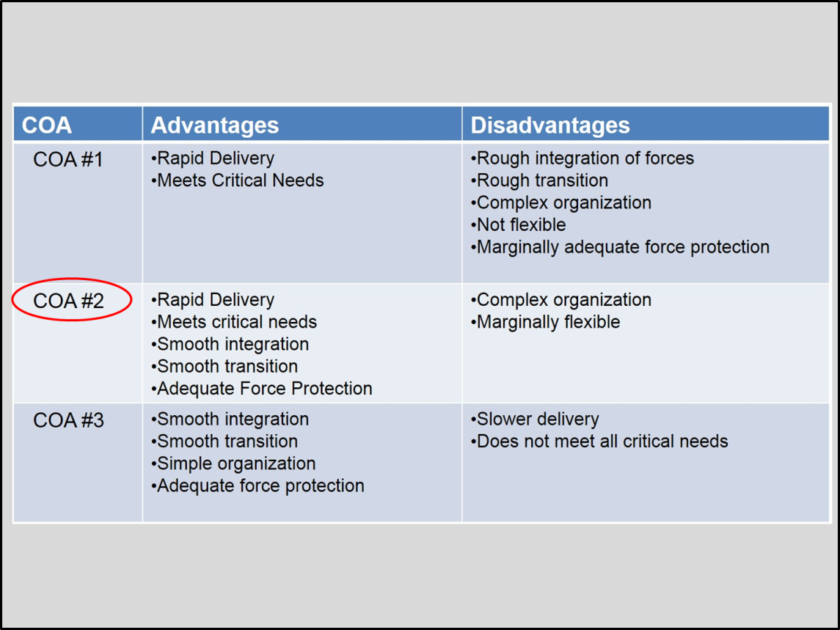
Figure 24: Sample COA Comparison Matrix (Descriptive)
7. Approve a Course of Action. The JPG briefs the results of the COA analysis and the COA comparison to the commander to obtain his decision on which COA to develop into the concept of operations (CONOPS) of the campaign. This enables the commander to refine his visualization of the campaign and provide further guidance to the staff on how to proceed with CONOPS development. It also prepares the commander for another IPR with the Secretary of Defense (or with his next higher command).
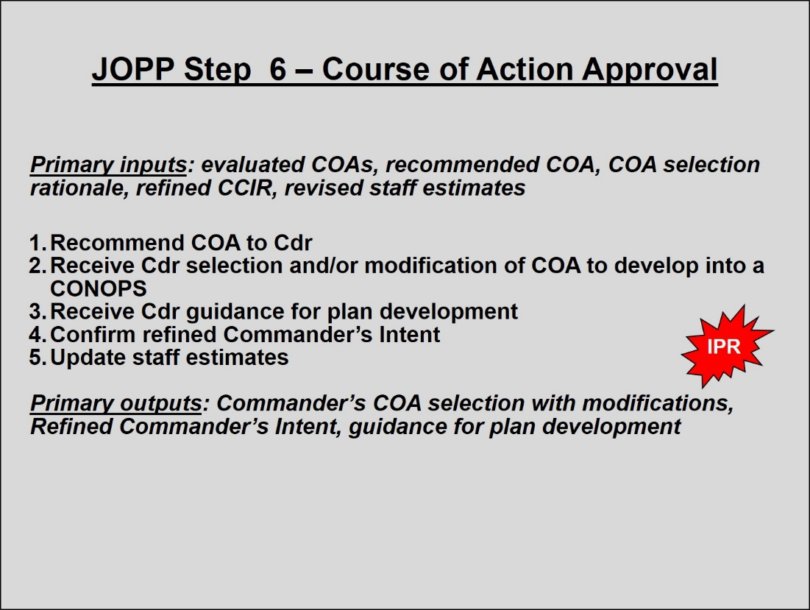
Figure 25: JOPP Step 6 ― Course of Action Approval
a. Recommend COA to the commander. The staff presents the COA analysis, and the recommended COA. The forum to present the results of COA comparison is the commander’s decision brief. Typically, this briefing provides the commander with an update of the current situation, an overview of the COAs considered, and a discussion of the results of COA comparison. This decision brief will also include an update on the understanding of the environment that was enabled through the wargaming.
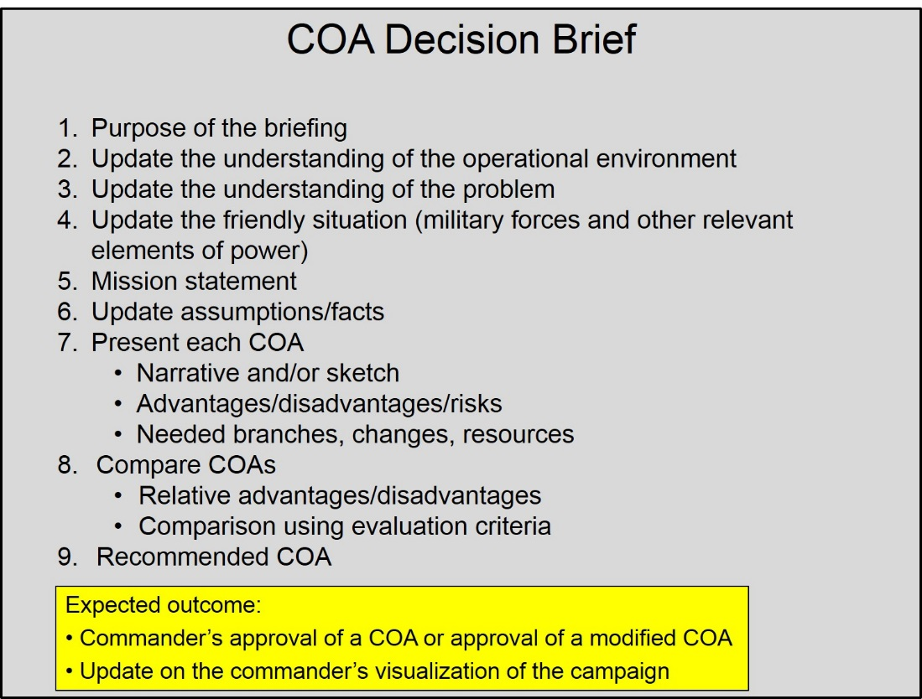
Figure 26: Sample COA Decision Brief Agenda
During the brief, it is important that dissenting views be heard so that the commander can understand all aspects of the analysis. Staff officers should be encouraged to expound on issues in their functional areas if needed. Subordinate commands should be present, or linked via video-teleconference. Other partners also should be invited to the brief, to include other government agencies and key multinational partners, to the extent possible or appropriate. Staff officers from those organizations are probably part of the JPG, so there should be no surprises.
b. Commander selects a COA or approves a modified COA. The commander will evaluate all analyses of the JPG, applying his own understanding of the environment and the mission and his visualization of the campaign to critically evaluate how each COA would accomplish the mission. The commander may select a single COA as presented, or may incorporate the best portions of several COAs to form a new one.
c. Receive commander’s guidance for concept development. As part of the COA decision brief, or following it, the commander will likely provide additional guidance that will enable the development of the approved COA into the concept of operations (CONOPS).
d. Confirm updated commander’s intent. Upon hearing the analysis of the COAs, the commander is likely to understand the environment and the problem(s) better. This may cause him to adapt his intent and/or guidance. This is an opportunity for the commander to transmit any updates to the staff and other relevant planning parties.
e. Update staff estimates and the commander’s estimate. Once the commander makes a decision on a COA, provides any additional guidance, and updates his intent, staff officers record this new information and refine their estimates of the campaign’s supportability from their functional viewpoint. At the combatant command level, the staff also prepares the commander’s estimate, which provides a concise statement of how the commander intends to accomplish the mission, and provides the necessary focus for continued campaign planning and developing an OPLAN/ OPORD. In crisis action planning, the commander’s estimate goes to CJCS for SecDef review and is the basis for a decision on which COA to refine and potentially execute. In deliberate planning, the commander’s estimate forms the basis for the next IPR with the SecDef.
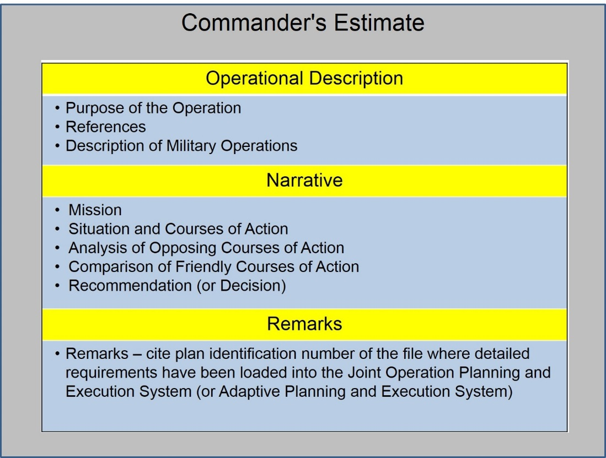
Figure 27: Sample Commander’s Estimate
f. Conduct in-progress review. During this IPR, the SecDef (or his representative) will consider the CCDR’s analysis and approve (or modify) the CONOPS for further development. Based upon the SecDef’s decision and further strategic guidance, the CCDR will refine his CONOPS and reissue his intent and planning guidance to drive development of the plan during the next step of the process. Often, the first two IPRs are combined into one briefing with the SecDef, especially for the theater campaign plan. See Annex A for more on SecDef IPRs.
8. Develop the Plan. After the commander has approved a course of action and provided additional guidance to the staff for development of the CONOPS and the full plan (with updates as required after the second IPR for combatant commands), the staff develops the CONOPS into an operations plan or operations order. The CONOPS must be developed to provide the detail required for the staff to build the base plan and prepare supporting annexes, and supporting and subordinate organizations to build supporting functional plans.
a. Review planning guidance. The staff should review the commander’s guidance as updated throughout the planning process and as modified as a result of the IPR and associated discussions by the commander.
b. Update the commander’s intent. The commander should republish his intent, with any changes to it that may result from his increased understanding of the OE and the problem, and his vision for the campaign.
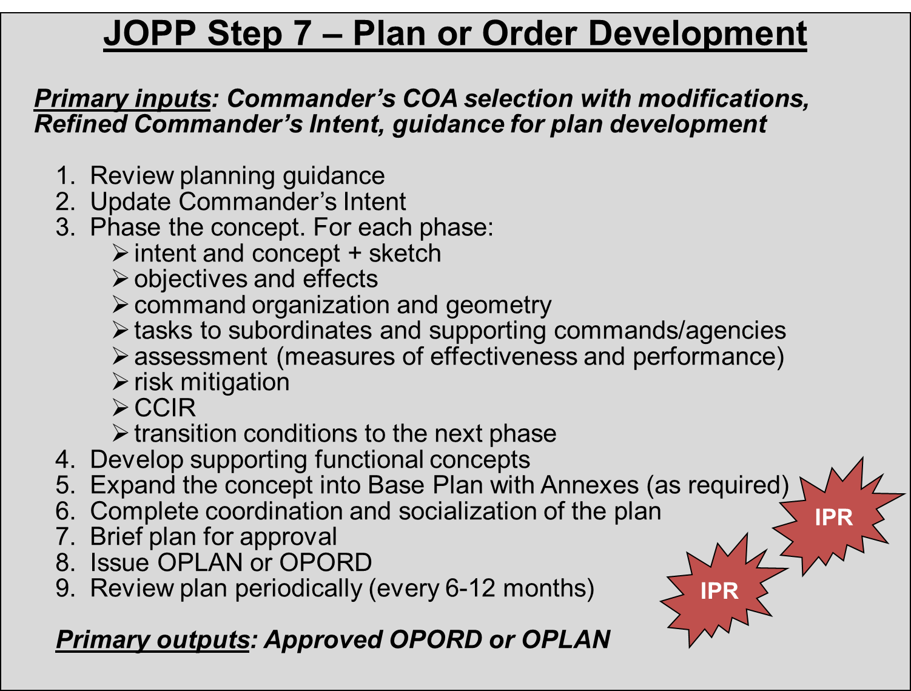
Figure 28: JOPP Step 7 ― Develop the Plan
c. Phase the concept. Refine the phasing of the campaign. Each phase is designed to nest with the intent for the overall campaign and sequenced to achieve an end state that will set conditions for commencement of the next phase. The commander will declare his intent for each phase that supports his overall intent for the campaign. Each phase must have a specified set of conditions for both the beginning and intended end state. Recognize that lines of operation or effort are likely to run throughout the phases to provide the logical framework for the entire campaign. The doctrinal phasing model is described below. However, each campaign is unique and the phasing must make sense for the campaign. While we would like to keep phases flexibly event-oriented, we must also consider the time-oriented resourcing requirements for the activities of each phase.
The type of phasing is dependent on the mission and the concept of operations of the campaign or operation. The model given below is one option for organizing the campaign or operation, but there are many others. Most important to organizing phases is that there is a clear set of conditions that are achieved at the end and beginning of each phase.
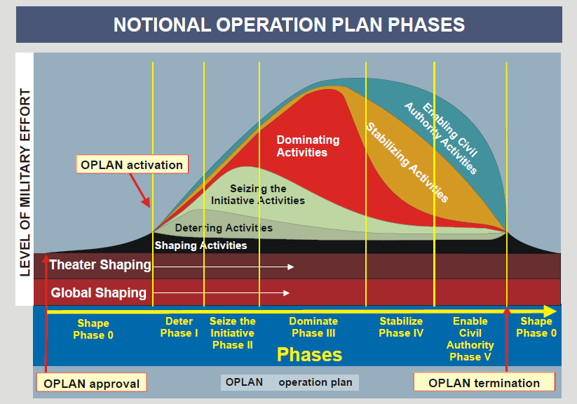
Figure 29: A Phasing Model
(1) Phase 0 - Shape. The goal of Phase 0 is to assure success by shaping perceptions and influencing the behavior of both adversaries and allies, developing allied and friendly military capabilities for self-defense and coalition operations, improving information exchange and intelligence sharing, and providing U.S. forces with peacetime and contingency access. Planning that supports most shaping requirements typically occurs in the context of day-to-day security cooperation, and CCDRs describe Phase 0 activities in the theater campaign plan, often as security cooperation activities. Some of the Phase 0 activities may take place routinely during steady-state operations, while others may be activated as a potential confrontation becomes more likely.
(2) Phase I - Deter. The goal of Phase I is to deter undesirable adversary action by demonstrating the capabilities and resolve of the joint force. Though many actions in the deter phase build on security-cooperation activities from Phase 0, deterrence differs from the shape phase in that it is principally preparatory actions that support or facilitate the execution of subsequent phases of the operation/campaign. Once the crisis is defined, these actions may include:
- mobilization
- tailoring of forces and other pre-deployment activities
- initial deployment into a theater
- employment of ISR assets to provide situational awareness
- setting up of transfer operations at en route locations to support aerial ports of debarkation
- development of mission-tailored C2, intelligence, force protection, transportation, and logistic requirements to support the JFC’s concept of operations.
Liaison teams and coordination with other agencies assist in setting conditions for execution of subsequent phases of the campaign or operation. Unless it is in our national interests to proceed to Phase III, the goal of Phase II is to return to Phase 0 conditions.
(3) Phase II - Seize the Initiative. JFCs seek to seize the initiative in combat and noncombat situations through the application of appropriate joint-force capabilities. In combat operations, execution of offensive operations at the earliest possible time is key to force the adversary to culmination and set the conditions for decisive operations. Rapid application of joint combat power may have to delay, impede, or halt the adversary’s initial aggression and deny initial objectives. If an adversary has achieved initial objectives, early and rapid offensive combat power can dislodge adversary forces from their position, creating conditions for the exploitation, pursuit, and ultimate destruction of both those forces and their will to fight during the dominate phase. Operations to gain access to theater infrastructure and to expand friendly freedom of action continue, while the JFC seeks to degrade adversary capabilities with the intent to resolve the crisis at the earliest opportunity. In all operations, the JFC establishes conditions for stability by providing immediate assistance to relieve conditions that precipitated the crisis.
(4) Phase III - Dominate. The dominate phase focuses on establishing control of the operational environment. When a campaign or operation focuses on conventional enemy forces, the dominate phase normally concludes with decisive offensive operations that drive an adversary to culmination and achieve the JFC’s operational objectives. In an irregular conflict, decisive operations dominate and control the operational environment through a combination of offensive and defensive combat, security, engagement, and relief and reconstruction activities. Dominate phase activities may establish the conditions for an early, favorable conclusion of operations or set the conditions for transition to the next phase.
(5) Phase IV - Stabilize the Environment. The stabilize phase is required when there is no fully-functional, legitimate, civil government present. The joint force may have to perform limited local governance, integrating the efforts of other supporting/contributing multinational and international organizations, NGOs, or USG agency participants until legitimate local entities are functioning. This assistance includes the provision of basic services to the population. The stabilize phase typically marks a change from sustained combat operations to stability operations. Stability operations are necessary to ensure that the threat, military and/or political, is reduced to a manageable level that the potential civil authority can control or, in noncombat situations, to ensure that the situation leading to the original crisis does not reoccur. Redeployment operations may begin during this phase.
(6) Phase V - Enable Civil Authority. This phase consists predominantly of joint force support to legitimate civil governance in theater. Depending upon the level of indigenous capacity, joint force activities during Phase V may be at the behest of that authority or they may be under its direction. The goal is for the joint force to enable the viability of the civil authority and its provision of essential services to the largest number of people in the region. This support includes coordination of joint force actions with multinational, interagency, and other organizational participants, establishment of measures of effectiveness (MOEs), and influencing the attitude of the population favorably regarding U.S. and local civil authorities’ objectives. Significant redeployment operations, particularly for combat units, will often occur during this phase. Achieving the military end state during this phase signals the end of the campaign or operation.
(7) For each phase, the campaign’s CONOPS should describe the following elements.
- Intent and schemes of movement and maneuver. The commander’s intent for the phase must be clear. Describe the purpose, end state, and the operational risk to the campaign during this phase. The schemes of movement and maneuver may be narratives of the various lines of operation and effort as they are executed during this particular phase. The flow of forces and capability into theater are broadly described as are subsequent joint force maneuver schemes to achieve the various operational objectives. In campaigns where LOEs are used (as opposed to LOOs) and/or where positional advantage may not be consistently critical to success, the scheme of maneuver uses the logic of purpose and may describe how and when certain objectives within each LOE must be achieved, especially in relation to the objectives on the other LOEs of the campaign.
- Objectives and effects (desired and undesired). Describe the objectives for each phase, and the major effects that must be achieved to realize those objectives. Describe how the force’s objectives are related to those of the next higher organization and to other organizations (especially if the military is a supporting effort).
- Tasks to subordinate and supporting commands and agencies. The commander assigns tasks to subordinate commanders, along with the capabilities and support necessary to achieve them. Area tasks and responsibilities focus on that specific area to control or conduct operations. Functional tasks and responsibilities focus on the performance of continuing efforts that involve the forces of two or more Military Departments operating in the same domain (air, land, sea, or space) or where there is a need to accomplish a distinct aspect of the assigned mission. Include identification of requests for support to organizations outside of DOD.
- Command and control organization and geometry of the area of operations. Note any changes to the command and control structure or to the geometry of the area of responsibility (for combatant commands) or joint operations area (for subordinate joint forces) or area of operations (for subordinate non-joint forces).
- Assessment methodology. Identify the basic methodology for assessing accomplishment of objectives. Include assessments to help gauge if the objectives actually support achievement of the end state.
- Risk mitigation. Identify the areas of risk concern to the commander and outline how the risk may be mitigated.
- CCIR and associated decision points.
- Transition to the next phase. Describe how the joint force will move to the next phase. Describe the end state conditions for the phase, which should tie directly to the initiation conditions for the next phase. Include a description of transition of control from the joint force to other parties for aspects of the overall campaign.
d. Develop supporting functional concepts. Once the general CONOPS is built, supporting concepts are built to ensure supportability and coordination among all of the functions. Some of the key functional concepts are for logistics support, force projection, information operations, joint fires, force protection, and command, control, and communications. The staff will review the functional concepts to ensure coordination.
At the combatant command level, the CJCS issues a planning order or alert order to direct preparation of supporting plans after receipt and approval of the commander’s COA as transmitted in the commander’s estimate. Similarly, the combatant command issues a planning order to subordinates. Subordinate commands generally will build their supporting campaign CONOPS upon receipt of the command’s CONOPS, but have almost certainly been working in parallel with their higher headquarters. Other organizations will also develop supporting concepts. The command informally coordinates with organizations outside of DOD to build mutually supporting concepts. The command will integrate these concepts into the campaign plan (in the base plan as appropriate and in the annexes). Once they are coordinated with the supported command, these supporting concepts become the basis for development of the supporting plans for those organizations.
Synchronization of the plan takes place once all of the supporting concepts have been developed. Synchronization is the art of arranging all activities (military and otherwise) in the right sequence and place, with the right purpose, to produce maximum effect at the decisive points. Synchronization will continue after development of the plan, through brief-backs, rehearsals, and execution. A synchronized and fully integrated CONOPS becomes the Base Plan. For Level 2 plans, this is the end of plan development, other than coordination.
e. Expand the CONOPS into a Base Plan with annexes. APEX provides specific guidance and procedures on the activities for organizations to prepare required plans and concepts. It directs the typical activities that other organizations will accomplish as they plan for joint operations. For example, a combatant command which is preparing a crisis-related OPORD at the President’s direction will follow specific procedures and milestones in force planning, TPFDD development, and shortfall identification. CJCSI 3122.01 JOPES Planning Policies and Procedures contains these specific instructions (The JOPES manuals are located on secure internet systems). APEX manuals will soon replace the entire JOPES series of manuals.
The staff and supporting commands focus on developing a cohesive and detailed plan for how to employ forces and capabilities throughout the campaign to realize the commander’s vision. As the CONOPS develops into a fully-detailed plan, a number of activities coincide in a parallel, collaborative, and iterative fashion rather than in a sequential and time-consuming manner. Time is always a factor; conducting simultaneous, synchronized development activities at all levels will be critical to shorten the planning cycle and make best use of the limited time available.
(1) Force planning. Force planning begins early during concept development but must be refined and finalized during detailed planning. There must be a balance between the flexibility provided by the plan and the requirements to identify forces, recalling that inclusion in a plan implies a level of preparation requirement for units. The commander determines force requirements, develops a letter of instruction for time phasing and force planning, and designs force modules to align and time-phase the forces in accordance with the concept under development. Major forces and elements initially come from those apportioned or allocated for planning by operational phase, mission, and mission priority. Service components then collaboratively make tentative assessments of the specific combat and supporting capabilities required. The commands should not be constrained by the apportioned forces, but must be able to provide clear rationale for capabilities required that are not apportioned. The commander typically describes force requirements in the form of broad capability descriptions or unit type codes, depending on the circumstances.
After sourcing the actual forces, the CCDR’s staff refines the force plan to ensure it supports the concept, provides force visibility, and enables flexibility. The commander identifies and resolves shortfalls, or reports shortfalls with a risk assessment during his review. The supported CCDR submits the required force packages through the Joint Staff to the force providers for sourcing as described in Appendix B.
(2) Support planning. The purpose of support planning is to determine the sequence of the personnel, logistics, and other support required to provide distribution, maintenance, civil engineering, medical, and other sustainment in accordance with the concept of operation. Support planning takes place in parallel with other planning, and encompasses such essential factors as executive agent identification and assignment of responsibility for:
- base operating support
- airfield operations
- management of non-unit replacements
- health service support
- personnel management
- financial management
- handling of prisoners of war and detainees
- theater civil engineering policy
- logistics-related environmental considerations
- support of noncombatant evacuation operations and other retrograde operations
- host nation assistance.

Support planning is primarily the responsibility of the Service Component Commanders who identify and update support requirements in coordination with the Services, the Defense Logistics Agency, and USTRANSCOM. They initiate the procurement of critical and low-density inventory items, determine host-nation support (HNS) availability, develop plans for total asset visibility, and establish phased delivery plans for sustainment in line with the phases and priorities of the concept. They develop battle damage repair programs, reparable retrograde plans, container management plans, force and line-of-communications protection plans, supporting phased transportation and support plans aligned to the strategic concept, and report movement support requirements. Service Component Commanders continue to refine their sustainment and transportation requirements as the force providers identify and source force requirements. The requirements and transportation planning must be integrated and coordinated by the CCDR to ensure synchronization with the concept of operations, to reduce redundancies and manage risk, and to integrate transportation requirements with the force flow.
(3) Deployment and redeployment planning. The anticipated operational environment dictates the type of entry operations, deployment concept, mobility options, pre-deployment training, and force integration requirements. The CCDR is responsible for developing the deployment concept and identifying predeployment requirements. The combatant command is also responsible for movement planning, manifested through the TPFDD file, assisted by the force providers and USTRANSCOM. In particular, USTRANSCOM robustly assists with current analysis and assessment of movement C2 structures and systems, available organic, strategic and theater lift assets, transportation infrastructure, and competing demands and restrictions. All parties recognize that operational requirements may change, resulting in changes to the movement plan. Planners must understand and anticipate the physical limitations of movement assets and infrastructure, and the impact of change, since any change will have an effect on the rest of the TPFDD. Finally, the supported command is responsible for Joint Reception, Staging, Onward Movement, and Integration (JRSOI) planning. JRSOI planning ensures an integrated joint force arrives and becomes operational in the area of operations as required.
The supported command, in coordination with the Joint Staff, USTRANSCOM, force providers, and supporting commands, conducts a refinement conference for deployment and JRSOI. The purpose of this conference is to ensure the force deployment plan maintains force mobility throughout any movements, continuous force visibility and tracking, effective force preparation, and full integration of forces into a joint operation while enabling unity of effort. This refinement conference examines planned missions, the priority of the missions within the operational phases, and the forces assigned to those missions.
(4) Nuclear strike planning. Commanders must assess the military as well as political impact a nuclear strike would have on their operations. Nuclear-planning guidance issued at the combatant-commander level depends upon national-level political considerations and the military mission. Although USSTRATCOM conducts nuclear planning in coordination with the supported GCC and certain allied commanders, the supported commander does not control the decision to use nuclear weapons.
(5) Shortfall identification. The supported commander continuously identifies limiting factors and capabilities shortfalls and associated risks as plan development progresses. Where possible, the supported commander resolves the shortfalls, and implements required controls and countermeasures through planning adjustments and coordination with supporting and subordinate commanders. If internal resolution is not possible, the supported commander reports these limiting factors and assessment of the associated risk to the CJCS. The CJCS and the Service Chiefs coordinate resolution, with one option being acceptance of risk.
(6) Feasibility analysis. The focus in this activity is to ensure assigned mission accomplishment using available resources within the plan’s contemplated time frame. The results of force planning, support planning, deployment planning, and shortfall identification will affect OPLAN or OPORD feasibility. The primary factors are whether the apportioned or allocated resources can deploy to the joint operational area when required, be sustained throughout the operation, and be employed effectively, or whether the scope of the plan exceeds the apportioned resources and supporting capabilities. Measures to enhance feasibility include adjusting the CONOPS, ensuring sufficiency of resources and capabilities, and maintaining options and reserves.
(7) Synchronization refinement. Planners frequently adjust the plan or order based on results of force planning, support planning, deployment planning, shortfall identification, revised JIPOE, changes to strategic guidance, or changes to the commander’s guidance resulting from his continuous operational design of the campaign. Refinement continues even after execution begins, with changes typically transmitted in the form of fragmentary orders (FRAGO) rather than revised copies of the plan or order.
f. Complete coordination of the plan. The planning requirements described above enable good coordination of the plan. The supported command’s CONOPS drives the supporting concepts, but not until the supported command completes coordination of all of the annexes to the plan can the supporting commands and agencies ensure that they have addressed all of the requirements adequately. Supported commands review all of the supporting plans once they are prepared to ensure that the plan is fully coordinated.
Planning for multinational operations is coordinated through various means. Individual treaty or alliance procedures set the stage for collective-security goals, strategies, and combined OPLANs, in accordance with U.S. doctrine and procedures. Thus, much guidance for joint operations is conceptually applicable to alliance and coalition planning; the fundamental issues are much the same. Host-nation support and mutual support agreements facilitate combined operations. Coordination of planning is through established, coalition bodies, and at the theater and operational levels by CCDRs or other subordinate U.S. joint commands who are charged with operational planning matters. This coordination should be continuous throughout the operational design and planning of the campaign, but there must also be a formal coordination step to validate that all of the coordination has been completed and accepted by all parties.
In a similar vein, coordination of the plan with interagency partners is conducted both informally and formally. CCDRs and JFCs should encourage and solicit maximum participation of appropriate interagency planners in the operational design of campaigns and operations. Their participation throughout planning is extremely beneficial to expand the perspectives and expertise provided in operational design and in achieving unity of purpose and then unity of effort in the campaign or operation. However, formal coordination of OPLANs is done at the Department level, once an OPLAN is approved by the SecDef.
g. Brief the plan for approval. Once completely coordinated, the plan should be briefed through to the commander for his validation, as well as to prepare him to brief the plan to the national leadership.
h. Final in progress review (IPR). Once the plan is completed, the CCDR submits it with the associated TPFDD file to the Joint Staff for review. The Joint Planning and Execution Community (JPEC) reviews the plan for adequacy (does the plan satisfy the mission and comply with guidance provided?); feasibility (are the required resources available in the timeframes anticipated?); acceptability (are the anticipated operations proportional and worth the anticipated costs? Is it politically supportable?); completeness (does the plan include all required components and answer the 5Ws plus how?); and compliance (does the plan comply with joint doctrine?).
In conjunction with the CCDR’s final IPR brief, the CJCS and Undersecretary of Defense for Policy (USD-P) will also offer their military advice. This advice includes identification of national military strategic issues arising from, or resolved during, plan review, such as key strategic risks and national-level decision points. The result of the final IPR is SecDef approval of the Base Plan and required annexes, the resolution of any remaining key issues, and approval to proceed with plan assessment, as applicable, with any amplifying guidance or direction. See Annex A for additional information about the SecDef IPRs.
i. Issue the OPLAN or OPORD. The approved plan is distributed to all subordinate commands and supporting commands, agencies, and other appropriate organizations. The command will have a method of maintaining the plan, that is, to distribute all changes to all stakeholders and to solicit reviews of the plan.
If the plan is issued as an OPORD, it will be immediately transitioned to execution. Effective transition of the plan from the planners who have been intimately involved in developing all of the details of the plan, to the operators, who will not be as familiar with the intricate details of the plan, is critical. A transition brief provides an overview of the current and desired operational environment, mission, commander’s intent and vision to provide information and direction to those who will execute the campaign. The brief should include items from the order or plan such as the commander’s intent, CCIRs, task organization, situation, concept of operations, execution (including branches and sequels), and planning support tools (synchronization matrix, JIPOE products, etc.). It should describe the interaction of the instruments of power to achieve the commander’s visualization of the campaign. Further, the brief should identify the projected points in the campaign that are of greatest risk and identify the likely decision points in the campaign. Successful transition ensures full understanding of the plan, the commander’s intent, and the concept of operations by staffs, subordinate and supporting commands and agencies.
Subordinate commanders give a confirmation brief after receiving the order or plan. Subordinate commanders brief the higher commander on their understanding of commander’s intent, their specific tasks and purpose, and the relationship between their unit’s missions and the missions of other units in the operation. The confirmation brief allows the higher commander to identify potential gaps in the plan, as well as discrepancies with subordinate plans. The senior commander also gains insights into how subordinate commanders intend to accomplish their missions.
Transition drills increase the situational awareness of subordinate commanders and the staff and instill confidence in and familiarity with the plan. Sand tables, map exercises, and various rehearsals are examples of transition drills. An example of a transition of the plan is from the J5 to the J35 or J3 for execution.
j. Review the plan periodically. Following final approval, the command maintains and updates the plan as required by changing conditions in the operational environment, strategic guidance, and resource levels, so that it remains current and readily executable during future crisis action as the President and SecDef may require. In most cases, the plan is reviewed regularly (up to every 18 months, annually for TCPs/FCPs), but should be reviewed as the commander’s assessment of his AOR changes through his continual operational design approach. For the highest priority GEF/JSCP-directed OPLANs, the SecDef may require more frequent reviews. See Annex A for additional information about the SecDef IPRs.

APPENDIX A: APEX IPR Process
1. Introduction. DOD IPRs are designed to ensure that plans remain relevant to SecDef direction throughout plan development and review. The IPRs provide an opportunity for the CCDR and SecDef to dialogue about the key aspects of the plan on a periodic basis. Probably most important, they also provide an opportunity to review the continuing relevance of plans as the global environment changes over time. The IPRs also ensure that the entire JPEC, as well as other USG agencies, is involved in the plan development and understands the guidance. JPEC reviews are required before any IPR. Civilian leadership expectations during IPRs include:
- Ensure all have common understanding of the problem set
- Conduct a dialogue about the concept or plan in language that avoids military jargon and a checklist-like approach to approval. Avoid trying to pin the civilian leaders to the literal requirements of the JOPP. Be prepared to dialogue in the manner preferred by these leaders and continue planning with whatever guidance they give.
- Always be prepared to return to basic assumptions at any time in the APEX process
- Identify issues with guidance and resolve them
- Understand the range of scenarios being considered and the options being explored
- Identify policy and resourcing issues that must be addressed by OSD
- Identify issues that require interagency coordination
- Understand limitations and/or shortfalls in forces or other enabling resources – and what can be done to mitigate them
- Identify key decisions and time sensitivity impacts
- Understand the risk being assumed – and what can be done to mitigate

2. Frequency of IPRs. The SecDef may direct an IPR at any time, but the general scheme for IPRs is:
- Theater Campaign Plans and Functional Campaign Plans will be reviewed at least annually, led by either the USD-Policy of the Deputy Assistant Secretary of Defense (DASD)-Plans, with SecDef leading selected reviews. A paper review will be provided to the SecDef.
- Major Contingency Plans are those directed by the GEF and JSCP designated as Level 4 and Level 3T (with TPFDD). These will normally undergo two or three IPRs during the planning cycle, led by USD-P, DASD-P or SecDef. A paper review may be provided to the SecDef.
- Lesser Contingency Plans (JSCP-directed Level 1, 2, and 3) will normally have one IPR during the planning cycle, led by USD-P or DASD-P, with a paper review to the SecDef.
3. In-Progress Reviews Summary and Content.
a. All IPRs should include the following:
- Discussion of the OE and the identified problem.
- Assumptions to include required conditions for plan success.
- Mission and commander’s intent.
- Operational approach.
- Results of assessments to support planning.
- Discussion of risk (to include if assumptions prove invalid) and risk mitigation.
- Discussion of allied/partner nation support.
- A discussion of policy issues related to the plan, such as authorities, resources, and dependencies.
b. IPRs for Theater and Functional Campaign Plans should include the following:
- Discussion of the OE, the identified problem, the theater strategy, assessment of ability to accomplish the GEF end states, associated risks.
- Discussion of how the CCMD will assess achievement of the plan’s theater end state.
- Summary of the Theater Posture Plan, Phase 0 activities, global force management and resource issues, and implications for the ability to accomplish intermediate military objectives.
- Discussion of the relationship between the TCP and contingency plans, and the influence of TCP activities on shaping or deterring phases of the contingency plans.
- Discussion of challenges and opportunities.
- Key capability gaps of global core partners that hinder accomplishment of the desired end state.
c. The CCDR may request to conduct an “azimuth check” with OSD prior to the first IPR to be able to provide best military advice. This azimuth check should be conducted for all new plans, on plans the CCDR wants to significantly revise, and on plans that require close coordination between two or more CCMDs. This azimuth check provides an opportunity for the discussion of options.

d. First IPR. CCDRs present the results of mission analysis during the first IPR. The purpose is to solidify guidance, and establish a common understanding of the OE and the problem. Prior to the IPR, the CCDR receives planning guidance, conducts threat/crisis assessment, conducts mission analysis, conducts estimates and develops assumptions.
Agenda items will likely include:
- Assessment of the OE.
- Definition of the problem facing the CCMD.
- Review of specified end state conditions and CCDR’s proposed military end state.
- Critical assumptions.
- Essential tasks.
- Critical operational limitations.
- Proposed mission statement.
- Commander’s initial operational approach.
- Necessary interagency/multinational input required to continue plan development. The outcome of the first IPR is a common view of the problem, the mission analysis and initial estimate insights.

e. Second IPR. CCDRs present the results of concept development and analysis during this IPR. The purpose is to share the CCDR’s vision of how forces will conduct operations to accomplish the mission. Prior to the second IPR, the CCDR develops options/COAs, conducts wargaming and performs feasibility analysis. Agenda items include:
- Review of strategic guidance, assumptions, termination criteria, mission statement.
- Review of the OE and description of adversary intent and most likely/most dangerous COAs.
- Description of the recommended COA, including objectives, key tasks, task organization, main and supporting efforts, and options within the COA to rapidly transition as conditions change.
- Description of alternative COAs considered and rationale for their non-recommendation.
- Identification of plan branches and sequels.
- Interagency/multinational coordination conducted and yet to be conducted.
- Ally/partner nation support required to mitigate U.S. capability gaps.
- Initial risk assessment.
- Assessment plan.
The goal of the second IPR is an understanding of the operational approach, availability of options, an approved COA for further development, and the impact of resource constraints. In certain circumstances, the first and second IPRs will be combined into one event.
f. Third IPR. CCDRs present their commander’s estimate, which includes the concept for deployment and concept of operations as well as any key issues. Prior to this IPR, the CCDR will present the plan to the Joint Chiefs of Staff in The Tank, the main purpose being to discuss the plan’s force requirements with the Service Chiefs. Prior to the third IPR, the CCDR conducts detailed planning of forces, support and transportation.
Agenda items for this IPR include:
- Review of feasibility analysis.
- Review the deployment concept.
- Review the concept of operations including the application of key joint (and multinational, if applicable) force capabilities.
- Review key risks and mitigation.
- Review key decision points and potential branches and sequels.
The goal of this IPR is an approved plan and an understanding of risk drivers and mitigation.
g. IPRs for periodic review. After a plan is issued, CCMDs continue to review the plan and assess its impact. Periodic IPRs are conducted to determine if the plan is still relevant. CCMDs may request a paper review if the plan has not substantially changed. Otherwise, the review is conducted by an IPR with either the SecDef or with the USD (Policy). CCDRs continue to adapt plans to the current global situation, conduct branch planning, and continue supporting plan development. Agenda items for this IPR include:
- Results of CCMD assessments of the plan.
- Key factors that impact possible revision of the plan.
- Feedback from socialization of the plan with other USG entities and multinational partners.
- Recommendation whether to refine, adapt, terminate, or execute (RATE) the plan.

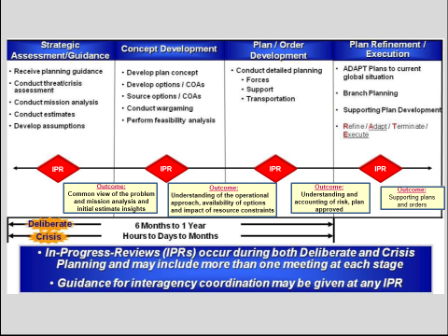

Figure A-1: Adaptive Planning and Execution Process
APPENDIX B: Global Force Management
Global Force Management is the DOD process to align force assignment, apportionment, and allocation methodologies to support joint force availability requirements, enable comprehensive insight into global availability of U.S. military forces, and provide senior decision makers a vehicle to accurately assess the impact and risk of proposed assignment, apportionment, and allocation changes.
1. Global Force Management Implementation Guidance (GFMIG). The GFMIG lays out the process, roles, missions, and functions to support the sourcing of combatant command requests for capabilities and forces to support emerging or crisis-based requirements. This biennial SecDef document establishes the processes to implement the Global Force Management (GFM) framework.
- SecDef assigns forces to CCDRs to meet UCP missions and responsibilities.
- SecDef apportions forces to CCDRs for planning.
- SecDef allocates forces to CCDRs to meet current operational requirements.
The three processes of assignment, allocation, and apportionment are related to each other. Figure B-1 shows the entire DOD force pool (every military unit, Soldier, Sailor, Airman, and Marine) within the "Service Institutional Forces" (recruiters, instructors, Service Title X forces—man, train, and equip) and "Operational Forces" boxes. This force pool is further divided by "assigned" (Forces For) to a CCDR, "unassigned" forces, and "Service retained" forces.
- Unassigned forces - Forces not assigned to a CCDR but retained under Service control to carry out functions of a Military Department.
- Service retained forces - AC and RC operational forces under the administrative control of respective Secretaries of the Military Departments, and not assigned to a CCDR. These forces remain under administrative control of their respective Services and are commanded by a Service-designated commander responsible to the Service – unless allocated to a CCDR for the execution of operational missions.
a. Apportionment for planning. The GFMIG groups forces into one of three apportionment “bins” (Figure B-1). The first bin contains forces apportioned for Homeland Defense planning. Bin "A" contains forces committed to ongoing operations. Bin "B" contains forces available for planning, both those that are readily available and those that are not (units in a degraded readiness posture for a variety of reasons that will require time to attain a deployable status). If a combatant command’s deliberate planning determines it requires forces from Bin "A," the CCDR must address this unsourced requirement with the SecDef through the Global Force Management Board (GFMB) process. The next edition of the GFMIG should add more granularity to the “not readily available” force pool within Bin B so that commanders and staffs can plan more accurately.
Figure B-1: Force Apportionment, Assignment, and Allocation Bins
b. Allocation for execution. Actual allocation of forces and capabilities occurs via the SecDef allocation process. As a point of clarification, the GFMIG only provides guidelines, policy, and processes for force allocation. Figure B-2 and its accompanying narrative describe this process in more detail.
2. Global Force Management Board (GFMB). The Director, Joint Staff chairs the Global Force Management Board with membership by representatives from OSD, the Joint Staff, Services, combatant commands, and DOD Agencies. The GFMB assesses and prioritizes combatant command requests for rotational capabilities, provides a prioritized list of combatant command requests to the Joint Force Coordinator and Joint Force Providers to use in identifying joint solutions for military capabilities among the Services, and frames any contentious issues for decision by the SecDef.

3. Joint Force Providers (JFP). The JFPs working through their assigned Service components, provide global sourcing recommendations via a Rotational Force Schedule (RFS) to fill GFMB-validated rotational force requirements.

- The Joint Staff J35 is the Conventional Joint Force Coordinator.
- USSOCOM serves as the Special Operations Forces JFP.
- USTRANSCOM serves as the mobility JFP.
- USSTRATCOM serves as the Joint Force Manager (JFM) for ISR and missile defense. The JFM develops recommended sourcing solutions collaboratively with the Joint Force Coordinator and JFPs for Missile Defense ISR capabilities and associated processing, exploitation, and dissemination capabilities.
- The geographic combatant commands serve as JFP for the General Purpose Forces assigned to their commands.
- The Services serve as JFP for the General Purpose Forces not assigned to a combatant command.
- DOD Agencies are JFPs for certain other capabilities not assigned to combatant commands or to the Services.
4. Force Allocation Process. The DOD uses the following force allocation process (including the corresponding steps in Figure B-2):
- CCDRs determine and validate the requirement then submit a Request for Force or Capability (RFF/C) to support annual or emerging operational requirements to the SecDef via the Joint Staff (steps 1 and 2 in Figure B-2).
- The Joint Staff validates the request and assigns the request to a JFP to determine a recommended sourcing solution (steps 3 and 4).
- The Joint Force Coordinator and JFP develop sourcing recommendations in coordination with the Services via their assigned global-looking Service Components. The recommendations will include any associated risks and other information considered germane to the sourcing recommendation. The recommendation must conform to existing OSD policy; any deviations must be accompanied by a detailed explanation for SecDef approval (steps 5 and 6).
- The Joint Staff receives the sourcing recommendations and staffs the draft deployment order (DEPORD) with DOD agencies and OSD. Combatant commanders and Service chiefs may communicate to the CJCS their assessment of risk or other issues associated with the recommended global sourcing solution. The Joint Staff coordinates with OSD, agencies, Services, or combatant commands with issues or equity to either articulate or adjudicate (if possible) issues that would result in a non-concurrence. The Joint Staff will, as required, convene an off-cycle GFMB, or Operations Deputies (OPSDEPS) Tank or JCS Tank to address and attempt resolution of contentious issues (step 7).
- The Joint Staff forwards the recommended sourcing solution with the non-concurrence, if not adjudicated in the GFMB, to the SecDef for approval (step 8).
- Upon SecDef approval, the DEPORD is forwarded for force flow execution in the Global Force Management Allocation Plan (GFMAP). The GFMAP is a consolidated directive that contains all SecDef allocation decisions in one document (step 9).

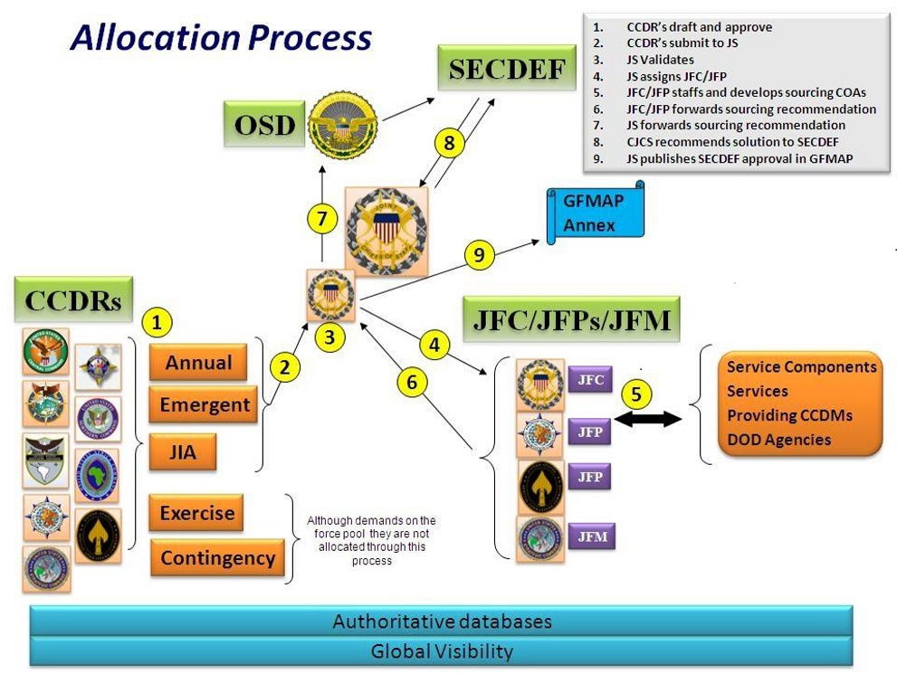

Figure B-2: Force Allocation Process
APPENDIX C: PMESII Systems Construct
The following is a partial list of the areas that should be considered during an analysis of each of the PMESII areas. Some may be potential nodes in each of the systems as well:
Political System
Leadership
Core Leadership
National Leadership
Regional Leadership
Local Leadership
Local Workers Parties
Regime Control of National Resource Systems
Security Apparatus
Secret Police
Detention Camps
Informants
Alliances & External Support
Legal
Symbolic
Domestic Image of Omnipotence, Omnipresence, Infallibility
Military System
Leadership
Command and Control
Intelligence
SIGINT
HUMINT
Electronic Warfare
Logistics
Mobilization
Civil Defense
Training
Underground Facilities
Stockpiles
Power Ventilation Access
Communications
Army
Artillery
Long-Range Missile Systems
Infantry
Armor
Engineers
Mobility
Mine Clearing
Bridging
Counter Mobility
Obstacles
Survivability
Navy
Surface Capabilities
Subsurface (Submarine)
Remote Control Vehicles
Mine Laying Submarines
SOF Platforms
Patrol Fleet Anti-Ship Missiles
Coastal Defenses
Radar Capabilities
Air Forces
Air-to-Ground
Fixed Wing
Rotary Wing
Air Defense
Radar/Integrated Air Defense System (IADS)
Precision Munitions Capabilities
Bases (Runways, Refuel Capabilities, Ramp Space)
Industrial/Technical Base (For Production and Repair of Advanced Equipment)
Communications
Missiles (Theater/Ballistic)
WMD (Research, Production, Storage, Delivery)
Space
Economic System
Industry
Financial
Distribution of Humanitarian Aid
Currency
Arms Exports
Corruption/Linkages
Black Market Agriculture
Drug Crops & Trafficking
Mining
Natural resource areas/production
Foreign investment
Trade linkages
Social System
Culture/System
Personality
History
Religion
Family Ties/Tribal Linkages
Organized Crime
Families: Traditional/Influential Controlling Major Decisions
Impact of Local Traditions
Infrastructure System
Transportation
Railroads
Trains
Bridges
Tunnels
Switches
Roads
Ships/Boats
Dams
Locks
Airports
Communications
Military Networks
Radio Telephone
Teletype Fiber Satellite
Visual
Civilian
Radio Telephone
Television Speakers
Signs
Energy/Power
Coal
Oil
Natural Gas
Hydro
Nuclear
Renewable Sources
Water

Information System
Education
Propaganda
Inside Country
Outside Country
Newspapers/Magazines
Information Technologies
Radio
Television
Internet
Social Media
Informal Transmissions (Word of Mouth/Rumor)
Cyberspace

THIS PAGE INTENTIONALLY BLANK

TAB A: Political System Points of Analysis
Political analysis of a foreign country begins with an assessment of the basic principles of government, governmental operations, foreign policy, political parties, pressure groups, electoral procedures, subversive movements, as well as criminal and terrorist organizations. It then analyzes the distribution of political power - whether it is a democracy, an oligarchy, a dictatorship, or has political power devolved to multiple interest groups such as tribes, clans, or gangs. Analysis must focus on determining how the political system really operates, not the way it is supposed to operate.
Basic Governmental Principles. The starting point of political analysis is the formal political structure and procedure of a foreign nation. Analysts must evaluate:
- Constitutional and legal systems.
- Legal position of the legislative, judicial, and executive branches.
- Civil and religious rights of the people.
- People's national devotion to constitutional and legal procedures.
Governmental Operations. Governments are evaluated to determine their efficiency, integrity, and stability. Information about how the government actually operates and/or changes its method of operation gives the intelligence user clues about the probable future of a political system. When assessing governmental operations, analysts should consider the following:
- Marked inefficiency and corruption, which differs from past patterns, may indicate an impending change in government.
- Continued inefficiency and corruption may indicate popular apathy or a populace unable to effect change.
- Increased restrictions on the electoral process and on the basic social and political rights of the people may mean the government is growing less sure of its position and survivability.
Foreign Policy. Analysis of a target country's foreign policy addresses the country's public and private stance toward the United States, foreign policy goals and objectives, regional role, and alliances. Analysts gather foreign policy data from various sources, to include:
- Diplomatic and military personnel.
- Technical collection systems.
- Official foreign government statements.
- Press releases.
- Public opinion polls.
- International businessmen and other travelers.
- Academic analyses.
Political Parties. Analysts study special interest parties and groups (e.g., labor, religious, ethnic, industry) to evaluate their:
- Aims.
- Programs.
- Degree of popular support.
- Financial backing.
- Leadership.
- Electoral procedures.
Pressure Groups. With few exceptions, most states have some type of formal or informal pressure groups. Examples include political parties, associations, religious or ethnic organizations, labor unions, and even illegal organizations (e.g., banned political party). The analyst must identify these pressure groups and their aims, methods, relative power, sources of support, and leadership. Pressure groups may have international connections and, in some cases, may be almost entirely controlled from outside the country.
Electoral Procedures. Elections range from staged shows of limited intelligence significance to a means of peaceful, organized, and scheduled revolution. In addition to the parties, personalities, and policies, the intelligence analyst must consider the circumstances surrounding the actual balloting process and changes from the historical norm.
Subversive Movements. In many countries, there are clandestine organizations or guerrilla groups whose intention is to overthrow or destroy the existing government. When analysts report on subversive movements, they should address:
- Organizational size.
- Character of membership.
- Power base within the society.
- Doctrine or beliefs system.
- Affiliated organizations.
- Key figures.
- Funding.
- Methods of operation.
Criminal and Terrorist Organizations. Criminal organizations in some countries are so powerful that they influence or dominate national governments. Analysts must examine the organization's influence or forceful methods of control. Most terrorist organizations are small, short-lived, and not attached to any government. Analysts should determine if external factors or even the area's government assists the terrorist group.

Political System Questions
National Political Structure:
- What is the type of governmental system in place?
  - Where does it draw its legitimacy from?
  - Are the sectors stable or in transition?
  - Does the electoral process affect them?
  - Where do they draw their power?
  - What is the source of their knowledge and intellectual income?
  - Who are the leaders? Where do they draw their power from?
  - Does a core bureaucracy staff them?
- Governmental Departments or Agencies (D/A)
  - Who are the key leaders? How are they linked within the power network?
  - Are the D/A stable or in transition?
  - Are new departments of agencies being created? If so, what is the cause of this transition? Societal/Cultural/Educational? Technical? Economic?
  - By D/A - What is the source of its workforce?
- Who are the leaders? Is it staffed by a core bureaucracy? What skill level?
  - Inter-Agency and Departmental dependencies?
  - External dependencies - Societal/Cultural/Educational.
National Political Demographics Structure:
- Ethnic and Religious Groups having political power:
  - Are these groups regionalized?
  - How do they exercise political power?
  - What is their legislative representation?
  - Is there a paramilitary structure?
- How do these Ethnic and Religious groups wield power within urban society? Rural society?
- Political Parties
  - What are the political parties? Externally or internally supported
  - Are they associated with ethnic, religious, or cultural groups?
  - Who are their leaders? Their allies?
  - What is their political opposition? Their allies?
- Political Action Groups
  - Where do they draw their power? Societal, cultural, technical, economic?
  - Where do they draw their intellectual capital?
  - What is the source of their leadership? Knowledge?
  - What are their external organs? Expatriate communities?
  - What is their relationship with the government?
Regional Political Relationships:
- Regional - Non-adversarial and adversarial? How are relations maintained – through economics, religion, culture, ideology, common needs?

- International - Non-adversarial and adversarial? How are relations maintained – through economics, religion, culture, ideology, common needs?
- Potential Allies during a conflict - National resolve to engage in conflict? Military resolve to engage in politically motivated action?
Other Considerations:
- Public confidence in government and in society.
- Factionalism or regionalism within the governmental structure. Challenges faced by the Government.
- Political effects caused by Organized Groups.
- Government Political Response to Group pressures.
- Political effects upon Internal and External Security - relates to Military.
- Government Response to Diplomatic Overtures.
- National Economic Goals affecting the Political structure.
- Police Mechanisms.

TAB B: Military System Points of Analysis
The analysis of the adversary’s military will focus on its leadership, capabilities, dispositions, and morale/commitment to its government, to include:
- Key military leadership, including their training and previous experience in senior leadership.
- Installations and facilities of a military significance (both primary and secondary purpose).
- Infrastructure in place to support identified installations and force structure.
- Military Units, including personnel and chain of command.
- Assigned equipment.
- Current and projected weapons system capabilities.
Military System Questions
Military Environment:
- Will the national leadership use military means to achieve objectives?
- Does the leadership intend to forge or enhance military ties with another state that poses a threat to regional security or U.S. interests?
- Does the leadership intend to enhance national military capabilities in a way that could be regionally destabilizing?
- Are the national leader's political goals a cause for concern?
- Key Leadership – residence, office, wartime command post, telephone, email, political patronage, religious affiliations, ethnic affiliations, personal assets, non-military activities, influences.
- Soldiers -- ethnic/religious composition by region of regular forces and elite forces, pay, training, morale, benefits, gripes/issues.
- Capabilities.
- Equipment imports: what, from whom, where based, points of entry.
- Support (spare parts, maintenance, and operational training).
- Indigenous production and assembly.
- Raw materials, natural resources.
- Supply - production, movement, storage.
- Days of supply on-hand of key supplies (e.g. rations, fuel, ammo, etc…).
- Transportation.
- Road capacity, primary lines of communication (LOC), organic transportation assets.
- Rail (same as roads).
- Water - Inland? Intra-coastal?
- Bridges - classification, construction materials, length, bypass.
- Tunnels - height/width restrictions, bypass.
- Organizations.
- Garrison locations, brigade or larger combat, battalion or larger combat support (CS) and combat service support (CSS).
- Naval port facilities, home stations.
- Airfields.
- Fixed fields, home station, associated dispersal/highway strips.
- Number and type aircraft at base.
- Intelligence, Surveillance and Reconnaissance (ISR).
- Assets and capabilities by echelon.
- National level/controlled assets.
- Associated ground stations/downlinks.
- Centralized processing and dissemination facilities.
- Center of excellence/HQ for each intelligence discipline.
- Commercial sources for imagery, dissemination capability, mapping, other.
- Military Communications.
- Fixed facilities.
- Mobile capabilities.
- Relay/retransmission sites Commercial access.
- Integrated Air Defense.
- Early warning.
- Target acquisition and tracking, guidance.
- Fixed launch sites.
- Mobile AD assets.
- Centralized C2.
- Airfields associated with counter-air assets.
- Airborne warning aircraft (e.g., AWACS).
- Electrical power requirements.
- Theater Ballistic Missile/Coastal Defense missiles.
- Fixed launch sites.
- Mobile assets.
- Meteorological stations supporting.
- C2 decision makers.
- Target acquisition.
- Target guidance/terminal guidance.
- Power requirements.
- Weapons of Mass Effects Capabilities.
- Number and type.
- Production, assembly, storage, delivery means.
- Imports required - source and mode of transport.
- C2 decision maker.
- C2.
- Rivalries - personal and inter-service.
- Decision making – dissemination/transmission means, direct or through chain of command.
- Special Capabilities.
- Special Operations Forces (SOF).
- Weapons of Mass Destruction (WMD).
- TBM.
- Human Intelligence (HUMINT).
- Submarines.
Military Situation: Under what conditions does the military execute its missions?
- Internal Conflict: Is there internal conflict within the military that could destabilize this country?
- Rivalry/Factionalism: Are there emerging or increasing rivalries or factionalism within the military?
- Power Struggle: Are there emerging or increasing power struggles within the military?
- Deteriorating Morale/Increasing Dissention: Is there deteriorating morale or increasing dissention within the ranks or in the officer corps?
- Civil-Military Relations: How loyal is the military to the current regime? Are there cultural or religious factors that might cause frictions and dissention? Are there changes or developments in civil military relations that could destabilize the country?
      - Government - Military Relations: Will the senior military leadership support and defend the government against internal resistance and insurgency? What factors might cause a loss of confidence and/or support? What factors might cause a military coup to occur?
      - Civil-Military Conflict: Is there increasing conflict between the civilian and military leaders? Is there a difference in views between junior and senior leaders toward service to the government? To the peoples/constitution?
      - Constitutional/Legal Conflict: Is there increasing civil military conflict over constitutional/legal matters?
- Socio-Military Conflict: Are there growing tensions/conflicts in socio-military relations that could destabilize the country?
      - Internal Security Role: Is the military assuming a new internal security role or increasing its involvement in internal security affairs?
      - Military Activities: Are military operations/activities having an increasingly adverse impact on society?
      - Criminal Activities: Is the military involved in criminal activity that are contributing to increased tensions/conflict between the military and the public?
- External Military Threat: Is an external military threat emerging or increasing?
      - Limited/Covert Military Action: Is an adversary engaging in or increasing limited/covert military action?
      - Conventional Military Action: Is an adversary preparing to engage in conventional military action against this country?
      - WMD/Advanced Weapons: Is an adversary trying to acquire or is in the process of deploying WMD or advanced weapons?
- Operational Status/Capability: Are there changes or developments in the military's operational status or capabilities that suggest pending military action?
      - Activity Levels/Patterns: Is there unusual change or a sudden increase in activity levels/patterns?
      - Personnel Status: Are there changes or developments in personnel status?
      - Force Capabilities: Are there significant changes or developments in force capabilities?

THIS PAGE INTENTIONALLY BLANK
TAB C: Economic System Points of Analysis
Analysis focuses on all aspects of the adversary’s economy that have the potential for exploitation. Among these are industrial production, agriculture, services and armament production. Concentration will be on those elements of the economy that are factors in foreign trade and factors on the internal economy that can have an impact on the political decision making process and popular support for the government. Both the official and underground (black-market) economies must be examined.
Concentration will be on the adversary and the regional and global countries with which it has its major trade and exchange linkages. Certain specific nations and regional economic alliances could be highly dependent upon adversary exports, and the impact upon these must be considered. The focus will be on critical elements of the trading partners that may be exploited and not their economy as a whole.
In the economic system, a great deal of information is available from open source. The initial task is to develop a baseline of information on the adversary’s economy, such as gross domestic product, growth rates, unemployment rates, money supply, economic plans, inflation, and national debt. Analysis may include:
Sources of National Wealth:
Natural Resources.
Products (Agriculture & Manufacturing).
Foreign Aid.
Foreign Trade.
Import/Export.
Trading Partners.
Domestic Consumption.
Management of the Economy.
Government Role.
Private Sector Role.
Corruption.
Slush Funds, Leaders' Bank Accounts.
Counterfeiting.
Economic System Questions
      - What are the key indicators of the economic health of the country(ies) of interest (COI)?
      - Which external factors have the most impact upon the economy? What areas of the economy are most susceptible to foreign influences and exploitation?
      - What is the impact of foreign economic assistance? What would be the impact of its reduction/removal?
      - What percentage of the economy should be classified as "black/gray market"? Are we able to quantify activities in this sector? Can we influence this sector?
      - What are the governmental rules on foreign investment? Who do they favor?
      - Which nations have the most to gain or lose from damage to, or a collapse of the economy? What are the most likely areas of economic growth?
      - Will there be growth in the private sector share of the economy? Who would benefit the most from this change?
      - How effective will be steps to diversify the economy?
      - What is the inflation rate? To what extent will steps to control inflation be successful?
      - Will government subsidies of selected products for domestic use continue? What would be the impact of their reduction/removal?
      - What is the anticipated trend in demand for foreign (particularly US) currency?
      - What is the prognosis for food production? Are they dependent on imports? Will rationing of essential goods continue? Which items are most likely to be rationed?
      - How will demographic factors (e.g., birth rate, adult/child ratio, rural migration to urban areas, etc.) affect the economy in the future?
      - What is the impact of the drug trade on the overall economy? Regional economies?
      - Will imports of military spending/hardware increase? Who are the most likely suppliers? Will these be cash transactions, or will a barter system be established?
      - What is this nation's standing within the International Monetary Fund and World Bank?
      - Is trade with European Union member nations expected to increase? If so, in what specific areas?
      - Have any key members of the economic sector leadership been educated in the West or China? If so, have they maintained contacts with their former colleagues?
      - Are changes to the current system of state-owned monopolies anticipated? If so, what will be the impact?
      - What are the key industries of the state(s)?
      - What are the major import/export commodities?
      - What is the trade balance? Is this a strength or vulnerability?
      - What is the labor situation (e.g., unemployment statistics, labor sources, unions, etc.)?
      - Who/what are the key government economic leaders/agencies?
      - Who are the principal business leaders in the country?

TAB D: Social System Points of Analysis
Analysis must study the way people, particularly the key leadership and natural leaders, organize their day-to-day living, including the study of groups within society, their composition, organization, purposes and habits, and the role of individuals in society. For intelligence purposes, analysts study seven sociological factors. The detailed list should be viewed as a guide for developing the necessary information to develop the Sociological Systems Summary for the target countries.
Population. Intelligence data derived from censuses and sample surveys describe the size, distribution, and characteristics of the population, including rate of change. Most countries now conduct censuses and publish detailed data. Analysts use censuses and surveys to evaluate an area's population in terms of:
- Location.
- Growth Rates.
- Age and Sex.
- Structure.
- Labor Force.
- Military Manpower.
- Migration.
Characteristics of the People. Analysts study social characteristics to determine their contribution to national cohesion or national disintegration. Social characteristics evaluated by analysts include:
- Social Stratification.
- Number and Distribution of Languages.
- Prejudices.
- Formal and Informal Organizations.
- Traditions.
- Taboos.
- Nonpolitical or Religious Groupings and Tribal or Clan Organizations Idiosyncrasies.
- Social Mobility.
Public Opinion. Key indicators of a society's goals may be found in the attitudes expressed by significant segments of the population on questions of national interest. Opinions may vary from near unanimity to a nearly uniform scattering of opinion over a wide spectrum. Analysts should sample minority opinions, especially of groups capable of pressuring the government.
Education. Analysts concentrate on the general character of education and on the quality of elementary through graduate and professional schools. Data collected for these studies include:
- Education Expenditures.
- Relationship between education and other social and political characteristics Education levels among the various components of society.
- Numbers of students studying abroad.
- Extent to which foreign languages are taught.
- Subjects taught in schools.
Religion. Religious beliefs may be a potentially dangerous friction factor for deployed U.S. personnel. Understanding those friction factors is essential to mission accomplishment and the protection of friendly forces. Analysts evaluate data collected on an area's religions, which includes:
- Types.
- Size of Denominations.
- Growth or Decline Rates.
- Cooperative or confrontational relationships between religions or sects, the people they represent, and the government.
- Ways the government deals with religious organizations.
- Roles religious groups play in the national decision making process.
- Religious traditions and taboos.
Public Welfare. To evaluate the general health of a population, analysts must identify:
- Health delivery systems.
- Governmental and informal welfare systems.
- Social services provided.
- Living conditions.
- Social insurance.
- Social problems that affect national strength and stability (e.g., divorce rate, slums, drug use, crime) and methods of coping with these problems.

Narcotics and Terrorism Tolerance. A population's level of tolerance for narcotics and terrorist activities depends on the relations between these organizations and the population as a whole. Analysts should determine if the tolerance is a result of the huge sums of money trafficker’s pump into the economy or a result of trafficker's use of force. Terrorists may be accepted and even supported by the local populace if they are perceived to be working for the good of the local people. The intelligence analyst must evaluate the way these organizations operate.

Sources. Due to the nature of the social focus area, the preponderance of information is envisioned to be open source. The initial task is to develop a baseline of information on the target nation. Basic data will be collected and analyzed. Numerous studies, sponsored by the U.S. Government as well as academic treatises are available. A more difficult problem will be making the essential linkages within the sociological area and with other focus areas, particularly political and economic.
Social System Questions
      - What are the general perceptions of social stability?
      - Who are the population’s most respected figures, why are they so respected, and how do they maintain the public focus?
      - What are the government's most effective tools for influencing the masses?
      - What dominant areas of society are emerging and causing instability or areas of conflict? Are any of these areas linked to political factors? Ethnic/racial?
      - What are the predominant economic areas that are contributing to, promoting, or exacerbating social instability?
      - How can interrelationships be established between religious and ethnic minorities in the COI? How can we effectively manipulate these relationships to affect a desired outcome?
      - What are perceptions of public safety primarily attached to? How is the level of violence defined by society? What elements may make it appear excessive?
      - What psychological effects does an increased level of violence have on a person's notion of safety?
      - What are the effects of increased criminal activity: on the family, the town, the region, and nationally?
      - How can the Coalition increase the psychological perception that the global economy is surpassing the COI?
      - How can the Coalition stimulate the notion that the government is failing to provide for basic elements, or is slow to produce results?
      - Examine the adverse effects of increased organized criminal activity upon society by industrial component. White collar or financial crime. Drugs and drug smuggling.
      - Proliferation of weapons: Note the types of weapons and to whom they are going.
      - Gang related activity: Is there a predominant ethnic group asserting themselves in this arena, and are they utilizing any particularly violent tactics to assert themselves?
      - What are the significant effects of increased public health problems? What public health issues have increased and how effectively is the government?
      - Identify how extensive the division of wealth is between ethnic and religious groups and their potential for promoting tension or conflict.
      - What are the effects of environmental problems having on society?
      - Identify the key groups adversely affected by increasing poverty rates.
      - Identify primary tools used by the government for influencing the masses. How do the masses validate information obtained by the government? Do they feel they need to validate information?
      - Who are the key opposition leaders? How do they influence the masses? How are they funded and by whom are they primarily funded?
      - Who are the key opposition groups? How do they influence the masses? How are they funded and by whom are they primarily funded? Identify any common themes to unite them, identify areas that may divide them.

      - How do opposition groups recruit? Do they target a specific social group? Is there a hierarchical structure? How are members dismissed from the ranks?
      - How do these groups affect one another? How do they affect similar groups in neighboring countries? Do they have external support?
      - What are each faction’s mechanisms for influencing the others? How do they communicate officially and unofficially? What factions are armed? Where do they get their weapons?
      - Are acts of civil disobedience increasing? Is the level of violence employed by the government to quell civil disobedience increasing? Are acts of vigilantism on the rise? How are disturbances quelled? What tools are brought to bear?
      - Identify consumer goods that are most valued by the COI's populace. Who controls supply? How are they networked? Any increase in a particular product?
      - What are the "hot button" issues dividing the various factions of the society?
      - What networks and mediums can be used to subvert and confuse each faction? What are the capabilities of regional allies to polarize these factions?
      - How are rumors spread most effectively?
      - What is the social perception of the military's ability to meet that threat? The states’ ability to meet the threat? The state’s ability to provide overall security in a micro/macro context?
      - How are troops conscripted? What are the incentives for service? What unofficial groups/associations exist within military? How do they recruit or dismiss people?
      - Is criminal behavior increasing within the military? What types of criminal activity occur within the military?
      - Identify the hierarchal structure of the military. Is there a dominant ethnic group assuming more leadership roles? What ethnic groups stay the most connected in the military, which groups are more apt to include outsiders?
      - Which ethnic and religious minorities feel the most repressed? How do they express their discontent? Do any organizations exist to channel their feelings? How responsive do they feel the government is to their issues?
      - How does the population view outside assistance? How likely is the government to ask for assistance? How is the need for assistance determined?
      - How are relief organizations viewed within the country? Are they busy? How effective are they at solving problems and meeting the needs of those they serve?
      - Problems with immigrant flows? How are refugees treated?
      - What consumer goods are in short supply? How are those goods brought to market, and who controls the flow of such goods? Is there a dominant ethnic group controlling the flow? How effective is the Black Market in producing hard to obtain goods?
      - What goods dominate the black market? Who are the primary producers and end receivers of goods? Is there a particular group emerging as the leader of the Black Market?
      - How are minority laborers networked with minority leaders? What are the links between labor groups and minority activists? What ethnic group(s) compose the majority of the skilled labor force? How is skilled labor kept from going abroad?

TAB E: Infrastructure System Points of Analysis
Infrastructure analysis focuses on the quality and depth of the physical structures that support the people and industry of the state. In developed countries, it is the underlying foundation or basic systems of a nation state; generally physical in nature and supporting/used by other entities (e.g., roads, telephone systems, and public schools).
Infrastructure System Questions
- Lines of Communications: Where are the key ports, airfields, rail terminals, roads, railroads, inland waterways, etc. located? Where are key bridges, tunnels, switching yards, scheduling/control facilities, depots/loading stations, switching yards, etc.?
- Electrical Power: Where are power plants, transformer stations, and relay and power transmission lines located? Where are the key substations, switching stations, and line junctures?
- Potable Water: Where are the water treatment plants, wells, desalination, bottling plants, and pumping stations? Where are the key pumping stations, control valves, and distribution line junctures?
- Telecommunications: What are the location and architecture of the domestic telephone system, cable, fiber-optic, microwave, internet, and cell phone networks and satellite stations? Where are the key control points and junctures?
- Petroleum and Gas: Where are the gas and petroleum fields, gathering sites, pumping stations, storage areas, refineries, and distribution lines? Where are the key pumping stations, control valves, and distribution junctures?
- Broadcast Media: What are the location, frequency, power, and radius of effective range (coverage) of the am/fm radio and TV stations? Where are the studios, antenna, and rely towers located? How are they powered? Where are the key control points and junctures?
- Public Health: What are the location of the hospitals and clinics? Are they adequately staffed, supplied, and equipped? Is the equipment well maintained? Is the staff well trained? Do they depend on foreign or domestic sources for their supplies, medications, and spare equipment parts? Where are the key control points and junctures?
- Schools: What are the location of the public, private, and religious primary and secondary schools and universities? Where are the key control points and junctures?
- Public Transportation: What are the public (bus/streetcar/taxi/etc.) transportation routes? Where are the key control points and junctures?
- Sewage Collection and Treatment: Where are the collections systems, pumping stations, treatment facilities, and discharge areas located? Where are the key control points and junctures?

Common Infrastructure Questions
- How are key facilities linked? (Physically, electronically, etc.)
- What are the key nodes? Where are they? Where are the disabling yet non-lethal/non-destructive infrastructure nodes?
- What are their alternates? What are the alternates for the above and how are they linked to the key facilities and each other?
- Are there indigenous capabilities? What indigenous capabilities could be used? How are they linked and organized? What are the critical nodes?
- What is the security surrounding the nodes?
- What is the security posture at these facilities? Who controls the forces? How are security forces/police/paramilitary networked? What training do they receive? What is their level of proficiency? Are they augmented as alert status (national or local) changes? What are the ground/naval/air defense capabilities at/near these facilities? How are they networked? What groups are likely to conduct industrial sabotage? How are they tasked, linked, supported?
- Who owns and who controls the infrastructure? Who owns and/or controls all of the above entities? Is ownership by private, corporate, or governmental entities? What organizations have regulatory oversight/control?
- What is the capability to repair damage to the system and restore it to service? Is maintenance and repair an integral part of the organization? What are their capabilities and limitations? Which contractors are normally used and for what purpose? Are repair/restore materials readily available or is there a long lead-time for critical supplies/components? Who are the key engineering contractors for these facilities? Can/will they share plans, blueprints, schematics, etc.?
- What would be the second-order effects of influencing the infrastructure?

TAB F: Information System Points of Analysis
Analysis of Information Systems and Operations includes:
      - Telecommunications capabilities and level of sophistication, tele-density rates, radio and television broadcast coverage including television, landline, cellular, Internet, radio, etc.
      - Interconnectivity of communications via ISDN, fiber optic, satellite, and microwave.
      - Primary nodes and trunks of telecommunications infrastructure including government, non-government, citizen, and military use of Information Operations.
      - Knowledge of COI key leaders' style and decision making habits, advisors' perception, and cultural influences.
      - Understanding governmental use of media influence, public affairs, and civil affairs interrelationships.
      - Knowledge of military, non-governmental organization, and law enforcement interrelationships.
      - Understanding of effects on adversary under psychological, computer network attack and defense, electronic warfare, and space operations.
- Locations and purpose of physical infrastructure of communications and broadcast towers, cables, and supporting operations centers are included within the infrastructure focus.
- Development of and use of computer network operating systems, IT industry skill sets, and software applications.
- Media affiliations, perceptions and sympathies to include censorship and self-censorship in news and entertainment print, and broadcast industries.

Information System Questions
- How effective are the COI’s network defense capabilities? What reactions could be expected following an incident? What recovery procedures are routinely exercised?
- What is the organizational structure of the telecommunications industry? How effective is the COI at managing physical security of infrastructure an implementing network security practices?
- What interrelationships exist between civil law enforcement, military, commercial and non-governmental agencies that would enhance the COI's response to an emergency?
- What redundancies exist within the COI's network to eliminate or reduce network down time? Cellular, satellite, landline, power back up? How effective is their exchange, backbone, architecture in providing redundancies?
- What would cause a slow-down of COI's network? In what ways can the effect be localized? (Geographic, logic, by agency, etc.)
- What bandwidth issues exist within the COI's communications industry? How well, and in what ways, does the government manage its allocation?
- What type of OPSEC practices does the COI routinely exhibit to deny exploitation?
- In what ways have military/civil/corporate operations centers improved their practices/tactics in keeping with the COI's technological improvements? Do they rely more heavily on computers/cellular/networks than in the past?
- What are the indicators, if they exist, that the COI has developed a more focused vision and strategic plan for using technology than it had in the late '90s? What effect has technology had on productivity, transportation, logistics, etc. in government, commerce, corporate, private sectors?
- How does the COI perceive their use of technology from a governmental perspective? From the citizens' perspective? Military? Business? Legal? Law enforcement? Non-governmental organizations?
- What is known about the COI's assessment of Blue network vulnerabilities and defense measures?
- Do regional and neighboring countries or satellite broadcasts (television, radio, and internet) have an audience in the COI's population? Which broadcasts are popular with citizens and what is the audience's demographic and statistic data? What programs or broadcasts are popular with minority political parties, resistance movements, academia, etc.?
- What is the topology design the COI networks utilize? Which exchanges and trunks are co-located within government-controlled facilities? Are government-commercial partnerships used to provide network services?
- What is known of current and planned technology projects: fiber optic cabling? ISDN access expansion? Satellite leases and launches? What is the operational status and capability of COI's Low-Earth Orbit satellites?
- What Internet domains are accessible to the population? Is reliable language interpretation software available? What licenses does the government require for web hosting?
- What governmental directives address network security in supporting national security objectives?
- What messages might be effective in the COI? What themes are prevalent in the media?
- What advances in communications technology have enabled improvements in military hardware employment? Describe the use of telecommunications technology in law enforcement operations.
- To what degree and direction are telecommunications infrastructure investments impacting military readiness? Describe the state of international telecommunications connectivity to the COI?
- Which current telecommunications and Internet security operations have been exercised? Is there a national crisis action plan?
- What practices and policies does the government use in monitoring information-related media (TV, radio, Internet, etc.)? What enforcement methods have been employed?
- Which print media and on-line content do citizens turn to for news? Entertainment? Social Media? Do censorship policies or self-censorship trends exist in the COI?
- Is there a market and distribution pipeline for recorded or intercepted news or entertainment programs? In what ways does law enforcement interact in this market?
- What is known about COl's network operating systems? What IT skill sets are known to be in high demand?
- Is software piracy prevalent? Counterfeiting? Drug smuggling? Organized crime? Identity theft?

THIS PAGE INTENTIONALLY BLANK

Appendix D: Crisis Action Planning
1. General.
Crisis Action Planning (CAP) is the time-sensitive, coordinated development of joint operation plans and operation orders for the deployment, employment, redeployment, and sustainment of assigned and allocated forces in response to a crisis. In CAP, a crisis may be defined as an unexpected, quickly developing situation which touches our national interests, creating new strategic conditions of such imminent or probable danger or opportunity that the rapid commitment or re-missioning of the instruments of national power may be necessary to avert or mitigate consequences or secure advantages to achieve existing or newly-developed national objectives.

CAP is one of two joint operation planning processes; the other being Deliberate Planning. Procedurally, both use JOPP and equally relate deeply with operational design. Furthermore, the same organizations and senior leaders who make up the Joint Planning and Execution Community (JPEC) are involved in both CAP and Deliberate Planning. Also, in CAP the authorities and responsibilities of the JPEC members remain the same as they are in Deliberate Planning. However, CAP differs from Deliberate Planning in important ways.

Deliberate Planning looks to a future environment bounded by a large body of assumptions about the political and military situation, to include forces that will be available. On the other hand, CAP is conducted within a real-time volatile situation and rapidly evolving operational environment where there are fewer assumptions, and where planners deal with allocated and available forces rather than apportioned forces. To keep ahead of an evolving crisis, CAP is both faster and more flexible than Deliberate Planning. In fact, within the CAP process, abbreviated formal orders may follow verbal instructions and CAP steps may be omitted, compressed, or combined. CAP planning is also much more narrowly focused than Deliberate Planning, since CAP generally seeks to resolve a single issue and has a much shorter time horizon. All of these factors influence CAP process and products.

One of these CAP-unique products is the specific set of standardized messages embedded in the CAP process. Although this may appear to restrict and slow the process, these formal messages are an important tool in keeping the JPEC synchronized and updated. Imagine an hourglass where the messages, staff work, phone calls, video teleconferences, and the volatile swirling of events are in the large upper portion of the glass and where the messages are the constricted center orifice. The messages harness all the elements of the disparate coordination by commanders and staffs and impose a coherency and authority on the information grounded in a single common understanding of the situation. The messages are the “ground truth” within the process.

CAP also differs from Deliberate Planning in that senior leaders in the JPEC, often times including the President, are involved actively, early, and deeply in the CAP process. Moreover, their personal interactions, as well as the interactions of their staffs and subordinate commanders form a robust and continuous vertical and horizontal coordination network, which informs and enables the process. Although CAP could function without such a network and rely strictly on formal message traffic, this would be a slow, cumbersome, and ultimately brittle method to address crisis resolution.

The outcome of CAP is different than that of Deliberate Planning. The Deliberate Planning process’s end result is an operations plan (OPLAN), which may or may not be executed (although portions of it Phase 0 may). CAP’s outcome, if it moves through all of its steps, is a body of executable (and often actually executed) operations orders (OPORDS). OPLANs have certain durability within APEX, whereas OPORDs are highly perishable since they are based on current situations and available forces which of course change over time.

The Deliberate Planning process and its products complement and facilitate CAP by enhancing the understanding of the staff about the operational environment and by building relationships that the staff may leverage during CAP. Moreover, the OPLANs created during Deliberate Planning, although rarely perfectly aligned with a crisis situation, allow for the rapid and confident development of courses of action during CAP.

The existence and applicability of “on the shelf” plans create three entry points for beginning CAP:

– Use an existing OPLAN or CONPLAN. This approach is viable if the situation presented during the crisis is aligned closely enough with the desired end states, assumptions, and mission contained in the existing plan. In this case, the conversion of the extant plan into a body of executable orders during CAP is rapid and fairly straightforward; depending of course on the Level (I through IV) of the plan. This is the most preferable start point for CAP.

– Modify an existing OPLAN or CONPLAN. This approach is suggested when the commander judges that while elements of the existing plan are applicable to the military requirements of the crisis, the staff must conduct additional planning to fully adapt the plan to the conditions and mission of the crisis. This is often occurs with Level I and Level II CONPLANS which may be perfectly matched to the situation, but are insufficiently developed to begin crafting OPORDs from.

– Start from a “blank sheet.” CCDRs must use this option if there is no plan on the shelf that is even close to the existing crisis situation.
2. Relationship between CAP and Deliberate Planning. Figure D-1 shows the relationship between Deliberate Planning and CAP.

Figure D-1: Relationship between Deliberate Planning and Crisis Action Planning

3. Crisis Action Planning Components. There are six components to Crisis Action Planning with corresponding message types.
- Situation Development – initiated upon observation of an event
- Situation Assessment – initiated by a CCDR Assessment (OPREP-3)
- Course of Action Development – initiated by a CJCS Warning Order (WARNORD)
- Course of Action Selection – initiated upon receipt by CJCS of proposed COA(s) from CCDR in a Commander’s Estimate, or by an Alert Order (ALERTORD) from CJCS
- Detailed Plan Development – initiated by a CJCS Planning Order (PLANORD)
- Execution – initiated by an Execution Order (EXORD)
The remainder of this handbook explains execution of the CAP process. Though the CAP process applies only to the JPEC, this handbook also describes the interaction of CAP with the various actors in the national security policymaking community. Figure D-2 graphically depicts the CAP process.
Figure D-2: Crisis Action Planning Process
SAMPLE OPREP-3 P

Component I ― Situation Development

The Situation Development step begins when an event occurs somewhere in a theater of operations. The observer recognizes the event as a potential problem and reports it as such. The actors that are initially involved include the Combatant Commander (CCDR) within whose theater the event occurs, and the intelligence community, including the Central Intelligence Agency (CIA) and the Defense Intelligence Agency (DIA). The DIA becomes cognizant of the event and reports it directly to the Secretary of Defense. The DIA will also share intelligence information with the CCDR within whose theater the event occurred.

The Director, National Intelligence will, if the situation and its severity warrant, brief the President providing background information on the area of the world and a chronology leading up to the event.

The Geographic Combatant Commander is the focus for Situation Development in the JPEC, as events occur within a theater. The CCDR makes the decision to inform the higher echelons. The CCDR sends an initial report on the incident to the SecDef, the CJCS, to other commands and agencies, and to subordinate commanders in the form of an OPREP-3 PINNACLE report. Note that the incident will be reported through other means, both inside and outside of DOD. The intelligence community may also submit a Critical Intelligence Report (CRITIC).

The CCDR, through its service components, begins to assess the readiness posture. The components activate procedures required to exercise Title 10 responsibilities. The Service Component Commanders report their status to their respective Services, and to their CCDR. The CCDR formulates a picture of the readiness of his command structure and the forces for planning, with any constraints that must be overcome. These forces apportioned for planning may not be currently assigned to the CCDR, but may be allocated to the CCDR in the event of a crisis that results in a military response. The CCDR provides guidance to the service components for further dissemination down to the individual unit level. The CCDR’s staff and the command’s service components should review applicable contingency plans.

DIA briefs the SecDef on the situation, who has also received the initial report from the CCDR. The SecDef now solicits advice from, and provides guidance to, the CJCS. He also prepares to brief the military aspects of the event to the President.

The CJCS provides direction to the Joint Staff after receiving the initial report from the affected CCDR, and guidance from the SecDef. He shares information with the Service Chiefs, and stands by to brief the President if required. The Joint Staff now begins to monitor the situation, evaluates the CCDR's actions, orders further intelligence gathering, and coordinates laterally all efforts with the Services. The JS provides constant feedback to the CJCS.

The Joint Staff J5 serves as the primary conduit of information between the military and the rest of the interagency community. The J5, or one of the J5 action officers, represents the military, along with a member of OSD Policy, at all interagency crisis coordination meetings, and prepares the Vice CJCS and the CJCS for attendance at the senior coordination meetings, such as the Principals and Deputies Committees in the National Security Council.

The Services can now perform their analysis having received information from the Joint Staff, guidance from the Service Chiefs, and input from the CCDR's Service Component Commanders. The Service staffs conduct preliminary analysis on component logistics, training, personnel and general operability of the respective components within the Combatant Command. The Service Chiefs formulate guidance and provide information to the CCDR’s Service Component Commanders. They also present, as members of the Joint Chiefs, input to the CJCS.

The CCDR submits an OPREP-3 Pinnacle Combatant Commander’s Assessment (PCA). This report provides the CCDR’s initial assessment of the situation to the CJCS, the other commands and agencies, and subordinate component commands, and incorporates initial guidance from the CJCS and critical information from the component commanders. This assessment will include an update on the current situation, actions being taken by the command and within the theater, identifies forces readily available and the earliest expected time for commitment of forces, and any barriers to the employment of military options. The CCDR may include his views on military options that may be used as the situation matures. In addition, the intelligence community may prepare Daily Intelligence Summaries (DISUMs).

The CCDR sends his PCA to the other Geographic Combatant Commanders (GCC), the Functional Combatant Commanders (FCC), the Services, the supporting Agencies (such as DIA, the Defense Logistics Agency (DLA), the Defense Information Systems Agency (DISA), the National Geospatial Agency (NGA)), as well as to subordinate commands. He may also send a copy to other interested parties, such as other agencies and affected ambassadors.
At this stage, the President has been made aware of an event with possible national security implications. The President's active role in the crisis action process occurs in subsequent phases. At the point when the CCDR's Assessment is in the hands of the SecDef and the CJCS, Situation Development is completed, although all concerned parties continue to maintain their situational awareness and understanding throughout the CAP process.

Component II ― Situation Assessment

Situation Assessment begins when the supported CCDR submits his Commander’s Assessment. This phase is characterized by increased awareness and reporting, with intense information gathering.

The CJCS will direct the staff to analyze the CCDR's Assessment. This analysis should include a review of current strategy and existing OPLAN data in the APEX database.
The CJCS will also forward the Assessment to the Service Chiefs, with a request that the Chiefs evaluate force readiness posture and sustainability issues. The Service Chiefs, having received guidance from the CJCS and reports from the component commanders of the affected CCDR, direct actions to increase and enhance resources for the CCDR if further military action becomes necessary. The Chiefs will generate logistics support from their level in a "top down" fashion, ensuring equipment fills, repair parts flows, food, fuel and ammunition replenishment and other logistics occur seamlessly to the CCDR's service components. The Departments of the Army, Navy and Air Force will analyze unit personnel fills. The Services now evaluate force readiness postures and sustainability, and identify possible requirements for Reserve Component forces that may require mobilization.

The individual Service Component Commanders within the affected Combatant Command assimilate the CCDR's guidance and disseminate the CCDR's Assessment of the event or crisis. The Service Component Commanders direct their subordinate commands to increase readiness reporting, adhering to any service policies or local command SOPs. Deployment or alert postures may be raised for certain units. The Service Components provide readiness information to the respective Service Chiefs.

The Services, having received from their staffs the status of logistics support and personnel fills that may be applied against the combatant command, provide this information to the CJCS and the individual component commanders working for the CCDR. The Services are responsible for Title X support of the forces of their respective component. This responsibility includes considering Reserve Component forces that may be required, and assessing budget impacts and developing input for supplemental appropriations. The Services work through the CCDR’s Service Component Commands to determine logistics and personnel readiness. This allows the Services to cross level as needed to provide required support to the affected GCC.

The FCCs will also receive the Commander’s Assessment. Each of these four-star commands may be involved in supporting the affected CCDR as the situation matures.

USTRANSCOM begins a review of the availability and status of strategic lift assets. USTRANSCOM will provide initial capability information to the CJCS as soon as possible. USSOCOM is responsible to provide special operations forces and capabilities to the theater. USSTRATCOM coordinates global strike, missile defense, and cyber-attack and -defense. These three FCCs commence initial assessment of capabilities and provide any pertinent information to the CJCS.

The Joint Force Providers (the Services, USTRANSCOM, USSTRATCOM, USSOCOM, the Agencies, and other GCCs with assigned forces) will review unit readiness to support the GCC. The readiness status of these forces is now the key factor in future actions taken by this Combatant Command.

The CCDR consolidates all analyses, readiness information, and other data that measures his ability to perform missions under various contingencies. He also aggressively collects intelligence within his theater. His staff conducts a review of any existing OPLANs and CONPLANs (and possibly develops new ones) that fit the situation and anticipated events. Periodically, the CCDR may send an updated situation report (SITREP). The CCDR also provides DISUMs, and Intelligence Situation Summaries (INTELSITSUM) as major developments occur. This collective body of information is provided to both the CJCS and the SecDef.

The CCDR may participate in a secure video teleconference in-progress review with the CJCS, SecDef, and other members of the JPEC. The purpose of this IPR is to enhance mutual situational awareness and understanding.

The President confers with his key advisors and cabinet members to weigh the diplomatic, military, economic, informational, and political implications of the event -- the "crisis." The National Security Advisor (NSA), the Director, National Intelligence (DNI), the SECSTATE, the SecDef, and other cabinet members as appropriate are included in the deliberations. The CJCS will most likely be present in his statutory advisory role. Each member provides his or her assessment and recommendations for the situation.

The National Security Advisor advises the President on the situation and its potential impact on national interests within the realm of our own well-being. The NSC will have conducted an analysis of the forming "crisis," a determination of its severity, and a preliminary statement of our national objectives. This information is provided to the President. DNI provides additional information from the national intelligence agencies.

SECSTATE discusses diplomatic ramifications of the event, both to the nation in which the incident occurred as well as to the United States. Possible reactions from both allies and adversaries for possible U.S. actions may now be "on the table" for discussion. The SECSTATE may discuss evacuation of U.S. nationals and civilian noncombatants. SECSTATE consults closely with the ambassador(s) in the country(ies) concerned.

SecDef and CJCS presents any reasonable military options that are now being reviewed.

Other cabinet members offer counsel as necessary to the President. The Secretary of Transportation, the Secretary of Commerce, the Secretary of Energy, and other cabinet officials have their opportunity to influence the first decision that the President makes in the Crisis Action Process.

The President, with counsel from the National Security Advisor and discussion with his cabinet, states the national objectives relative to the situation and, of these, the national interests that may be at stake. Diplomatic, informational, economic and military options are discussed in detail. The President will then provide guidance back to his National Security Advisor for the development of any policy directives.

The National Security Advisor may formally state the President's position in a policy directive document. The NSA assembles an interagency working group to assist in the formulation of this policy document.

The SecDef, upon receiving Presidential guidance, translates the intent and the military objectives into possible military options, and provides this to the CJCS.

The CJCS, with input from all players in the Crisis Action Process, now recommends to the President and Secretary of Defense that a directive to develop specific courses of action be developed. Acting on information from many sources, the CJCS may also recommend that certain units be put on alert or even earmarked for deployment, through a Deployment Order or Prepare to Deploy Order. Note that only the SecDef can direct deployment of military forces. The CJCS can issue orders that direct units to prepare for deployment, or for planning tasks, but can only issue orders directing deployment with the approval of the SecDef.

The Situation Assessment step comes to an end once the decision is made for military COA development. All parties continue to assess the situation to maintain current situation awareness and continually improve their understanding of the situation.

Component III ― Course of Action Development

Though CCDRs have likely already begun to consider potential operational approaches for military options for resolving the crisis, the Course of Action Development step begins when the President and the Secretary of Defense direct that military courses of action be developed.

The SecDef will formulate additional strategic guidance and discuss it with the CJCS for complete understanding prior to further action. The CJCS issues a Warning Order to the entire military structure that provides the strategic guidance. The Warning Order describes the updated situation, establishes command relationships, states the current mission, objectives, assumptions and constraints, refers the planners and executors to the applicable OPLANs and CONPLANs, allocates forces to the mission, tasks transportation assets, establishes a tentative C-Day and the anticipated D-Day, and provides guidance on administration, logistics, communications and other areas as appropriate. The bottom-line purpose of the Warning Order is to direct the supported CCDR to prepare feasible and acceptable Courses of Action (COA).

The supported CCDR may participate in an in-progress review (likely by secure video teleconference) with the SecDef, CJCS, and other members of the JPEC to verify mutual understanding of the mission given in the WARNORD. This is also an opportunity to confirm assumptions upon which planning is based. The IPR may include actors outside of the JPEC, such as other concerned agencies, ambassadors, and selected multinational partners’ senior representatives.

The supported CCDR directs his staff and his subordinate component commanders to develop viable COAs. The CCDR has three basic options:
- the staff may use an existing OPLAN and modify it to bring it up to date
- if a CONPLAN or an OPLAN for a different situation that may have some applicability exists, the staff may simply need to further develop it to make it executable
- if no existing OPLAN is appropriate, then a concept of operations and time-phasing of forces must be developed from scratch.

In any case, the staff should review any existing Time-Phased Force Deployment Data (TPFDD) (the coordinated detailed list of independent force modules that must be moved into the theater, with corresponding times, departure and arrival ports, and modes of movement). The CCDR must now consider movement of the forces within the theater, either organic or TPFDD-filled. The supported CCDR publishes a TPFDD Letter of Instruction, which sets the parameters for incorporation of new forces into the theater -- their deployment, replacement and redeployment.

The Services implement their responsibilities of resourcing and sustainment planning -- regardless of the COA ultimately chosen. The readiness posture of the components in the affected Combatant Command is the motivating force for all efforts by the Services.

The supported CCDR decides what COAs are most supportable, and tasks the subordinate and supporting commands, agencies and services to evaluate his COA recommendations, through an Evaluation Request Message (ERM). The rest of the JPEC now analyze the supported CCDR’s COAs.

The component commands work with their respective Service staffs to develop feasible force lists to support the COAs. The Service Staffs, working under the parameters of the CJCS Warning Order, the supported CCDR’s ERM, and instructions from the Service Chiefs, analyze the supportability of COAs being considered.

USTRANSCOM will refine force requirements and analyze all required movements under each considered COA. USTRANSCOM provides the supported CCDR and the CJCS with land, air and sea estimates for each COA through a Deployment Estimate. In this estimate, USTRANSCOM surfaces any significant limitations, such as late closures, maximum port workloads, insufficient strategic lift, and incomplete or inaccurate movement data.

USSOCOM and USSTRATCOM evaluate the proposed COAs and develop their own scheme of support for each of the proposed COAs; and analyze the COAs for "pros" and "cons" for supportability.

Other GCCs, if affected, will evaluate each of the proposed COAs. The major involvement for any regional command is the possible releasing of units from its theater into the affected one, usually on a temporary basis, and contingent on the ultimate mission to be performed. These commands assess the impact on their operations if such forces are transferred.

Once the analysis is complete, the supporting CCDRs, Agencies, Services, and subordinate component commands prepare and send an Evaluation Response Message to the supported CCDR and to the CJCS that provides their assessment of the proposed COAs.

Assimilating all the information provided by his component commanders and the supporting Combatant Commands, Agencies, and Services, the supported CCDR prepares the Commander's Estimate. This estimate captures the considered COAs and provides the CCDR’s recommended COA. It includes a statement of the mission, the latest updated situation and the CCDR's own ongoing actions, an analysis of opposing courses of action, a comparison of all COAs under consideration, and the CCDR's recommended COA, and identifies shortfalls, constraints, and problem areas.

The CCDR also identifies his desired C2 structure, such as formulation of a Joint Task Force. The Course of Action Development step ends when the CCDR submits his Commander’s Estimate to the CJCS.

Component IV ― Course of Action Selection

The Course of Action Selection step begins when the CJCS receives the Commander’s Estimate.

The CJCS, having received all information and COA recommendations from the supporting CCDRs, the Service Chiefs and the Joint Staff -- and the Commander's Estimate from the supported CCDR -- consolidates and provides the information to his staff for a final review and COA recommendation. The Joint Staff conducts a thorough review of the Commander's Estimate and the Evaluation Response Messages, and packages the COA recommendation for the CJCS.

The CJCS provides the Commander’s Estimate along with questions and guidance from the President and SecDef to the Joint Staff and the Service Chiefs for further analysis. At this stage, the CJCS may elect to concur with the supported CCDR's recommended COA – in whole or in part – or he may direct development of additional COAs.

The CJCS may direct publication of a Planning Order (PLANORD) prior to final COA selection by the President and Secretary of Defense. The purpose of the PLANORD is to direct execution planning by all elements. The order saves time by allowing all participants to commence execution of all actions that would be common to the COAs under study, providing the CJCS flexibility in directing military activities in response to fast-breaking events inherent in a crisis. The Planning Order identifies the planning assumptions, forces and resources for planning, defines the objective, tasks and constraints, provides further planning guidance, and gives the supported CCDR a deadline for an Operations Order. If the situation is extremely time-sensitive, the PLANORD may replace a WARNORD.

The supported CCDR will direct his component commanders to execute their portions of the PLANORD from the CJCS, any additional mandates provided by the CCDR, and all actions to prepare themselves for future anticipated missions.

The Service Component Commanders work logistics aspects (supply, transportation, and services), personnel cross-leveling processes, finalization of any plans to accept and incorporate units that will be provided to them by the JFPs, and take other actions required to increase readiness.

The Service Chiefs review the COAs from two perspectives – as members of the Joint Chiefs (and advisors to the President and Secretary of Defense) and as the heads of their respective services (with interest and influence on logistics and personnel resourcing). The Service Staffs work on any details germane to the readiness of the CCDR’s Service Components and provide feedback and updates to the Service Chiefs as necessary. The Service Chiefs update the CJCS on any important issues revolving around adherence to the specifications of the PLANORD, and any problems for executing and supporting the Courses of Action under consideration.

USTRANSCOM is now focused on the COAs as directed in the PLANORD. The USTRANSCOM staff works all aspects of strategic lift for COAs to completion and provides feedback to the CJCS and the supported CCDR.

USSOCOM and USSTRATCOM plan to conduct the tasks specified in the PLANORD in conjunction with the supported CCDR.

The Joint Staff J3 alerts the JFPs that are likely to be allocated to the supported CCDR for the crisis. The JFPs’ focus will be on further preparation of units for both deployment into the gaining theater as well as other measures to ensure preparedness when these units "hit the ground" in the crisis theater. All commands keep the CJCS and the supported CCDR fully informed.

The supported CCDR provides progress reports to the CJCS, along with the habitual DISUMs and SITREPs. The CCDR reports any major execution issues to the CJCS –
issues that may have arisen from either the Service Components or from the other CCDRs and Agencies rendering support.

The President articulates any questions, concerns and perceived problems with the military courses of action to the SecDef to address. In a major crisis, the President may direct the supported CCDR to participate directly in these discussions. SecDef provides gives the President his recommended COA. With the advice of his cabinet and advisors, coupled with the SecDef's counsel and military COA recommendation, the President decides on the final Course of Action.

SecDef provides the President-approved Course of Action to the CJCS with any necessary strategic guidance and additional input. CJCS transmits this guidance to the community with an Alert Order. The Alert Order is a record communication that the President has decided to pursue a military solution to the crisis. The Joint Staff will, with guidance from the CJCS, amplify and modify the information found in the Planning Order to construct the Alert Order. The Alert Order provides tasks to the supported CCDR and to supporting Commands, Agencies, and Services. It contains specific information on the combat forces used, the strategic lift which will be utilized, and C-Day and L-Hour information. If the President had decided earlier what COA to use, the Alert Order may replace the PLANORD earlier in this step.

The Alert Order must be approved by the SecDef. Transmittal of the Alert Order ends Course of Action Selection.

Component V ― Detailed Plan Development

Detailed Plan Development begins upon receipt of the CJCS Alert Order by the community.

The Alert Order is not an order to execute, though in certain cases in a compressed timeline, an EXORD can be issued instead of an Alert Order. It must be transformed into an OPORD that can be executed when directed by the SecDef. To build a coordinated set of executable OPORDs, the JPEC must closely coordinate execution planning, force preparation, and deployability posture reporting. The JPEC works out actual combat and support forces, sustainment parameters, and strategic transportation resources to a fine level of detail.

The supported CCDR, using the approved COA and the Alert Order, constructs an OPORD, which will provide his components and supporting commands a detailed set of tasks and missions for the upcoming operations. The OPORD includes task organization, instructions for the conduct of operations, logistics support, and command and control structure. The supported CCDR will also publish a TPFDD letter of instruction (if not done previously), providing procedures for the deployment, Joint Reception, Staging, Onward Movement, and Integration (JRSOI), replacement and redeployment of the forces that are (or will be) part of his command or in a supporting role. The CCDR will validate that early-deploying forces' requirements are adjusted as needed in response to both the alert order and the current situation. The CCDR is responsible to ensure the entire community is using APEX, and provides instructions to enable this. The CCDR submits the OPORD, along with a summary of critical shortfalls, to the CJCS for final review. The CCDR also provides the OPORD to the supporting CCDRs, Services, and Agencies, to enable them to complete coordination of their supporting operations orders.

The CJCS keeps SecDef informed on progress of all actions at all levels – Pentagon, supported CCDR, supporting CCDRs, Services, and Agencies. As execution planning continues, CJCS transmits information and guidance between SecDef and the community, most critically the supported CCDR. The Joint Staff monitors all preparations for the execution of operations and deconflicts scheduling and over-commitment of forces. The CJCS reviews the supported CCDR's operations order and supporting OPORDs and provides input back to the CCDRs, Services, and Agencies.

The Services, with the guidance provided by the CJCS and the latest information portrayed in APEX, resource estimated sustainment requirements and shortfalls identified in the Defense Readiness Reporting System. The Services determine and finalize mobilization requirements and take actions to mobilize forces. The Services also recommend or initiate actions to improve manpower status and industrial readiness. The Services submit any mobilization requirements to SecDef for Presidential approval.

The subordinate component commanders, in receipt of their CCDR's guidance, the CJCS Alert Order, and updated information from the Services, prepare their component operations plans (to the point where only an execution date would transform them into orders). The component commanders' major concerns are the reception of allocated units into the theater. They plan for the initial sustainment of supplies (usually for a 30-day time frame). The Service Components also plan for personnel fills.

USTRANSCOM, in coordination with the GCCs, and acting on the alert order and the lift requirements of the supported CCDR, continues to develop feasible transportation schedules. If not done previously, USTRANSCOM conducts a deployment estimate for all force movements, and personnel and logistics sustainment flows into the affected theater. Information is passed to the CJCS and the supported CCDR in the form of air and sea movement schedules. USTRANSCOM constructs its supporting order and informs the SecDef of any requirement for activation of any level of the Civil Reserve Air Fleet (CRAF) and/or Voluntary International Service Agreements (VISA) for surface shipping that may be required to support expanded transportation requirements.

USSOCOM and USSTRATCOM develop their own supporting OPORDs for the supported CCDR’s OPORD.

The JFPs focus on preparing the supported CCDR's forces for planning and provide other support as needed by the supported CCDR. They monitor deployment preparedness – the status of units and equipment, unit availability for deployment, positioning of units for strategic lift, and location of transportation support units at intermediate and debarkation ports. The JFPs update specific unit movement data in APEX.

Detailed Plan Development ends when the CJCS has provided the executable OPORD and supporting OPORDs to the SecDef.

Component VI ― Execution

Execution begins upon approval of the OPORD by SecDef. The purpose of this step is to implement execution orders and execute the operation.

The Supported CCDR will likely participate in one more planning IPR with the SecDef. This last IPR is to go through the OPORD in detail, to ensure coordination across the JPEC and outside of the JPEC, and to confirm consonance with the President’s intent.

The SecDef (or the CCDR if directed by the President or SecDef) will brief the President on the operation, to include the status of all forces, including any recommendations for mobilization of Reserve Component forces, and provides a recommendation for execution, postponement, cancellation, or alteration of further deployment efforts. The President, having received the advice and recommendation from the SecDef and other Cabinet members, and having been completely briefed on the details of the military course of action, now decides what to do. The President decides to execute the course of action he selected previously, or he may decide to postpone or cancel the execution.

If the President directs execution, the SecDef now directs the CJCS to issue an Execute Order (EXORD). This order directs the supported CCDR to carry out his OPORD or directs implementation of an OPLAN, and the supporting CCDRs to execute their supporting OPORDs or OPLANs. The EXORD is a record communication that may include further guidance, instructions, or amplifying orders to all the participants in the operation. If the President and Secretary of Defense want to deploy forces, but not necessarily employ them yet, they may direct publication of a Deployment Order instead of an EXORD. The EXORD specifies the execution time for the operation (D-day and H-hour) and reconfirms deployment time (C-day and L-hour). It also specifies any combat force and strategic lift information, as well as any deviations to the OPORD. The CJCS passes the EXORD to the supported CCDR, supporting CCDRs, Agencies, and Services, directing them to execute their OPORDs, with any specified modifications.

CJCS monitors all aspects of the conduct of the operations throughout execution, and, based on progress reports from the CCDRs, Agencies, and Services (via APEX), and recommends to the SecDef any actions needed to effect a quick and successful termination for the crisis. The CJCS may introduce revisions to the current ongoing execution, ensuring that all new changes still reflect the Course of Action selected by the President, or he may recommend revision of the approved Course of Action. The CJCS continues to assess accomplishment of objectives, and reports milestones to the SecDef.

The CCDR executes his OPORD, directing Service Component Commanders and other subordinate commanders to execute their orders. The CCDR monitors progress, and reports all pertinent information for future operations and attainment of objectives. He maintains constant contact with the SecDef (via the CJCS) for all changes – to include termination, change of mission and redeployment.

The supported CCDR will revalidate movement requirements in APEX, begin first increment deployments, and schedule subsequent deployments. The CCDR will direct his component commanders to ensure that all reception and onward-movement capabilities exist and are supportive for incoming force assets.

The supported CCDR continuously informs the CJCS of his progress. The CCDR will also report all force and resource shortfalls (not able to be internally resolved) to the CJCS for resolution. The exchange of information between the CCDR and the SecDef (through the CJCS) is crucial. The CCDR is the primary source of information reflecting changing conditions "on the ground," expeditiously reporting these changes to the CJCS.

Services concentrate on sustainment of the forces for prolonged operations. The Defense Logistics Agency, the Contracting Command, the Service materiel commands, and other wholesale supply and procurement activities are now focused on sustainment for future operations in the affected theater. The Services, in coordination with the supported CCDR’s Service Component Commands, will monitor the deployment database in APEX and ensure that no conflicts exist between requirements and movement assets.

Subordinate Component Commanders will execute their individual operations orders, executing all tasks and missions explicit or implied in the CCDR's OPORD. The component commanders will work with the respective Service Chiefs to continue to report movements and meet short-term and long-term sustainment requirements.

USTRANSCOM executes its operations order in concert with the supported CCDR's OPORD. USTRANSCOM coordinates the deployment of forces in synchronization with the supported CCDR's force and sustainment priorities, as coordinated on the TPFDD. USTRANSCOM reports the progress of deployment activities (to include shortfalls to be resolved) to the CJCS and the supported CCDR. USTRANSCOM closely checks the first deployment increment and adjusts movement schedules to ensure lift support. USTRANSCOM will report arrivals and departures of air and sea carriers in APEX, and will ensure that the database accurately reflects all movements. USTRANSCOM begins to work on subsequent deployment increments by allocating lift assets and formulating movement schedules in APEX. USTRANSCOM will continually develop and supply airlift and sealift capability estimates to all entities supplying whole units, personnel or sustaining supplies. USTRANSCOM will also dispatch liaison teams to supported and supporting commanders as necessary.

USSOCOM and USSTRATCOM execute their OPORDs to aid the supported CCDR, reporting progress of efforts to both the CJCS and the supported CCDR.

The JFPs deploy forces to the gaining CCDR and update the APEX database to reflect all movements.

The SecDef keeps the President and the rest of the Cabinet informed on the progress of military actions. He makes recommendations for any changes based on advice received from the CJCS and the supported CCDR.

As the situation develops, the President decides when the crisis has been resolved satisfactorily using military force, in combination with the other instruments of national power. Soliciting the advice from his Cabinet, advisors, the SecDef and the CJCS, the President determines if the crisis has been resolved, or has reached a point where military means can be terminated. Once the operation arrives at a juncture where an acceptable conclusion of the crisis is attained, the execution of the military Course of Action terminates and the entire Crisis Action Process comes to an end.

Reference Times (JP 1-02). Deliberate plans and CAP reports, orders, and messages often reference dates and times that are defined as follows:

  - C-day. The unnamed day on which a deployment operation commences or is to commence. The deployment may be movement of troops, cargo, weapon systems, or a combination of these elements using any or all types of transport. The letter "C" will be the only one used to denote the above. The highest command or headquarters responsible for coordinating the planning will specify the exact meaning of C-day within the aforementioned definition. The command or headquarters directly responsible for the execution of the operation, if other than the one coordinating the planning, will do so in light of the meaning specified by the highest command or headquarters coordinating the planning.
  - D-day. The unnamed day on which a particular operation commences or is to commence.
  - F-hour. The effective time of announcement by the Secretary of Defense to the Military Departments of a decision to mobilize Reserve units.
  - H-hour. The specific hour on D-day at which a particular operation commences.
  - H-hour (amphibious operations). For amphibious operations, the time the first assault elements are scheduled to touch down on the beach, or a landing zone, and in some cases the commencement of countermine breaching operations.
  - I-day. The day on which the Intelligence Community determines that within a potential crisis situation, a development occurs that may signal a heightened threat to U.S. interests. Although the scope and direction of the threat is ambiguous, the Intelligence Community responds by focusing collection and other resources to monitor and report on the situation as it evolves.
  - L-hour. The specific hour on C-day at which a deployment operation commences or is to commence.
  - L-hour (amphibious operations). In amphibious operations, the time at which the first helicopter of the helicopter-borne assault wave touches down in the landing zone.
  - M-day. The term used to designate the unnamed day on which full mobilization commences or is due to commence.
  - N-day. The unnamed day an active duty unit is notified for deployment or redeployment.
  - R-day. Redeployment day. The day on which redeployment of major combat, combat support, and combat service support forces begins in an operation.
  - S-day. The day the President authorizes Selective Reserve call-up (not more than 200,000).
  - T-day. The effective day coincident with Presidential declaration of national emergency and authorization of partial mobilization (not more than 1,000,000 personnel exclusive of the 200,000 call-up).
  - W-day. Declared by the President, W-day is associated with an adversary decision to prepare for war (unambiguous strategic warning).

Appendix E: Glossary
Activity – a function, mission, action, or collection of actions (JP 1-02).

Alliance — the relationship that results from a formal agreement between two or more nations for broad, long-term objectives that further the common interests of the members (JP 1-02).

Alliances are formalized, usually enduring, relationships, such as NATO. The term "combined' is typically applied to organizations operating within an alliance framework, although "allied" often is used when it is politically desirable to highlight the treaty-based relationship, as in "Supreme Headquarters Allied Powers, Europe."

Army design methodology – a methodology for applying critical and creative thinking to understand, visualize, and describe unfamiliar problems and approaches to solving them. (ADP 5-0).

Assessment – a continuous process that measures the overall effectiveness of employing joint force capabilities during military operations; determination of the progress towards accomplishing a task, creating a condition, or achieving an objective (JP 1-02).

Campaign – a series of related military operations aimed at achieving strategic and operational objectives within a given time and space (JP 1-02).

Coalition — an arrangement between two or more nations for common action
(JP 1-02).

Coalitions are ad hoc arrangements, and the politics of such efforts may dictate the term CFLCC as coalition force land component command. That is, partner nations may deliberately seek to emphasize the fact that they are NOT part of a United States-led alliance, and so the use of "coalition" or even "multinational" (as in Multinational Corps-Iraq) may be expedient to account for domestic and international political considerations.

Combined – a term identifying two or more forces or agencies of two or more allies operating together (JP 1-02).

Combined refers to organized efforts among allies, such as one might find in the United States/Republic of Korea Combined Forces Command. Definitions in JP 1-02, though, for components below that include combined force air component commander (CFACC), and combined joint special operations task force (CJSOTF) ... although there are enough other "C" acronyms with "combined" in them that using CFLCC as combined force land component commander is appropriate.

Commander’s Critical Information Requirement (CCIR) – an information requirement identified by the commander as being critical to facilitating timely decision-making (JP 1-02).

Concept of Operations (CONOPS) – a verbal or graphic statement that clearly and concisely expresses what the joint force commander intends to accomplish and how it will be done using available resources (JP 1-02).

Course of Action (COA) – a sequence of activities that an individual or unit may follow; a scheme developed to accomplish a mission (JP 1-02).

Crisis Action Planning (CAP) – The Adaptive Planning and Execution System involving the time-sensitive development of joint operations plans and operations orders for the deployment, employment, and sustainment of assigned and allocated forces and resources in response to an imminent crisis (JP 1-02).

Decision Point – a point in space and time when the commander or staff anticipates making a key decision concerning a specific course of action (JP 1-02).

Decisive Point – a geographic place, specific key event, critical factor, or function that, when acted upon, allows commanders to gain a marked advantage over an adversary or contribute materially to achieving success (JP 1-02).

Effect – the physical or behavioral state of a system that results from an action, a set of actions, or another effect; the result, outcome, or consequence of an action; a change to a condition, behavior, or degree of freedom (JP 1-02).

End state – the set of required conditions that defines achievement of the commander’s objectives (JP 1-02).

Framing – the act of building mental models to help individuals understand situations and respond to events. Framing involves selecting, organizing, interpreting, and making sense of an operational environment and a problem by establishing context (ADRP 5-0).

Line of Effort –using the purpose (cause and effect) to focus efforts toward establishing operational and strategic conditions by linking multiple tasks and missions (JP 1-02).

Line of Operations – a line that defines the interior or exterior orientation of the force in relation to the enemy or that connects actions on nodes and/or decisive points related in time and space to an objective(s) (JP 1-02).

Multinational – between two or more forces or agencies of two or more nations or coalition partners (JP1-02).
Multinational is the generic term for operations that involve forces from more than one country. It is general in nature, so that the doctrine of Joint Pub 3-16 is entitled Multinational Operations.

Objective – the clearly defined, decisive, and attainable goal toward which every operation is directed; the specific target of the action taken which is essential to the commander’s plan (JP 1-02).

Operational Approach – the broad general actions to solve the problem. The operational approach serves as the main idea that informs detailed planning and guides the force through preparation and execution (ADRP 5-0).
A description of the broad actions that the force must take to transform current conditions into those desired at end state (JP 5-0).

Operational Design -- the conception and construction of the framework that underpins a campaign or major operation plan and its subsequent execution (JP 1-02).

Operational Environment – a composite of the conditions, circumstances, and influences that affect the employment of capabilities and bear on the decisions of the commander (JP 1-02).

Reframing – involves revisiting earlier hypotheses, conclusions, and decisions that underpin the current operational approach. Reframing can lead to a new problem statement and operational approach, resulting in an entirely new plan (ADP 5-0).

Strategic Estimate – the broad range of strategic factors that influence the commander’s understanding of its operational environment and its determination of missions, objectives, and courses of action (JP 1-02).

Option – a description of how military activity, in combination with other instruments of power, may be used to achieve national objectives. Combatant commanders provide options to the CJCS and SecDef to help shape the development of national policy and strategy (USAWC).

Synchronization – the arrangement of military actions in time, space, and purpose to produce maximum relative combat power at a decisive place and time (JP 1-02).

System – a functionally, physically, and/or behaviorally related group of regularly interacting interdependent elements; that group of elements forming a unified whole (JP 1-02).

Termination Criteria – the specified standards approved by the President and/or the Secretary of Defense that must be met before a joint operation can be concluded (JP 1-02).
Unified Action – the synchronization, coordination, and/or integration of the activities of governmental and nongovernmental entities with military operations to achieve unity of effort (JP 1-02).

This appendix includes extensive information from: Patrick C. Sweeney, A Primer for: Guidance for Employment of the Force (GEF), Joint Strategic Capabilities Plan (JSCP), the Adaptive Planning and Execution (APEX) System, and Global Force Management (GFM) (Newport, RI: U.S. Naval War College, 6 December 2013), 16-19.

