Driving Directions to the Malette Training Center (MTC)
Team C4ISR Campus Building 6008
From RT. 22 Gate
- Continue on RT 22 / Harford Blvd.
- Make right onto Maryland Blvd.
- At 3rd light, make a left onto Combat Drive, stay in the right lane for about ½ mile until you see two grey steel buildings on your left hand side.
- After the grey buildings, take the second left, this will put you behind the large parking lot
- Continue for about ½ miles and make a right at the first street. There will be a small utility building immediately on your left (currently there is a “NO TRUCK” sign at the corner of street entrance)
- The MTC will be on your left.
- *Note: if arriving after normal work hours or on the weekend, please use the 715 gate.
From RT. 715 Gate
- Continue on RT 715 / Maryland Blvd.
- At 2nd light, make a right onto Combat Drive, stay in the right lane for about ¾ mile until you see two grey steel buildings on your left hand side.
- After the grey buildings, take the second left. There will be a large parking lot on your left which is behind the Team C4ISR campus buildings. Continue for approximately ½ miles and turn right at the small utility building with a fence around it. The MTC will be on your left. Drive beyond the MTC to the two parking lots in the front of the building.
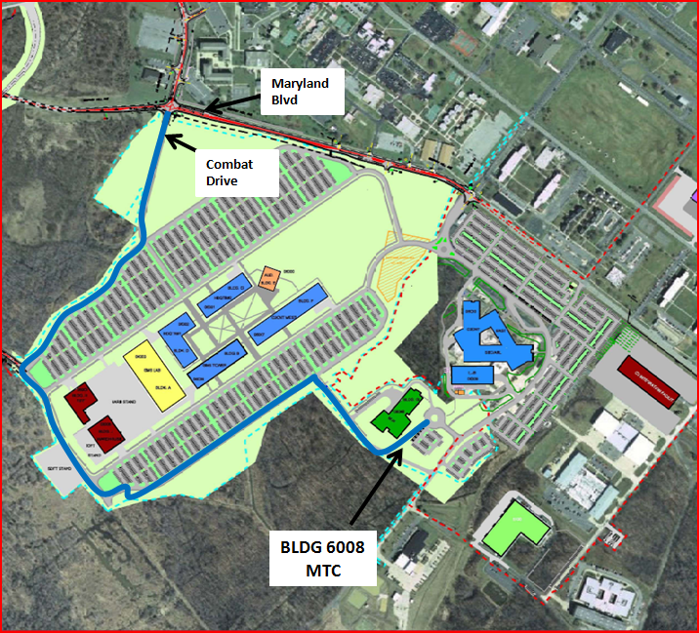
Additional parking is available in the parking lot of the Team C4ISR campus buildings.

