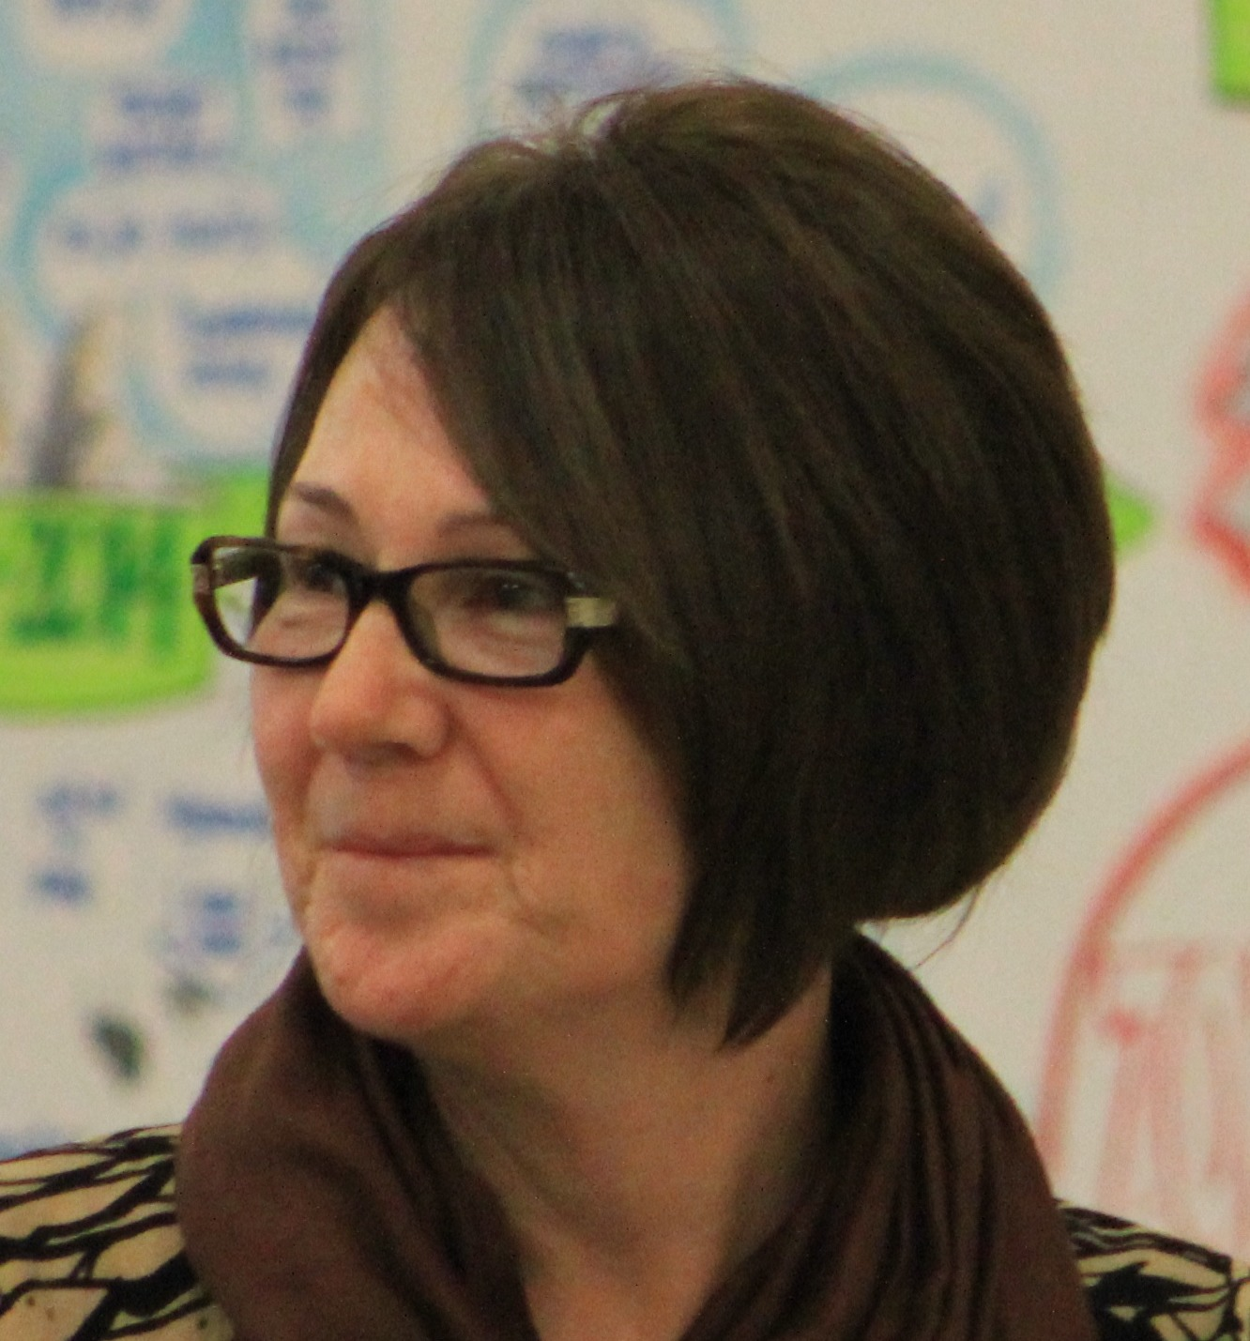
Claire Meany is a senior consultant, facilitator and coach for Transformation Strategies. She holds a BA in Psychology and an MA in Human Resource Development both from The George Washington University.

Claire has worked closely with many business leaders during her 25-year career, addressing a variety of leadership topics including understanding personal style, how to influence and create change, leadership styles, delegation, motivation, facilitation, team development, conflict resolution and coaching. She serves her public sector clients as an organization development consultant, program director, facilitator, designer and executive coach. Since 2002 she has delivered numerous hours of facilitation and coaching to front-line, mid-level and executive level federal employees from NSA, Department of Homeland Security, USDA, DC Superior Court, The Department of the Army and the Department of Justice as well as other private sector clients: Pearson PLC, Nokia Mobile Phones and Gettysburg College, just to name a few. Claire works with the following instruments in her facilitation of management and front line training sessions: OPM Leadership 360, MBTI, DiSC Classic 2.0, Everything DiSC, DiSC Management, FiroB, 4 Lenses, Thomas-Kilmann Conflict Mode Instrument, Coaching Behaviors Inventory, Political Savvy Skills Assessment and the Hogan Assessment System.

Claire has also served as faculty and coach in the Georgetown University Organization Development program and leads Leadership in Action and Management in Action - sessions that focus on developing managers and leaders at various levels. Claire's areas of special interest include helping leaders engage and get the best out of all of their employees. In 1999 she co-authored a chapter in the Linkage Inc.'s Best Practices in Organization and Human Resources Development Handbook documenting a focused employee development and retention initiative utilizing career development, leadership and management development, skills for dialogue, skills for motivation as tools to increase employee engagement. Most recently, she was a contributing author of Engaging Leadership – Three Agendas for Sustaining Achievement, which launched in the United States during the spring of 2010.
Claire Meany has worked in multiple arenas within DOD, the Intelligence Community and Department of the Army to deliver management and leadership programs. She is the current OPM Visiting Program Director for the Aberdeen Proving Ground Senior Leadership Cohort Program and a Visiting Program Director for Leading with Impact, an intelligence community front line leadership program.
Claire is an American Citizen who has lived in New York, Washington, DC and San Francisco. She has travelled extensively in the United States and abroad and enjoys experiencing different cultures. She is a student of Martial Arts and holds the rank of Second Degree black belt and training instructor in Tae Kwon Do. She is currently focused on her personal energy and has spent focused time on physical training. She recently completed her first half marathon and mini-triathlon. She is married to Steve Meany and is the mother of two mischievous boys, Shay (16) and Paolo (14). She currently resides in the Annapolis, Maryland area.

