JILL HINSON
Principal Consultant

PROFESSIONAL HIGHLIGHTS
Senior Level Consultant, Facilitator/Leadership Trainer and Coach with expertise in developing and managing complex, large‐scale change initiatives, leadership development programs, team development and senior team alignment retreats. As an innovative thinker, is driven to make a positive impact, doing work informed by the Appreciative Inquiry methodology and complexity science research. Known for partnering and coaching senior leaders and executives to create simple, well thought out interventions that improve performance.
- Led company-wide change management initiatives and strategies
- Develop and implement strategy for culture change and value re-clarification
- Coaching senior leaders and teams to increase alignment and performance
- Plan and implement team effectiveness programs
- Run and develop effective performance management systems
- Design and facilitate leadership development programs;
- Develop and implement organization engagement surveys

PROFESSIONAL EXPERIENCE
Aberdeen Proving Ground Leadership Cohort May 2011 to Current
Executive coach to a team composed of Senior Leaders, GS-15, at Aberdeen Proving Grounds. The action learning team is part of year long Senior Leadership Cohort for high potential senior leaders. Coaching involves interventions on team development, team process, individual and team learning and team outcomes. Coaching also includes debriefing OPM Assessment Center Feedback, OPM 360, DiSC assessment, Community Bases Projects and Personal Energy Management work.

Department of Justice: LEAP Program October 2009 - Current
One-on-one coaching to support learning for mid level manager participants of the DOJ Leadership Program. The face-to-face coaching sessions debriefed assessments including OPM 360, MBTI and EQi. The in-person session was supplemented by several “on-line” coaching/feedback sessions.

NSA Executive Assessment Program July 2010 – Present
Provide one-on-one coaching to NSA executive leaders attending a weeklong program focused on developing executive leadership skills. The coaching sessions include debriefing assessments including: OPM 360, DiSC Classic 2.0, DiSC Management Profile, and the Change Style Indicator.

NSA Mid-Level Management Program September 2010 – Present
Support NSA Mid-Level leaders (GS-15) attending a weeklong leadership development program by providing one-on-one coaching. This includes; helping participants review OPM 360 and DiSC Management Profile, identify opportunities, sharing leadership models & tools “just-in-time”, and actions plan to strengthen leadership effectiveness.

FDA: CDER – Leadership Development Program December 2010 – October 2011
Ten month coaching partnership for one-on-one coaching for leaders (GS14-15). The coaching relationship supports participants in developing individual learning goals, integrating classroom learning and applying learning to their roles. Debriefing assessments is also included.

Center for Progressive Leadership Executive Coaching & Leadership Training for Executive Fellowship Program 2011
Serve as executive coach for executives and leaders in non-profits and international companies. One-on-one coaching supports learning goals and application of their own personal development action plans. Selected to lead small group coaching sessions to integrate and reflect on classroom learning.

Leading Change in Complex Times, NTL Institute December 2010 – Present
Co-Design and facilitate a 3-day program on leading change in complex times. The program focuses on deepening understanding of how to create patterns of innovation, collaboration and agility, core elements enabling today’s success. Leaders learn new tools that are providing revolutionary insights and important contributions to the way we understand and influence social systems. The session provides simple models, tools and approaches to create patterns of collaboration, innovation and adaptability in organization and teams, foundational theories of complexity science; models and tools to enable change and neuroscience research that informs individual change.

National Gallery of Art – Leadership Development Program & Training March 2010- Present
Design and deliver a yearlong training series to support participants in developing core leadership competencies including: Leading Self, Leading Others, and Leading the Organization. The program includes the integration of Action Learning Team Projects.

QuickStart for Managers 2010 to Present
Designed and facilitate a virtual management development learning program that focuses on the development of core management skills. Models and theories included are: strategic thinking, delegation, feedback, coaching, conflict management, difficult conversations, high-performing teams, and leading change and leadership influence.

American Diabetes Association - October 2011 to Present
Supported VP of HR to facilitate HR sessions to increase awareness and alignment to customer needs and behaviors that build HR credibility. Conducted a team assessment via interviews as input to ongoing sessions with team to develop HR-wide process for project management and process improvements. This initiative is focused on building a high-performing, customer centric culture within HR.

American Society of Clinical Oncology - November 2010 to March 2011
Completed an assessment and intervention to increase capability of cross-departmental collaboration and individual capacity to deal with conflict productively. The intervention involved group training, individual coaching, and leadership meeting facilitation. The training series focused on building capacity to give feedback, deal with conflict and have difficult conversations productively. Conducted Kirkpatrick level I & II program evaluation.

Alcatel-Lucent - 2010 to Present
Designed and implemented a four-part cross-divisional leadership program to build leadership capacity leading culture change and model leadership imperatives. Elements included; Leading the Transformation, Leading with Courage & Passion, Coaching for Performance and Accountability and Collaborating as a Global Team Player

WORK HISTORY

Change Fusion, Managing Partner – 2009 – Present
S.W.I.F.T. (Society for Worldwide Interbank Telecommunications), Director Corporate Programs – 2001- 2009
Nordstrom, held various Marketing roles including Advertising Coordinator, Event Marketing Manager and Internal Communications Director 1990 – 2001

EDUCATION & CERTIFICATIONS

American University/NTL, Washington DC Master of Science degree in Organizational Development, June 2004

James Madison University, Harrisonburg VA, Bachelor of Business Administration, May 1989, magna cum laude

Certified to administer FIRO B – Human Element
Certified by Barry Oshry/Power & Systems to run The Organization Workshop
Certified by Human Systems Dynamics, an emerging field of research/practice that applies principles of complexity, nonlinear dynamics and chaos theory to study groups, teams and organizations.

PROFESSIONAL AFFILIATIONS & PRESENTATIONS

Ragan’s Communication Leadership Summit: “Engaging numbers: How to use research and involvement to drive employee engagement.” May 2005

Int’l Association of Business Communicators, “Employee Engagement” Spring 2003

NTL Annual Member Meeting: Organization Network Analysis, 2010
NTL Annual Member Meeting: Leading Change in Complex Times, 2010
NTL (National Training Laboratory Institute) Member

Board Member, President Elect, Chesapeake Bay Organization Development Network
MARCIA FEOLA
Principal Consultant

PROFESSIONAL HIGHLIGHTS

Marcia Feola, Principal, PowerfulWork, LLC, a small consulting firm specializing in building energized, collaborative and sustainable organizations. Marcia is a Master Certified Coach with over 30 years of experience as an executive, organization development consultant, executive coach and educator. Her expertise in systems thinking, change management, leadership development enables her to provide theory, context and strategy to organizational dilemmas and leadership challenges.

As Managing Director and Senior Faculty Member of the Georgetown University Organization Development and Change Leadership Programs for eleven years, she trained and coached hundreds of leaders and consultants in the complex dynamics of systems change. Her expertise in systems thinking, change management, leadership development enables her to provide theory, context and strategy to organizational dilemmas and leadership challenges.

Her clients are national, international, government, for-profit and non-profit organizations to include: National Security Agency, Office of Naval Intelligence, Department of State, USDA, Pension Benefit Guarantee Corporation, MedImunne, Equal Justice Works and Georgetown University Medical Center.

PROFESSIONAL EXPERIENCE

Executive Coaching: Regularly provide coaching to executive and senior level leaders to effect significant and sustainable personnel and professional change in order to have high impact in their organization. Coaching is custom designed for each client. It always begins with a full assessment of the client’s current situation. Surveys, 360 feedback instruments, Myers Briggs Indicator, Clark Wilson Inventory, Total Leadership Circle, and other measurement processes are available as part of the assessment. Work is targeted at the high impact areas, goals are established and strategies developed. Coaching is focused on supporting and guiding the executive to achieve maximum success.

Relevant clients:

Leaders Developing Leaders - A Program for NSA DISES and DISL Executives: Developing a program for National Security Agency Executives DISES and DISL to help them define their role and develop skills in coaching and mentoring the next generation of leaders.

Aberdeen Proving Ground, US Army, May 2011 to present: Provide coaching to a composed of high potential senior leaders, GS-15, at Aberdeen proving Ground as part of a yearlong leadership cohort program. Coaching includes debriefs of OPM Assessment Center Feedback, OPM 360, DiSC assessment, and focuses on team processes and development as well as individual and team learning and outcomes.

Leadership/Management Development: Marcia brings 18 years of her own experience as an executive to this challenging role. She regularly designs and facilitates leadership programs for senior executives as well as emerging leaders. These programs are designed to support leaders in an exploration of their leadership style and their potential impact on others.

Organization Development: Consistent and powerful work done in a variety of organizations for over 25 years. Facilitating and consulting efforts are designed to build effective, high performance organizations. A major goal is always to build organizational capacity and create learning environments to ensure continued success.

Work Teams: Significant work and achievement in the area of functional and cross-functional work teams. Work focuses first on educating the organization on the realities and practical implications of creating teams. Membership, charters, leadership, work processes, accountability mechanisms, team behavior, facilitation, communication strategies, reward and compensation are integral parts of the work.

Speaking, Training and Writing: Develop and deliver a full range of training interventions on: leading and managing organizations, leadership presence, facilitation essentials, facilitation mastery, consulting skills, meeting management, and leading in changing times.

WORK HISTORY

GEORGETOWN UNIVERSITY, Director & Senior Faculty Member – 1992-present
Organization Development Program, Change Leadership Program, Health Care Administration Program, International Student Exchange Programs

POWERFULWOK, LLC - Principal and Senior Consultant --1990 – present

GALLAUDET UNIVERSITY -- 1983 - 1990
Dean, Student Affairs, Director Student health Services
NORTHERN VIRGINIA SUBSTANCE ABUSE PGM -Executive Director 1976-82

EDUCATION
Somatic Coaching, The Strozzi Institute, 2011
Mindfulness Based Stress Reduction, University of Massachusetts, 2010
Certified Professional Coach, Coaches Training Institute, 20001
Certificate in Organization Development, Georgetown University, 1990
MA, Health Care Administration, George Washington University, 1976
BA, Business Administration and English Literature, George Washington University, 1974

PROFESSIONAL AFFILIATIONS
Organization Development Network
Consulting Women’s Network
FRANK H. (JOSH) STROUP
Principal Consultant

Josh Stroup manages his own training and consulting firm,
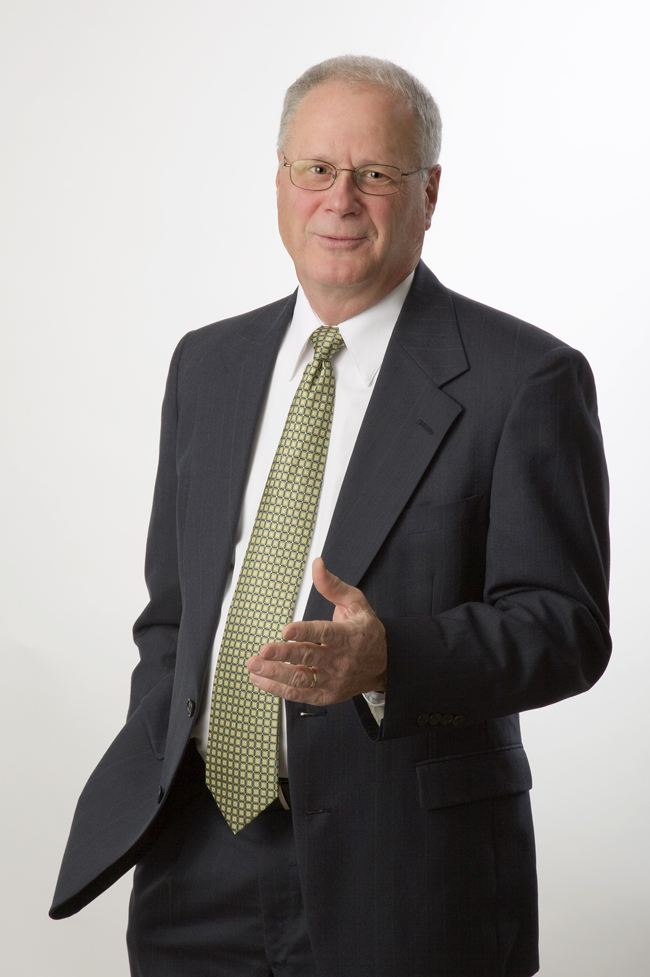
QTS Performance Solutions, based in Harrisburg PA. QTS now
serves a variety of organizations in the service, manufacturing,
government and non-profit sectors, providing:

- Leadership development
- Customer service and service leadership
- Management team consultation
- Executive/management coaching
In his QTS business, Josh provides training/facilitation, management team consulting, and executive coaching services. In his role with the Federal government’s Office of Personnel Management, Josh serves as an adjunct faculty member for open enrollment and custom leadership programs. He also works extensively as a coach with various OPM programs at both Eastern and Western Management Development Centers and custom client sites.
Josh is certified to use a number of behavioral assessments: DiSC Behavior Style Profile (including 363 for Leaders Profile), OPM 360º Feedback, Conflict Dynamics Profile, and Service Quality Leadership Survey.
A sampling of QTS clients includes: AAA Central Penn, Adhesives Research, Hershey Entertainment and Resorts Co. (HE&R), The Manitowoc Company, Nemours Health & Prevention Services, Prelude Services Inc., Verizon and multiple government agencies. While at HE & R, Josh served as the interim coordinator for the Center for Learning and Leadership Development, assessing leadership and customer service training needs, implementing new courses, and building its reputation.
Prior to starting QTS in 1993, Josh spent 11 years at Training Resource Corporation, a publisher of training materials and custom course design firm, guiding the publishing operation, developing course materials, and managing projects. While at TRC, he also served as President and part owner of a subsidiary, The Training Store Inc., a catalog for off-the-shelf training materials. Josh was responsible for fiscal management, catalog design and production, product selection, marketing plans and personnel.
Josh is co-author of customer service training materials, The Service Pro™ (HRD Press). He also created the Quick Tips™ training approach, used by supervisors to train their front-line service people in a variety of businesses.
Professionally, Josh is a member and past president of Central PA Chapter of the American Society for Training and Development. He holds a BA from the College of Wooster (Ohio) and advanced degrees from and McCormick Theological Seminary (Chicago) and the University of Illinois (Chicago).

FREDERICK C. JEFFERSON III
Principal Consultant

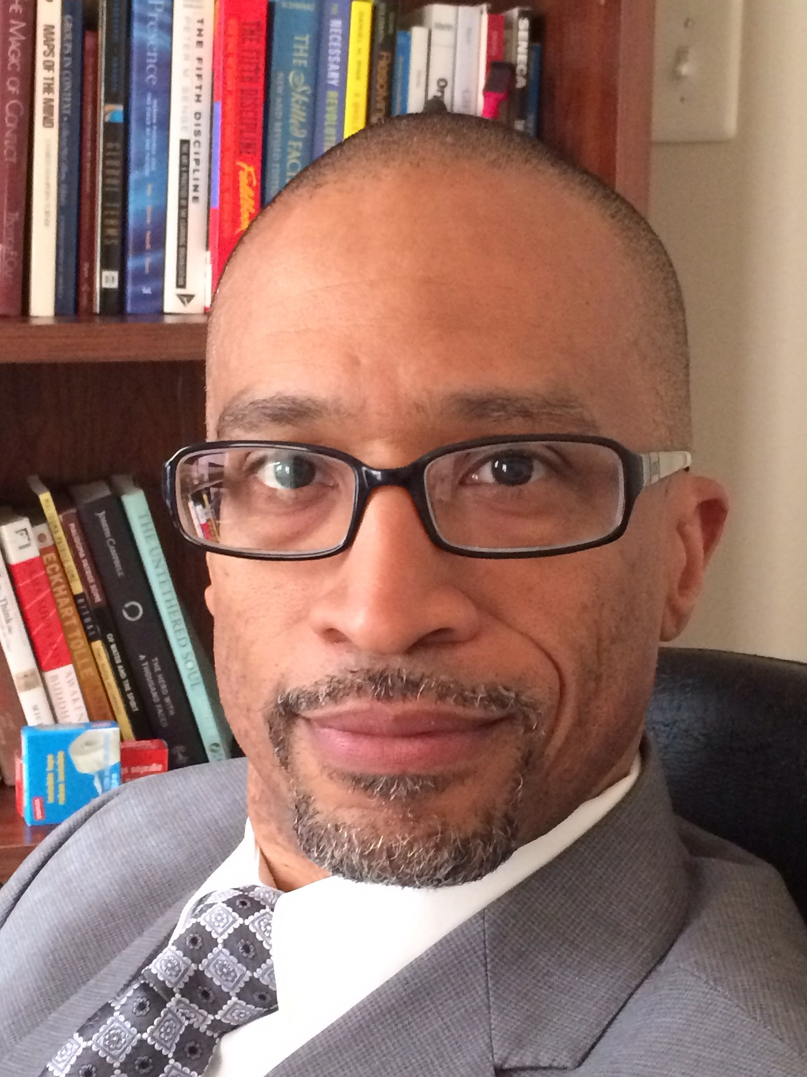
Frederick Jefferson, MSOD, Senior Organization Development Consultant, is a results oriented executive coach with more than 20 years of international experience in organization change management, leadership development, and strategic communications. His creative, energetic and innovative approach to coaching, team development, and organization transformation has resulted in numerous client successes. Frederick’s thought provoking coaching and consulting presence encourages leaders to take stock of their strengths, get clear on their goals, and gain perspective on how to effectively accelerate change and drive organization effectiveness.
Previously, Frederick was a Lead Information Systems Engineer at the MITRE Corporation, a not-for- profit organization that operates research and development centers assisting the United States government with, scientific research and analysis, development and acquisitions, systems engineering and integration, and civil agency modernization. His primary role was as an Organization Change Management lead on multiple customer projects spanning numerous government agencies to include the IRS, VA, US Courts, and HHS. Key results included developing leadership development programs, designing team building off-sites, facilitating organization assessments and coaching senior leaders and managers.
Core Areas of Expertise
- Coaching and Leadership/Team Development
- Workshop Design & Facilitation
- Organization Assessment & Employee Engagement
- Strategic Communications
Frederick is an active member of NTL and was one of six Executive Coaches chosen to participate in NTL’s Non-Profit Leadership of Color coaching initiative designed to provide leadership training, best practices and one-on-one coaching, in support of leaders of color in the Washington D.C. area.
Prior to his work at MITRE, Frederick was a Strategic Communications Consultant at Booz Allen Hamilton. During his tenure, his work primarily focused on change communications within the Intel community and Department of Defense. In addition to his Strategic communication work, Frederick was one of the principle course designers of Booz Allen Hamilton’s Change Management Advanced Practitioners Program. A graduate-level certification program for change management practitioners, generated through a partnership between Georgetown University’s McDonough School of Business and Booz Allen Hamilton. Frederick holds a master’s degree in Organization Development from American University/NTL, an undergraduate Bachelor of Arts degree in Organizational Psychology from Cambridge College, and is currently pursuing a doctoral degree at George Washington University in Executive Leadership and Human and Organizational Learning. Frederick’s work experience spans numerous government agencies, large corporations, and not-for-profit organizations. He is a certified MBTI practitioner and is a graduate of the University of Rochester Warner Center/ McArdle Ramerman Leadership Coaching Certificate Program.

